Lab 03: Logisim evolution

9 bit encoder (it is ignoring the lower bits)

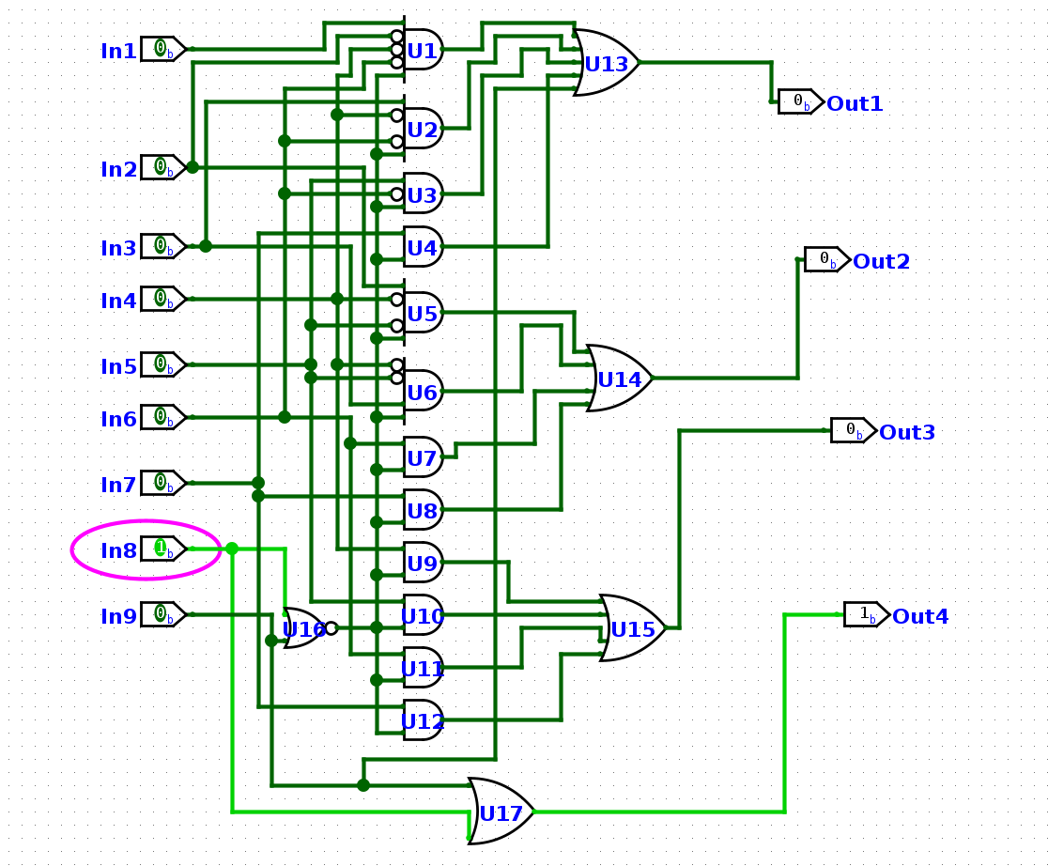

Main circuit:
