Lab 02: Logisim-evolution

Equation1:
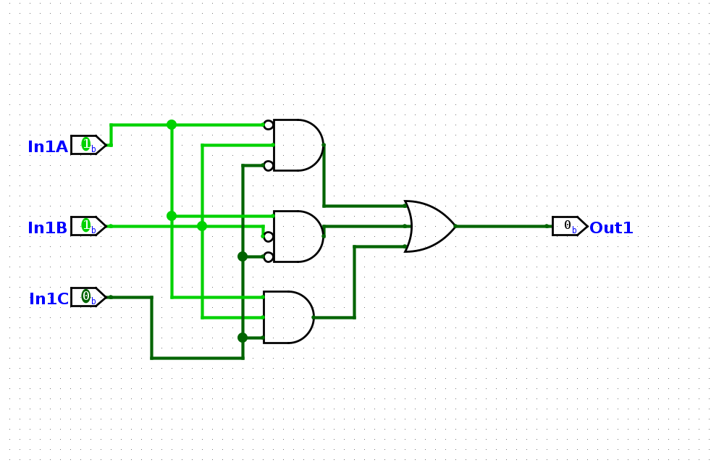

Equation2:

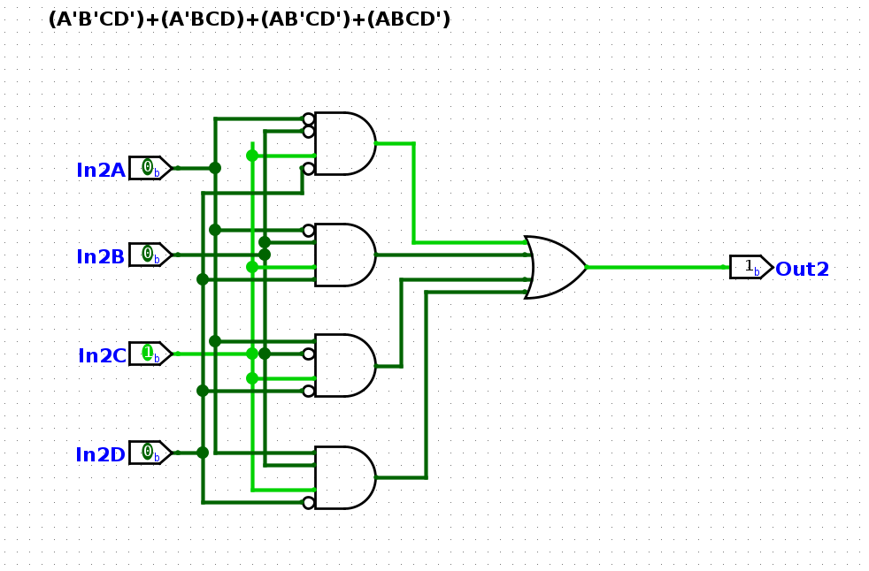
I didn’t use the test files. Cheking with poke, seems to give adequate results.

