The purpose of the lab was to crate an image diagram from chronogram

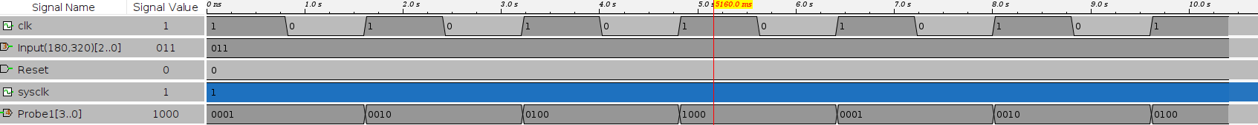
image 1.

For that several Counter sub circuits were created including the universal sub circuit, which allowed to choose the encoder using select

below is first asynchronous up counter

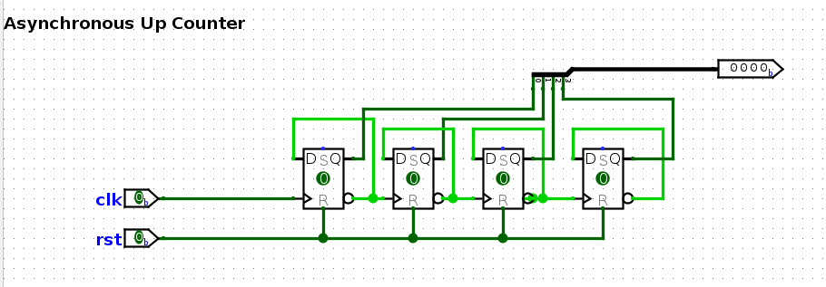
image 2.

other counter are pretty similar and are given in the lab manual.

So below will be main and Universal sub circuits

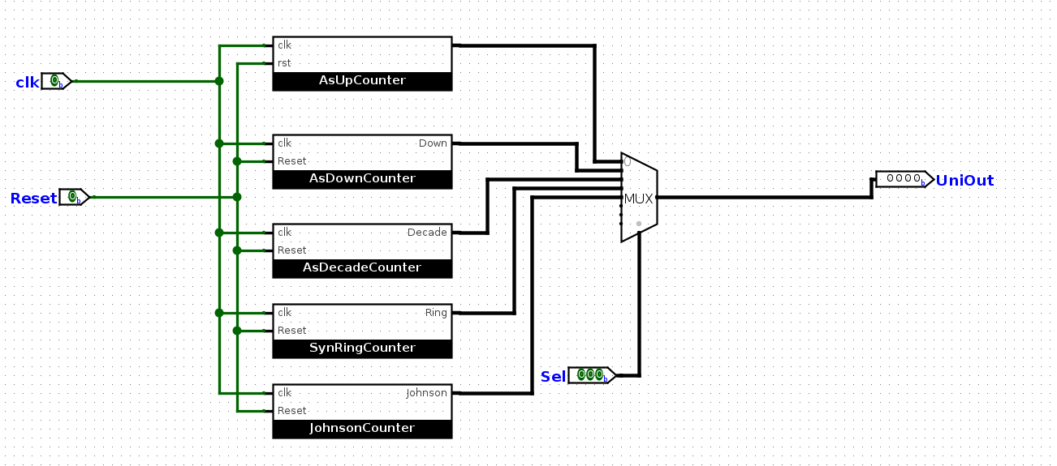
Universal

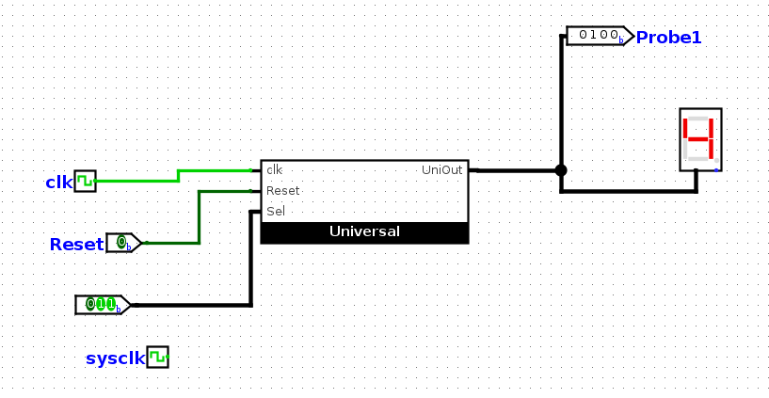
main circuit

