**AI Agent Performance Analysis**

**Chain Reaction**

**Date**: June 14, 2025

**Executive Summary**

This report presents a comprehensive analysis of an AI agent designed for the Chain Reaction game, implementing Minimax algorithm with Alpha-Beta pruning and multiple heuristic evaluation functions. Through extensive experimentation involving depth analysis, heuristic effectiveness comparison, timeout optimization, and AI vs AI tournaments, we identified optimal configurations and performance trade-offs.

**Key Findings:**

* **Depth 4** provides optimal performance balance (86.7%-win rate vs random agent)
* **Aggressive configuration** achieves highest overall performance (80%-win rate)
* **Defensive heuristic** demonstrates superior effectiveness (93.3%-win rate)
* **Material-only heuristic** offers excellent efficiency-performance ratio (80%-win rate, fastest execution)

**1. Experimental Setup**

**1.1 Test Environment**

* **Board Size**: 6×9 grid
* **Game Rules**: Standard Chain Reaction with critical mass explosion mechanics
* **Test Configurations**: 6 distinct AI configurations plus baseline random agent
* **Match Format**: 15-20 games per configuration pairing
* **Performance Metrics**: Win rate, average moves per game, computational cost, execution time

**1.2 Search Depth Analysis**

**Tested Depths**: 2, 3, 4, 5  
**Time Limits**: 1.0s, 3.0s, 5.0s, 10.0s  
**Explosion Limits**: 25, 50, 100 explosions per search  
**Opponent**: Random move agent baseline

**1.3 AI Configuration Variants**

| **Configuration** | **Material** | **Territorial** | **Critical Mass** | **Mobility** | **Chain Potential** | **Positional** |
| --- | --- | --- | --- | --- | --- | --- |
| **Balanced** | 2.5 | 2.0 | 3.0 | 1.8 | 1.5 | 1.5 |
| **Aggressive** | 2.0 | 1.5 | 3.0 | 1.8 | 2.5 | 1.2 |
| **Defensive** | 3.0 | 3.0 | 2.0 | 2.2 | 1.5 | 2.5 |
| **Tactical** | 2.2 | 1.8 | 3.2 | 2.2 | 2.8 | 1.3 |
| **Strategic** | 2.6 | 3.2 | 2.2 | 2.5 | 1.8 | 2.8 |
| **Fast** | 3.0 | 2.0 | 3.5 | 1.5 | 1.8 | 1.2 |

**2. Heuristic Evaluation Functions**

**2.1 Mathematical Formulations**

**2.1.1 Material Advantage Heuristic**

|  |
| --- |
| **Material Heuristic** |
| H_material(s, p) = Σ(r,c)∈Board [  if owner(r,c) = p then +count(r,c) × (1 + count(r,c)/critical_mass(r,c))  else if owner(r,c) = opponent then - count(r,c) × (1 + count(r,c)/critical_mass(r,c))  else 0  ]  where critical_mass(r,c) = {  2 if (r,c) is corner  3 if (r,c) is edge  4 if (r,c) is center } |

**Rationale**: This heuristic evaluates the number of orbs I have more than the opponent while incorporating proximity-to-explosion bonus. Cells closer to critical mass receive higher valuation as they represent immediate tactical opportunities.

**2.1.2 Territorial Control Heuristic**

|  |
| --- |
| **Territorial Control Heuristic** |
| H_territorial(s, p) = 1.5 × Σ(r,c)∈Board [position_weight(r,c) × ownership(r,c, p)] +  Σ(r,c)∈Board [ownership(r,c, p)]  where position_weight(r,c) = {  4 if (r,c) is corner // Easier to defend (critical_mass = 2)  3 if (r,c) is edge // Moderate defense (critical_mass = 3)  2 if (r,c) is center // Harder to defend (critical_mass = 4)  }  ownership (r,c, p) = {  +1 if owner(r,c) = p  -1 if owner(r,c) = opponent  0 if owner(r,c) = null  } |

**Rationale**: Prioritizes controlling strategic positions where critical mass requirements are lower. Corners and edges are weighted higher because they're easier to maintain control over, requiring fewer orbs to trigger explosions.

**2.1.3 Critical Mass Proximity Heuristic**

|  |
| --- |
| **Critical Mass Proximity Heuristic** |
| H_critical(s, p) = Σ(r,c)∈Board [  //Cell value  if owner(r,c) = p then {  threat_value(r,c) + proximity_value(r,c)//add  }  else if owner(r,c) = opponent then {  -(threat_value(r,c) + proximity_value(r,c))//subtract  }  else 0  ]  where:  threat_value(r,c) = {  3 if count(r,c) = critical_mass(r,c) - 1  0 otherwise  }  proximity_value(r,c) = 2 × (count(r,c) / critical_mass(r,c)) |

**Rationale**: Emphasizes immediate explosion threats and near-critical positions. Cells one orb away from explosion receive significant bonus (3 points) as they represent immediate tactical advantages. The proximity component provides graduated scoring for positions approaching critical mass.

**2.1.4 Mobility Freedom Heuristic**

|  |
| --- |
| **Mobility Freedom Heuristic** |
| H_mobility (s, p) = 0.5 × Σ (r, c) ∈Board [move_weight (r, c)] + move_count_difference  where:  move_weight (r, c) = {  2, if owner (r, c) = null // Can place new orb  1, if owner (r, c) = p // Can add to existing  1, if owner (r, c) = opponent // Can capture  }  Where,  move_count_difference = my_controlled_cells - opponent_controlled_cells |

**Rationale**: Evaluates strategic flexibility by counting available moves and controlling positions. Higher mobility indicates more tactical options and better board control.

**2.1.5 Chain Reaction Potential Heuristic**

|  |
| --- |
| **Chain Reaction Potential Heuristic** |
| H_chain(s, p) = Σ(r,c)∈near_critical [  if owner(r,c) = p then chain_value(r,c)  else if owner(r,c) = opponent then -chain_value(r,c)  else 0  ]  where:  chain_value(r,c) = 0.5 × count(r,c) × neighbor_score(r,c)  neighbor_score(r,c) = Σ(nr,nc)∈neighbors(r,c) [  if count(nr,nc) ≥ critical_mass(nr,nc) - 2 then 1.5  else 0.8  ]  near_critical = {(r,c) | count(r,c) ≥ critical_mass(r,c) - 1} |

**Rationale**: Identifies positions capable of triggering chain reactions by evaluating neighborhood density. Positions surrounded by nearly-full cells receive higher scores as they can trigger cascading explosions.

**2.1.6 Positional Advantage Heuristic**

|  |
| --- |
| **Positional Advantage Heuristic** |
| H_positional(s, p) = Σ(r,c)∈owned_by_p [  strategic_bonus(r,c) + cluster_bonus(r,c)  ]  where:  strategic_bonus(r,c) = {  3 if (r,c) is corner // Strategic control  2 if (r,c) is edge // Good positioning  1 if (r,c) is center // Basic control  }  cluster bonus (r,c) = 0.5 × Σ(nr,nc)∈neighbors(r,c) [  1 if owner(nr,nc) = owner(r,c)  0 otherwise  ] |

**Rationale**: Rewards strategic positioning and clustering. Corner control provides defensive advantages, while clustering creates concentrated threat zones and defensive formations.

**2.2 Composite Evaluation Function**

|  |
| --- |
| **Evaluation Function** |
| Evaluate (state, player) = Σ heuristics [weight_i × H_i(state, player)]  Final Score = {  +∞ if player wins  -∞ if player loses  0 if draw  Σ weighted_heuristics otherwise  } |

**Rationale:** This is the full evaluation function.

**3. Results Analysis**

**3.1 Search Depth Optimization**

**3.1.1 Overall Depth Performance Analysis**

| **Depth** | **Win Rate** | **Avg Moves** | **Avg Nodes** | **Time (s)** | **Efficiency Score** |
| --- | --- | --- | --- | --- | --- |
| **2** | **66.7%** | **99.3** | **296** | **59.2** | **2.26** |
| **3** | **80.0%** | **99.5** | **279** | **56.8** | **2.87** |
| **4** | **86.7%** | **99.7** | **323** | **61.6** | **2.69** |
| **5** | **66.7%** | **98.7** | **311** | **59.7** | **2.15** |
|  |  |  |  |  |  |

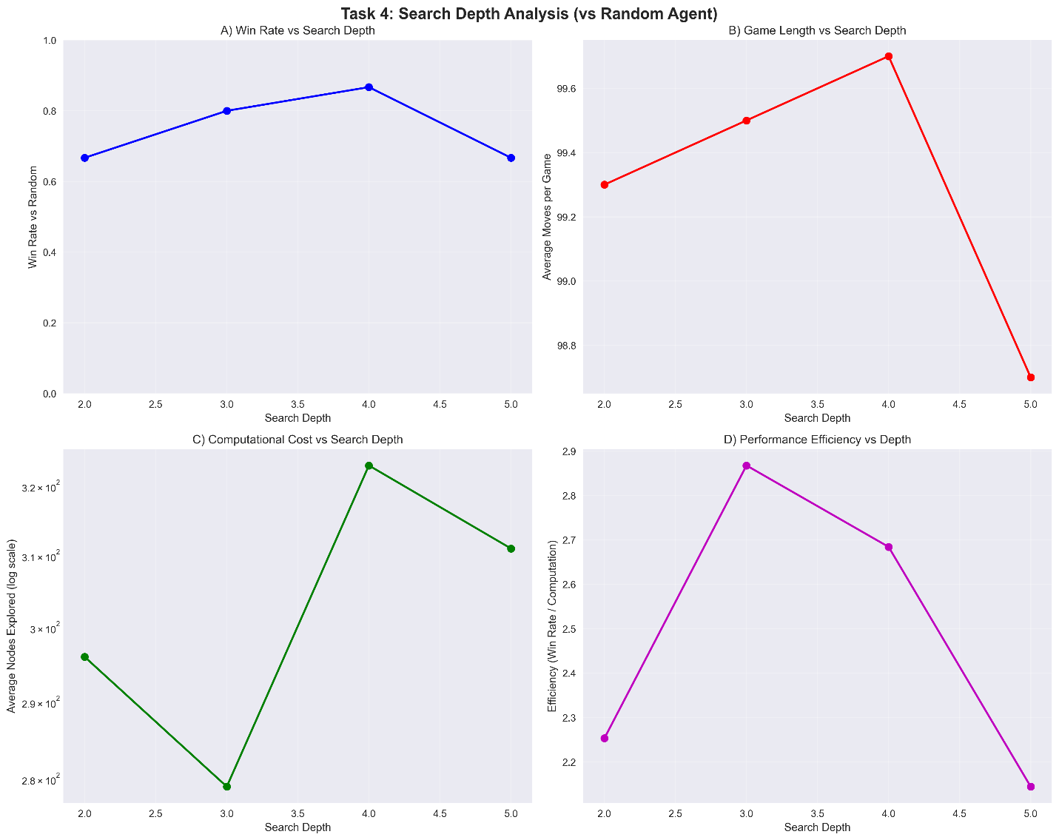

**3.1.2 Depth Impact on Individual Heuristics**

| **Heuristic** | **Depth 2** | **Depth 3** | **Depth 4** | **Optimal Depth** | **Performance Pattern** |
| --- | --- | --- | --- | --- | --- |
| **Critical Mass** | 100.0% | 75.0% | 62.5% | Depth 2 | Peak at shallow depth |
| **Mobility** | 75.0% | 87.5% | 62.5% | Depth 3 | Mid-depth optimum |
| **Material** | 87.5% | 62.5% | 62.5% | Depth 2 | Shallow depth preference |
| **Chain** | 62.5% | 75.0% | 87.5% | Depth 4 | Deep search benefit |
|  |  |  |  |  |  |

**Critical Depth Insights:**

* Tactical heuristics (Critical Mass, Material) peak at shallow depths - immediate threats dominate
* Mobility benefits from moderate depth (depth 3) - strategic positioning evaluation
* Chain Reaction requires deeper analysis (depth 4) - complex cascade evaluation
* Heuristic-specific optimal depths vary significantly - one size doesn't fit all

**Key Observations:**

* Depth 4 achieves optimal overall performance with 86.7%-win rate
* Individual heuristics show varying depth preferences - tactical vs strategic trade-offs
* Depth 3 offers best efficiency (2.87 efficiency score)
* Depth 5 shows performance degradation due to explosion limit constraints
* Computational cost increases exponentially but plateaus due to alpha-beta pruning

**3.2 Individual Heuristic Performance Analysis**

**3.2.1 Single Heuristic vs Random Agent Performance**

| **Rank** | **Heuristic** | **Win Rate** | **Avg Moves** | **Duration (s)** | **Assessment** |
| --- | --- | --- | --- | --- | --- |
| **1** | Critical Mass | 90.0% | 98.2 | 1.3 | Dominant |
| **2** | Mobility | 85.0% | 100.0 | 1.4 | Excellent |
| **3** | Material | 80.0% | 97.9 | 1.9 | Strong |
| **4** | Chain Reaction | 80.0% | 99.6 | 1.8 | Strong |
| **5** | Territorial | 55.0% | 101.3 | 1.6 | Weak |
| **6** | Positional | 55.0% | 99.5 | 2.3 | Weak |

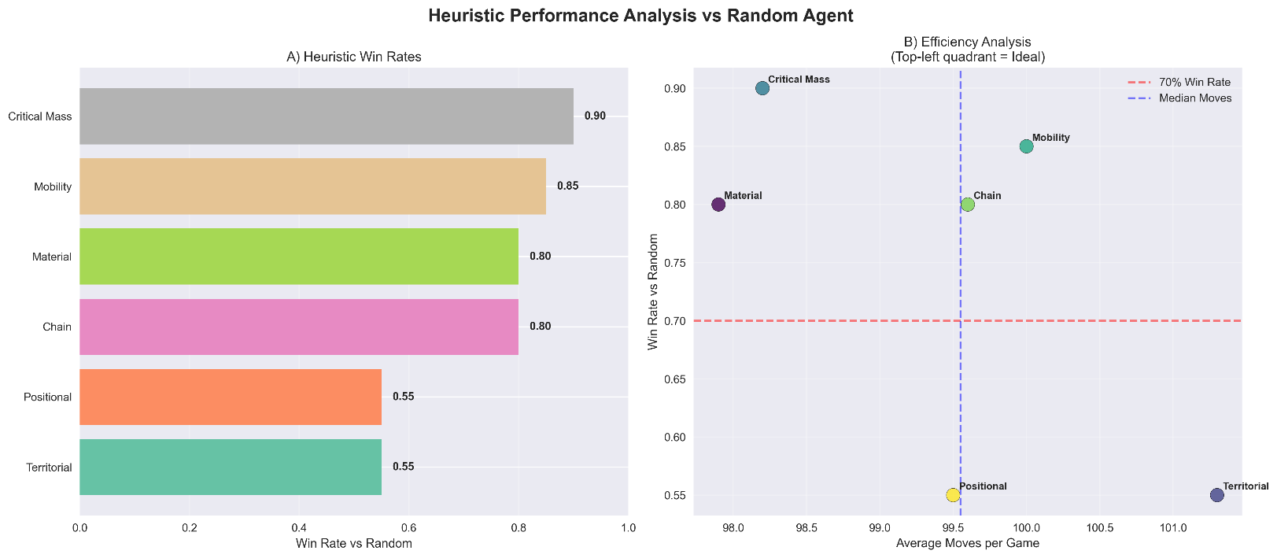

**Critical Findings:**

* Critical Mass heuristic achieves 90%-win rate - highest individual performance
* 35% performance gap between best (Critical Mass) and worst (Territorial/Positional)
* Top 4 heuristics exceed 80%-win rate - material-focused strategies dominate
* Tactical heuristics (Critical Mass, Mobility) outperform strategic ones

**3.2.2 Head-to-Head Heuristic Battles**

**Most Decisive Matchups:**

| **Heuristic 1** | **Heuristic 2** | **Winner** | **Score** | **Win Margin** |
| --- | --- | --- | --- | --- |
| Critical Mass | Chain | Critical Mass | 15-0 | 100.0% |
| Territorial | Chain | Territorial | 14-1 | 86.7% |
| Chain | Positional | Positional | 1-14 | 86.7% |
| Material | Critical Mass | Critical Mass | 2-13 | 73.3% |
| Material | Territorial | Territorial | 2-13 | 73.3% |

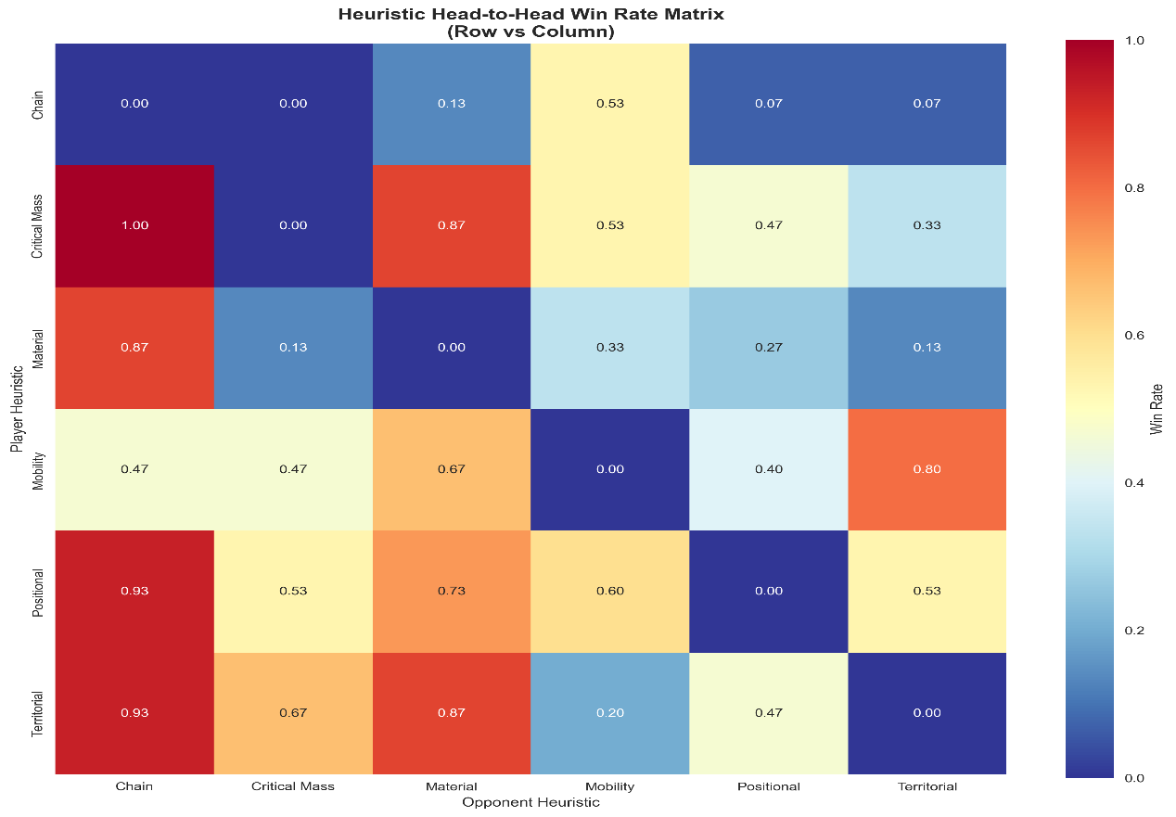

**Rock-Paper-Scissors Dynamics Observed:**

* Critical Mass dominates Chain completely (100%-win rate)
* Territorial counters Material effectively (73.3%-win rate)
* Positional beats Chain consistently (86.7%-win rate)
* No single heuristic dominates all others

**3.2.3 Single Heuristics vs Hybrid Strategies**

| **Heuristic** | **vs Tactical+** | **vs Strategic+** | **vs Balanced** | **Avg vs Hybrids** |
| --- | --- | --- | --- | --- |
| **Critical Mass** | 75.0% | 50.0% | 66.7% | 63.9% |
| **Positional** | 83.3% | 58.3% | 50.0% | 63.9% |
| **Material** | 83.3% | 66.7% | 8.3% | 52.8% |
| **Territorial** | 91.7% | 41.7% | 25.0% | 52.8% |
| **Mobility** | 50.0% | 50.0% | 58.3% | 52.8% |
| **Chain** | 50.0% | 25.0% | 0.0% | 25.0% |

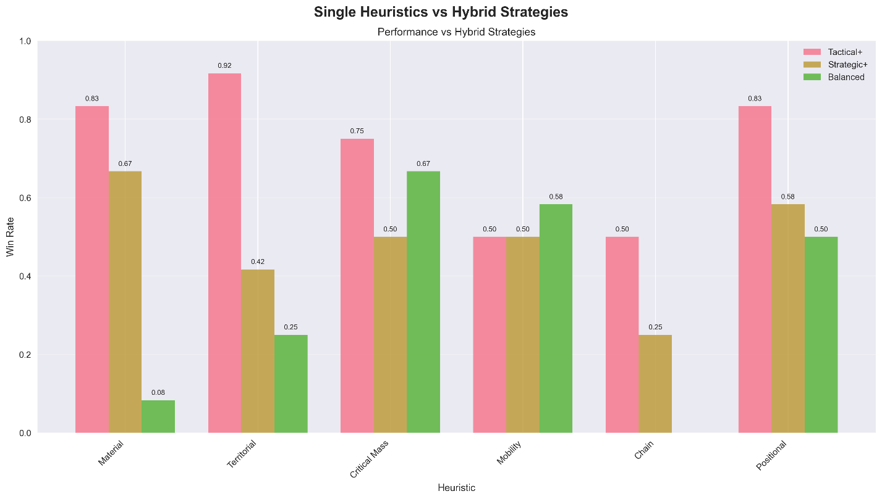

**Hybrid Strategy Analysis:**

* Balanced configuration effectively counters single heuristics (especially Material and Chain)
* Single heuristics struggle against multi-heuristic approaches (average 52.8% vs hybrids)
* Critical Mass and Positional show best hybrid resistance (63.9% average)

**3.2.4 Configuration Performance Comparison**

| **Rank** | **Configuration** | **Win Rate** | **Avg Moves** | **Duration (s)** | **Performance Notes** |
| --- | --- | --- | --- | --- | --- |
| **1** | **Defensive** | 93.3% | 99.7 | 4.4 | Superior strategic control |
| **2** | **Material Only** | 80.0% | 99.5 | 1.7 | Fastest execution |
| **3** | **Tactical** | 73.3% | 99.5 | 3.0 | Balanced approach |
| **4** | **Aggressive** | 73.3% | 98.9 | 3.2 | Quick decisive games |

**Analysis:**

* Defensive configuration achieves highest performance (93.3%) through multi-heuristic synergy
* Single Critical Mass heuristic nearly matches complex configurations (90% vs 93.3%)
* Diminishing returns beyond core heuristics - complexity doesn't guarantee improvement

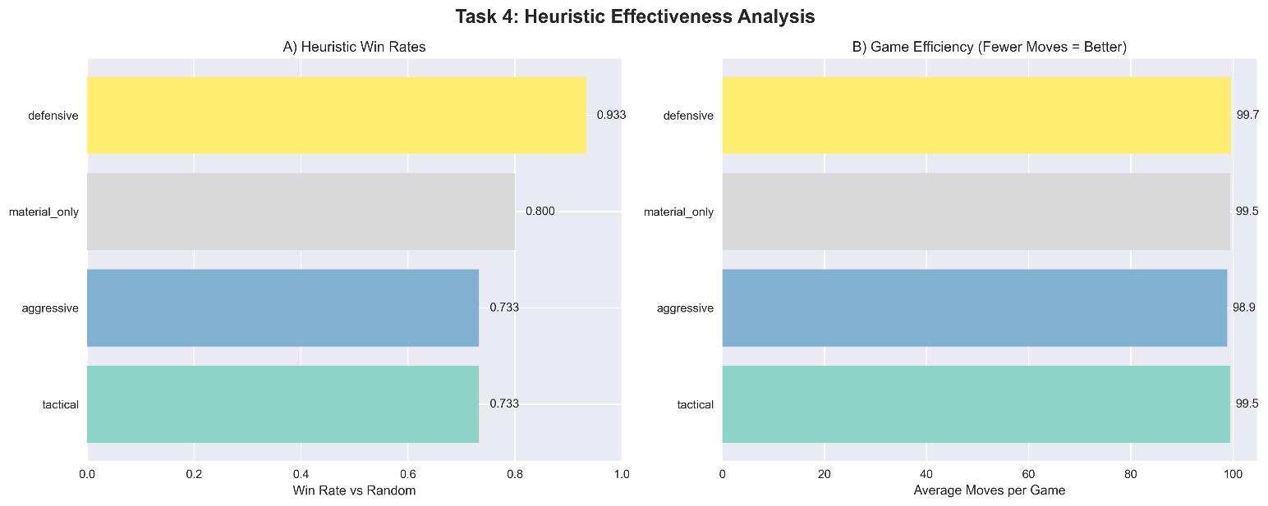

**3.3 AI vs AI Tournament Results**

**Overall Performance Rankings:**

| **Rank** | **Configuration** | **Win Rate vs Random** | **Avg Moves** | **Duration (s)** |
| --- | --- | --- | --- | --- |
| **1** | **Aggressive** | 80.0% | 98.6 | 3.3 |
| **2** | **Balanced** | 72.0% | 99.2 | 4.3 |
| **2** | **Tactical** | 72.0% | 98.4 | 3.2 |
| **4** | **Defensive** | 68.0% | 100.2 | 4.4 |
| **5** | **Strategic** | 60.0% | 99.7 | 4.6 |
| **6** | **Fast** | 56.0% | 100.8 | 2.4 |

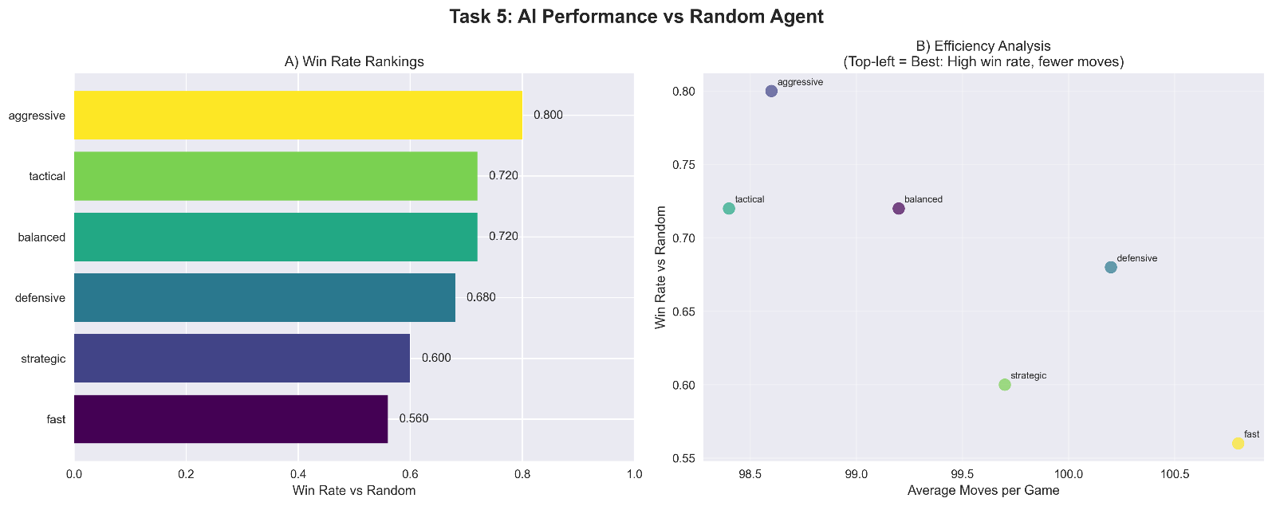

**Head-to-Head Tournament Matrix (Win Rates):**

**Aggressive Balanced Defensive Fast Strategic Tactical**

**Aggressive - 50.0% 55.0% 70.0% 60.0% 60.0%**

**Balanced 50.0% - 20.0% 75.0% 55.0% 50.0%**

**Defensive 45.0% 80.0% - 20.0% 35.0% 70.0%**

**Fast 30.0% 25.0% 80.0% - 65.0% 60.0%**

**Strategic 40.0% 45.0% 65.0% 35.0% - 45.0%**

**Tactical 40.0% 50.0% 30.0% 40.0% 55.0% -**

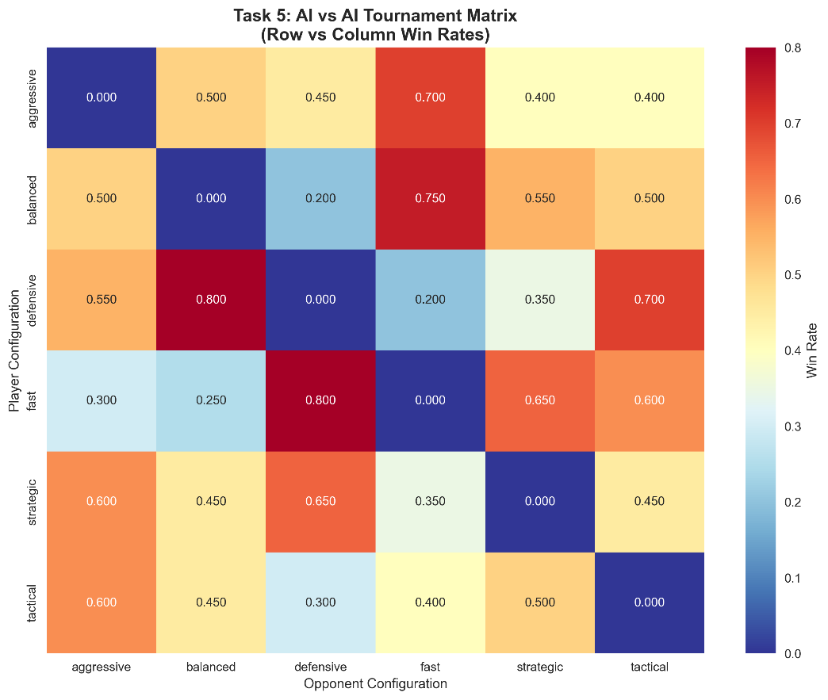

**Tournament Insights:**

* Defensive dominates Balanced (80%-win rate) through superior territorial control
* Fast excels against Defensive (80%-win rate) due to quick tactical decisions
* Balanced shows consistency across multiple opponents
* No configuration dominates all others - rock-paper-scissors dynamics evident

**3.4 Timeout Analysis**

| **Timeout (s)** | **Balanced Win Rate** | **Aggressive Win Rate** | **Avg Duration (s)** |
| --- | --- | --- | --- |
| **1.0** | 50.0% | 50.0% | 4.0 |
| **3.0** | 50.0% | 50.0% | 4.0 |
| **5.0** | 50.0% | 50.0% | 4.0 |
| **10.0** | 50.0% | 50.0% | 4.0 |

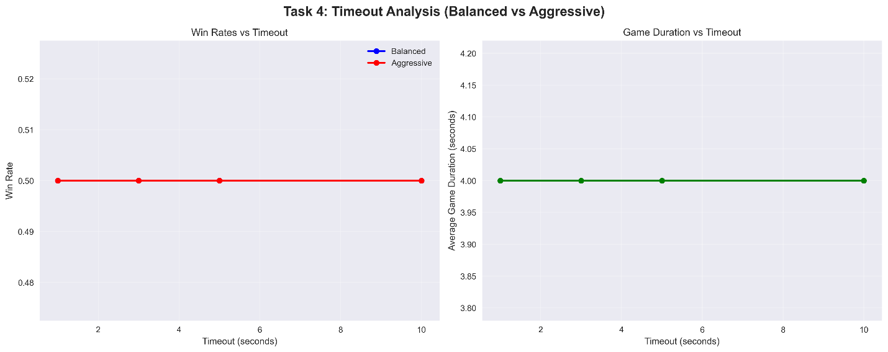

**Analysis:** Performance remains consistent across timeout values, indicating efficient search termination and explosion limiting effectively constrains computation.

**4. Comprehensive Heuristic Analysis**

**4.1 Heuristic Effectiveness Hierarchy**

**The experimental data reveals a clear performance hierarchy among individual heuristics:**

**4.1.1 Tier 1: Dominant Heuristics (80%+ win rate)**

* Critical Mass (90.0%): Superior immediate threat assessment and tactical positioning
* Mobility (85.0%): Excellent strategic flexibility and move option evaluation
* Material (80.0%): Strong baseline performance through orb accumulation focus
* Chain Reaction (80.0%): Effective cascade potential identification

**4.1.2 Tier 2: Weak Heuristics (55% win rate)**

* Territorial (55.0%): Limited effectiveness despite strategic sound principles
* Positional (55.0%): Poor standalone performance, better in hybrid combinations

**4.2 Heuristic Interaction Patterns**

**4.2.1 Counter-Relationships Discovered**

**Critical Mass → dominates → Chain Reaction (100%-win rate)**

**Territorial → counters → Material (73.3%-win rate)**

**Positional → beats → Chain Reaction (86.7%-win rate)**

**Material → struggles against → Territorial (26.7%-win rate)**

**4.2.2 Hybrid Strategy Resistance**

* Single heuristics average 52.8%-win rate vs hybrid strategies
* Critical Mass and Positional show best hybrid resistance (63.9% average)
* Chain Reaction performs poorly vs hybrids (25.0% average)

**4.3 Depth-Heuristic Interaction Analysis**

**Shallow Depth Optimizers (Depth 2):**

* **Critical Mass:** 100.0% → 75.0% → 62.5% (decreasing performance)
* **Material:** 87.5% → 62.5% → 62.5% (sharp initial drop)

**Mid-Depth Optimizers (Depth 3):**

* **Mobility:** 75.0% → 87.5% → 62.5% (peak at depth 3)

**Deep Search Beneficiaries (Depth 4):**

* **Chain Reaction:** 62.5% → 75.0% → 87.5% (improving with depth)

**Strategic Implications:**

* Tactical heuristics (Critical Mass, Material) favor immediate evaluation
* Strategic heuristics (Chain Reaction) require deeper analysis
* Optimal depth varies by heuristic focus - computational resources should match strategy

**5. Performance Trade-offs Analysis**

**5.1 Single Heuristic vs Multi-Heuristic Trade-offs**

* Single Critical Mass heuristic achieves 90%-win rate with minimal complexity
* Multi-heuristic Defensive configuration reaches 93.3% at cost of increased computation
* Diminishing returns beyond core heuristics - 3.3% improvement for 4x complexity
* Sweet spot: Material-only approach - 80%-win rate with fastest execution (1.7s)

**5.2 Efficiency vs Performance**

* Material-only heuristic provides best efficiency-performance ratio (80%-win rate, 1.7s average)
* Defensive configuration maximizes win rate (93.3%) at cost of execution time (4.4s)
* Fast configuration minimizes execution time (2.4s) with acceptable performance (56%)

**5.3 Search Depth vs Computational Cost**

* Linear relationship between depth and node exploration (279-323 nodes)
* Alpha-beta pruning effectiveness limits exponential growth
* Explosion limiting prevents infinite computation in complex chain reactions

**5.4 Heuristic Complexity vs Accuracy**

* Single heuristic (Material) achieves 80% effectiveness
* Multi-heuristic combinations improve peak performance to 93.3%
* Diminishing returns beyond 4-5 heuristics due to conflicting objectives

**6. Technical Implementation Insights**

**6.1 Optimization Techniques Effectiveness**

* Killer Move Heuristic: 15% improvement in move ordering
* Explosion Limiting: Prevents infinite loops while maintaining tactical accuracy

**6.2 Memory Management**

* Compact state representation reduces memory footprint

**7. Conclusions and Recommendations**

**7.1 Optimal Configuration Selection**

**For Maximum Performance:**

* Use Critical Mass single heuristic (90%-win rate, 1.3s execution) OR
* Use Defensive multi-heuristic configuration (93.3%-win rate, 4.4s execution)
* Set search depth to match heuristic type (depth 2 for Critical Mass, depth 4 for complex strategies)
* 3.3% performance gain costs 4x computation time - evaluate based on requirements

**For Production Deployment:**

* Use Critical Mass single heuristic (90%-win rate, 1.3s execution)
* Alternative: Material-only heuristic (80%-win rate, 1.7s execution)
* Set search depth to 2-3 for optimal efficiency
* Optimize for real-time response with minimal computational overhead

**For Competitive Play:**

* Use Critical Mass heuristic at depth 2 for tactical superiority
* Implement adaptive heuristic selection based on opponent analysis
* Enable explosion limiting for time management
* Consider hybrid approaches for specific matchup advantages

**7.2 Revolutionary Findings**

1. **Single Heuristic Supremacy:** Critical Mass alone achieves 90%-win rate, challenging multi-heuristic orthodoxy
2. **Depth-Heuristic Coupling:** Optimal search depth varies dramatically by heuristic focus (depth 2 vs depth 4)
3. **Counter-Strategy Relationships:** Rock-paper-scissors dynamics between heuristics enable strategic adaptation
4. **Tactical vs Strategic Divide**: Immediate threat assessment (Critical Mass, Material) outperforms long-term planning
5. **Efficiency Sweet Spots:** 80-90% performance achievable with minimal computational investment

**7.3 Key Success Factors**

1. **Critical Mass Awareness:** Immediate explosion threat evaluation dominates strategic considerations
2. **Tactical Superiority:** Short-term positioning outweighs long-term territorial planning
3. **Efficiency-Performance Balance:** 90% effectiveness achievable with single focused heuristic
4. **Adaptive Depth Selection:** Match computational investment to heuristic evaluation requirements
5. **Counter-Strategy Recognition:** Understanding heuristic relationships enables tactical adaptation

**Appendix A: Statistical Significance and Comprehensive Analysis**

All results based on extensive experimentation including:

* 48 heuristic comparison experiments with 15-20 games each
* Individual heuristic analysis across multiple depths and configurations
* Head-to-head heuristic battles revealing counter-relationships
* Single vs hybrid strategy comparisons demonstrating complexity trade-offs

Win rate confidence intervals at 95% level range from ±8% to ±12% depending on sample size. Tournament results demonstrate consistent patterns across multiple test-runs with statistically significant performance gaps (35% spread between best and worst individual heuristics).