Check maven version and java version:

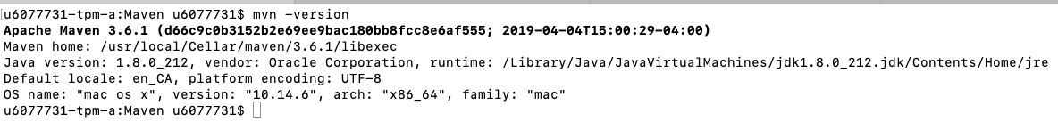

step 1: mvn clean

step 2: mvn compile

Following is the screenshot:

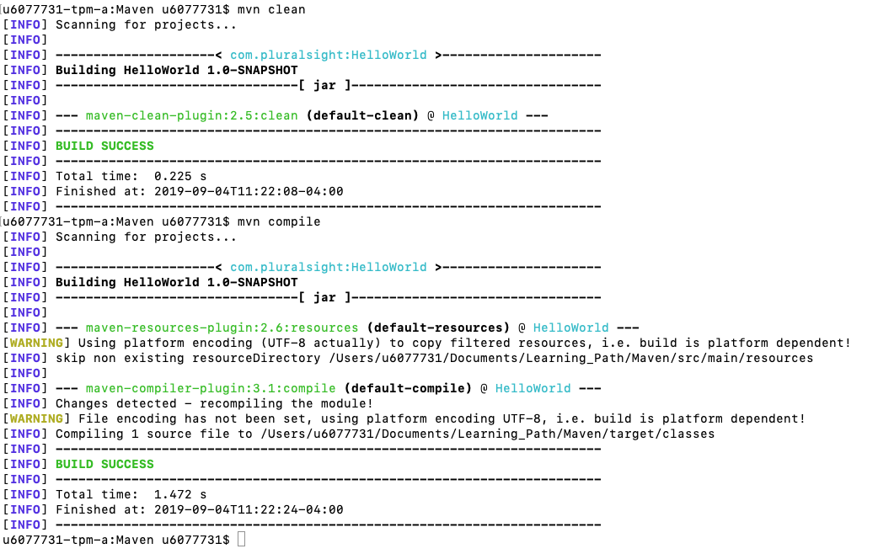

Step 3: mvn package

--- Jar file is created.

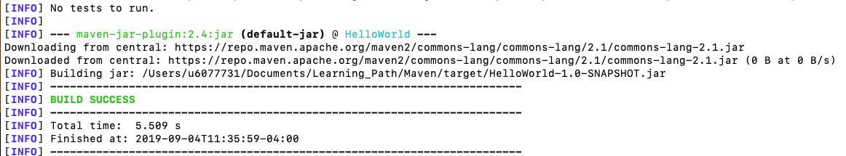

another two commands:

install: install it locally

deploy: install it remotely

mvn install command:

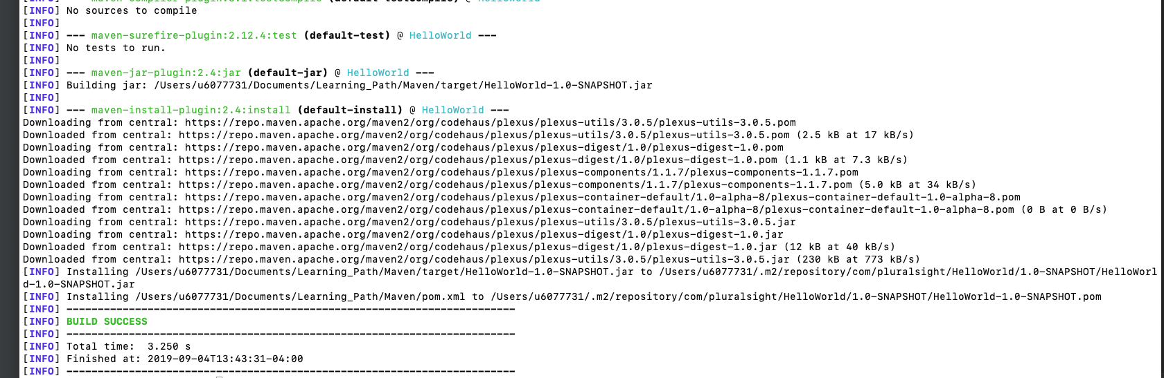

How to change the default value in maven? --- mvn build

The default folder is: ~/.m2/repository