PROJECT REPORT

To Submit Site Map To The Google Search Console

# 1. INTRODUCTION

## 1.1 Overview

The main objective of this project is to submit site map to the google search console.

## 1.2 Purpose

A sitemap to the Google Search Console is a fundamental aspect of search engine optimization (SEO). It helps search engines better understand and index your website, leading to improved visibility in search results and a more effective online presence.

2. PROBLEM DEFINITION AND DESIGN THINKING

2.1 Empathy Map

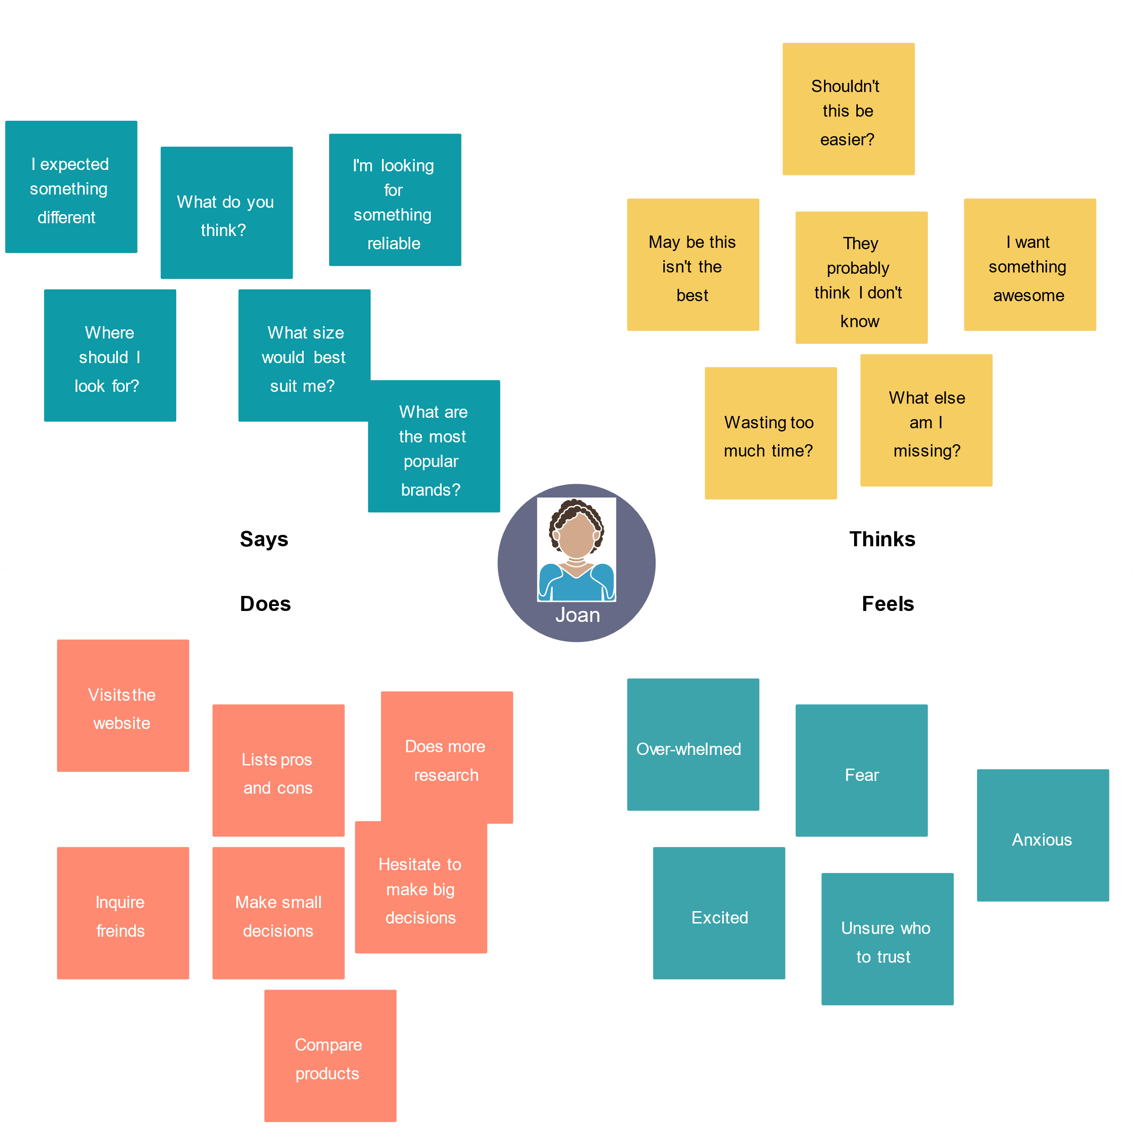

## 2.2 Ideation and Brainstorming Map

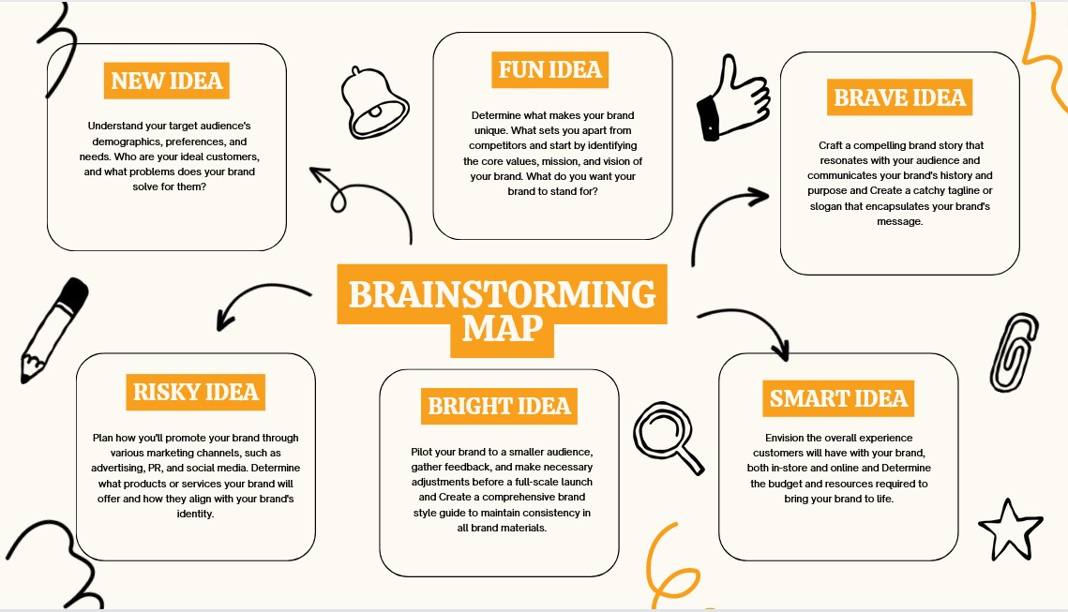

# 3. RESULTS

# Submitting a sitemap to Google Search Console is a crucial step in ensuring that your website's pages are properly indexed by Google.

Remember that it may take some time for Google to crawl and index thepages in your sitemap. Be patient and regularly check Google Search Console for any issues or updates related to your sitemap.

It's essential to keep your sitemap up to date, especially when you add new content or make significant changes to your website, by resubmitting an updated sitemap to Google Search Console.

# 4.IMAGES RELATED TO THE PROJECT

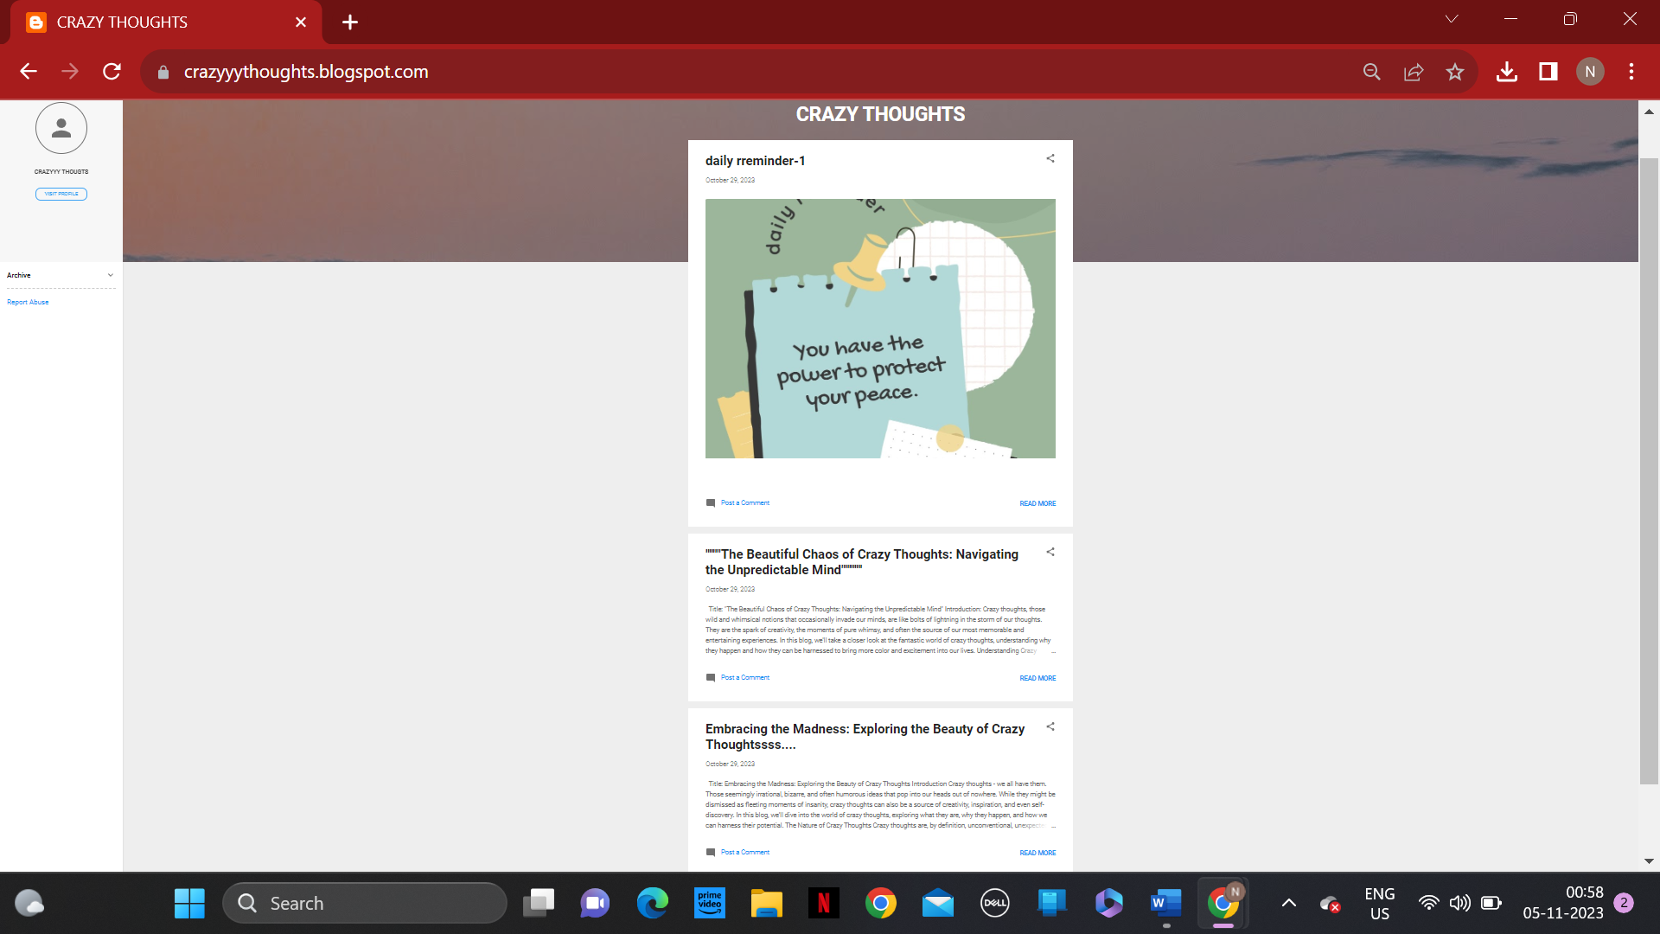

*BLOGGER WEBSITE CRETED FOR THIS PROJECT

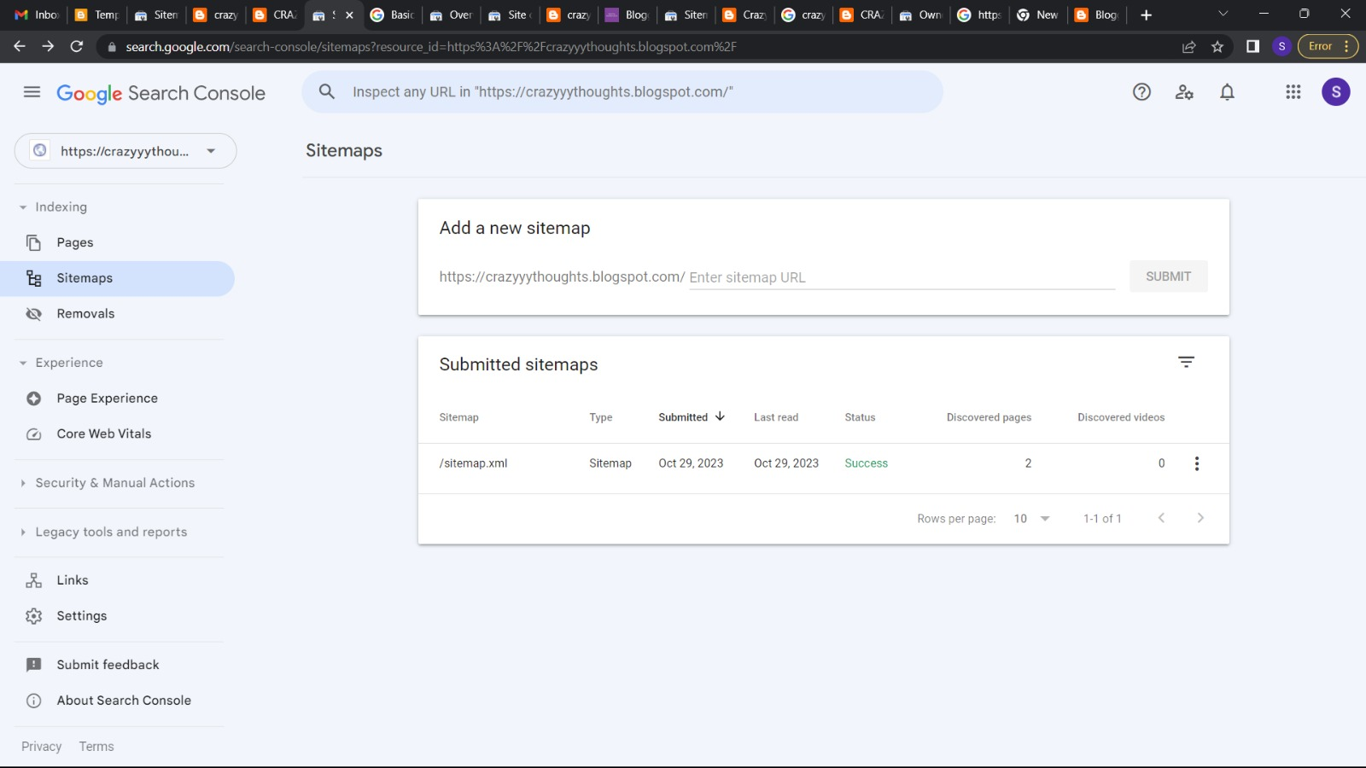

*SUBMITING THE SITEMAP OF THE BLOGGER WEBSITE IN GOOGLE CONSOLE

*

# 5. ADVANTAGES AND DISADVANTAGES

|  |  |
| --- | --- |
| 4.1 Advantages |  |
|  |

**Improved Indexing:** Sitemaps provide a structured way to inform search engines about the pages on your website, helping them index your content more efficiently and comprehensively.

**Faster Discovery of New Content:** When you add new pages or update existing ones, including them in the sitemap ensures that search engines discover and index these changes more quickly.

**Content Prioritization**: You can specify the priority of different pages in your sitemap, influencing how search engines prioritize crawling and indexing. This is particularly useful for highlighting important or frequently updated content.

**Crawl Efficiency:** A well-structured sitemap helps search engines understand the relationships between pages and the overall structure of your site, leading to more efficient crawling.

**Identifying Indexing Issues:** The Search Console can alert you to indexing problems or errors, providing valuable insights into issues that may affect your site's visibility in search results.

## 4.2 Disadvantages

**Complexity**: Creating a sitemap can be a complex task, especially for large and intricate websites. It may require technical knowledge or the use of sitemap generation tools.

**Resource Consumption:** Generating and updating sitemaps, especially for large websites with frequent content changes, can consume server resources, impacting the website's performance.

**Privacy Concerns:** Sitemaps can potentially reveal the structure and organization of your website to anyone who has access to your sitemap file. This could be a privacy concern in some cases.

**Duplicate Content:** If not managed correctly, sitemaps may inadvertently include duplicate or low-quality pages. This can confuse search engines and impact your SEO efforts negatively.

# 6. APPLICATION

The applications of a site map in the Google Search Console are diverse and valuable. They contribute to better search engine optimization, efficient indexing, and overall improved performance and visibility of your website in Google search results. Improved Indexing, Faster Discovery of New Content, Content Prioritization, Crawl Efficiency, Identifying Indexing Issues, Monitoring Performance, International Targeting, Security Alerts are some salient applications

# 7. CONCLUSION

In conclusion, We've successfully completed the tasks and projects within our scope, demonstrating our commitment to excellence and productivity. We have created a blogger website for our project and we have extracted the site map using a website and submitted the sitemap in the google console. As we move forward, it's essential to build upon these accomplishments, continually improve, and set new benchmarks for future endeavour. The work done serves as a testament to our capabilities and provides a strong foundation for future success.