**使用操纵杆控制机器人**

实验平台：Ubuntu 16.04、ROS Kinetic、SONY PS3游戏手柄

Github官网下载PS3的功能包：https://github.com/ros-drivers/joystick_drivers.git

编译好

安装这个包：sudo apt-get install ros-kinetic-joy

将PS3游戏手柄通过蓝牙跟主机相连

安装依赖包然后编译

rosdep install ps3joy

rosmake ps3joy

配对

将蓝牙适配器的MAC地址加载到PS3手柄

sudo bash

rosrun ps3joy sixpair

读取来自适配器的MAC地址：

sudo hciconfig hci0 up

hciconfig

拔掉适配器，通过USB线连接PS3手柄和电脑。更改PS3手柄的MAC地址：

sudo bash

rosrun ps3joy sixpair [MAC address]

通过蓝牙连接手柄

拔掉USB线，插上蓝牙适配器

sudo bash

rosrun ps3joy ps3joy.py

连接成功显示：Connection is Activated.

确信手柄跟电脑连接好了：sudo jstest /dev/input/jsX

在ROS中测试它的功能：

rosrun joy joy_node

如果看到输出信息，则表示正常

查看来自手柄的数据：rostopic echo joy

使用游戏杆数据在turtlesim中移动海龟

在工作空间的src目录下创建一个catkin Package

catkin_create_pkg learning_joy roscpp turtlesim joy

cd ~/catkin_ws/

catkin_make

写一个遥控节点：

创建一个learning_joy/src/turtle_teleop_joy.cpp文件

内容如下：

#include <ros/ros.h>

#include <geometry_msgs/Twist.h>//该头文件包含twist消息，我们可以发布twist命令//给turtle。

#include <sensor_msgs/Joy.h>//该头文件包含joystick消息，因此我们可以监听到joy //topic

class TeleopTurtle

{

public:

TeleopTurtle();

private:

void joyCallback(const sensor_msgs::Joy::ConstPtr& joy);

ros::NodeHandle nh_;

int linear_, angular_;

double l_scale_, a_scale_;

ros::Publisher vel_pub_;//发布者会使用geometry_msgs/Twist类型发布主题，这个类//型是在turtlesim功能包中声明的。

ros::Subscriber joy_sub_;//订阅者会通过名为joy的主题得到数据。处理游戏杆的节//点会发布数据到这个主题。

};//创建了一个TeleopTurtle的类，并且定义了joyCallback函数，也创建了稍后要用到//的订阅者跟发布者

TeleopTurtle::TeleopTurtle():

linear_(1),

angular_(2)

{

nh_.param("axis_linear", linear_, linear_);

nh_.param("axis_angular", angular_, angular_);

nh_.param("scale_angular", a_scale_, a_scale_);

nh_.param("scale_linear", l_scale_, l_scale_);

vel_pub_ = nh_.advertise<geometry_msgs::Twist>("turtle1/cmd_vel", 1);

//发布者发布turtle的command_velocity主题

joy_sub_ = nh_.subscribe<sensor_msgs::Joy>("joy", 10, &TeleopTurtle::joyCallback, this);

//订阅操纵杆主题用来驱动turtle

}

void TeleopTurtle::joyCallback(const sensor_msgs::Joy::ConstPtr& joy)

{

geometry_msgs::Twist twist;

twist.angular.z = a_scale_*joy->axes[angular_];

twist.linear.x = l_scale_*joy->axes[linear_];

vel_pub_.publish(twist);

}

int main(int argc, char** argv)

{

ros::init(argc, argv, "teleop_turtle");

TeleopTurtle teleop_turtle;

ros::spin();

}

编译并且运行Turtle Teleop

添加下面两行到CMakeList.txt文件：

add_executable(turtle_teleop_joy src/turtle_teleop_joy.cpp)

target_link_libraries(turtle_teleop_joy ${catkin_LIBRARIES})

编写Launch文件启动所有需要的节点：

<launch>

<!-- Turtlesim Node-->

<node pkg="turtlesim" type="turtlesim_node" name="sim"/>

<!-- pkg为节点的功能包，type为需要运行的那个节点，name为节点的名字-->

<!-- joy node -->

<node respawn="true" pkg="joy"

type="joy_node" name="turtle_joy" >

<param name="dev" type="string" value="/dev/input/jsX" />

<param name="deadzone" value="0.12" />

</node>

<!--respawn=”true”表示关闭节点后会再次重启节点，rosparam可操作多个参数，以及yaml文件参数，param一次性只能指定一个参数，且是标准类型的参数。-->

<!-- Axes -->

<param name="axis_linear" value="1" type="int"/>

<param name="axis_angular" value="0" type="int"/>

<param name="scale_linear" value="2" type="double"/>

<param name="scale_angular" value="2" type="double"/>

<node pkg="learning_joy" type="turtle_teleop_joy" name="teleop"/>

</launch>

roslaunch learning_joy turtle_joy.launch

北通阿修罗手柄各按键分布情况

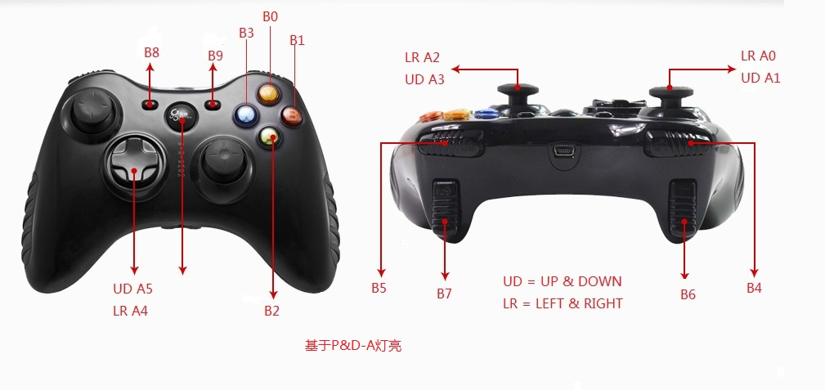

北通阿修罗手柄控制源代码

//Using the betop joystick to drive the turtle of turtlesim

#include <ros/ros.h>

#include <geometry_msgs/Twist.h> //includes the twist msg so that we can publish twist commands to the turtle

#include <sensor_msgs/Joy.h>//includes the joystick msg so that we can listen to the joy topic

//create the TeleopTurtle class and define the joyCallback function that will take a joy msg.

class TeleopTurtle

{

public:

TeleopTurtle();

private:

void joyCallback(const sensor_msgs::Joy::ConstPtr& joy);

ros::NodeHandle nh_;

int Axis0_angular, Axis1_linear, Axis2_angular, Axis3_linear, Axis4_angular, Axis5_linear;

//axis control the turtle go forward,go back,turn left and turn right

int Buttons0, Buttons1, Buttons2, Buttons3, Buttons4, Buttons5, Buttons6, Buttons7, Buttons8, Buttons9, Buttons10, Buttons11;

//the array subscript of each button

double Axis0_angular_scale, Axis1_linear_scale, Axis2_angular_scale, Axis3_linear_scale, Axis4_angular_scale, Axis5_linear_scale;

bool Buttons0_status, Buttons1_status, Buttons2_status, Buttons3_status, Buttons4_status, Buttons5_status, Buttons6_status, Buttons7_status, Buttons8_status, Buttons9_status, Buttons10_status, Buttons11_status;

ros::Publisher vel_pub_;

ros::Subscriber joy_sub_;

};

TeleopTurtle::TeleopTurtle() :

Axis0_angular(0), Axis1_linear(1), Axis2_angular(2), Axis3_linear(3), Axis4_angular(4), Axis5_linear(5), Buttons0(0), Buttons1(1), Buttons2(2), Buttons3(3),

Buttons4(4), Buttons5(5), Buttons6(6),Buttons7(7), Buttons8(8), Buttons9(9), Buttons10(10), Buttons11(11)

//initialize the subscript of each axis and button

{

nh_.param("axis0_angular",Axis0_angular,Axis0_angular);

nh_.param("axis1_linear", Axis1_linear, Axis1_linear);

nh_.param("axis2_angular", Axis2_angular, Axis2_angular);

nh_.param("axis3_linear", Axis3_linear, Axis3_linear);

nh_.param("axis4_angular", Axis4_angular, Axis4_angular);

nh_.param("axis5_linear", Axis5_linear, Axis5_linear);

nh_.param("axis0_angular_scale",Axis0_angular_scale,Axis0_angular_scale);

nh_.param("axis1_linear_scale", Axis1_linear_scale, Axis1_linear_scale);

nh_.param("axis2_angular_scale", Axis2_angular_scale, Axis2_angular_scale);

nh_.param("axis3_linear_scale", Axis3_linear_scale, Axis3_linear_scale);

nh_.param("axis4_angular_scale", Axis4_angular_scale, Axis4_angular_scale);

nh_.param("axis5_linear_scale", Axis5_linear_scale, Axis5_linear_scale);

vel_pub_ = nh_.advertise<geometry_msgs::Twist>("turtle1/cmd_vel", 1);

//create a publisher that will advertise on the command_velocity topic of the turtle

joy_sub_ = nh_.subscribe<sensor_msgs::Joy>("joy", 1, &TeleopTurtle::joyCallback, this);

//subscribe to the joystick topic for the input to drive the turtle.

//if our node is slow in processing incoming messages on the joystick topic,up to 1 messages

//will be buffered before any are lost

}

void TeleopTurtle::joyCallback(const sensor_msgs::Joy::ConstPtr& joy)

{

geometry_msgs::Twist twist;

twist.angular.z = Axis0_angular_scale*joy->axes[Axis0_angular];

twist.linear.x = Axis1_linear_scale*joy->axes[Axis1_linear];

//take the data from the joystick and manipulate it by scaling

//it and using independent axes to control the linear and angular

//velocities of the turtle.

vel_pub_.publish(twist);//publish the twist message

}

int main(int argc, char** argv)

{

ros::init(argc, argv, "teleop_turtle");

TeleopTurtle teleop_turtle;

ros::spin();

}