Result:When the basketry catch fish,it will add 10 score,if catch bomb,it will end game.

Github link:https://github.com/Crazyinfy32/Exercise2.git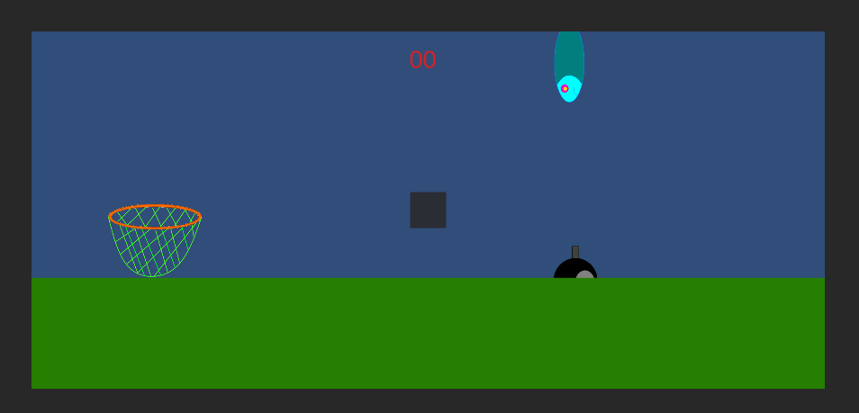

Unity Version:2021.3.20f1