

This plot is an adequate representing distribution of people on the basis of age between 17 and 90. It shows that

the maximum number of age group is between 30 and 40 while the least age groups is between 80 and 90.

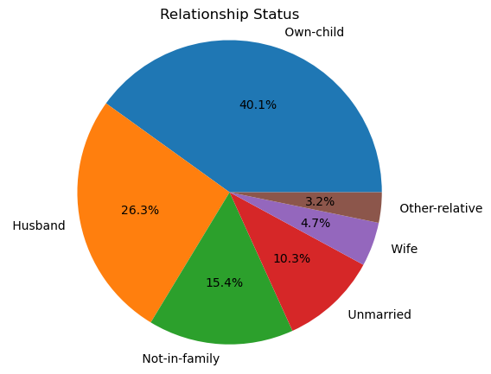

The above pie-chart shows that out of total population 3.2% are in other relation,

4.7% are wives, 26.3% are husbands, 40.1% own children, 15.4% are no in family

while 10.3% are unmarried.

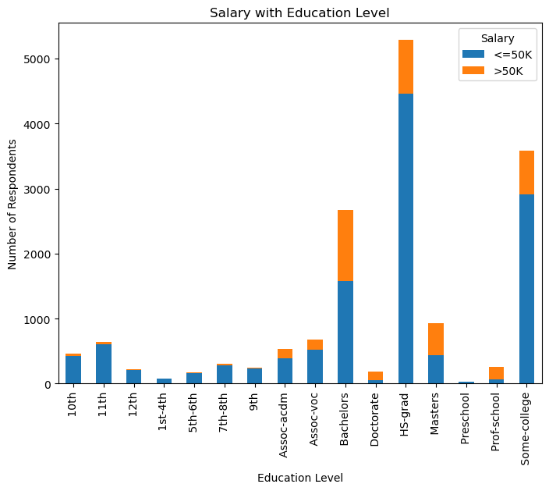

The horizontal bar chart above shows that people with HS-grad are the highest number of people having less than or equal to 50k salary while people with Assoc-voc are among the average receiving less than or equal to 50k salary. On other hand, people with this degree are the highest to receive salary greater than 50k.