PCA

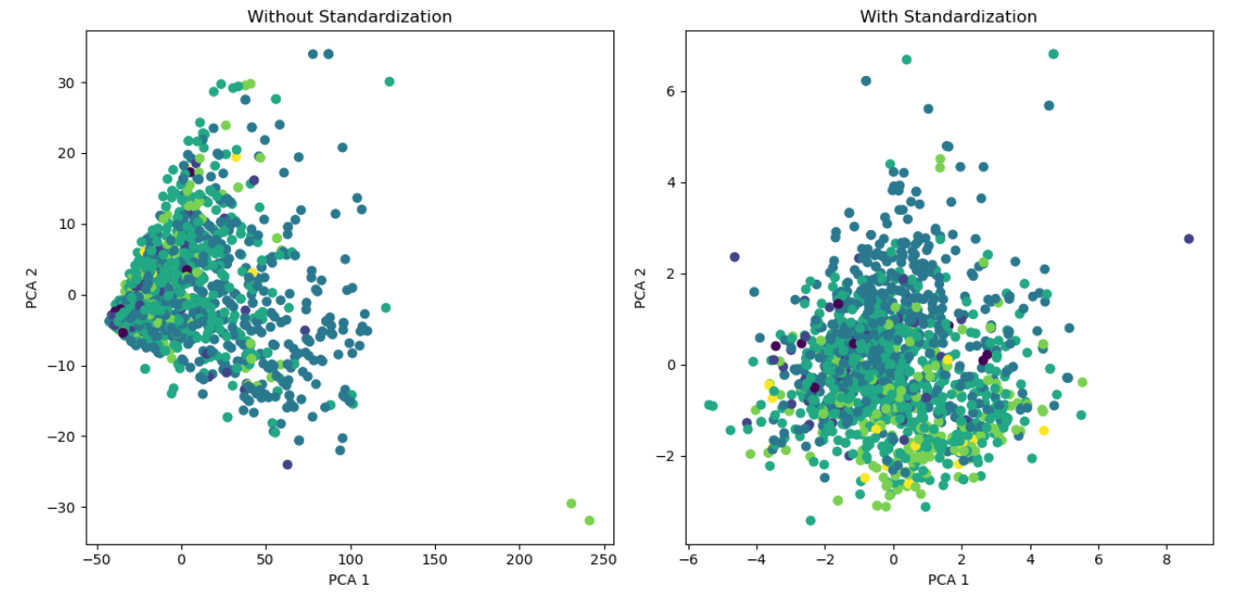

t-SNE

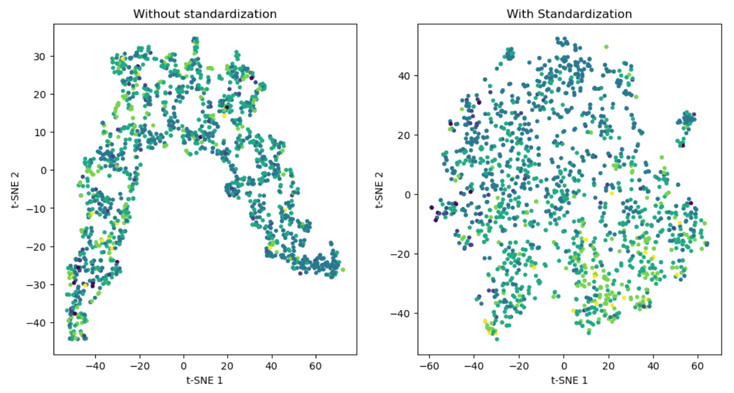

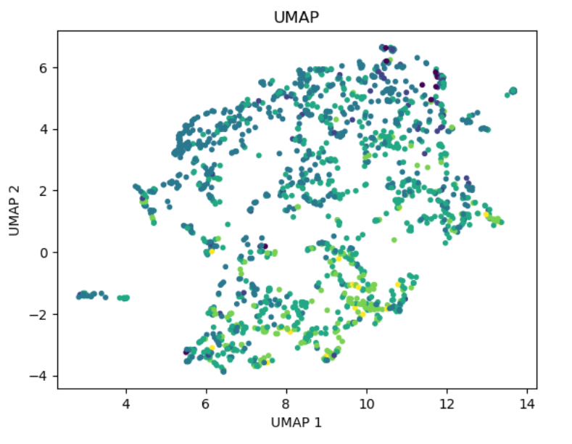UMAP

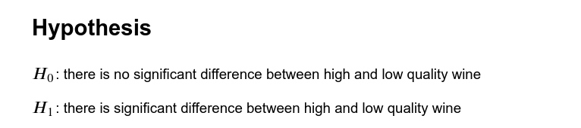

Firstly, I tested and found that, there is positive correlation between the amount of ‘alcohol’ and ‘quality’ of wine. Then I wanted to see if there exist any relationship between high quality (>=7) and low quality (<7) wine with regard to the amount of ‘alcohol’. Since it involves multiple categories of wine quality, I found it Analysis of Variance (ANOVA) suitable for this test.

