Intermediate programming with R

Writing in Markdown

## Learning Objectives

Learn how to write documents using Markdown syntax.

So far, we've written a README.txt file for our project, which is just plain text. There's nothing wrong with a plain text readme, but we can spice it up a little. In this lesson, we'll learn the basics of Markdown syntax. Markdown is a language that provides some basic text upgrades over just plain text, including bolding and italicizing text. Understanding the basics of writing in Markdown will be helpful for the next few lessons, when we go over the basics of writing reports using R Markdown.

To make sure we can get started, let's make sure everyone has the knitr package installed:

install.packages('knitr')

Let's make a new README file using the markdown language. Go up to File -> New File -> R Markdown.

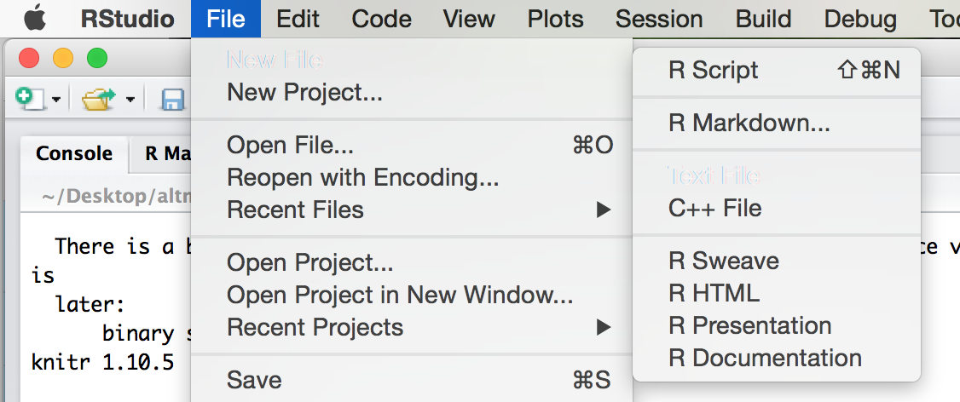

A screen will pop up asking us what kind of document we wish to create. Let's name our demo report "Trial Report" and fill in your name. Ensure that "Document" is highlighted to the left and that "HTML" is chosen. Click "Ok".

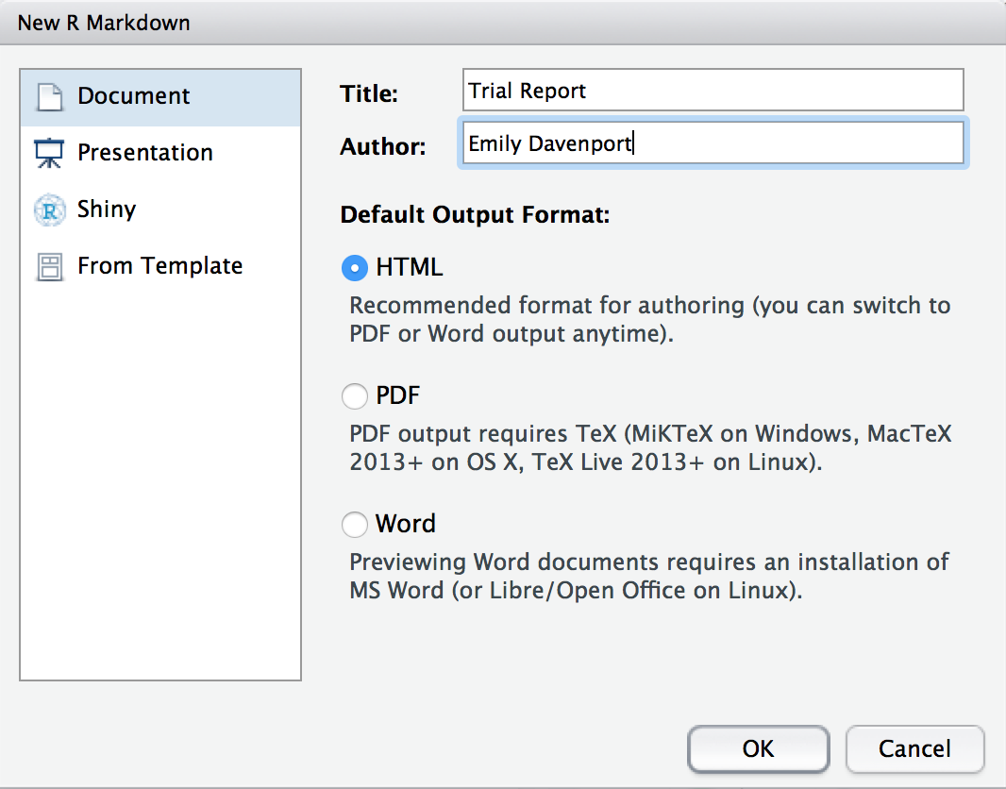

Now we have the example R Markdown file open. The first thing you'll notice at the top is a header which includes your name, the title of the document, the date, and a field called output. This header tells the package knitr some information it might need about your document, including what format you want the final report rendered in.

The next thing you'll notice is white space with some text describing an R Markdown document. White space in this document represents text of the report you would like to display. You can put anything here describing your analysis, results, etc. and it will be recognized as text and not R code.

You can think of it like commenting your code, however, by using R Markdown, you can incorporate fancy text features like italics, bold, bullet lists, etc. Here is how to incorporate some text features:

# To have a header, put a hashtag in front of the text.   
## The more the hastags...  
### The smaller the text.  
#### I find most markdown syntax logical, except for this.  
  
To have plain text, just type plain text!  
  
Put a blank line between paragraphs, otherwise text will flow from one paragraph to another.  
If you look in the code block, this sentence is technically on a new line.  
  
Use asterisks or underscores to make something **bold** or _italic_, respectively.  
  
If you want a code box, use `backtics` around what you want in the box.  
  
You can make a list of things you want for lunch!  
  
- Banana  
  
- Deep dish pizza  
  
- Bubble tea  
  
- Insulin  
  
> Blockquotes are offset a bit.  
>  
> So fancy.

# To have a header, put a hashtag in front of the text.

## The more the hastags...

### The smaller the text.

#### I find most markdown syntax logical, except for this.

To have plain text, just type plain text!

Put a blank line between paragraphs, otherwise text will flow from one paragraph to another. If you look in the code block, this sentence is technically on a new line.

Use asterisks or underscores to make something **bold** or *italic*, respectively.

If you want a code box, use backtics around what you want in the box.

You can make a list of things you want for lunch!

* Banana
* Deep dish pizza
* Bubble tea
* Insulin

Blockquotes are offset a bit.

So fancy.

Back in our demo script, you'll see some of these markdown elements are used. For example, the word knit is in bolded (using asterisks), and there are code chucks near the bottom that say echo = FALSE.

In addition to the white space, you'll gray blocks that have ``` at the top and bottom. These are called chunks. If the start of a chunk has {r} at the end of the ticks, knitr will recognize the code in that chunk as R code and run it when rendering the HTML. In your R Markdown, the code will look like:

In your final report, the code will look like:

summary(cars)

## speed dist   
## Min. : 4.0 Min. : 2.00   
## 1st Qu.:12.0 1st Qu.: 26.00   
## Median :15.0 Median : 36.00   
## Mean :15.4 Mean : 42.98   
## 3rd Qu.:19.0 3rd Qu.: 56.00   
## Max. :25.0 Max. :120.00

These are the basics of writing R Markdown, but the fun comes in by actually generating a report. To generate a report, click on the button on the top bar that says "Knit HMTL":

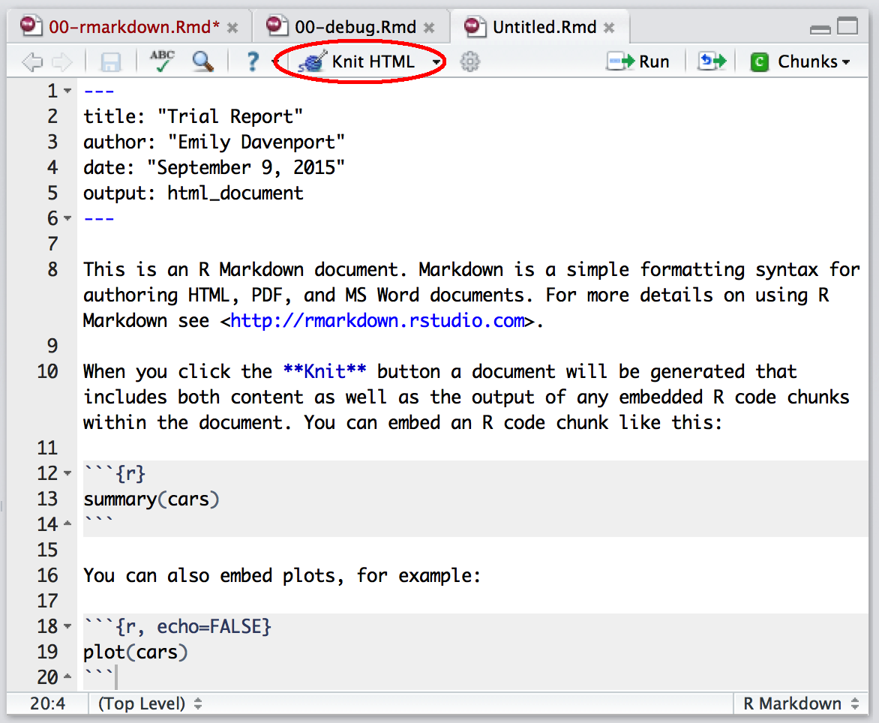

When you click on this link, you see in the console that RStudio is running and rendering your R Markdown file. An HMTL file will pop up where you'll see the rendered report. You can see the header has been rendered, there are code and results chunks displayed, and even plots are shown right in the report.