THE SCENE
  - Visual Identity, Game UX and Low-Data Engineering Playbook
  - A concise human-readable guide to accompany the full Codex folder • v1.0 • 12 October 2026

The decision
Build a visually distinctive Lagos music world that is faster and more enjoyable than a heavy cinematic prototype. Use high-quality composition, compact locations, believable avatar motion, tactile interactions and a layered loading strategy. Do not load the entire city, all album images or any unplayed songs at login.
Codex should use the included README/AGENTS resolver to locate the Master GDD, individual chapters, screen atlas, design tokens, reference images, media budgets and quality gates. This document is a guide, not a replacement for those canonical chapters.

Why Lagos Life looks simpler
The user screenshot shows simple models, flatter textures and modest environmental detail. These techniques are consistent with lowering GPU cost, data transfer and art-production complexity, but the images do not reveal the actual engine, performance measurements or the developer’s motivations. We cannot claim that the team intentionally chose a plain style solely for speed.

Visual north star
- A living city, not a static illustrated map or a screen full of cards.
- Music Square in daylight: warm, colourful but restrained.
- City Studio and Release Hall: clear tactile stations with minimal HUD.
- The Basement and special awards: richer lighting only when the moment deserves it.
- Mobile screens: world-first; context actions in expandable sheets.
- Desktop screens: central world plus optional panels; never full-screen dashboards by default.

Working colour and typography system
Role | Proposed token | Usage
Dark ink | #101720 | World HUD / sheets
Panel | #1D2933 | Solid accessible surfaces
Paper | #F5F1EA | Light dialogue / neutral screens
Jade | #19A982 | Primary action
Orchid | #9572D7 | Desk emphasis
Coral | #E56C78 | Social and emphasis, rare
Amber | #E6AF5F | Warm environment / event
Use one subsetted licensed UI sans font with system fallback (candidate Inter/DM Sans/Manrope; choose after licence/device tests). Do not encode text as images. Use 44 px touch targets for important actions and tabular figures for numeric fields.

The four forms of Desk
- Persistent chip. A discreet icon, not a robot following the avatar.
- Today / Next Moves. Two or three verified choices with real time/cost/eligibility.
- Contextual help. At studio, release desk, venue stage and label A&R table; dismissible.
- Ask Desk. Phase 1 guided questions, same action registry. Phase 2 optional cheap LLM explanation. Player always confirms.

First-visit / low-data target budgets
Area | Alpha starting target | Important caveat
Bootstrap | ≤1 MB compressed | measure actual bundle/shell
First interactive 3D scene | aim ≤4 MB transfer | not 4MB including played songs
Basic mobile render | sustain 30 FPS | test physical Android and iPhone
Returning visit | ≤1 MB new bytes excluding music | cache and version by content
Music no-play idle | 0 music bytes | audio opt-in; do not preload
First event | 20 real clients then test 50 | not 1000 virtual bodies
These are initial prototype budgets, not achieved metrics. On a sustained 2 Mbps link, 4MB alone takes ~16 seconds to transfer; progressive entry and data-saver mode are mandatory if serving constrained mobile networks.

Why images and songs can get expensive
A 1024×1024 uncompressed RGBA texture occupies ~4 MiB in GPU memory even if its downloaded JPEG/WebP is small. Art should be resized by actual display size, reused where possible, and unloaded on travel. Audio is recurring traffic: four minutes at 64 kbps consumes ~1.92 MB; at 96 kbps ~2.88 MB. Request audio only when selected; optional lower/higher quality through browser-tested codecs.

The exact loading sequence
- HTML HUD/session + world-loading feedback.
- Initial small scene, avatar, camera, collision and one real action.
- Near players, nearby readable signs and media thumbnails.
- Next room on navigation/boarding, while current scene remains usable.
- Deferred high-resolution art, full catalogues, unrelated districts, decorative cinematics.

Non-negotiable correctness guardrails
- Concept images are not authoritative facts: label roster imagery shows 6, but canonical V1 active funded artists ≤3.
- Concept 52-week contracts, owning real music masters, imaginary streaming revenue and massive ads reach must NOT be implemented.
- Actual venue capacity is bounded by tested room size and human attendance.
- GDD small-venue financial baseline, not picture UI prices, defines initial game testing.
- Lagos Life account/avatar/wallet integration is NOT promised without documented and authorised SDK endpoints.
- A Desk recommendation cannot book, spend, publish, sign, send messages or fabricate a public opportunity.

What Codex must deliver with each milestone
- Working first interaction and a low-spec mobile screen recording or captures.
- Before/after size and FPS measurements, cold/warm load, current scene / new scene transition.
- Device matrix: Android Chrome, iPhone Safari, desktop.
- Explicit passed and failed acceptance cases, known limitations and accurate GDD references.
- Founder decision request for scope/rights/money/moderation conflicts, rather than guessing.

Full kit contents
- AGENTS.md + README.md (autonomous Codex context discovery)
- docs/visual/ART_DIRECTION_AND_DESIGN_SYSTEM.md
- docs/visual/SCREEN_AND_INTERACTION_ATLAS.md
- docs/visual/IMAGE_REFERENCE_INDEX.md + 14 reference images and contact sheet
- docs/engineering/PERFORMANCE_MEDIA_AND_LOADING.md + ALPHA_BUDGETS.json
- docs/quality/QA_ACCEPTANCE_AND_RELEASE_GATES.md
- docs/decisions/CANONICAL_RULES_AND_OPEN_QUESTIONS.md
- docs/gdd/ (all existing canonical chapters and master docs)
- tools/audit_assets.py (advisory static size report)
Important: full reference images are design-only and must not be inserted into production as heavyweight background textures. Real assets need authored meshes, material atlases, image-derivative pipeline, audio streaming and rights checks.

Selected reference: physical world & mobile HUD
Public social square  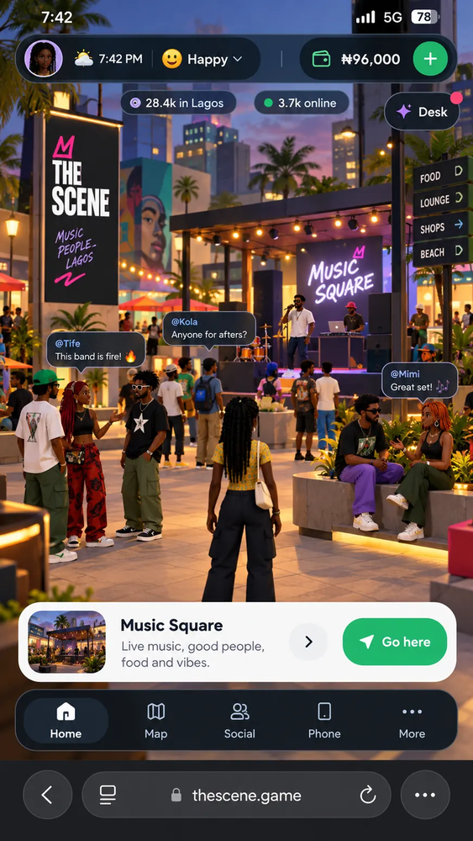 | Venue equipment shopping  