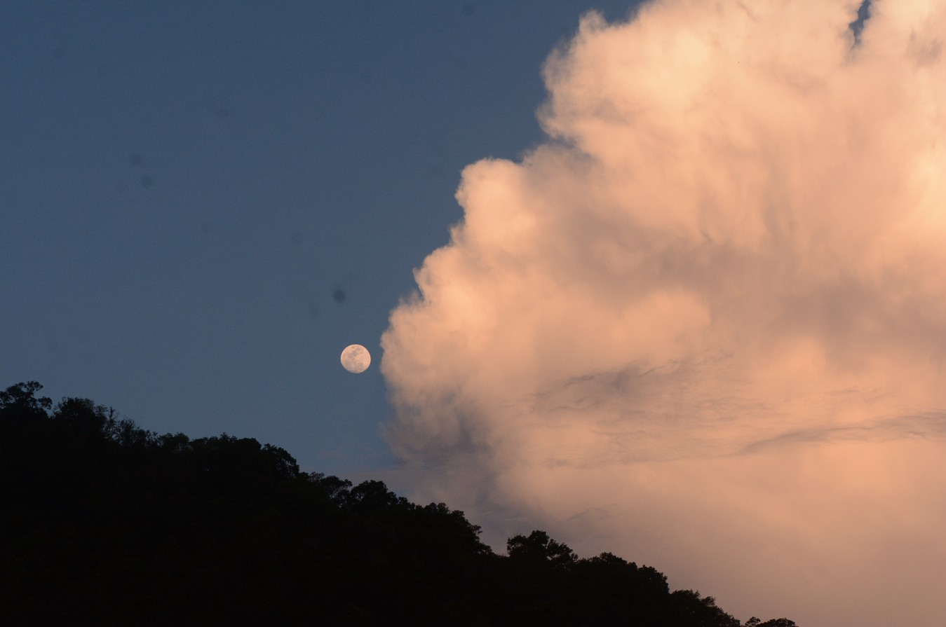
The first section of the website can stay the same. The text needs updating for the ‘welcome to floating’ section. Add these two photos so that the text is the same lenght on the page as the images.

WELCOME TO FLOATING
Floating Paradise is a sea-based guesthouse, proudly solar-powered, and sheltered in a mangrove bay. Built consciously above the water, it invites a slower rhythm of living, where mornings begin gazing out to the horizon, days unfold barefoot, and life follows the tides more than the clock.

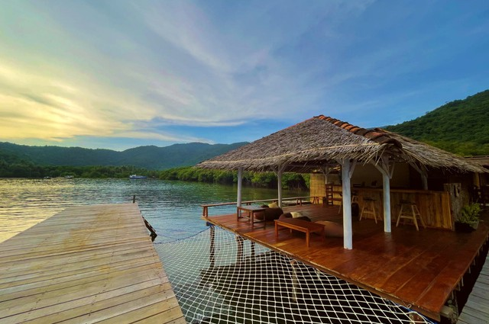
With just three cosy rooms, all locally crafted using wood and bamboo, with direct jetty access to deep water, and the reef at your doorstep, itʼs a unique, secluded, nature escape.

Swim, snorkel, kayak, fish, explore nearby beaches, or practice yoga on our open decks overlooking the horizon. At night, watch phosphorescent plankton glow beneath you or spot shooting stars above, not forgetting our fresh, abundant meals too.

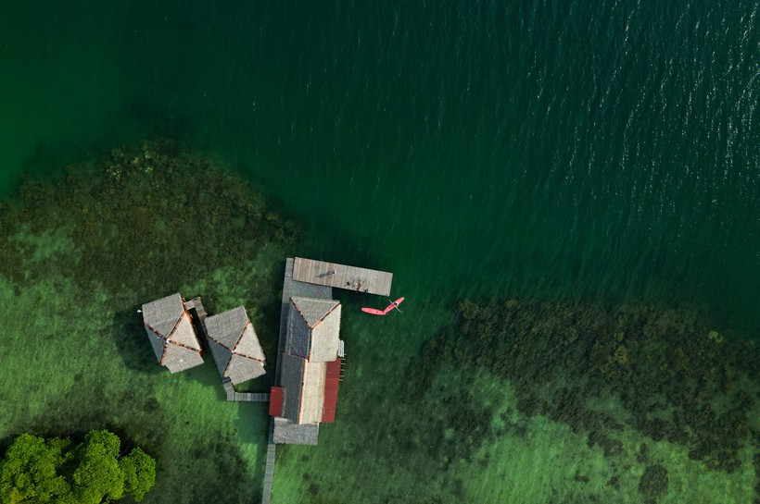
Immerse yourself in this unique tropical island space; slow down, reconnect, contribute sustainably, and connect to nature, all at Floating Paradise. We are more than a place to stay, we are a gateway to unforgettable experiences.

Whether you seek adventure or relaxation, our team is here to craft your perfect stay.

Comfort, exploration, and rejuvenation await in this tropical island paradise. We canʼt wait to welcome you!

Below is a whole new section for the homepage

BUILT BY HAND, POWERED BY SUN
At first glance, Floating may appear simple.
Natural materials. Open air. Timber, thatch, weave, salt air. Nothing polished to perfection. Not entirely sealed away from the elements.

And that is exactly the point.
Every structure at Floating Paradise is built from natural materials that live in relationship with the sea, the sun, the wind and the rain, they fade and weather. They require care. They need replacing. The roof is renewed. The wood is tended. The details are revisited again and again.

We do not build to resist nature.
We build to exist within it.

Choosing natural materials means choosing maintenance over permanence. It means accepting cycles rather than chasing “forever.ˮ What may look simple is, in truth, ongoing care, for this bay, for Karimunjawa, for our planet.

Just as intentionally, Floating runs entirely on solar power. There is no mainland grid supporting us.
Every light, every fan, every system relies on a carefully built, hand-crafted solar network.

Tono, self-taught and deeply committed, designed and built this system himself. It is safe, reliable and entirely powered by the sun, but it requires constant attention, monitoring, learning and upgrading.
Living off-grid is not a shortcut. It is daily devotion.

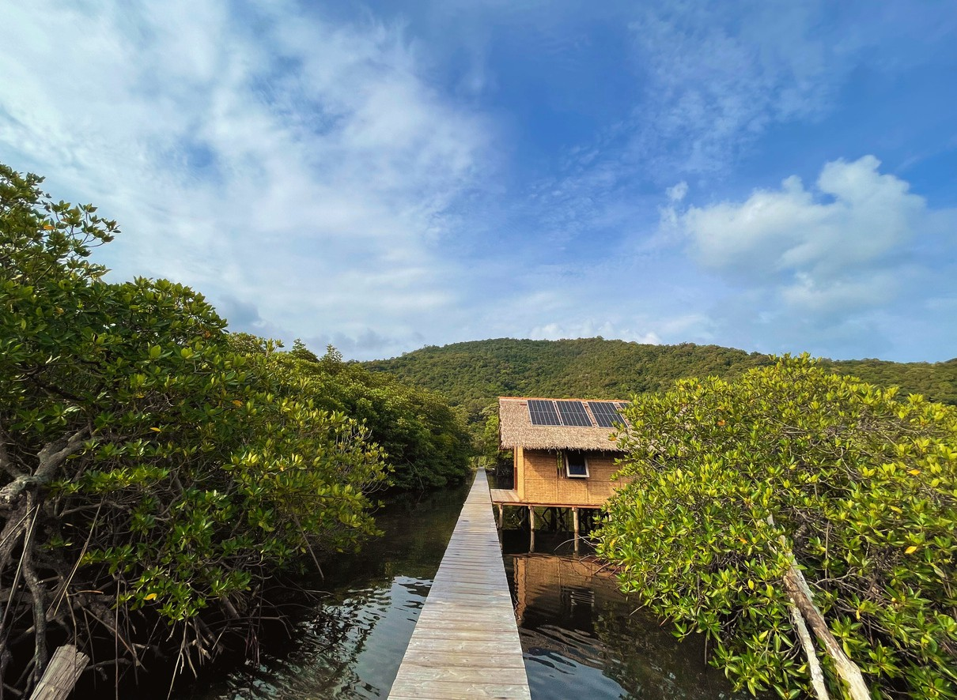
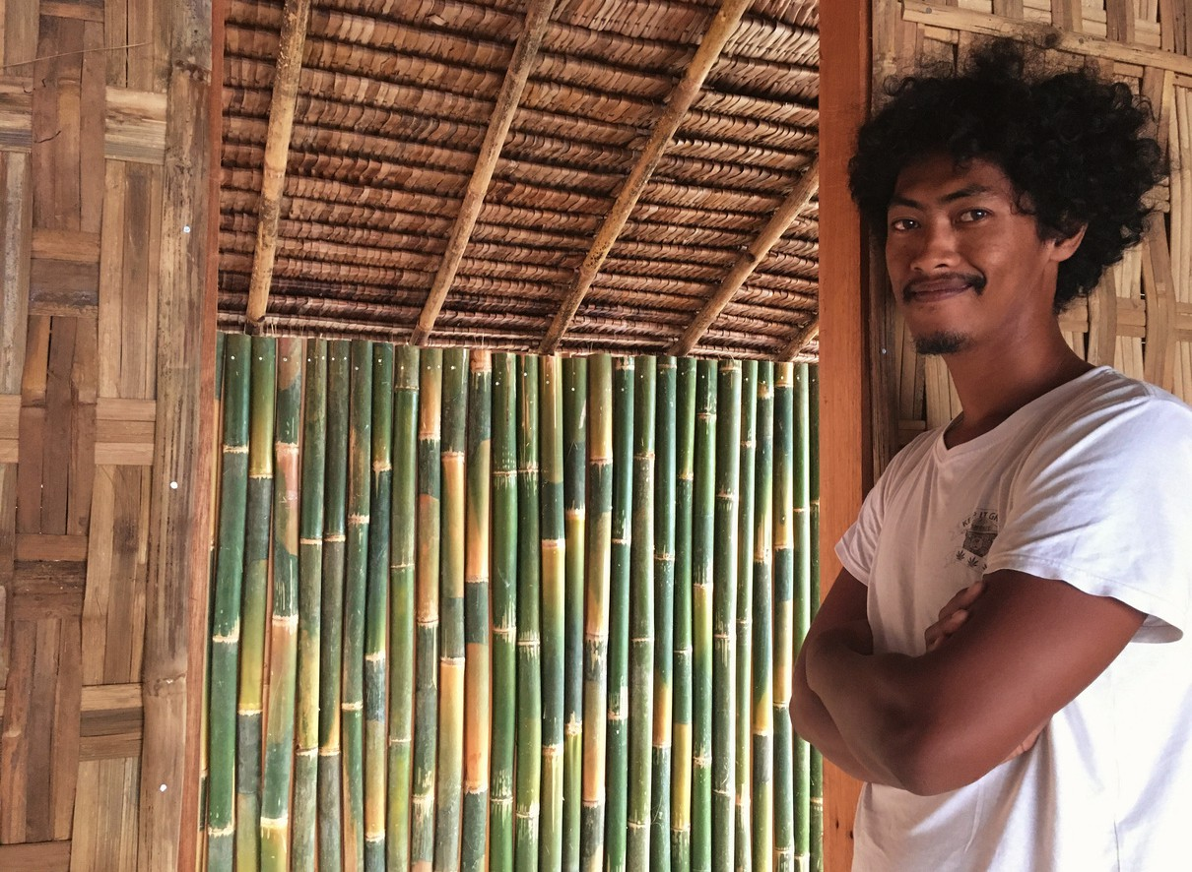

When you stay here, you are not paying for luxury in the conventional sense.
You are supporting craftsmanship. Renewable energy. Natural materials. Cyclical rebuilding. Human hands. Long-term care.

Floating is simple by design.
Yet simplicity, when created with intention and responsibility, carries depth and value.
It is cared for, again and again.

OUR FLOATING BUNGALOWS
Suspended above the reef, our three handcrafted bamboo bungalows invite you to live between sea and sky.

Built by hand and shaped by the elements, each bungalow has its own personality; no two are the same. Wake with the sunrise shimmering across the water, watch the tide shift beneath your feet, and fall asleep to the quiet rhythm of the waves.

Inside, natural textures and open design create a space that feels both grounded and free. Each bungalow features a queen bed (or larger), a private ensuite with fresh water shower, sink, and flushing toilet, and a generous balcony with comfortable seating; your front-row seat to panoramic views of the sea and mangroves.

These are not just rooms, theyʼre a place to exhale, to soften, and to float.
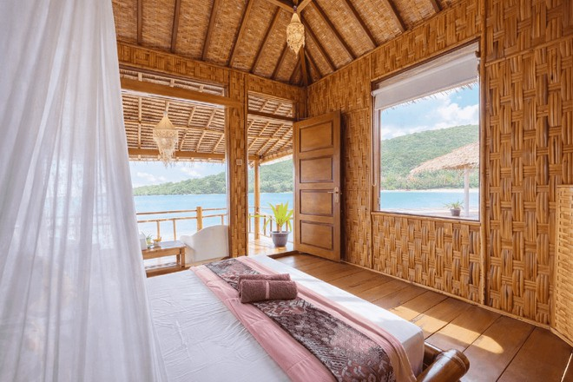
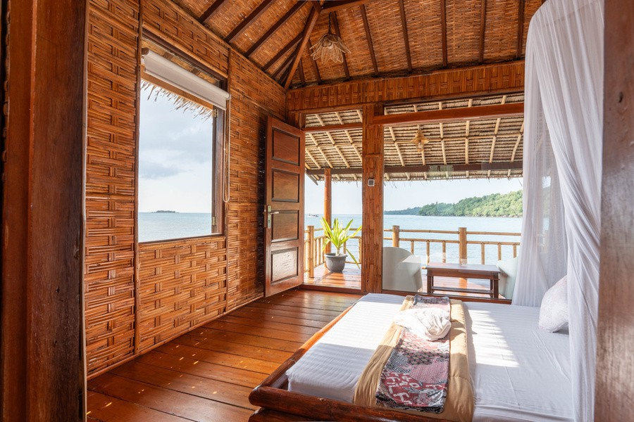
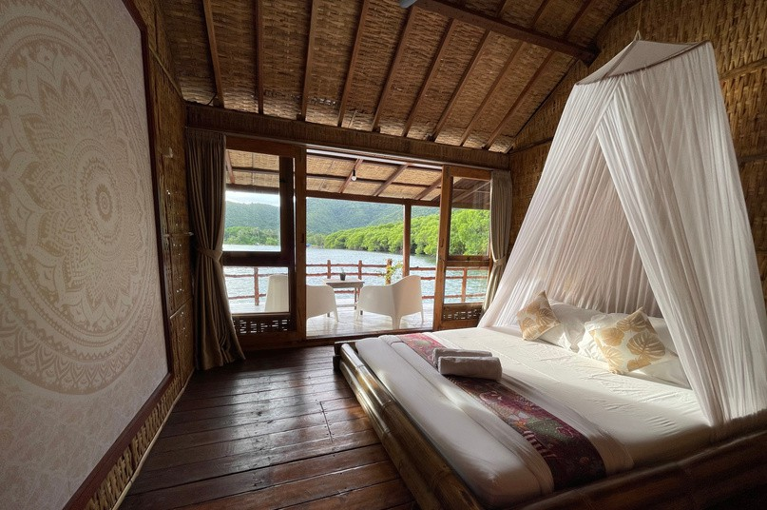

The layout for the bungalows can be the same, but when the guest clicks on any of the rooms they need to be directed to the Tripla booking system to reserve the room. Here is the link: <script async src="https://tripla.jp/sdk/j avascript/tripla.min.js" data-triplabot- code="019c5054-aa76- 72af-8207-
e3dd1c280fa3"></script>

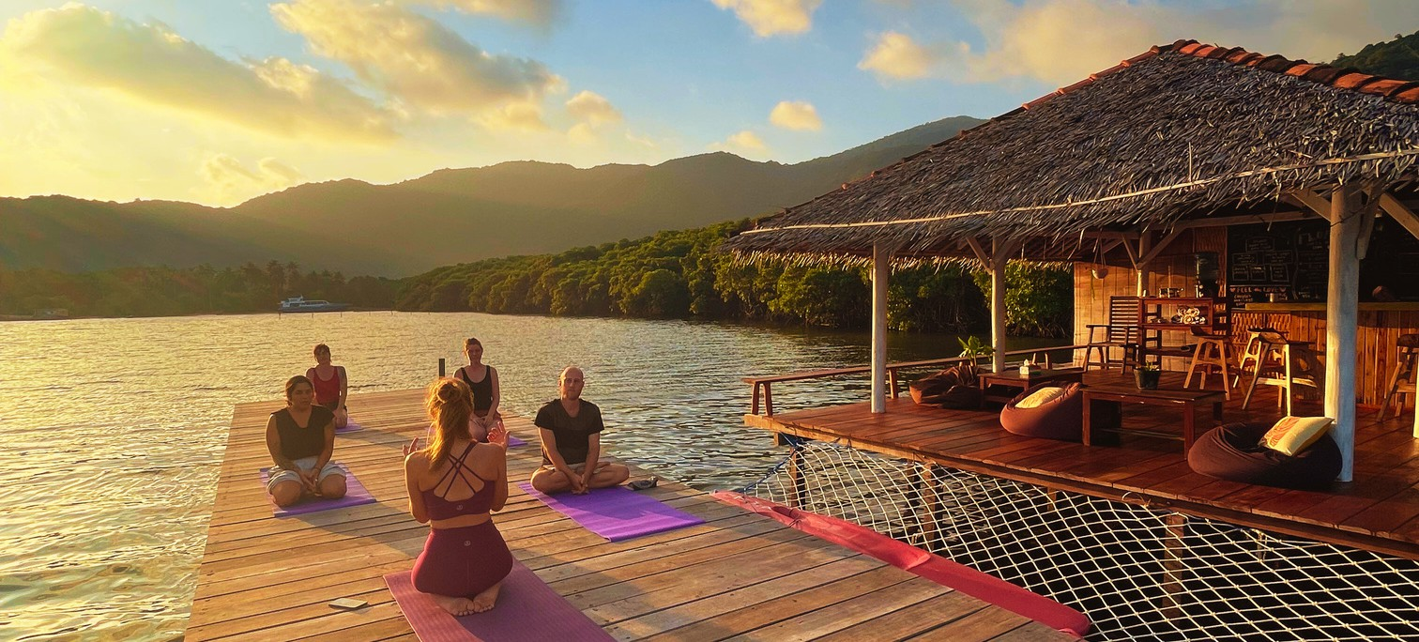

THE ART OF FLOATING
8–14 June 2026
Floating Paradise · Karimunjawa

New to Floating Paradise
A 7 day nature-based yoga retreat above the sea

An intimate island retreat with sunrise and sunset yoga on our jetty, nature and community contributions And plently of time to unwind, realign and embrace the flow of life

This is yoga as a way of being Come float with us
READ MORE
Below is a whole new section for the homepage. The button needs to lead to the new ‘yoga retreat’ page of the website

The text for the ‘explore karimunjawa’ page all needs updating. Layout can stay the same. The photo’s also need updating too, and are all in this folder: https://drive.google.com/drive/folders/1ry4eIk8K9Xdx8sdf2gQiVAnYiMY9jt19?usp=share_link
EXPLORE KARIMUNJAWA
We offer a range of activites on site, or that depart direct from Floating.

PRIVATE ECO BOAT TOUR
Our most popular and exclusive service is a full-day private boat trip departing directly from Floating Paradiseʼs pier. During this tour you can explore the most breathtaking, and less touristic areas of the archipelago. Guided by a well-trained, English speaking guide and a friendly captain, youʼll discover vibrant reefs and untouched tropical islands while enjoying a truly unforgettable day.

In line with our eco-friendly principles, we ensure all trips are as sustainable as possible: no single-use plastics are used, rubbish is collected and taken back with us, and we prioritise reef preservation by avoiding harmful practices like feeding fish or consuming parrotfish.

Destinations vary depending on weather, ensuring both safety and minimal environmental impact.
PRE-BOOK NOW

OPEN AIR SUNSET YOGA
As the heat softens and the sky begins to glow, we gather at the end of Floatingʼs jetty for a steady, grounding Hatha Flow practice. This 75 minute practice blends breathwork, meditation, yogic philosophy as well as mindful sequencing. Expect a balanced flow, gentle enough for beginners, with options to deepen for more experienced practitioners. We focus on alignment, conscious breathing, and moving at a pace that allows you to truly feel each posture.

Practicing above the water as the sun sets over the bay creates a naturally calming atmosphere. The rhythm of the sea and the changing light become part of the experience, supporting nervous system regulation and deep relaxation.

Classes are led by Astrid, Floatingʼs resident teacher with five years of experience. Mats are provided, just bring comfortable clothing and an open mind.

End your day grounded, stretched, and steady.
RETREAT INFO
All buttons in the explore section should lead to the ‘extra’ section on Tripla so that the guests can order directly. Besides the yoga button, it should lead to the retreat page

KAYAK, LUNCH S CHILL
Explore the reef and mangroves of Karimunjawa at your own rhythm.
Our new two-person kayaks invite you to paddle through crystal-clear water, discover secluded beaches, and glide quietly above vibrant coral reef. Follow the shoreline, explore the mangrove forest, or simply drift and soak in the stillness of island life.

For Floating Guests
Kayak use is complimentary during your stay, just head out when the tide is right and the sea is calling.

For Outside Guests – Kayak Day Experience
Join us between 10am–3pm for a curated off-grid adventure: Welcome drink & beach towels
Use of a two-person kayak (with built-in dry bag) Free mask & snorkel rental
Fresh seafood lunch (with vegetables & fruit bowl) Access to freshwater shower, jetty & bar area
10% off all bar orders

Rp350,000 per person
Pre-booking required · Maximum 4 outside guests per day

Paddle. Swim. Eat. Rest.
A simple, beautiful day above the sea.
RESERVE NOW

TREKKING NYAMPLUNGAN
For those craving movement and panoramic reward, Nyamplungan Trek is one of Karimunjawaʼs most iconic hikes.

This half-day adventure takes you to the islandʼs second-highest peak, climbing through tropical forest on a reasonably steep but manageable trail. Along the way, youʼll pass native trees, hear the sounds of the jungle, and feel the shift from sea breeze to mountain air.

At the summit, youʼre met with sweeping views across the archipelago and the wild northern coastline, a perspective few visitors experience.

As part of the journey, youʼll have the opportunity to plant a sapling at the top, contributing directly to the islandʼs reforestation efforts. Itʼs not just a hike, itʼs a way to leave a living footprint.

Challenge your body. Expand your view. Give something back.
PRE-BOOK NOW

TASTES OF PARADISE
At Floating, meals are slow, fresh, and deeply local; shaped by the sea, the seasons, and what the island provides that day.

Our kitchen celebrates the flavours of Karimunjawa with fragrant Indonesian classics, freshly caught fish, tender squid, vibrant vegetable dishes, and nourishing plant-based options. Every plate is prepared to order using local ingredients, served with rice, seasonal vegetables, and fresh fruit.

We donʼt rush food here. Ingredients are sourced daily and dishes are prepared fresh, which is why we kindly ask guests to pre-order lunch and dinner.

At the bar, youʼll find chilled long drinks, cold beers, fresh juices, coconuts, and good coffee; simple, refreshing companions to island living.

Button enables to download menu
SEE OUR MENU

TURTLE SANCTUARY
In the same bay as Floating Paradise, the Turtle Sanctuary is an initiative led by Balai Taman Nasional Karimunjawa (BTN), the authority responsible for protecting the marine ecosystem of Karimunjawa.

The sanctuary supports sea turtle conservation by safeguarding eggs from predators, monitoring hatchlings, and increasing their chances of survival during their most vulnerable early stage of life. By protecting nests and coordinating safe releases, the program helps strengthen declining turtle populations in the region.

Guests are welcome to visit the sanctuary and participate in the release of baby sea turtles, which usually takes place in the afternoon. Watching the hatchlings make their first journey to the sea is a simple yet powerful experience.

The visit is Rp150,000 per person (transport included). Please remember to bring your National Park entrance ticket and a little small change if you would like to contribute directly to the conservation efforts.

A meaningful way to witness — and support — the future of the reef.
PRE-BOOK NOW

GETTING TO KARIMUNJAWA
Travelling to Karimunjawa is part of the adventure. As boat seats are limited and demand is often high, we recommend arranging your tickets in advance.

EXPRESS BAHARI FAST BOAT
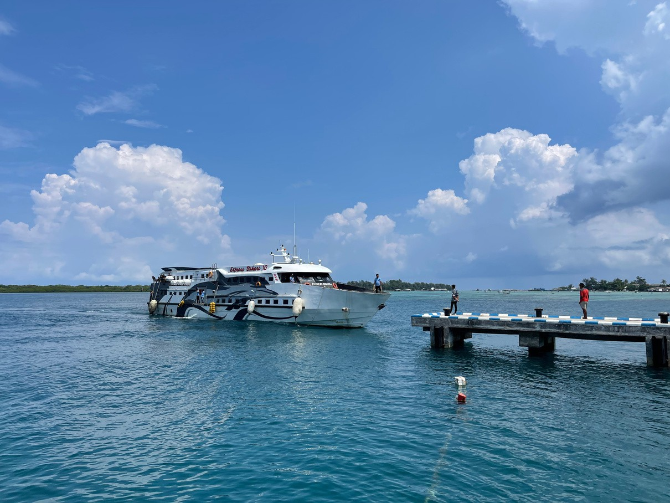
The most popular way to reach the island is with the fast boat operated by Express Bahari.

Typical schedule:

Jepara → Karimunjawa: Morning departure (usually around 09:00) and on some days an additional early afternoon departure (around 13:00)

Karimunjawa → Jepara: Morning departure (usually around 11:00) and on some days an earlier departure (around 07:00)

The journey takes approximately 2 hours.

Fast boat tickets:

Executive Class: Rp300,000 per person (one way) VIP Class: Rp350,000 per person (one way)

EASY BOOKING THROUGH FLOATING
You can now reserve your boat tickets directly through our booking system when confirming your stay. Booking through us offers a smooth and simple experience:
QR boarding pass sent directly to you
No need to queue at the harbour ticket office Secured seats in advance
International-friendly payment options

Please note that booking directly with the boat company usually requires an Indonesian bank payment method. Many of our international guests find it easier to arrange tickets through us for this reason.

Ferry Option
If the fast boat is fully booked, a public ferry is also available. Duration: approximately 4.5 hours
Price: around Rp180,000 per person (one way)

PRIVATE TRANSFERS
If you are arriving in Semarang, we can arrange a private car transfer to Jepara Kartini Harbour or to your hotel in Jepara.
We can also arrange private transport from Yogyakarta directly to Jepara. Transfers can be added during your booking process.
BOOK NOW
Again this button should lead to the ‘extras’ section of Tripla where guests can directly order and pay for their boat tickets.

ON THE ISLAND
Karimunjawa is a small and relaxed island.
Life here moves at a slower pace, and transport options are simple.

Floating is located just outside the main village area, in a quiet bay surrounded by mangroves and sea.
From the harbour, the journey to Floating takes approximately 15–20 minutes by road.

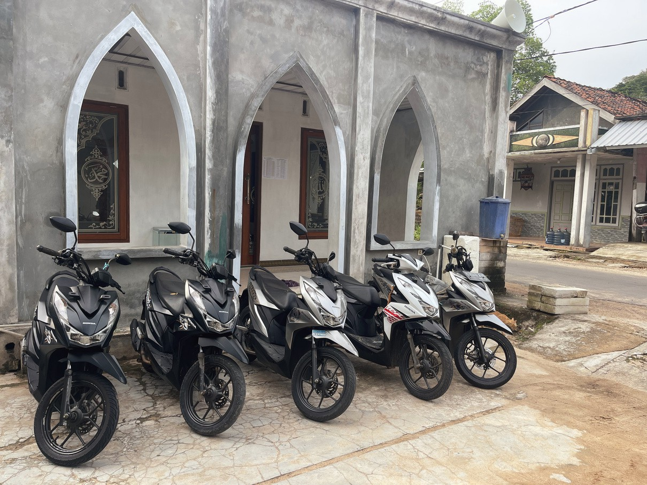
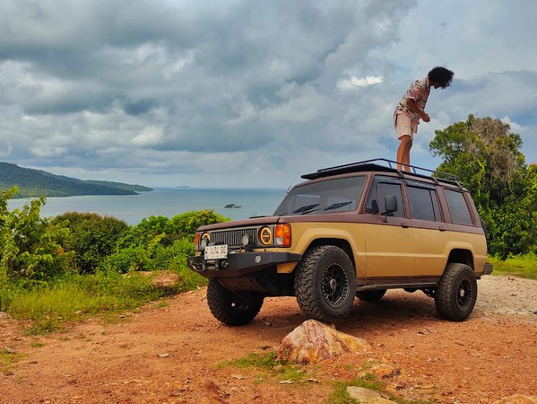

TAXI SERVICE
Local taxis are available at the harbour and around the village. We are happy to help you arrange a pick- up on arrival or a transfer back to the harbour on departure day. A taxi from the harbour/town to Floating is Rp150,000 for a single trip, and we follow the prices set by the islandʼs drivers association.

SCOOTER RENTAL
For guests who would like more independence, we offer scooter rental for Rp100,000 per day, including helmets.

Scooters are the most flexible way to explore the island; beaches, viewpoints, small cafés and village life are all within easy reach.
RESERVE NOW

Again this button should lead to the ‘extras’ section of Tripla where guests can directly pre-order and pay for a scooter.

ACCESS TO FLOATING
Karimunjawa is part of a national park and remains naturally undeveloped in many ways.
Roads are simple, infrastructure is modest, and weather can sometimes influence travel plans.

Floating is located in a quiet bay outside the main village area. The main road leading east across the island is narrow, hilly and not lit at night. It then turns onto a dirt track that passes through an old shrimp farm before reaching our parking area. The track can become muddy during the rainy season.

We are accessible by both scooter and car.

We recommend travelling with light luggage and an open mindset. Life on a small island invites flexibility, patience and presence.

For guests who prefer not to drive at night, local taxis are available. We also offer seasonal local cuisine on-site, and when our kitchen is closed, we organise reliable food delivery from the village.

Our team is always happy to assist to ensure your arrival and stay are smooth and well supported.

Floating is designed for guests who appreciate nature, simplicity and being close to the elements. If you are looking for polished resort infrastructure, Karimunjawa may feel different. If you enjoy authenticity, sea air and a slower rhythm, you will feel very at home.

This text only needs updating.

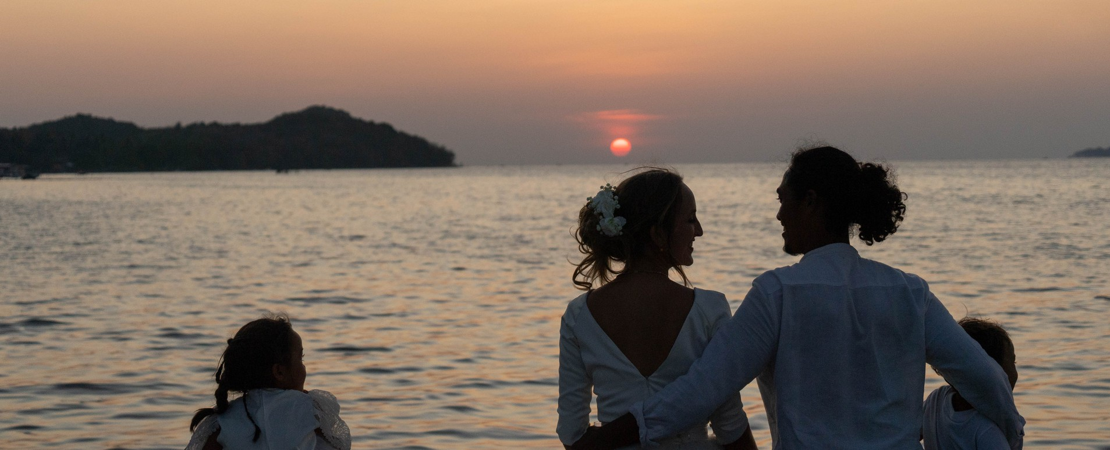

OUR STORY
When Astrid and Tono met, i t didnʼt take long for them to realise that they shared the same dream in l i fe; to create a space where people could connect, learn from each
other and be part of something meaningful in this world.

Karimunjawa seemed l ike the perfect place; being Tonoʼs homeland and the most ‘ at homeʼ Astrid had felt anywhere, they decided to see what they could do together. The
place now known as Floating Paradise was a l i ttle spot they used to come to often, where they felt at peace and aligned with nature, i t seemed l ike the perfect spot to share with l ike-minded travelers.

Over the years, their shared passion for nature, the community and family became more apparent. As well as this sleepy l i ttle guesthouse, theyʼve also set up an
educational charity on the island and built their family home, which they share with their two children.

Their dream is that Floating Paradise not only offers a retreat from the business of l i fe, but also serves as a gentle reminder of the beauty of l iving harmoniously with the
world around us.

Only the ‘our story’ text needs updating on this page.

