**Calculation of λ max of organic compounds using**

**Woodward Fieser rules**

Select the group of compounds from the tab.

1. **CONJUGATED DIENE CORRELATIONS,**
2. **α, β UNSATURATED CARBONYL COMPOUNDS OR KETONES**
3. **AROMATIC COMPOUND**
4. On clicking the tab show the structure of a compound in the selected group randomly.

NB: Examples of the structure of the compounds in various groups are given below.

1. Also show the details to be entered for the selected group as given below.

Refer Fig: 1.

**CONJUGATED DIENE CORRELATIONS**

Base value - Input Box

Alkyl substituent or Ring residue attached to the parent diene - Input Box

Double bond extending conjugation - Input Box

Exocyclic double bonds - Input Box

Polar groups: -Input Box

λmax - Input Box

**α, β UNSATURATED CARBONYL COMPOUNDS OR KETONES**

Base value - Input Box

Alkyl substituent or Ring residue in α position - Input Box

Alkyl substituent or Ring residue in β position - Input Box

Alkyl substituent or Ring residue in γ position - Input Box

Alkyl substituent or Ring residue in δ position - Input Box

Double bond extending conjugation - Input Box

Polar groups in α position - Input Box

Polar groups in β position - Input Box

Polar groups in γ position - Input Box

Polar groups in δ position - Input Box

Exocyclic double bonds - Input Box

Homodiene compound - Input Box

λmax = Input Box

**AROMATIC COMPOUNDS**

Base value- - Input Box

Alkyl group or ring residue in ortho position - Input Box

Alkyl group or ring residue in para position - Input Box

Alkyl group or ring residue in meta position - Input Box

Polar groups in ortho position - Input Box

Polar groups in para position - Input Box

Polar groups in meta position - Input Box

λmax = - Input Box

1. Allow the student to enter the required details from the shown structure of the compound.
2. If the λmaxcalculated by the student is correct, show the message λmax is correct else show λmax is wrong.

NB: Calculation of the λmax is also given below.

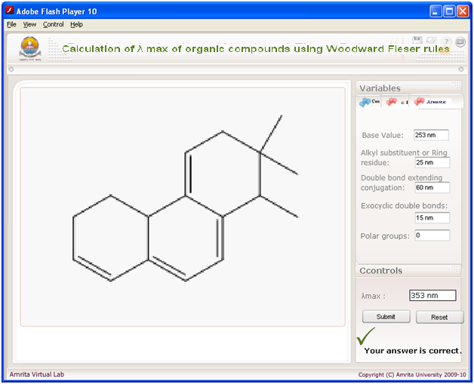

Fig :1

**STRUCTURES**

1. **EXAMPLES FOR CONJUGATED DIENE CORRELATIONS**



Base value = 214 nm

Alkyl substituent = 2 x 5 = 10 nm

λmax = 224 nm

Base value = 253 nm

Substituents = 4 x 5 = 20 nm

Double bond extending conjugation = 1 x 30 = 30 nm

λmax = 303 nm



Base value = 214 nm

Ring residue = 3 x 5 = 15 nm

Exocyclic double bond = 1 x 5 = 5 nm

λmax = 234 nm





Base value = 253 nm

Ring residue = 3 x 5 = 15 nm

Exocyclic double bond = 1 x 5 = 5 nm

λmax = 273 nm



Base value = 214 nm

Ring residue = 2 x 5 = 10 nm

Exocyclic double bond = 1 x 5 = 5 nm

λmax = 232 nm



Base value = 214 nm

Ring residue = 5 nm

λmax = 219 nm

Base value = 253 nm

Ring residue = 5 x 5 = 25 nm

Exocyclic double bond = 3 x 5 = 15 nm

Double bond extending conjugation = 2 x 30 = 60 nm

λmax = 353 nm



Base value = 253 nm

Ring residue = 3 x 5 = 15 nm

Exocyclic double bond = 1 x 5 = 5 nm

Double bond extending conjugation = 1 x 30 = 30 nm

Polar group in oAc = 0 nm

λmax = 303 nm





Base value = 214 nm

Ring residue = 3 x 5 = 15 nm

Exocyclic double bond = 1 x 5 = 5 nm

Polar group in Br = 5 nm

λmax = 239 nm

Base value = 253 nm

Ring residue = 4 x 5 = 20 nm

Exocyclic double bond = 2 x 5 = 10 nm

Double bond extending conjugation = 1 x 30 = 30 nm

λmax = 313 nm





Base value = 214 nm

Ring residue = 5 x 5 = 25 nm

Exocyclic double bond = 3 x 5 = 15 nm

Double bond extending conjugation = 1 x 30 = 30 nm

λmax = 284 nm

Base value = 253 nm

Ring residue = 8 x 5 = 40 nm

Exocyclic double bond = 3 x 5 = 15 nm

Double bond extending conjugation = 1 x 30 = 30 nm

λmax = 323 nm



1. **α, β UNSATURATED CARBONYL COMPOUNDS OR KETONES**

Base value = 214 nm

α- Substituents = 1 x 10 = 10 nm

β- Substituents = 2 x 12 = 24 nm

λmax = 248 nm



Base value = 215 nm

β- Substituents = 1 x 12 = 12 nm

δ- Substituents = 1 x 18 = 18 nm

Double bond extending conjugation =1 x 30 = 30 nm

Exocyclic double bond = 5 nm

λmax = 280 nm



Base value = 215 nm

Ring residue, in β- position = 2 x 12 = 24 nm

Exocyclic double bond = 1 x 5 = 5 nm

λmax = 244 nm





Base value = 215 nm

Ring residue, in α Position = 1 X 10 = 10 nm

Ring residue, in β- position = 1 x 12 = 12 nm

λmax = 237 nm



Base value = 215 nm

Ring residue, in α Position = 1 X 10 = 10 nm

Ring residue, in β- position = 2 x 12 = 24 nm

Exocyclic double bond = 10 nm

λmax = 259 nm

Base value = 215 nm

Ring residue, in α- Position = 1 X 10 = 10 nm

Ring residue, in δ- position = 1 x 18 = 18 nm

Exocyclic double bond = 1 x 5 = 5 nm

Double bond extending conjugation = 1 x 30 = 30 nm

Homo diene compound =1 x 39 = 39 nm

λmax = 317 nm





Base value = 215 nm

Ring residue, in β- Position = 1 X 12 = 12 nm

λmax = 227 nm



Base value = 215 nm

Ring residue, in α- Position = 1 X 10 = 10 nm

Ring residue, in β- position = 2 x 12 = 24 nm

Exocyclic double bond = 1 x 5 = 5 nm

λmax = 254 nm

Base value = 202 nm

Ring residue, in β- position = 1 x 12 = 12 nm

λmax = 214 nm





Base value = 202 nm

Ring residue, in β- position =1 x 12 = 12 nm

Polar group –OH in α- position = 35 nm

λmax = 249 nm



Base value = 215 nm

Ring residue, in β- position =1 x 12 = 12 nm

Ring residue in α- position = 1 x 10 = 10 nm

λmax = 237 nm

1. **AROMATIC COMPOUNDS**

Base value =246 nm

Ring residue in o- position = 1 x 3 = 3 nm

Polar group -OCH3 in p- position = 25 nm

λmax = 274 nm





Base value =246 nm

Ring residue in o- position = 1 x 3 = 3 nm

Polar group -OH in m- position = 7 nm

λmax = 256 nm



Base value =246 nm

Ring residue in o- position = 1 x 3 = 3 nm

Polar group -OCH3 in p- position = 25 nm

Polar group -OCH3 in m- position = 1 x 7 nm

λmax = 281 nm



Base value =250 nm

Polar group -OCH3 in o- position = 7 nm

λmax = 257 nm

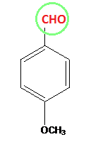 Change CH3 to CHO

Base value =250 nm

Polar group -OCH3 in p- position = 25 nm

λmax = 275 nm



Base value =246 nm

Ring residue in o- position = 1 x 3 = 3 nm

Alkyl substituent -CH3 in m- position = 3nm

Polar group -Br in p- position = 15 nm

λmax = 267 nm



Base value =246 nm

Ring residue in o- position = 1 x 3 = 3 nm

Polar group -Br in m- position = 2 nm

λmax  = 251nm