**Hard Skills:**

**Irina Verbilovich**

Junior Frontend Developer

[*ira.verbilovich@mail.ru*](mailto:ira.verbilovich@mail.ru) *(gmail.com)*

HTML5 / CSS3 (SCSS)

BEM-methodology

Flexbox, Grid

JavaScript

Photoshop / Figma

**Soft Skills:**

Creativity

Affability

Willingness to learn

Self-organized

**Languages:**

English (Advanced C1)  
German (Beginner A1)

**Works / Certificates:**

**Networks:**

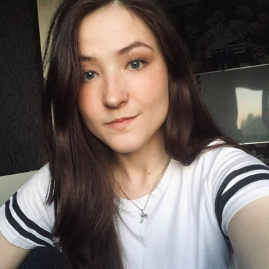LinkedIn - **https://www.linkedin.com/in/irina-verbilovich/**

**Courses I have already finished**

*IT Academy:*

1. Website Development with HTML, CSS & JS - ***2021****FreeCodeCamp:*

1. Responsive Web Design - ***2020***

*Coursera:*

1. Responsive Website Basics: Code with HTML, CSS, and JavaScript (University of London) – ***2020***

2. Responsive Web Design (University of London) – ***2020***

3. Programming Foundations with JavaScript, HTML and CSS (Duke University) – ***2020***

4. Introduction to HTML5 (University of Michigan) - ***2020***  
5. Introduction to CSS3 (University of Michigan) – ***2020***

**Courses I am taking at the current moment**  
Udemy:

1. The Complete JavaScript Course 2021: From Zero to Expert! (Javascript, DOM, OOP) - ***2021***

2. The Complete 2021 Web Development Bootcamp - ***2021***

**Education**

Belarussian State University **-** Faculty of social and cultural communication **(Linguist / translator of two foreign languages English and German)**

***2014 – 2019***