**在按钮中嵌入icon图标有两种方法。第一种是在Flex应用中创建一个变量，利用[Bindable]和[Embed] ，在代码中以参数形式传入制定图标（icon）的路径，然后利用类似icon="{Icon}"的代码嵌入到按钮中。第二种是利用@Embed()和参数中指定图标的路径。**

## 例1:

资源类：

**package** Pure.resource.Icon

{

**public** **class** Arrow

{

[**Embed**(source = **"assets/pureMaps/car0.png"**)]

[**Bindable**]

**static** **public** **var** aspect0:Class;

[**Embed**(source = **"assets/pureMaps/car1.png"**)]

[**Bindable**]

**static** **public** **var** aspect1:Class;

[**Embed**(source = **"assets/pureMaps/car2.png"**)]

[**Bindable**]

**static** **public** **var** aspect2:Class;

[**Embed**(source = **"assets/pureMaps/car3.png"**)]

[**Bindable**]

**static** **public** **var** aspect3:Class;

[**Embed**(source = **"assets/pureMaps/car4.png"**)]

[**Bindable**]

**static** **public** **var** aspect4:Class;

[**Embed**(source = **"assets/pureMaps/car5.png"**)]

[**Bindable**]

**static** **public** **var** aspect5:Class;

[**Embed**(source = **"assets/pureMaps/car6.png"**)]

[**Bindable**]

**static** **public** **var** aspect6:Class;

[**Embed**(source = **"assets/pureMaps/car7.png"**)]

[**Bindable**]

**static** **public** **var** aspect7:Class;

[**Embed**(source = **"assets/pureMaps/car8.png"**)]

[**Bindable**]

**static** **public** **var** aspect8:Class;

}

}

使用者：

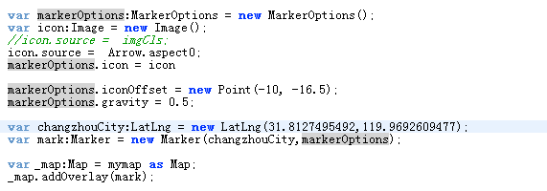

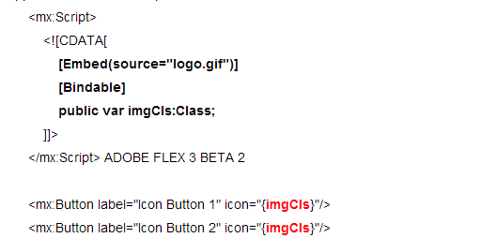

例2：

