1: 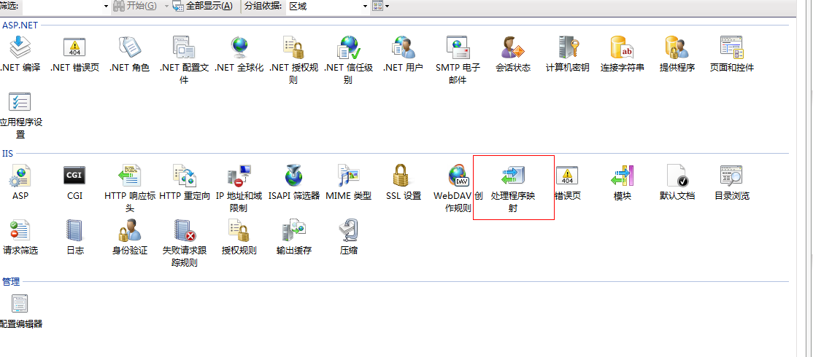

2

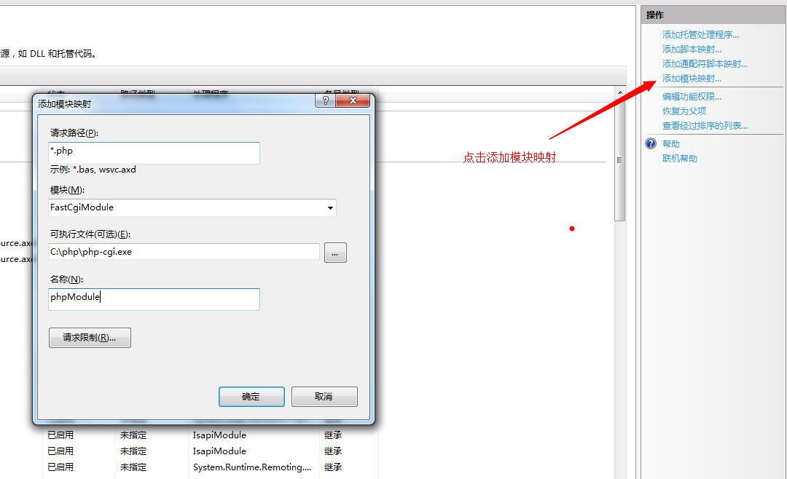

3 配置mysql



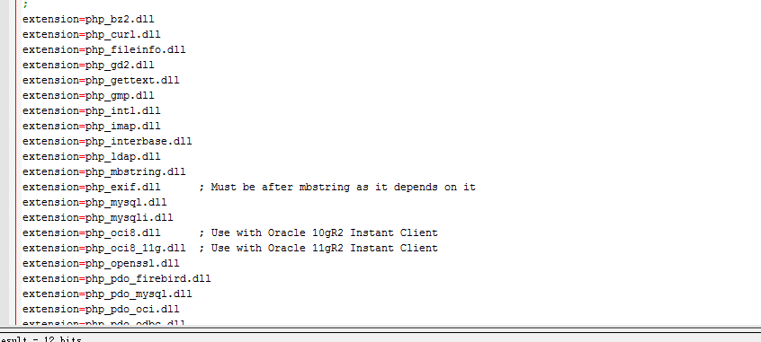

4常见问题

[Deprecated: mysql_connect(): The mysql extension is deprecated and will be removed in the future:](http://blog.csdn.net/ww122081351/article/details/12871081)

**解决方法2：**

常用的php语法连接mysql如下

[?](http://www.ttlsa.com/html/2502.html)

|  |  |
| --- | --- |
| 1  2  3  4  5  6  7 | <?php  $link = mysql_connect('localhost', 'user', 'password');  mysql_select_db('dbname', $link);    改成mysqi  <?php  $link = mysqli_connect('localhost', 'user', 'password', 'dbname'); |

常用mysql建表SQL如下

[?](http://www.ttlsa.com/html/2502.html)

|  |  |
| --- | --- |
| 1  2  3  4  5 | <?php  //  老的  mysql_query('CREATE TEMPORARY TABLE `table`', $link);  // 新的  mysqli_query($link, 'CREATE TEMPORARY TABLE `table`'); |

**解决方法三：**  
在php程序代码里面设置报警级别

[?](http://www.ttlsa.com/html/2502.html)

|  |  |
| --- | --- |
| 1  2 | <?php  error_reporting(E_ALL ^ E_DEPRECATED); |

Deprecated的问题就这样解决掉了，不过还是建议大家尽快取消mysql的用户，全部都走向mysqli或者mysqlnd等等。mysql确实是太不安全而且太老旧了。