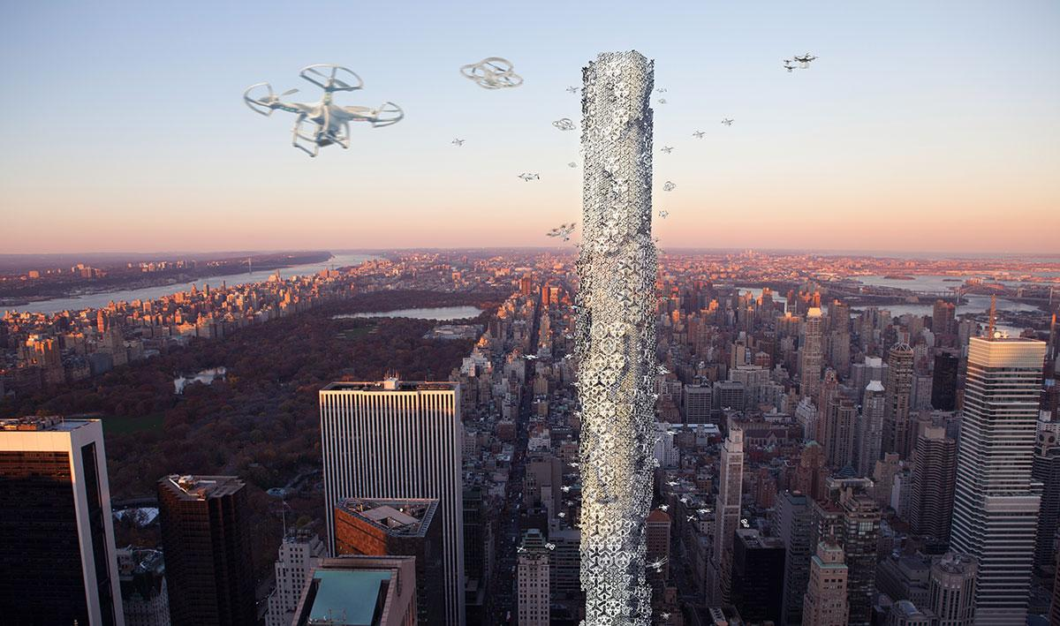
WCCI 2018
2nd Workshop on Computational Intelligence and Smart Cities

Due to the recent success of:
- special session on Smart Cities and Operations Research at the XLIX SBPO, Blumenau/SC, Brazil, 2017;
- special session on Computational Intelligence for Smart Cities at the 2017 IEEE Symposium Series on Computational Intelligence, Honolulu/Hawai, USA, 2017;
- Special session dedicated to "La recherche opérationnelle pour les Smart cities", ROADEF, 2018; and
- 1st workshop on Smart Cities and Computational Intelligence at the XIII Congresso Brasileiro de Inteligência Computacional, Niterói/RJ, Brazil, 2017;

We opened this call for the The IEEE World Congress on Computational Intelligence (IEEE WCCI), one of the largest technical event in the field of Computational Intelligence, that will be held in the city of Rio de Janeiro - RJ, from 08 – 13 July 2018.
New york city in the future.
Extracted from eVolo Magazine 2016 Skyscraper Competition, Mohammad, Zhao & Zhu (2016).
http://www.evolo.us/competition/the-hive-drone-skyscraper/
http://www.ecomp.poli.br/~wcci2018/workshops/

The workshop will be focused on the following theme:
Computational Intelligence and Smart/Digital Cities: Innovative machine learning, metaheuristics, blockchain and other decentralized solutions.

Motivation

Cities' constant evolution has been driven human beings footsteps.
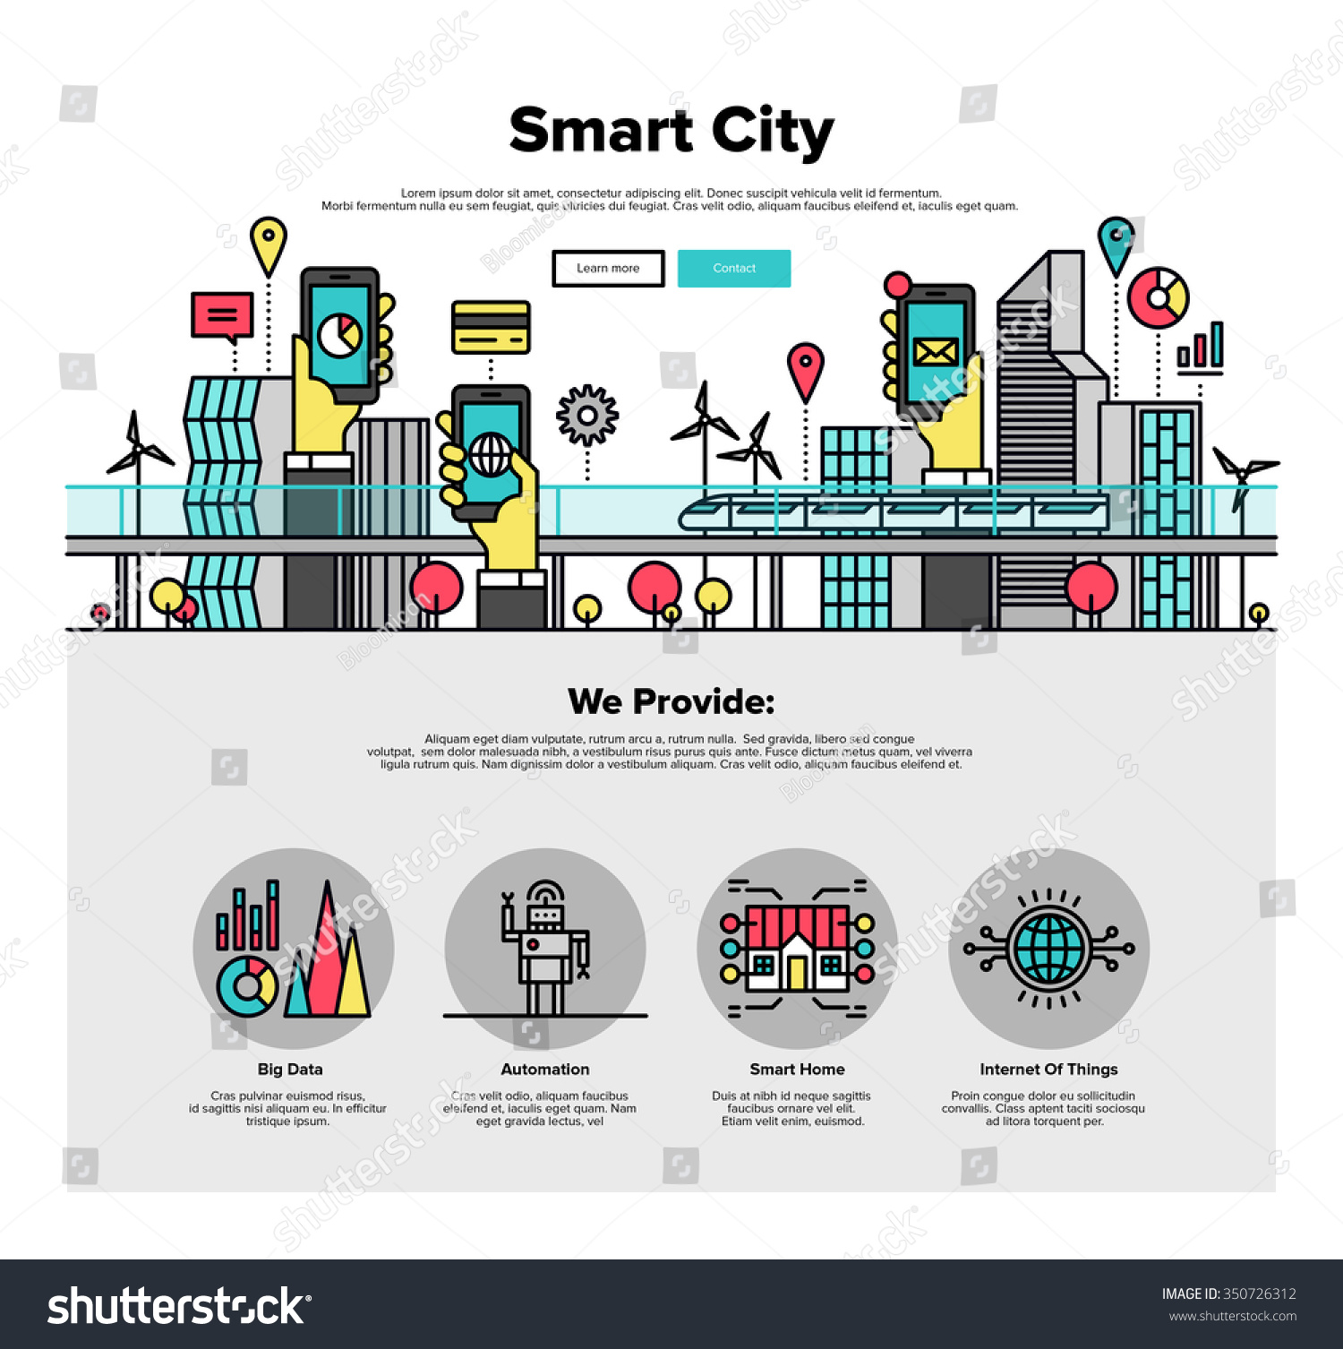
Allied to the advancement of machines, cities are evolving into a new paradigm, being called Smart Cities.
This evolution, closely related to devices equipped with high-performance computational skills, is happening in urban and rural areas.

Besides promoting a decentralization of the current system, the new cities open doors for different autonomous agents to optimize their own interests. In this context, combinatorial optimization plays a fundamental role for more precise, efficient and balanced decision making. In addition, interaction with citizens is not overlooked, new tools contribute to society by promoting a more participatory economy and development.
On the other hand, such advance must take place in a sustainable manner, since new ideas and ways of harnessing existing resources are being studied. This universe of possibilities opens doors for researchers to see distinct environments of complex and multicriteria decisions.
This call invites researchers to submit papers related to the following topics (but not exclusively):

- Computational Intelligence (CI) applied for urban planning and engineering solutions;
- Smart and digital cities solutions with metaheuristics and/or decentralized systems;
- Cities and cryptocurrencies;
- CI and blockchain inspired technologies;
- CI applied for the insertion of renewable energy resources with microgrids;
- CI for Smart Cities (SC) and Smart Grids (SG);
- CI applied for SC logistics;
- SC and Internet of Things;
- CI for Smart/Green Homes;
- CI for decentralized environments;
- CI and citizens;
- Green Computing and Green Operations Research;
- High performance computing and SC;
- City of Things and CI testbed for SC;
- Reviews, trends and state-of-the-art ideas for SC and: combinatorial optimization problems,
artificial and computational intelligence, citizens, IoT, SG, renewable resources, among others.

Important dates and guidelines:

Submission should follow WCCI 2018 guidelines and deadlines, available at http://www.ecomp.poli.br/~wcci2018/submissions/#Importantdate

WT1 Final Schedule

WT1: Workshop on Computational Intelligence and Smart Cities
Date: MONDAY, 9th July, 2018. From 2:10pm to 6-30pm
Room: Aruba

2:10pm – 4:10pm
2:10pm – 2:20pm:
Opening session

2:20pm – 3:00pm:
Plenary talk: High performance computation applied to Cities’ IoT devices
by Igor Machado Coelho 3:00pm – 4:10pm:
Round table: Digital cities and blockchain technologies
- Mediator:
- Panel:
  - Luiz Satoru Ochi, professor of Computer Science at UFF;
  - Thays Aparecida de Oliveira, PhD Student at Universitat Pompeu Fabra/Spain;
  - XXXXX
  - XXXXX
  - XXXXX
  - XXXXX
  - XXXXX



4:10pm – 4:30pm
Coffee Break

4:30pm – 6:00pm
Technical Session
Chairs: Luiz Satoru Ochi, Vitor Coelho and Igor Coelho

- 4:30PM Computational Intelligence and Adaptation in VANETs: Current Research and New Perspectives. Marcia Pasin, Amal El Fallah Seghrouchni, Assia Belbachir, Sarajane Marques Peres and Anarosa Alves Franco Brandao.
- 4:50PM Formalization and certification of software for Smart Cities. Erick Grilo and Bruno Lopes
- 5:10PM Citizens and Information and Communication Technologies. Thays A. Oliveira, Alexandre C. Barbosa, Helena Ramalhinho and Miquel Oliver
- 5:30PM Logistics SLA Optimization Service for Transportation in Smart Cities. Edcarllos Santos, Puca Huachi Penna, Igor Machado Coelho, Heder Dorneles Soares and Luiz Satoru Ochi and Luidi Simonetti
- 5:50PM Cryptocurrencies for Smart Territories: an exploratory study. Alexandre Barbosa, Thays Oliveira and Vitor Coelho

6:10pm – 6:30pm:
Closing session
Motivational talk: “If Tesla was alive: Cities’ microgrids revolution”
by Vitor Nazário Coelho

Organizers

Vitor Nazário Coelho, Grupo da Causa Humana and Instituto de Computação, Universidade Federal Fluminense, Brasil, vncoelho@gmail.com

Vitor Nazário Coelho is a scientist engaged in scientific and social causes. Technician in Electronic Instrumentation, Control and Automation Engineering, PhD degree in Electrical Engineering of Federal University of Minas Gerais. Currently, working as a Post-doc Researcher at Fluminense Federal University. Vitor has been investigating different fields of high performance computing, such as: metaheuristics, multi-agent systems, multi-objective optimization, trying to embed them into low-cost devices. During his 8 years of study in the field of optimization, he had already sought for solving different complex combinatorial optimization problems, focusing on sustainable development, microgrids, time series forecasting, vehicle routing problems, scheduling, among others.

Igor Machado Coelho, Departamento de Informática e Ciência da Computação, Universidade do Estado do Rio de Janeiro, Brasil, igor.machado@ime.uerj.br
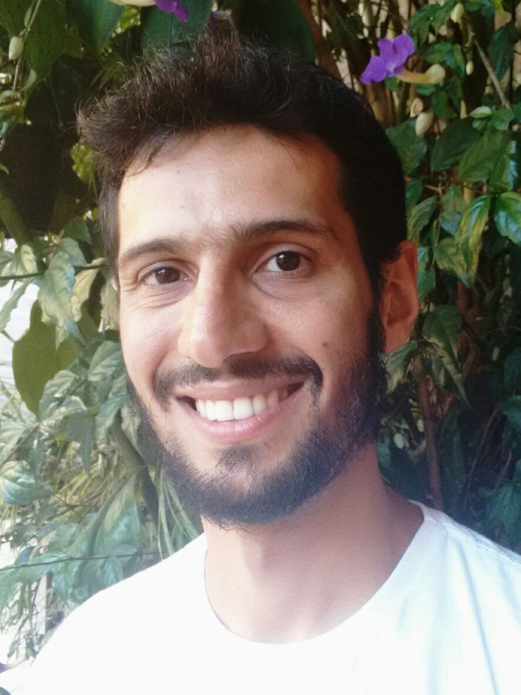
Igor Machado Coelho received the B.S. in Computing from Federal University of Ouro Preto, Brazil, the M.S. and PhD degree in Algorithms and Optimization in 2015 at the Computing Institute of Fluminense Federal University, Niterói, Brazil. He is currently Adjunct Professor in Computer Science Department at State University of Rio de Janeiro. He is one of the creators and maintainer of the OptFrame project, a framework for combinatorial optimization. His research interests include the resolution of challenging combinatorial optimization problems in fields of Vehicle Routing, OpenPit Mining Operational Planning, Smart Grid, and the development of novel algorithms for emerging computing architectures.

Luiz Satoru Ochi, Instituto de Computação, Universidade Federal Fluminense, Brasil,
satoru@ic.uff.br

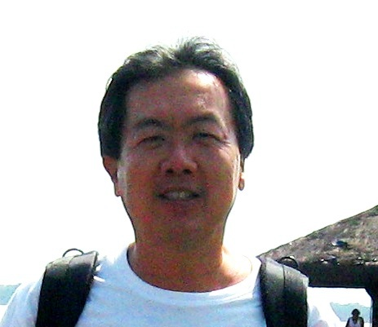
Luiz Satoru Ochi obtained his B.Sc. in Mathematics and his PhD in Computing and Systems Engineering at COPPE in Federal University of Rio de Janeiro (UFRJ), Brazil. He is a full professor at Fluminense Federal University (UFF), Brazil. He was a visiting Professor at University of Colorado at Boulder - USA. He was the General Coordinator CAPES-COFECUB Project (Brazil & France), in Graphs and Algorithms, including UFF, UFRJ, University of Grenoble, from 1997-2000. He was Coordinator of the graduate course (Masters and PhD) in Computer Science at UFF. His is a Researcher 1C level with grant from the National Council for Scientific and Technological Development (Conselho Nacional de Desenvolvimento Científico e Tenológico - CNPq), Brazil. His research interests are MixedLinear Integer Programming, Operations Research, Metaheuristics, Computational Intelligence, Vehicle Routing Problem. He is the author of more than 290 research articles in chapter-books and specialized journals.


Thays Aparecida de Oliveira, Department of Engineering and Information & Communication Technologies, Universitat Pompeu Fabra, Spain, thaysoliveira7@gmail.com

Thays Aparecida de Oliveira received the B.S. in Business from Fedederal University of Ouro Preto, Brazil, the M.S. degree in Strategic Management, Marketing and Innovation in 2016 at the Federal University of Lavras, Brazil. Currently, working as a PhD Candidate at the Department of Engineering and Information & Communication Technologies at Universitat Pompeu Fabra, Barcelona, Spain. Her research interests include citizens; works with population integration in urban centers, applying personal and web questionnaires; studies including consumer and citizens behavior. In the technological area, she is researching in the PhD relationships between citizens and digital cities, understanding citizens' necessities in the cities.

Helena Ramalhinho Lourenço, Department of Economics and Business, Universitat Pompeu Fabra, Spain, helena.ramalhinho@upf.edu
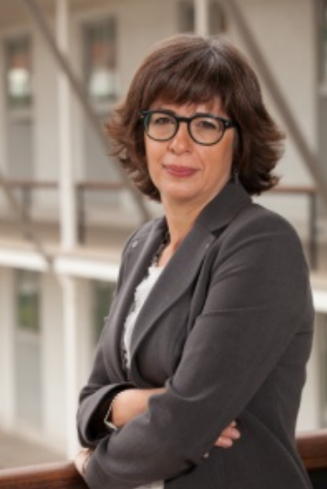
Helena Ramalhinho Lourenço is an Full Professor at the Economics and Business Department at the University Pompeu Fabra, Barcelona, Spain. She has a B.A. and Master degree in Statistics and Operations Research from the University of Lisbon, Portugal, and a Ph.D. in Operations Research from Cornell University, New York, USA. She has been involved in different research projects and consulting for firms in the area of Operations Research and Logistics. Helena has published several articles in prestigious international scientific journals and has presented her work at international congresses and conferences. Helena teaches at various undergraduate, master’s and PhD`s programs. She is currently the director of the Business Analytics Research Group and a researcher at the Center for Operational Research at the University of Lisbon. Her research interests include Operations Research, Scheduling, Combinatorial Optimization, Metaheuristics, Iterated Local Search, Heuristic Search Optimization, Vehicle Routing, Job-Shop Scheduling, Supply Chain Management, Logistics, Production and Operations Management.

Miguel Oliver, Department of Engineering and Information & Communication Technologies, Universitat Pompeu Fabra, Spain, miquel.oliver@upf.edu

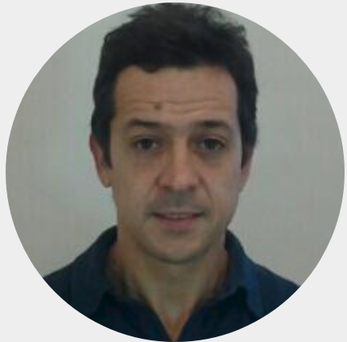
Since 2001, Miquel Oliver is a Associate Professor at the Department of Engineering and Information & Communication Technologies and in charge Communication. He has been involved in the government of the UPF as Vice-Rector for Institutional Strategy and Quality (2008-13). He received his Ph.D. from Universitat Politèncica de Catalunya in 1999, a Degree in Business Administration (UOC, 2009) and GloColl Executive Education (Harvard, 2011-12). Before joining UPF, he was associate professor at the UPC, visiting scholar at Rutgers University (US). He is leading the multidisciplinary Networking and Strategies Research Group (NeTS). He has been visiting scientist at the MIT (2013-14) and in Columbia University (2011). His research is on wireless communications, with a multidisciplinar view including regulation, telecom policies and economic impact. Prof. Oliver has authored over 60 technical papers, as well as edited three books, holds three patents, supervised ten PhD thesis, advising an spinoff project. Four of his papers have received the best paper award. Has has two Jaume Vicens Vives awards from the Generalitat de Catalunya. Miquel Oliver is currently the director of the Telefonica's Chair devoted to MOOCs.

Andréa Cynthia Santos, Technological University of Troyes, France, andrea.duhamel@utt.fr

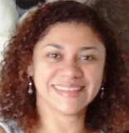
Andréa Cynthia Santos is an associate Professor at the Technological University of Troyes, France. She leads innovative projects in disaster logistics and urban transportation networks. The project “Tactical optimization strategies to adapt urban transportation networks (TOAST)” was awarded a European prize “Le monde” Smart-cities on urban mobility category in 2017. Her research is dedicated to Operations Research/Management Science problems, especially combinatorial optimization problems in transportation and network design, with applications for smart cities, humanitarian logistics and urban transportation. In theoretical terms, her contributions are mainly on robust optimization to handle optimization problems with uncertain data. The methods developed in her scientific research are part of some decision-making systems. She has published twenty articles in reputed international reviews, and made more than sixty communications in national and international conferences.

