Function Point
A Function Point (FP) is a unit of measurement to express the amount of business functionality, an information system (as a product) provides to a user. FPs measure software size. They are widely accepted as an industry standard for functional sizing.
They have decided to focus on five types of components:
- EI - external inputs, which are the components responsible for introducing changes in system's internal data.
- EO - external outputs, which are the ways system's internal data can be presented, but beware - there are a few similarities with EQ components, though.
- EQ - external inquiries, which are the methods for reading system's data without modifying it.
- EIF - external interface files, which are responsible for exchanging data with other systems.
- ILF - internal logical files, which are files that are being used by the system itself.

Steps to calculate Function Point
1. Compute the adjusted function point (CFP)

CFP = Sum of all the Complexities of all the EI's, EO's EQ's, ILF's and EIF's
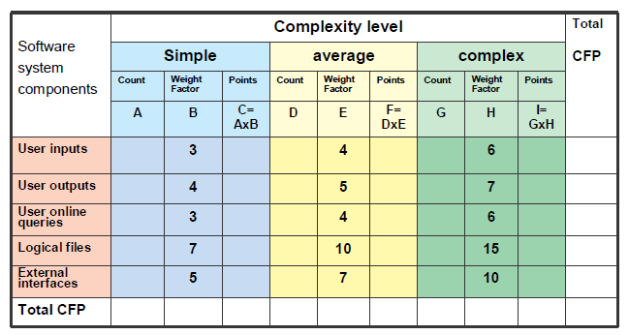

2. Compute TDI for the project

TDI = Sum of (DI of 14 General System Characteristics) where DI stands for Degree of Influence.
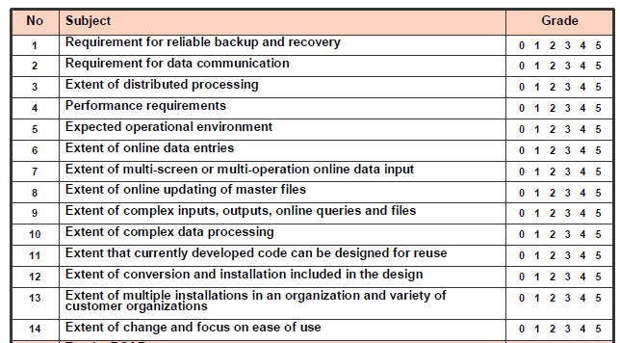
Once the TDI is determined we can put it in the formula below to get the VAF/TCF(Technical Complexity Factor)
TCF /VAF = 0.65 + (0.01 * TDI)
3. Compute the number of function point (FP) FP = UFP * VAF

