Calculate the cyclomatic complexity of the given program:

int divide (int x, int y)
{
if (y != 0) /* Condition 1 */
{
return x / y;
}
else if (x == 0 && y > 2)
{
return 1;
}
else
{
printf (“div by zero\n”);
return 0;
}
}
The size of an organic type software project is 50 KLOC. If unit cost of effort is Rs.20,000/- per PM, estimate the development time and cost of the software project.

Suppose that a project was estimated to be 400 KLOC. Calculate the effort and development time for each of the three modes i.e. organic, semidetached and embedded.
(Organic a=2.4, b=1.05, c = 2.5, d=0.38; Semidetached a=3.0 ,b=1.12 ,c =2.5, d=0.35 ; Embedded a=3.6,b=1.20,c=2.5, d=0.32)

Define Cyclomatic Complexity. Calculate the cyclomatic complexity of the given graph below:
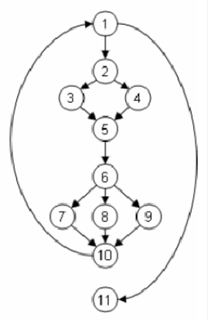
Draw the control flow graph and calculate the cyclomatic complexity of the given code snippet:

A = 10
IF B > C THEN
A = B
ELSE
A = C
ENDIF
Print A
Print B
Print C

Assume that the size of an organic type software product has been estimated to be 32,000 lines of source code. Assume that the average salary of software engineers be Rs. 15,000/- per month. Determine the effort required to develop the software product and the nominal development time.

Consider a project with the following functional units :
- Number of user inputs = 50
- Number of user outputs = 40
- Number of user enquiries = 35
- Number of user files = 06
- Number of external interfaces = 04

Assuming all complexity weighing factors as average [4, 5, 4, 10, 7] and TDI as 42, calculate function points for the given project.

Compute the function point value for a project with the following information domain characteristics:
(1) No. of user inputs = 30
(2) No. of user outputs = 20
(3) No. of user inquiries = 08
(4) No. of files = 7
(5) No. of external interfaces = 6

Assume all weighing factors as average (4,5,4,10,7) and TDI as 28.

Calculate the cyclomatic complexity of the given program

- Procedure greater;
- Integer: x,y,z = 0;
- enter the value of x;
- enter the value of y;
- if x > y then
- z = x;
- Else
- z = y;
- end greater

Consider a database system needed for an organization with the system size of 3KDSI as an organic project. Calculate the effort, duration of development and average staffing of the project.(Organic a=2.4, b=1.05, c = 2.5, d=0.38)

