Unit III
Risk Management - Software Risks, Risk Identification, Risk Projection and Risk Refinement, RMMM Plan
- Introduction to Risk and Risk Management
Risk is defined as a future negative consequence which is a possibility of suffering loss signifying the impact on the software might result in increased production cost, development of poor-quality software package, not having the ability to finish the project on time.

It is defined as a potential problem that may or may not occur in the future. This possibility of suffering from loss in software development process is called a software risk. Risk can be reduced and managed according to tight and managed planning and assessment.
Risk is managed by different strategies i.e. reactive and proactive.
Risk Strategies:
- Reactive Risk Strategies: A reactive strategy may be a risk management strategy monitors the project for seemingly risks for taking corrective actions once necessary.
It is typically perceived because the “lowest” or most simple variety of risk management and is principally propagated because it is related to aviation safety programs that area unit early in implementation; not terribly developed safety program and lack of safety culture.
These forms of risk area unit usually underdeveloped risk and area unit vital for brand spanking new safety programs. Programs while not sturdy reactive risk management ways area unit exposed to considerable risk. These risks area unit applied once risk happens.
The essential component of reactive risk space area unit as follows:
- Mitigating safety events when hazard has occurred.
- Minimizing damage from critical situation.
- Acting quickly and with efficiency in response to undesirable incidents.
- Decision making in concern with threats, risk, etc. safety.
- Proactive Risk Strategies: A proactive strategy begins at the initial state as technical work is initiated to identify potential risks and assess their probability and impact to rank the risk by its importance.
Proactive risk management is commonly applied in anticipation of risk.
The primary goals of proactive risk management are as follows:
- Identify behaviors that cause hazard incidence and stop it before it happens;
- Identify root causes before they cause hazard occurrence; and
- Understand safety “inputs” which helps in underlying causes that lead to safety performance.
Risk involves the following two characteristics:
- Uncertainty: It is uncertain that risk may happen. In such case, risk may or may not happen. There is no certainty of risk to happen.
- Loss: If the risk becomes a reality, unwanted consequences or losses will occur.

Risk management is a software engineering practice with processes, methods and tools for managing risk in a project. It provides a disciplined environment for proactive decision making by providing access continuously what can go wrong, determining what risks are important to deal with and implementing strategies to deal with those risks.

Risk management includes the following steps during risk resolving:

- Risk Identification: It helps in identifying the risk.
- Risk Analysis: It helps in understanding the occurrence of risk, its impact and time of occurrence.
- Risk Assessment: It is measured in terms of probability of occurrence, loss and risk exposure.
- Risk Planning for Resolution: It deals with risk in terms of strategies and execution.
- Risk Monitoring: It monitors the risk for its occurrence, impact and implication until it is resolved.
- Risk Mitigation: It helps to meet the challenges of risk occurrence in effective implementation.

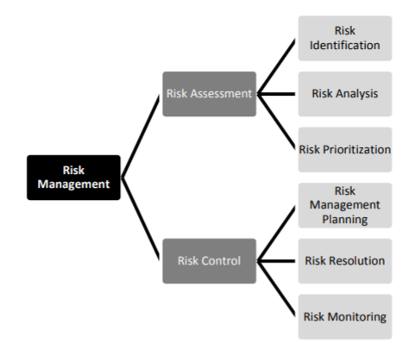

- SOFTWARE RISK

Software risk is defined as a measure of the chance of the risk occurrence and the loss due to its exposure.

Types of Risk

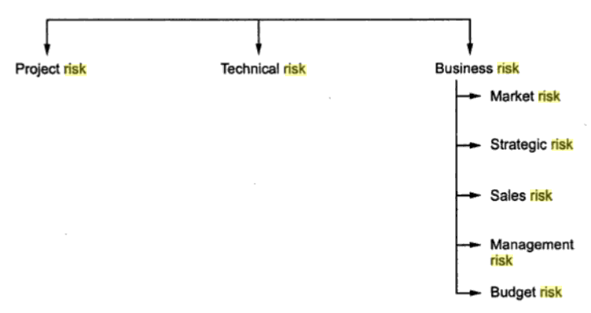
- Project Risk
- Technical Risk
- Business Risk

- Project Risks: Project risk is mainly concerned with different sorts of monetary fund, schedule, staffing, resource and customer-related issues. Since computer code is intangible, it’s terribly tough to observe and management a computer code project i.e. it’s terribly tough to manage one thing that is not visible to a naked eye and cannot be seen.

- Technical Risks: Technical risk is concerned with potential style, implementation, interfacing, testing and maintenance issues. It is the degree of uncertainty between the actual and optimal design solutions. It mainly impacts on the quality and timeline of the project.

- Business Risks: Business risk is a future possible risk that may prevent from achieving business goals. It includes the strategies that help in controlling business plans.

The various types of business risks are defined as:

- Market Risk : It aims at building an excellent product or system that no one really wants.
- Strategic Risk : It aims at building a product that no longer fits into the overall business strategy for the Company.
- Sales Risk : It aims at building a product that the sales force doesn’t understand how to sell.
- Management Risk : It aims at losing the support of senior management due to change in focus or a change in people.
- Budget risk : It aims at losing budgetary or personnel commitment.

According to Charette, risk is categorized in the following three categories:

Known risks are the risks which are identified prior during the identification of project specification and analysis of the scope and definition. They are thoroughly analysed by reviewing project plan and the environment in which project is being developed. For example, resources required for development, tools and techniques needed, lack of problem domain knowledge, expected delivery date etc.

Predictable risks are those which are foreseeable/expected and extrapolated from past project experience. For example, staff turnover, stakeholder communication, support and maintenance of the project etc.

Unpredictable risks are unforeseen, unexpected and hard, if not impossible, to identify in advance. For example, change in policies affecting business project etc.

- RISK IDENTIFICATION

Risk identification is defined as a process of handling specific inputs that generates a set of output or risk with context to the software proposed to be developed. It is a systematic attempt to specify threats to the project plan which can be achieved by identifying known and predictable risk.

There are two distinct types of risks approaches:
1) Generic risk identification which includes potential threat identification to a software project.
2) Product-specific risk identification which includes threat identification specific to a product with clear knowledge of technology, people and the environment which are specific to the software.

Known and predictable risks are categorized in the following generic subcategories:

• Product size defines the risks which identifies the overall size of the software to be developed or modified.
• Business impact risks are associated with consistency specified by management or the marketplace.
• Stakeholder characteristic risks define the sophistication of the stakeholders and the developer’s ability to communicate within a specific time duration.
• Process definition risks are related with the degree that defines the software process to be followed by the development organization.
• Development environment risks are related with the availability and quality of the tools and techniques required to build the product.
• Technology to be built risk is associated with the system complexity and technology used for system development.
• Staff size and experience risk identifies the risk associated with the experience of the personnel who are deployed on the software development.

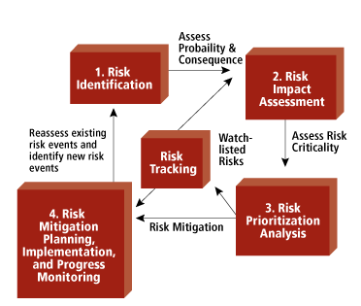
Fig: Risk Identification

3.1 Assessing Overall Project Risk

After conducting a survey, following few questions/points to be taken care of have been derived from risk data which are important for the success of a project:

1. To have top software and customer managers formally committed to support the project.
2. To have enthusiastically committed end-users to the project and the system/product to be built.
3. To have a software engineering team which fully understands the needs and requirements of the customers.
4. To have customers who are involved fully in the definition of requirements,
5. To have end-users who believe in and have realistic expectations.
6. To have stable project scope.
7.To have a software engineering team carrying & possessing right mix of skills.
8. To have stable project requirements.
9. To have a project team equipped with experience of the technology to be implemented.
10. To have adequate number of people on the project team for execution of the job.
11. To have all customer/user constituencies who agree on the importance of the project and on the requirements for the system/product to be built.

3.2 Risk Components and Drivers

The U.S. Air Force has published certain guidelines for software risk identification requiring that the project manager must identify the risk drivers that can affect the software risk components. The different risk components are:

• Performance risk defines the degree of uncertainty associated with the specifications of the product and its use.
• Cost risk defines the budget uncertainty that is uncertain during the product development.
• Support risk is associated with the degree of uncertainty that deals with the adaptation of change in software.
• Schedule risk defines the uncertainty whether the product will be delivered on time according to the planned schedule.

The impact of each risk driver on the risk component is divided into one of four impact categories—negligible, marginal, critical, or catastrophic.

The impact category is chosen based on the characterization that best fits the description in the table.
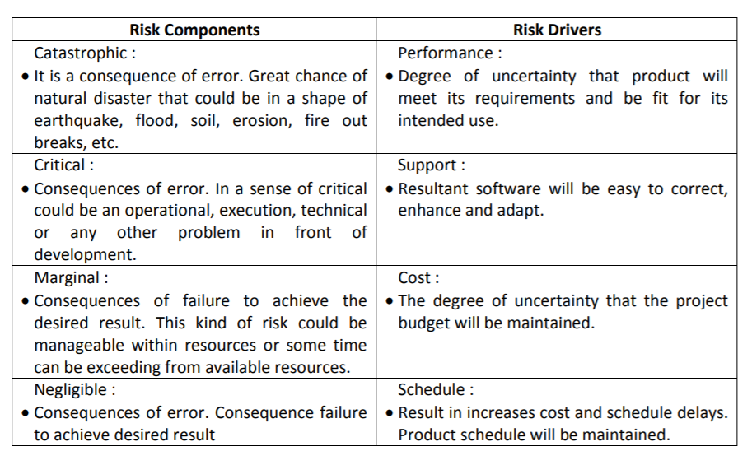

- RISK PROJECTION

Risk projection, is also called risk estimation which attempts to rate each risk as likelihood or probability that the risk is real and the consequences of the problems associated with the risk, should it occur.
The project planner, managers and technical staff performs four different risk projection activities, which helps to prioritize the risk which helps in easy allocation of resources for handling them. These are as follows:

(1) It establishes a scale that reflects the perceived likelihood of a risk.
(2) It outlines the consequences of the risk.
(3) It estimates the impact of the risk on the project and the product.
(4) It maintains the overall accuracy of the risk projection in order to have clear understanding of the software.

4.1 Developing a Risk Table

When building the risk table given below Table 1, the project team first enlists all probable risk with the help of risk item checklist. Each risk is then classified into various categories such as project size (PS), technology (TI), customer (C), staff (PS), business(BU) and developing environment (DE).

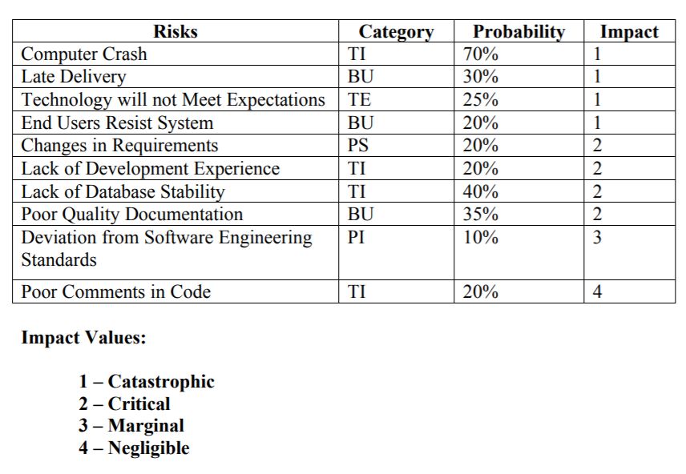

Table 1: Sample Risk Table

The probability of occurrence of each risk is then estimated by each team member individually. After identifying probability, impact of each risk is assessed. During impact assessment, each risk component is assessed using the characterization and impact categories like catastrophic, critical, marginal and negligible to identify an overall impact value. After the table is build, it is then sorted by probability and impact. The high-probability, high-impact risks percolate to the top of the table, and low-probability risks drop to the bottom. This accomplishes first-order risk prioritization.

The project manager studies the resultant sorted table and defines a cutoff line. The cutoff line (drawn horizontally at some point in the table) signifies that only risks that lie above the line will be further looked after and the others below the line are re-evaluated to accomplish second-order prioritization.

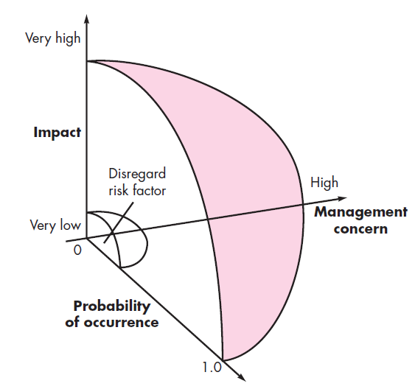
Fig.1 : Risk and Management Concern
Image Source: Software Engineering by Pressman

Risk impact and probability have a distinct influence on management concern. A risk issue that includes a high impact however has a very low chance of prevalence should not absorb a major amount of management time.

However, high-impact risks with moderate to high probability and low-impact risks with high probability ought to be carried forward into the risk analysis steps that follow.

All risks that lie higher than the cutoff line should be managed and specify in last column of the table underneath RMMM column.

  - Assessing Risk Impact

While assessing the risks impact three factors are considered – nature of risk, scope of the risk and timing at which risk occurs.

The nature of the risk indicates the type or kind of risk. For example, if software requirement is poorly understood, the software processes gets poorly designed and will not satisfy the specification. The scope of a risk combines the severity of the risk. Finally, the timing of a risk determines when and for how long the impact will be felt.

U.S. Air Force has suggested the following steps to determine the overall risk impact:
(1) Calculate the average probability of various risk component.
(2) Determine the impact of risk on each component based using risk drivers.
(3) Build the risk table and analyze the impact of risk and its probability.

Risk exposure RE can be calculated by the following formula:
Risk Exposure = Probability of occurrence of risk X Cost

For example, Consider a software project with 74% of risk probability in which 20 components were developed from the scratch. Each component has on an average 100 LOC and each LOC have an average cost of $15. Then the risk exposure can be calculated as

Cost = number of components*LOC*cost of each LOC
= 20*100*15 = $30,000

RE=Probability of occurrence of risk * Cost
= 0.74 * 30000 = $22,500.

- RISK REFINEMENT

Risk refinement is a process of specifying risk into a detailed risk at the later stage for easily mitigating,monitoring and managing it.

David P. Gluch has introduced a CTC format i.e. condition-transition-consequence to be used during the process of risk refinement. It is expressed as current condition, a transition over time, and possible consequences.

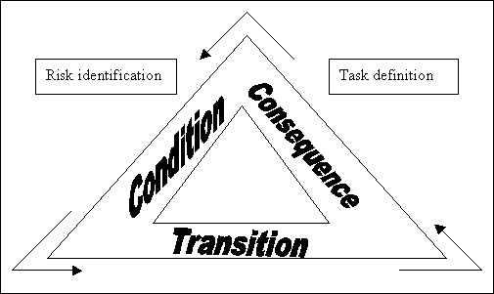

Given that all reusable software package elements should change to specific style standards which some don't change, then there's concern that solely 70% of the planned reusable modules may very well be integrated into the as-built system, leading to the necessity to custom engineer the remaining 30% components.
This general condition is refined within the following manner:

Sub condition 1. When certain reusable components were developed with no knowledge of internal design by a third party.
Sub condition 2. The design commonplace for components interfaces has not been coagulated and will not change to sure existing reusable parts.
Sub condition 3. Implementation of reusable components in a non-supported environment language.

The shortfall remains the same with the sub conditions however the refinement helps to isolate the underlying risks and helps in simplifying the analysis and response.

6. Risk Mitigation, Monitoring, and Management(RMMM)
RMMM stands for risk mitigation, monitoring and management, whose main goal is to identify as many potential risks as possible, measure and monitor the severity of risk to suggest resolution strategy by generating a plan.

RMMM plan deals with risk in a systematic manner using these different strategies.
RMMM is summarized as: Risk Mitigation is a process of risk prevention i.e. it focuses on avoiding the risk to be occurred. Risk Monitoring is a phenomenon of tracking the risk occurred. Risk Management includes contingency plans to be implemented if risk occurs.
When all risks have been identified, they will then be evaluated to determine their probability of occurrence. Plans can then be created to avoid every risk, to trace every risk to see if it's a lot of or less doubtless to occur, and to set up for those risks should they occur.

RISK MITIGATION: It deals with proactive planning for risk avoidance by developing team strategies to reduce the possibility or the loss impact of a risk. Risk mitigation produces a scenario within which the risk can be eliminated or otherwise resolved.

It is the process of strategizing options and actions to enhance opportunities and reduce threats to project objectives and includes tracking identified risks, identifying new risks, and evaluating risk process effectiveness throughout the project.

Following are the steps to be taken for risk mitigation:
  - To find the probable risk, it is necessary to communicate the associated staff.
  - Before project begins, eliminate all the causes of risk creation.
  - Develop a policy beneficial for project development, in case any staff resigns.
  - Update the current status of project time to time to continue with project development smoothly.
  - Timely maintenance of documents in standard format.
  - Periodic reviews can be conducted to monitor the progress of the work.
  - Critical activities can be conducted with additional staffing, if required.

RISK MONITORING: Risk monitoring is ongoing activity of risk management. It involves identifying risk and controlling designs by tracking the execution of risk management and continuing to identifying and managing new risks.

It is necessary that the risk must be monitored continuously by the project risk manager and the project team to ensures that new and changing risks have been detected and well- managed and the corresponding actions are implemented effectively.

It also monitors the execution of planned strategies for the identified risks and evaluates their effectiveness. Risks needs to be revisited at regular intervals for the team to re-evaluate each risk to determine when new circumstances caused its probability and/or impact to change. At each interval, some risks may be added to the list and others taken away. Risks needs to be reprioritized to have action plans and which move “below the line” and no longer need action plans. Identifying proactive actions is a key to successful risk management owned by individuals and are monitored.

If an unanticipated risk emerges, or a risk’s impact is greater than expected, the planned response may not be adequate, than additional responses to control the risk should be performed.

Monitoring focuses on the following:

- Periodic risk review.
- Following policies and procedures.
- Cooperation among team members.
- Identification of the type of problem occurring.
- Implementing a contingency plan
- Taking corrective actions
- Changing the project objectives

RISK MANAGEMENT: Risk management is a project tracking activity which is carried out throughout the development process to identify, manage and control risks during the development process.

It focuses on risk containment and mitigation. Management starts with identification of plan, and when risk arises it impact is minimized depending upon the experience and knowledge of the entire team.

The primary objectives are to assess whether predicted risks do, in fact, occur and to ensure that the desired actions to minimize risk are properly applied. It collects information that can be used for future risk analysis.

It includes the following activities:

- Identify the risks and its cause.
- Prioritize all risks.
- Create a plan linking each risk to a mitigation.
- During the project monitor risk triggers.
- In case of risk materialization, implement the mitigating action.
- Communicate risk status throughout project.

RMMM Plan

The RMMM plan documents all the work performed as a part of risk analysis and is used by project manager as a part of overall project plan. Some software team develop RMMM plan where each risk is documented individually using risk information sheet (RIS). The risk mitigation and monitoring start after the project is started and the documentation of RMMM is completed.

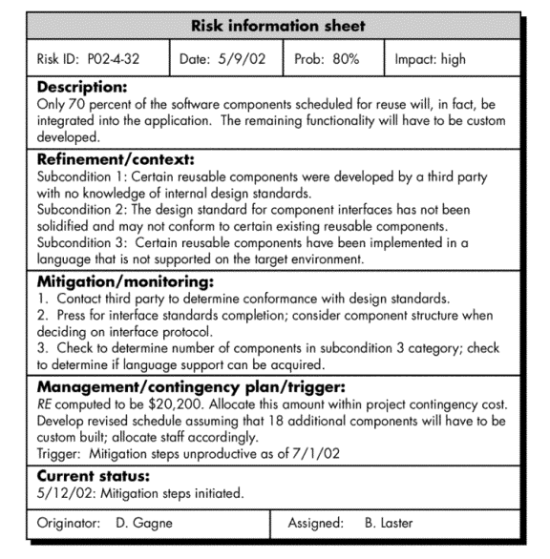
Fig: Risk Information Sheet
Image Source: Software Engineering by Pressman

Questions

- Define risk with its strategies.
- Explain reactive risk strategies with its components.
- Explain different steps includes during risk resolving.
- State and explain different types of risk.
- Explain the process of risk identification.
- Explain various risk components and risk drivers.
- Explain the concept of risk projection.
- Describe the process of risk refinement.
- Explain how RMMM helps in identifying the severity of risk.

