Software Quality Assurance: Elements of SQA, SQA Tasks, Goals, and Metrics, Formal Approaches to SQA, Six Sigma, Software Reliability, The ISO 9000 Quality Standards, Capability Maturity Model

- Introduction to Quality

Quality varies from user to user, product to product as well as it differs from the use of the system. It is an abstract factor to be defined but is recognized as to be present. It can be defined as fitness for use or conformance to standards. A quality product is defined in terms of its fitness of purpose robustness i.e. a quality product is intended to meet the user’s expectations. For software products, fitness of purpose is analysed in terms of satisfaction of the specifications as mentioned in Software Requirement Specification documentation.
Software quality can be defined based on the following:
- Customer focus and satisfaction
- Functional and specification requirements
- Ease of use, learning and maintainability
- Adherence to development standards

Software quality management provides independent checks on software development process. For small system development, software quality management is done with the help of informal communication between team members. For large system, it is done with respect to the following features:
a) Quality Assurance: It aims in forming the organizational procedures and standards. It is performed to ensure that the software is of high quality.
b) Quality Planning: Its main focus is on selecting appropriate procedures and standards for implementing the software project.
c) Quality Control: It ensures that the software must be developed using quality procedures and standards.
The quality management checks whether or not the software being developed is as per the organizational goals and standards.
Software quality assurance (SQA) is a process which assures that all software engineering processes, methods, activities and work items are monitored and comply with the defined standards.
It is outlined as a planned and systematic approach to the analysis of the standard of and adherence to the software standards, processes and procedures.
It ensures that a software system meets its quality goals with the use of effective tools and methods, assuring that the standards will be followed throughout the software acquisition life cycle.
A formal definition of package quality assurance can be put as “the systematic activities providing proof of the fitness to be used of the entire product.” Software quality assurance is achieved through the utilization of established guidelines for internal control to make sure the Integrity and prolonged lifetime of the product.

Quality assurance is the set of support activities required to produce adequate confidence that processes area unit established and incessantly improved so as to develop a product that meet specifications and area unit acceptable use. Quality control is that the method by that product quality is compared with applicable standards and also the action taken once heresy is detected. Auditing is the inspection/ assessment activity that verifies compliance with plans, policies and procedures.

- Elements of Software Quality Assurance
The elements of SQA are listed as under:
- Standards: A broad array of software engineering standards and related documents have been produced by the IEEE, ISO and other standards organizations. Standards may be adopted voluntarily by a software engineering organization or imposed by the customer or other stakeholders. The job of SQA is to ensure that standards that have been adopted are followed and that all work products conform to them.
- Reviews and audits: Technical reviews are a quality control activity performed by software engineers for assessment of software. The intention behind is to uncover errors. Audits are a type of review performed by SQA personnel with the intent of ensuring that quality guidelines are being followed for software engineering work. For example, an audit is a review process which might be conducted to ensure that reviews are being performed in a manner that will lead to the highest likelihood of uncovering errors.
- Testing: Software testing is a quality control function with one primary goal of finding and detecting errors. The job of SQA is to ensure that testing is properly planned and efficiently conducted so that it has the highest likelihood of achieving its primary goal.
- Error/defect collection and analysis: The only way to improve is to measure how you’re doing. SQA collects and analyzes error and defect data to better understand how errors are introduced and what software engineering activities are best suited for eliminating them.
- Change management: Change is one of the most disruptive aspects of any software project. If it is not properly managed, change can lead to confusion. The confusion in turn almost always leads to poor quality.
- Education: Every software organization wants to improve its software engineering practices and maintain them of a high degree. A key contributor to improvement is education of software engineers, their managers and other stakeholders. The SQA organization takes the lead in software process improvement and is a key proponent and sponsor of educational programs.
- Vendor management: Three categories of software are acquired from external software vendors—shrink-wrapped packages (e.g., Microsoft Office), a tailored shell [Hor03] that provides a basic skeletal structure that is custom tailored to the needs of a purchaser and contracted software that is custom designed and constructed from specifications provided by the customer organization. The job of the SQA organization is to ensure that high-quality software results by suggesting specific quality practices that the vendor should follow (when possible) incorporating quality mandates as part of any contract with an external vendor.
- Security management: With the increase in cyber crime and new Government regulations regarding privacy, every software organization should institute policies that protect data at all levels, establish firewall protection for Web Applications and ensure that software has not been tampered with internally. SQA ensures that appropriate process and technology are used to achieve software security.
- Safety: Since a software is almost always a pivotal component of human rated systems (e.g. automotive or aircraft applications), the impact of hidden defects can be catastrophic. SQA may be responsible for assessing the impact of software failure and for initiating those steps which are required to reduce risk.
- Risk management: Although the analysis and mitigation of risk is the concern of software engineers, the SQA organization ensures that risk management activities are properly conducted and that risk-related contingency plans have been established.

- SQA Tasks, Goals, and Metrics
  - SQA Tasks
Software quality assurance comprises of a different task associated with technical engineers and an SQA team responsible for planning, record keeping, analysis and reporting.
These activities are performed by an independent SQA team that:
- Prepares a SQA plan for a project: During project planning, a plan is developed and is reviewed. The project activities ensuring quality are carried out by the software engineering and SQA team which are governed by the plan. The plan identifies assessments and audits to be performed, standards applicable to the project, procedures for error reporting and tracking, documents to be produced by the SQA group and the feedback will be provided to the software system project team.
- Reviews software engineering activities to verify compliance with the defined software process: The SQA team monitors and control the discrepancies if any in the process.
- Audits designated software work products to verify compliance with those defined as part of the software process: The SQA team reviews selected work products, identifies, documents and tracks deviations; verifies that corrections have been made and document the result periodically.
- Ensures that deviation in software work and work products are documented and handled according to a documented procedure: Deviations could also be encountered within the project set up, method description, applicable standards or in product technical work.
- Records any non compliance and reports to Senior Management: Non compliances, if any are tracked until they are resolved.
  - Goals, Attributes, and Metrics
The SQA defines various following goals:

- Requirements quality: The quality of all work products that follow are strongly influenced by the correctness, completeness, and consistency of the requirements model. SQA should make sure that the software team has properly reviewed the specifications/requirements to attain a high level of quality.
- Design quality. Every element of the design model should be assessed by the software team to make sure that it exhibits high quality which the design itself conforms to the requirements. SQA checks for design attributes which are quality indicators.
- Code quality. Source code and related work products which must conform to local coding standards and exhibit characteristics that will facilitate maintainability. SQA ought to isolate those attributes that permit an inexpensive analysis of the standard of code.
- Quality control effectiveness. A software team should apply limited resources in a way that has the best chance of achieving a high-quality result. SQA analyzes the allocation of resources for review and testing to assess whether they are being allocated in the most effective manner.

GOALS | ATTRIBUTES | METRICS
Requirements Quality | Ambiguity | Number of Weak Phrases and optional Phrases.
Requirements Quality | Completeness | Number of To Be Determined (TBDs) and To be Added (TBAs).
Requirements Quality | Understandability | Document Structure. Readability Index.
Requirements Quality | Volatility | Count of Changes / Count of Requirements. Life cycle stage when the change is made.
Requirements Quality | Traceability | Number of software requirements not traced to system requirements. Number of software requirements not traced to code and tests.
Product (Code) Quality | Structure/Architecture | Logic complexity. GOTO usage. Size.
Product (Code) Quality | Maintainability | Correlation of complexity/size.
Product (Code) Quality | Reusability | Correlation of complexity/size.
Product (Code) Quality | Internal Documentation | Comment Percentage.
Product (Code) Quality | External Documentation | Readability Index.
Implementation Effectivity | Resource Usage | Staff hours spent on life cycle activities.
Implementation Effectivity | Completion Rates | Task completions. Planned task completions.
Testing Effectivity | Correctness | Errors and criticality. Time of finding of errors. Time of error fixes. Code Location of fault.

Table: Software quality goals, attributes, and metrics

- Formal Approaches to SQA
So far, we have discussed that software quality is job of everyone, which can be achieved with the help of continuous monitoring and controlling, requirement analysis, design, coding, and conducting audits and formal reviews by performing a multitiered testing strategy. To achieve quality, software documentation needs to be maintained and updated periodically meeting the accepted software development standards.

Quality is dependent on various factors which can be measured using a variety of indices and metrics.

Over the years software engineering community has argued that a more formal approach to software quality assurance is required, since a computer program is a mathematical object. A rigorous syntax and semantics is defined for every programming language, and for identification of software requirements. If the specifications and the programming language can be represented in a rigorous manner then application of mathematical proofs must be applicable to demonstrate the correctness of a program that conforms exactly to its specifications. Few of Dijkstra [Dij76a] and Linger, Mills, and Witt [Lin79], among others, hs proved the program correctness and the use of structured programming concepts.

- Six Sigma
Six Sigma is a statistical software quality assurance discipline. It is a data-driven approach used for eliminating defects and increasing profit in any process from production to transactional and from product to service.

The main objective of Six Sigma methodology is to reduce the defects by implementing measurement-based strategy whose primary focus is on improving methods of development.
Six Sigma projects follows the following two project methodologies:
- DMAIC (Define, Measure, Analyze, Improve, Control), is a data-driven quality strategy for improving processes and enhancing an existing business process for incremental improvement.
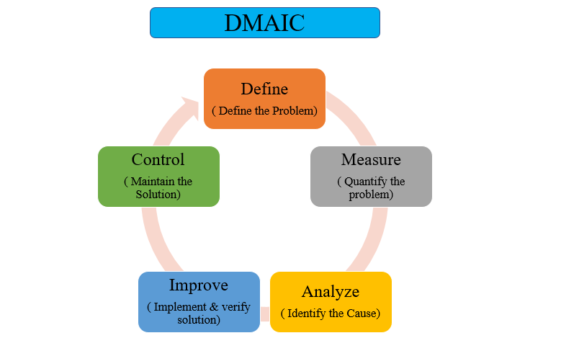
- Define: It identifies the customer specifications, project goals and deliverables.
- Measure: It helps in understanding current performance and establishing the baseline for improvement.
- Analyze: The purpose of analysis id to determine and validate the root causes of any defects.
- Improve: It establish the solution to eliminate defects and correct the process.
- Control: It manages future process performance and controls the existing processes.

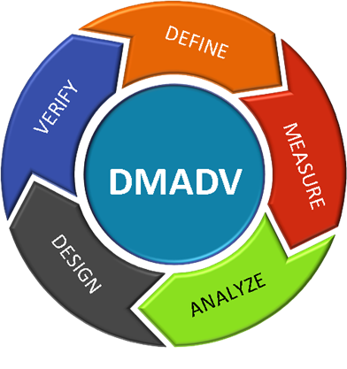
- DMADV (Define, Measure, Analyze, Design, Verify), is an improvement system which deals with designing new products and processes which results in a more predictable, mature, and detect free performance. The primary focus on the development of a new service, product or process as opposed to improving a previously existing one.
- Design: Create a process that meets customer needs and expectations.
- Verify: It involves verifying that the end result must meet the customer requirements.

- Software Reliability

Software reliability is defined in statistical terms as "the probability of failure-free operation of a computer program in a specified environment for a specified time".

Measures of Reliability and Availability:

Most hardware-related reliability models are predicated on failure due to wear rather than failure due to design defects. In hardware, failures due to physical wear (e.g., the effects of temperature, corrosion, shock) are more likely than a design-related failure. Unfortunately, the opposite is true for software. In fact, all software failures can be traced to design or implementation problems; wear does not enter into the picture.

A simple measure of reliability is meantime-between-failure (MTBF), where
MTBF = MTTF + MTTR

The acronyms MTTF and MTTR are mean-time-to-failure and mean-time-to-repair, respectively.

In addition to a reliability measure, we must develop a measure of availability. Software availability is the probability that a program is operating according to requirements at a given point in time and is defined as
Availability = [MTTF/(MTTF + MTTR)] 100%

The MTBF reliability measure is equally sensitive to MTTF and MTTR. The availability measure is somewhat more sensitive to MTTR, an indirect measure of the maintainability of software.

- The ISO 9000 Quality Standards

Quality assurance is a planned and systematic approach necessary to provide a high degree of confidence in the quality of a product. It provides quality assessment of the quality control activities and determines the validity of the data for identifying the quality.
The main function of quality assurance is to define the standards as product standards and process standards.
Quality assurance is a function consisting of auditing and reporting activities which helps in determining the effectiveness of the quality system.
Importance of Standards
● Encapsulation of best practice- avoids repetition of past mistakes.
● They are a framework for quality assurance processes - they involve checking compliance to standards.
● They provide continuity - new staff can understand the organisation by understanding the standards that are used.
Problems with Standards
● They may not be seen as relevant and up-to-date by software engineers.
● They often involve too much bureaucratic form filling.
● If they are unsupported by software tools, tedious manual work is often involved to maintain the documentation associated with the standards.
Standards Development
● Involve practitioners in development. Engineers should understand the rationale underlying a standard.
● Review standards and their usage regularly. Standards will quickly become noncurrent and this reduces their believability amongst practitioners.
● Detailed standards should have associated tool support. Excessive clerical work is that the most important grievance against standards.
ISO 9000: The ISO 9000 quality assurance models. It is an international set of standards for quality management which is applicable to a range of organisations from manufacturing to service industries and treat an enterprise as a network of interconnected processes. ISO 9001 applicable to organisations that design, develop and maintain products.

ISO 9001 is a generic model of the quality process that must be instantiated for each organisation using the standard which describes the elements of a quality assurance system. These elements embrace the structure, procedures, processes, and resources needed to implement quality planning, quality control, quality assurance, and quality improvement.
However, ISO 9000 doesn't describe however a corporation ought to implement these quality system elements.

It is the chance to understand, control, and improve the process network that offers, perhaps, the greatest benefit to organizations that design and implement ISO-compliant quality systems.

ISO 9000 certification Quality standards and procedures should be documented in an organisational quality manual. It helps in creating organizational quality manuals which are used to identify organizational quality processes by satisfying its customers, meet regulatory requirements, and achieve continual improvement.

The requirements diagrammatic by ISO 9001 address topics like management responsibility, quality system, contract review, style management, document and information management, product identification and traceability, method management, examination and testing, corrective and preventive action, management of quality records, internal quality audits, training, servicing, and applied math techniques.

In order for an organization to become registered to ISO 9001, it should establish policies and procedures to deal with every of the wants simply noted and then be able to demonstrate that these policies and procedures are being followed.

- Capability Maturity Model

The Software Engineering Institute (SEI) Capability Maturity Model (CMM) was developed in 1980 as a result of the research done on the method of evaluating the work of subcontractors. It is used to develop and refine an organization's software development process and to measure the maturity of an organization process.

The SEI capability maturity model is derived from the ideas of quality improvement applied to software development. The five-level improvement model is shown in Figure below. The five stages are called maturity levels. Each represents an improvement in the software process. An organization’s software capability can be improved by advancing through these five stages or levels. The CMM helps organizations to select improvement strategies based on current process maturity status and to identify critical issues in quality and process improvement.

The following descriptions outline the primary characteristics of the software process for each level of the CMM.
1. Initial: At the initial level, software process is generally as ad hoc. The organization operates without formal procedures, cost estimates or project plans. There are few mechanisms to ensure that procedures are followed. Tools, if they exist, are not well integrated. Change control is lax or non-existent. Senior management neither hears about nor understands software problems and issues. Success generally depends on the efforts of individuals, not the organization.
2. Repeatable: At the repeatable level, project controls have been established over quality assurance, change control, cost, and schedule. This discipline enables earlier successes to be repeated, though the organization may have problems applying these techniques to new applications.
3. Defined: The defined software process, for both management and engineering activities, is
documented, standardized, and integrated across the organization. The process is visible; that is, it can be examined and improvements suggested.
4. Managed: This level requires that measures of software process and product quality be collected so that process effectiveness can be determined quantitatively. A process database and adequate resources are needed to continually plan, implement, and track process improvements.
5. Optimizing: At the optimizing level, quantitative feedback data from the process allows continuous process improvement. Data gathering has been partially automated. Management has changed its emphasis from product maintenance to process analysis and improvement. Defect cause analysis and defect prevention are the major activities of this level.

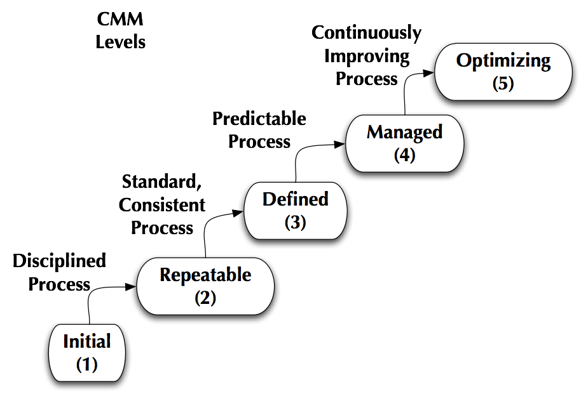
Fig: Levels of CMM

Questions

- Explain the concept of Quality.
- Explain the various elements of Software Quality Assurance.
- Explain SQA Task,Goal and Metrics.
- Define Six Sigma with its methodologies.
- Write a note on software reliability.
- Explain ISO 9000 Quality Standards.
- Explain Capability Maturity Model with diagram.

