3D Models to Voxels Converter with Poly2VoxUI (GUI Version) (AutoHotkey Script)

This tutorial will show you how to use Poly2VoxUI and convert the 3D Models with textures into Poly2Vox, KV6ToSchematic, etc! Make sure you have Autohotkey installed, and Poly2Vox Downloaded if you don’t have the file! Which you can get here!
http://advsys.net/ken/download.htm

Now for the Program, If you are Looking for a Free Program to Export to *.3DS I’d Recommend Blender 2.59 or Earlier! (As Later Versions Removed the *.3DS Export)

So if you have a 3D Model to import to blender from another software, from my case I used *.DAE! And I imported it into blender from the file tab!
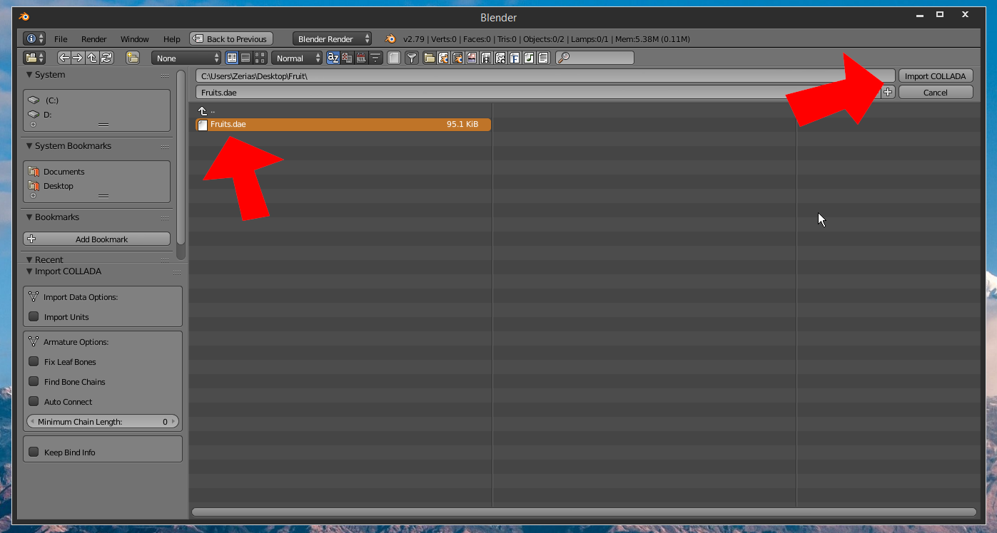
Now that it has been imported to Blender! There will be no texture but the texture should be there, or be able to preview, if there’s no textures either way then you should be able to add your own! And after that you should be able to export to *.3DS from the export option from the file tab!

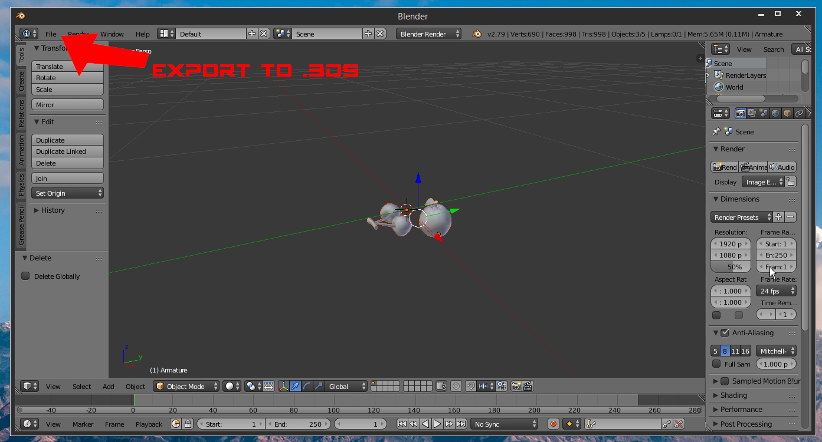
After you export it. You should be able to export it into a ZIP which I do recommend! Make sure the PNG textures as filenames as “8 Characters or Less” otherwise it won’t work with the textures once converted to voxel!
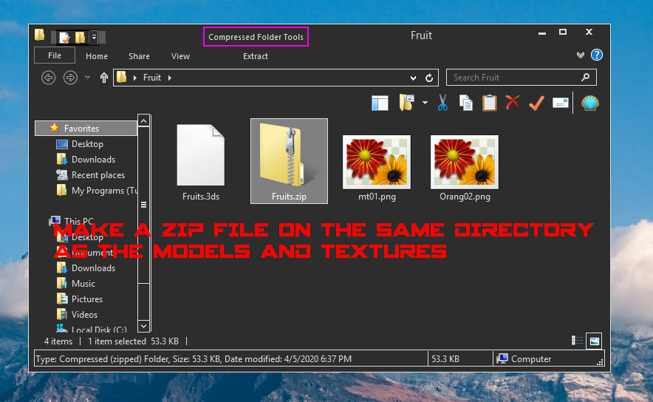
Now you should run Drag the AHK file into Autohotkey! I’d recommend copying the “App, and Poly2VOXUI.ahk” onto the same directory as Autohotkey’s Executable! Otherwise it may not work and you might need to edit the AHK to make it match everything!
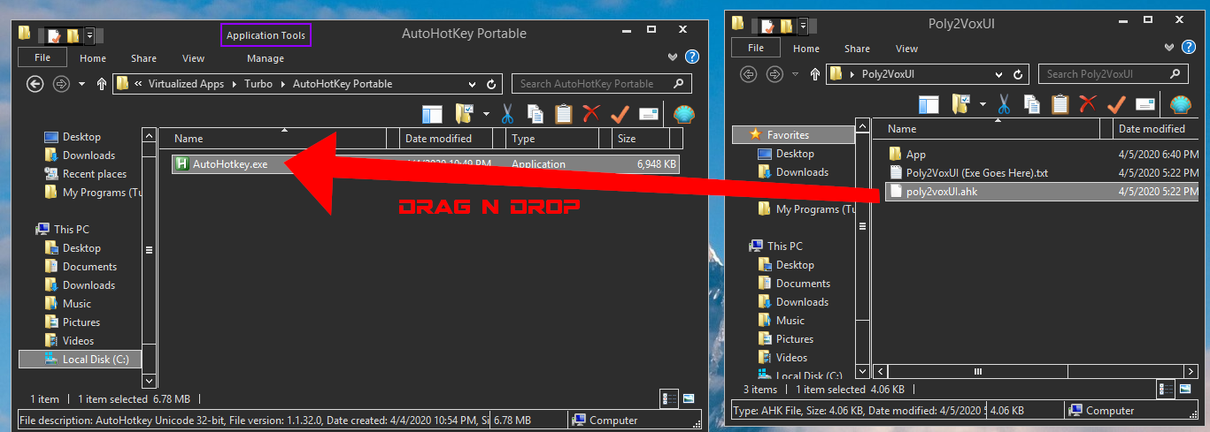
Now it should display Poly2VoxUI Script! Next you should open your new ZIP file!
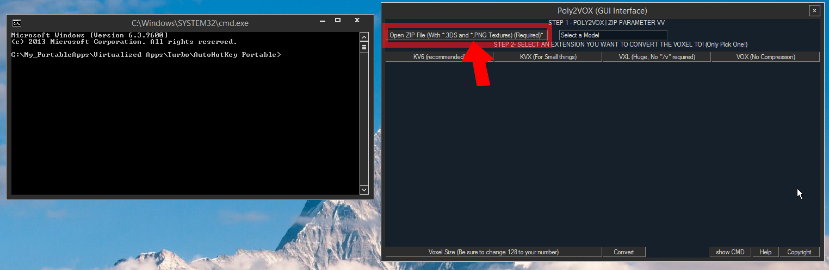
Open it by Clicking it here then click open!
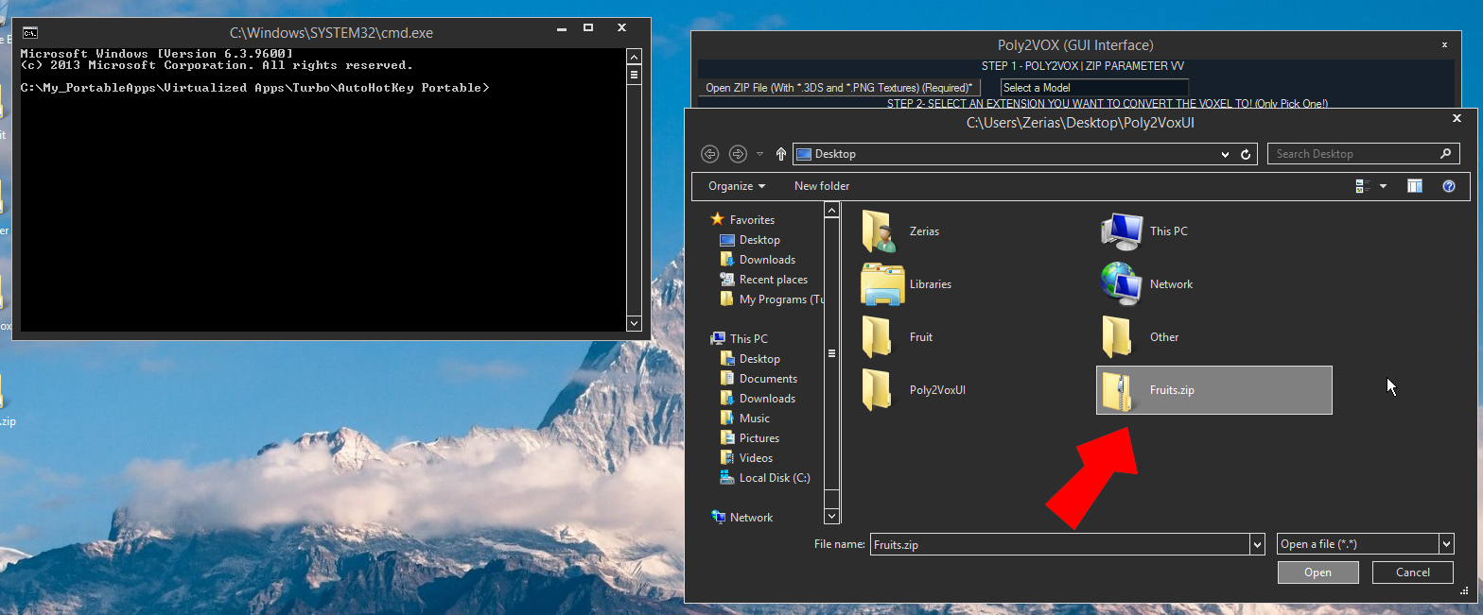
After that, it automatically renames it to a filename that Poly2Vox recognize! Next, you should Click “*.KV6” or other voxel file formats to prepare to convert to a Voxel!
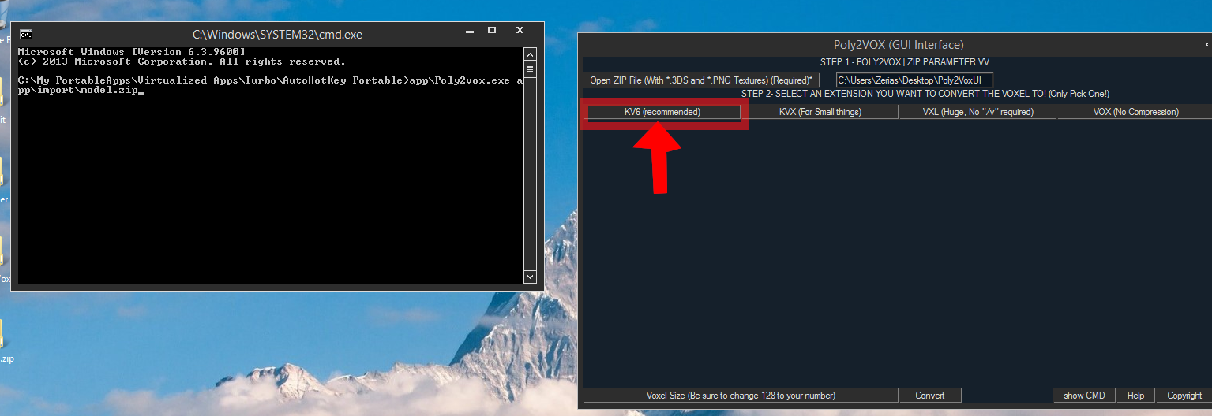
Then click on the Voxel Size. which automatically adds /v128 However you can change the /v128 to /v%numberofyourchoice% “without %numberofyourchoice%”
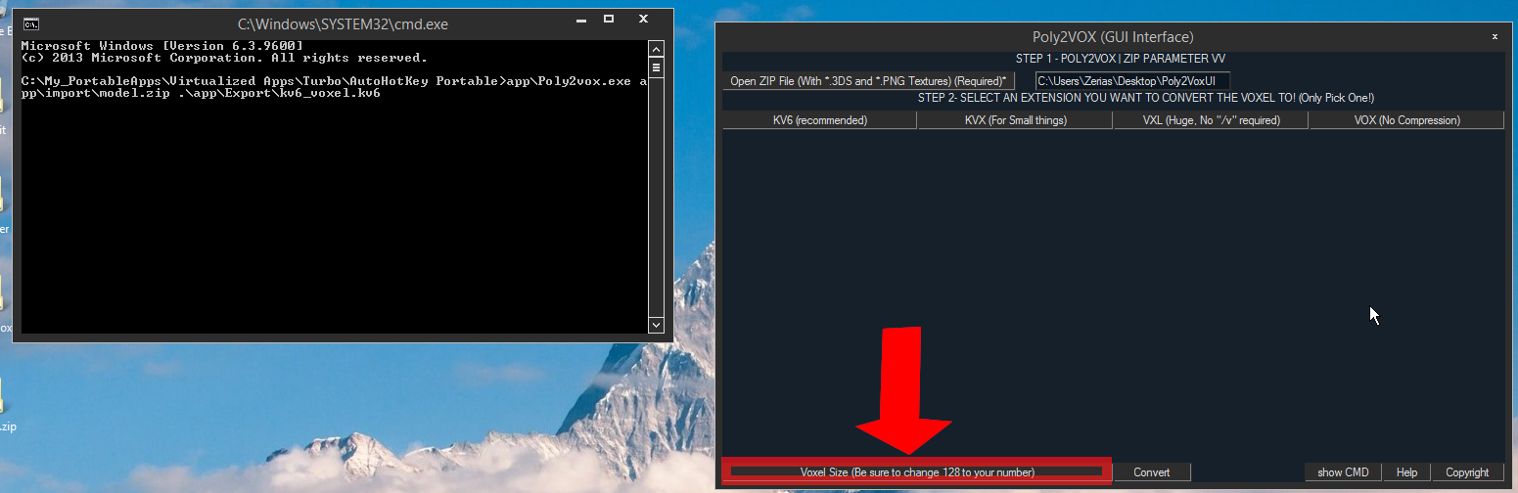
Now hit Convert for the Voxel File!
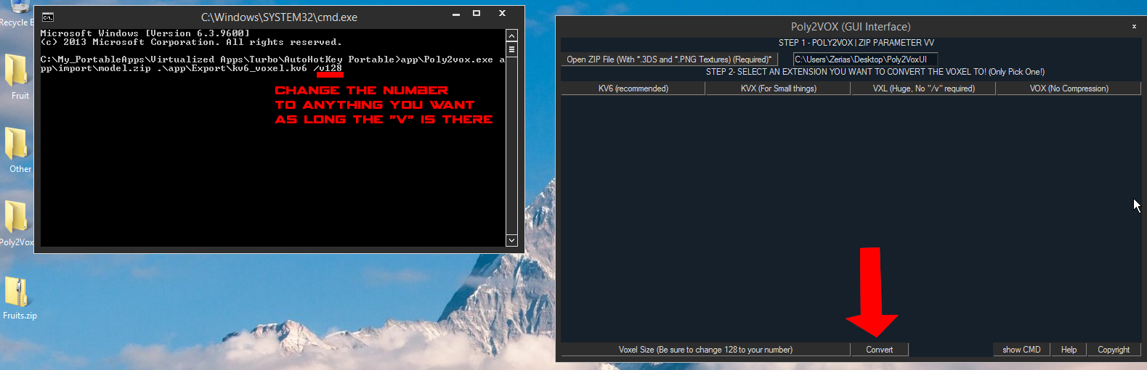
If the PNG and model say Loaded Successfully! Then it worked otherwise, you may get a “NOT FOUND FORMAT” or something like that!

However, if poly2vox isn’t recognized by the command line. Then you will need to move the “App Folder and Poly2voxUI.ahk” on the same directory as the Autohotkey executable is located!
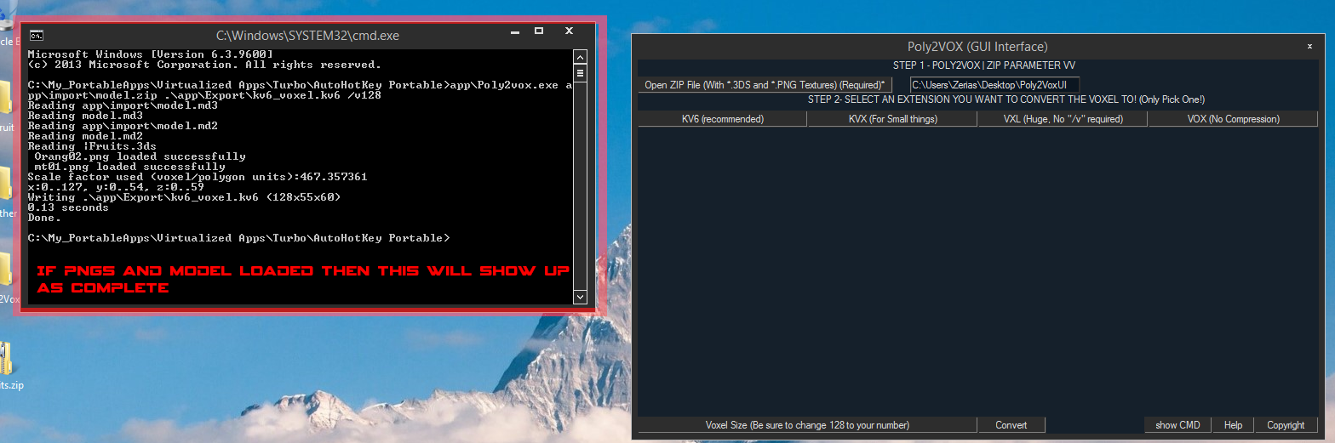
To make sure Everything worked. Use Slab6 to open your Voxel file!
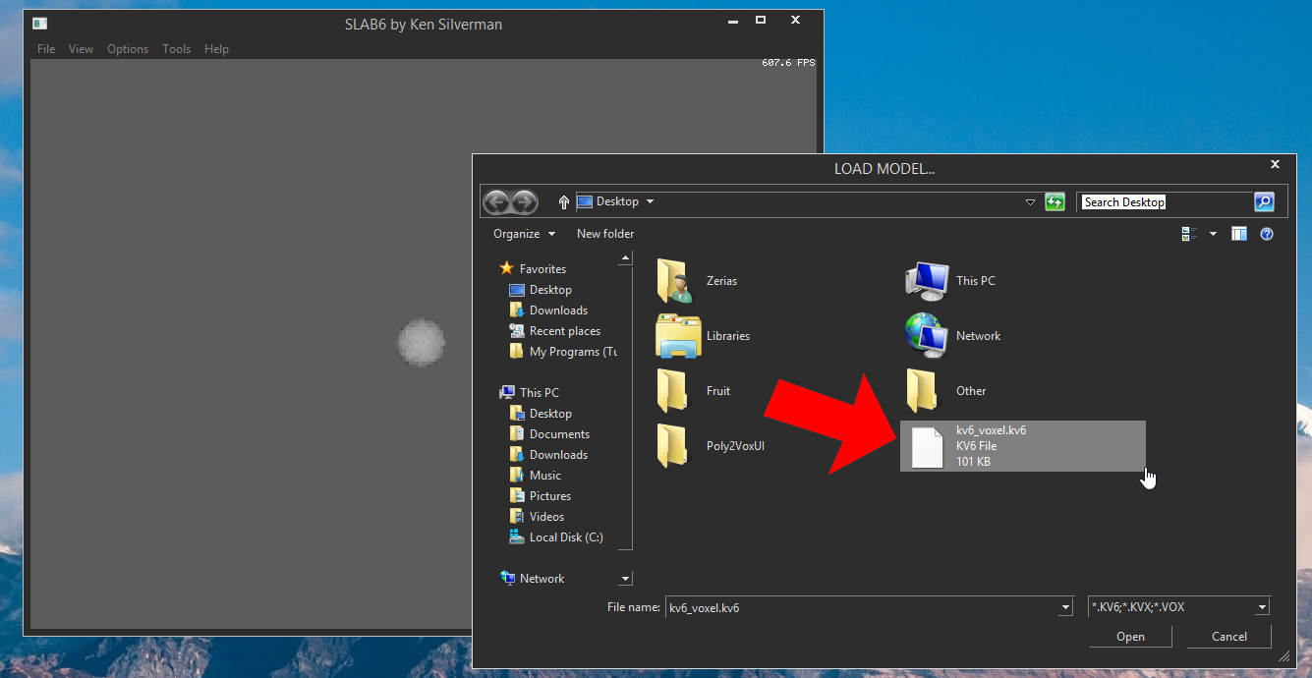
And if it showed correctly as this pic did! Then you’re good!
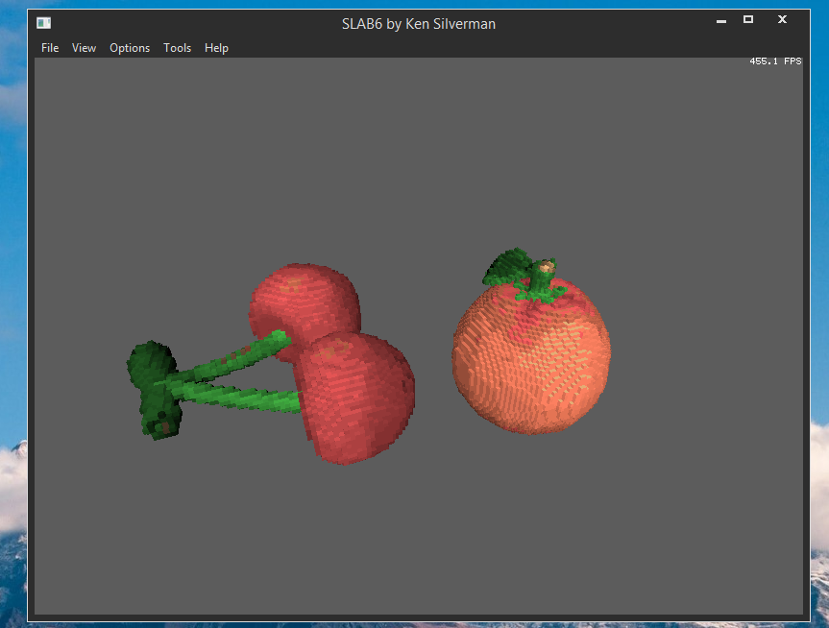
Now you should be able to convert the KV6 Model with a program called “KV6ToSchematic.jar” so you can import it to Minecraft with MCEdit!

Thanks for reading this guide!

Credits
Poly2Vox & Slab6 - Ken Silverman
KV6ToSchematic - Anonym927
Blender - Blender Foundation
Command Line Autohotkey GUI Script - Red Hat Boy from AutoHotKey Forums
Poly2VoxUI (GUI) by CreativeKeviinDrive

