BUILD A EMPLOYEE TRAVEL APPROVAL APPLICATION FOR CORPORATES

1. INTRODUCTION

1.1 OVERVIEW

A travel approval request approval process is a series of actions that an employee or traveler follow to acquire management constant to implement a trip. The travel approval request is essential for every business as easting your employees travelling can accelerate their enthusiasm to carry out their job.

1.2 PURPOSE

This helps gather employee trip details and allows you to reject or approve their travel and reimburse their expenses. Travel request form are designed to give management an overview of the intended business trip from both a cost and a strategic point of view.

2. PROBLEM DEFINITION & DESIGN THINKING

2.1 EMPATHY MAP

2.2 IDEATION & BRAINSTROMING MAP

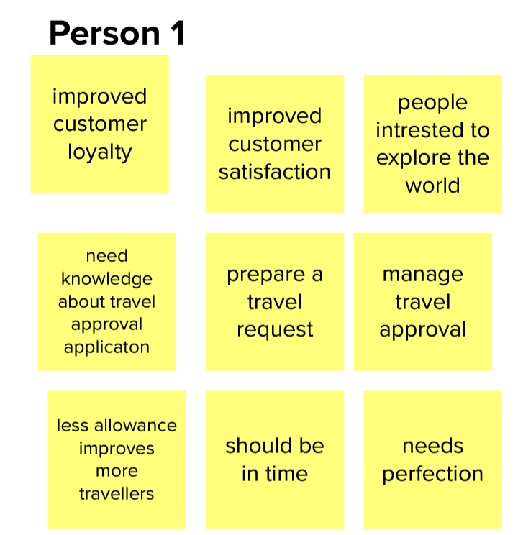

3. RESULT

3.1 DATA MODEL

|  |  |
| --- | --- |
| OBJECT NAME | FIELDS IN THE OBJECT |
| Obj1 | |  |  |  |  | | --- | --- | --- | --- | | FIELD LABEL | DATA TYPE |  |  | | Travel approval name | Text | | | Owner | Text | | |
| Obj2 | FIELD LABEL DATA TYPE   |  |  | | --- | --- | | Department | Text | | Owner | Text | |

3.2 ACTIVITY & SCREENSHOT

4 TRAILHEAD PROFILE PUBLIC URL

TEAMLEADER- <https://trailblazer.me/id/abalaji36zzz>

TEAM MEMBER 1 - <https://trailblazer.me/id/athangarasu>

TEAM MEMBER 2 –https://trailblazer.me/id/anups38

5. ADVANTAGES & DIADVANTAGES

ADVANTAGES

1. Approvals on time. The entire process of planning and managing a trip is a long and stressful process.
2. Increases compliance and reduce costs.
3. Faster process.

DISADVANTAGES

1. It’s another process for everyone to think about. An extra layer of bureaucracy costs time and efficiency.
2. Sometimes it may delay.
3. Prices may vary in the meantime and the number of times the traveller has to rebook.

6.APPLICATIONS

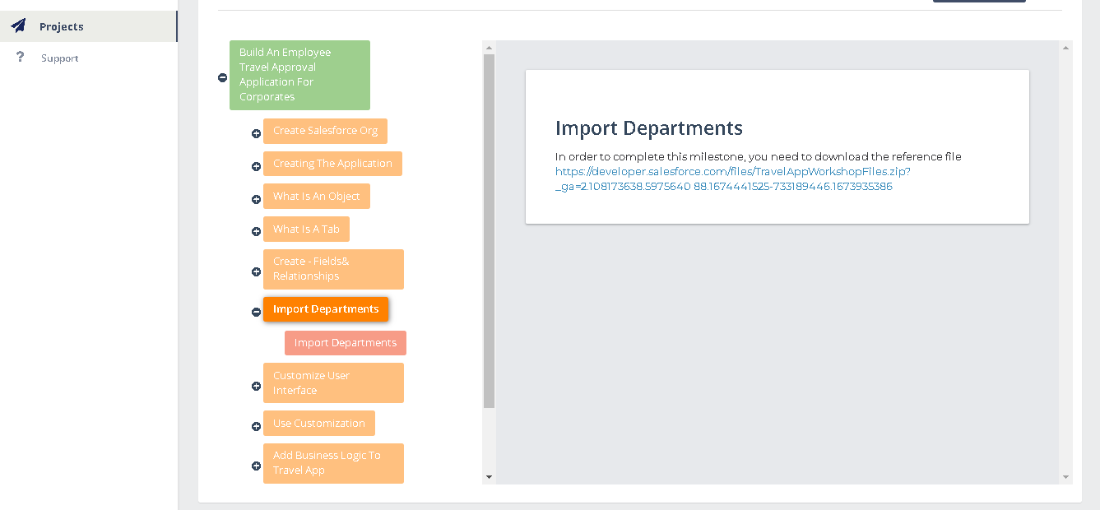

7.CONCLUSION

1. Consult all relevant travel stakeholders.
2. Create an organized travel approval process.
3. Manage things all in one place during the approval process.

8. FUTURE SCOPE

The possibilities and scope for the application of machine learning in travel are endless.

­­