1. Download and Install Arduino IDE From Internet.
2. Go to Files preferences and add the below URL.

https://dl.espressif.com/dl/package_esp32_index.json

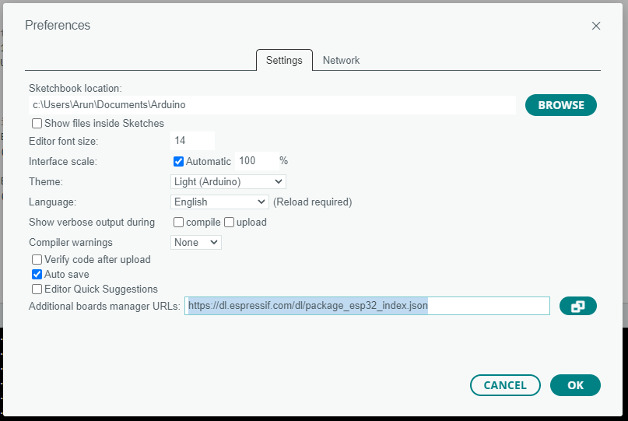

1. Open the Boards Manager. You can go to **Tools**> **Board**> **Boards Manager and search Esp32 and install esp32 by Espresssif Systems.**

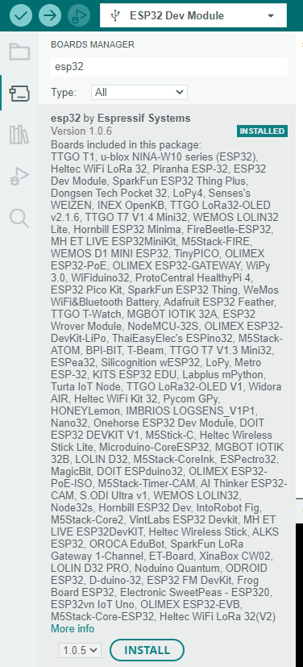

1. Then run the below code and test the Module.
   1. /*********
   2. Rui Santos
   3. Complete project details at https://RandomNerdTutorials.com/vs-code-platformio-ide-esp32-esp8266-arduino/
   4. *********/
   5. #include <Arduino.h>
   6. #define LED 2
   7. void setup() {
   8. // put your setup code here, to run once:
   9. Serial.begin(115200);
   10. pinMode(LED, OUTPUT);
   11. }
   12. void loop() {
   13. // put your main code here, to run repeatedly:
   14. digitalWrite(LED, HIGH);
   15. Serial.println("LED is on");
   16. delay(1000);
   17. digitalWrite(LED, LOW);
   18. Serial.println("LED is off");
   19. delay(1000);
   20. }
2. Select the Board Type and COM port to flash the bin file.

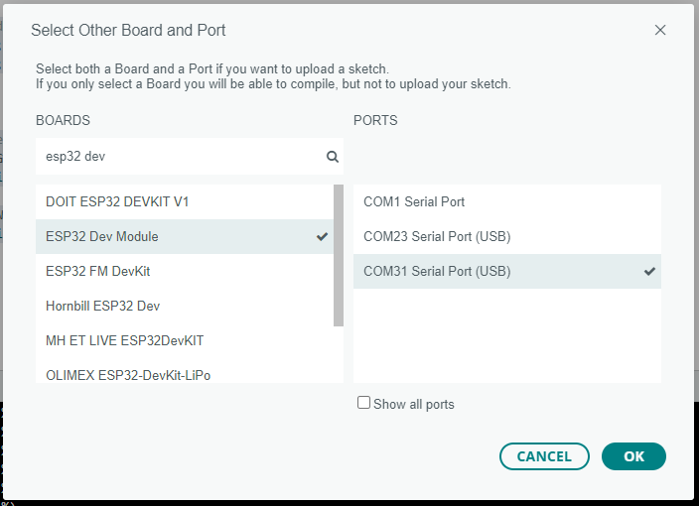

1. Then click on Run Button.

