**QUECTEL EC25 KERNEL FLASHING PROCEDURE**

Step 1: Copy Paste the “QFlash_V5.2_EN” folder in your PC.

Step 2: Goto QFlash_V5.2_EN->Release

Step 3: Run “QFlash_V5.2.exe”

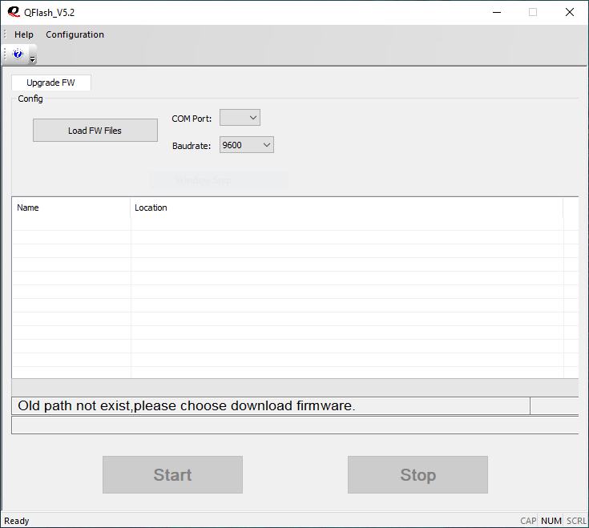

QFlash_V5.2.exe

Step 4 : In “QFlash_V5.2.exe” click “Load FW Files” Button

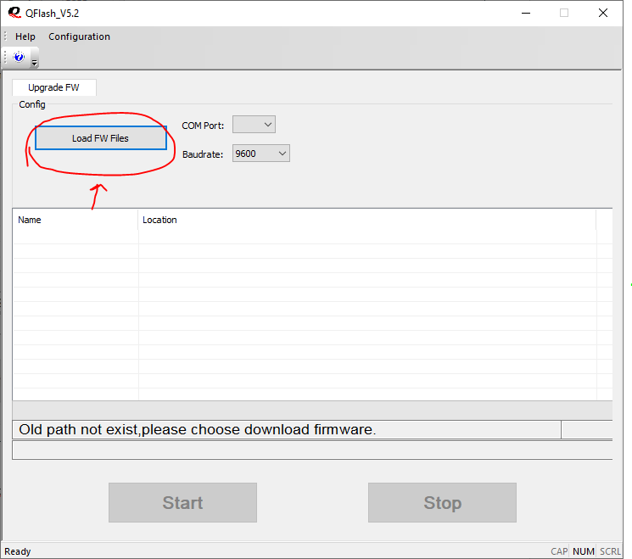

Step 5 : After clicking “Load FW Files” Button. Goto the Kernel files folder in your PC.

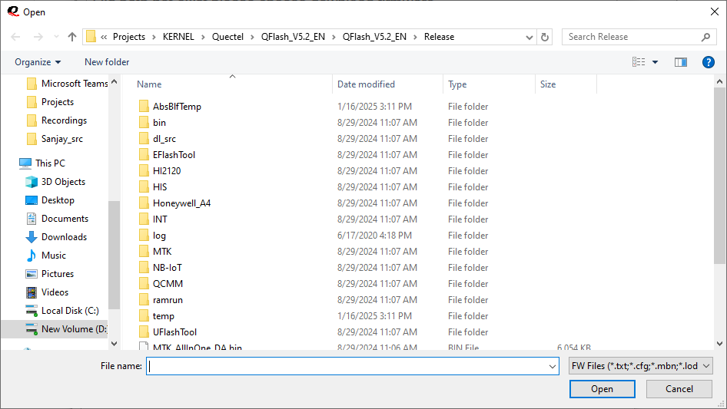

Step 6 : Click “appsboot.mbn”

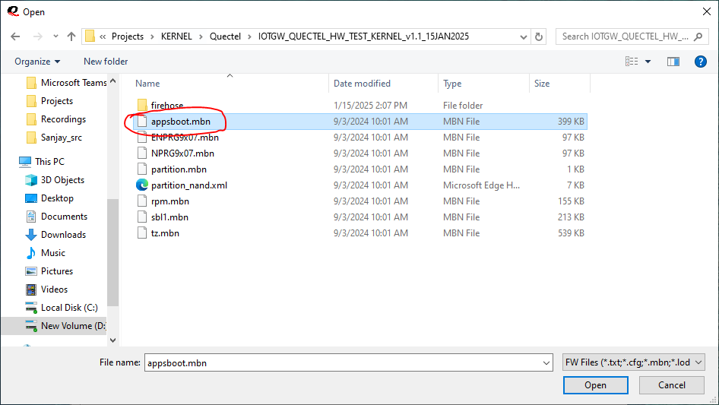

Step 7 : Click “Open”

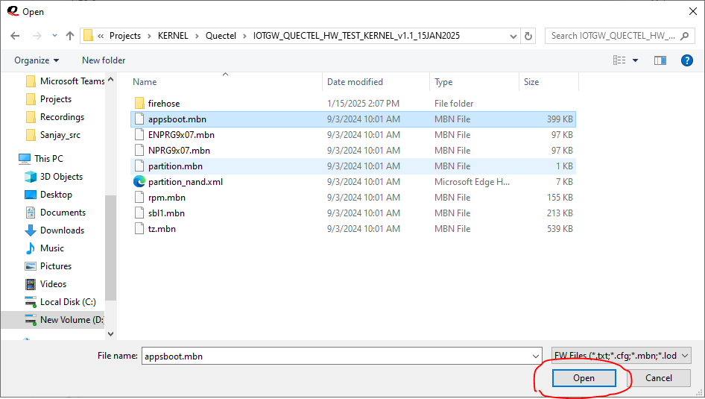

Step 8 : Click “Configuration” and select “Sahara only”

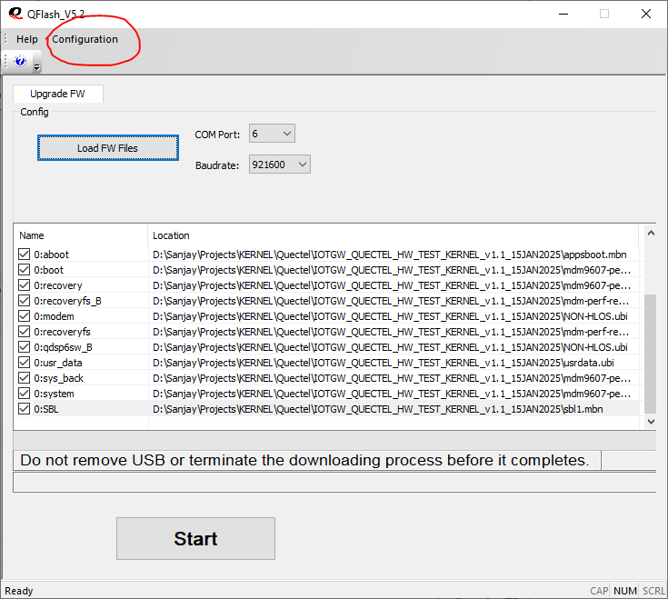

Step 9 : Set your COM Port number and Baudrate

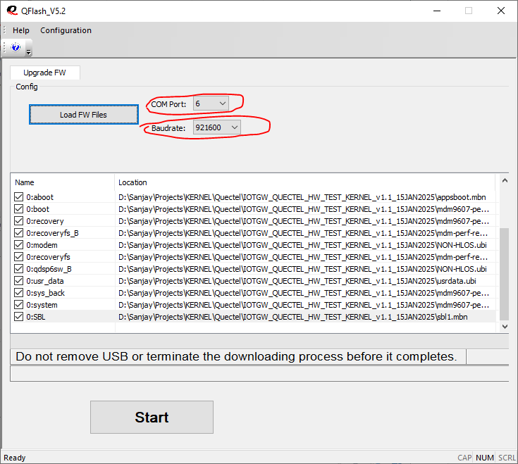

Step 10 : Click “Start”

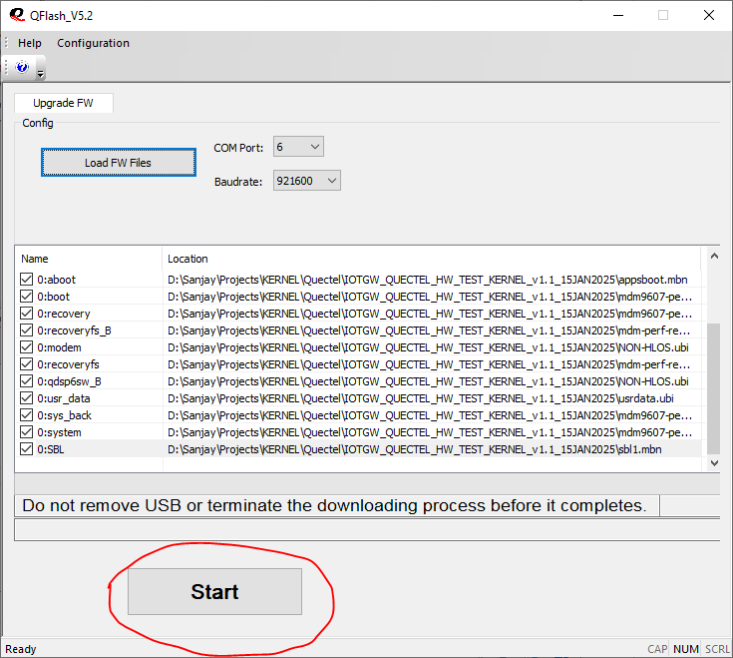

Step 11: Kernel Uploading will start

