FLASHING STEPS TO BE FOLLOWED

STEP 1 :

Click THE FLASH_LOADER_DEMO[flash_loader_demo_v2.8.0.exe] and install it and then make sure the card to be flashed is in boot mode.

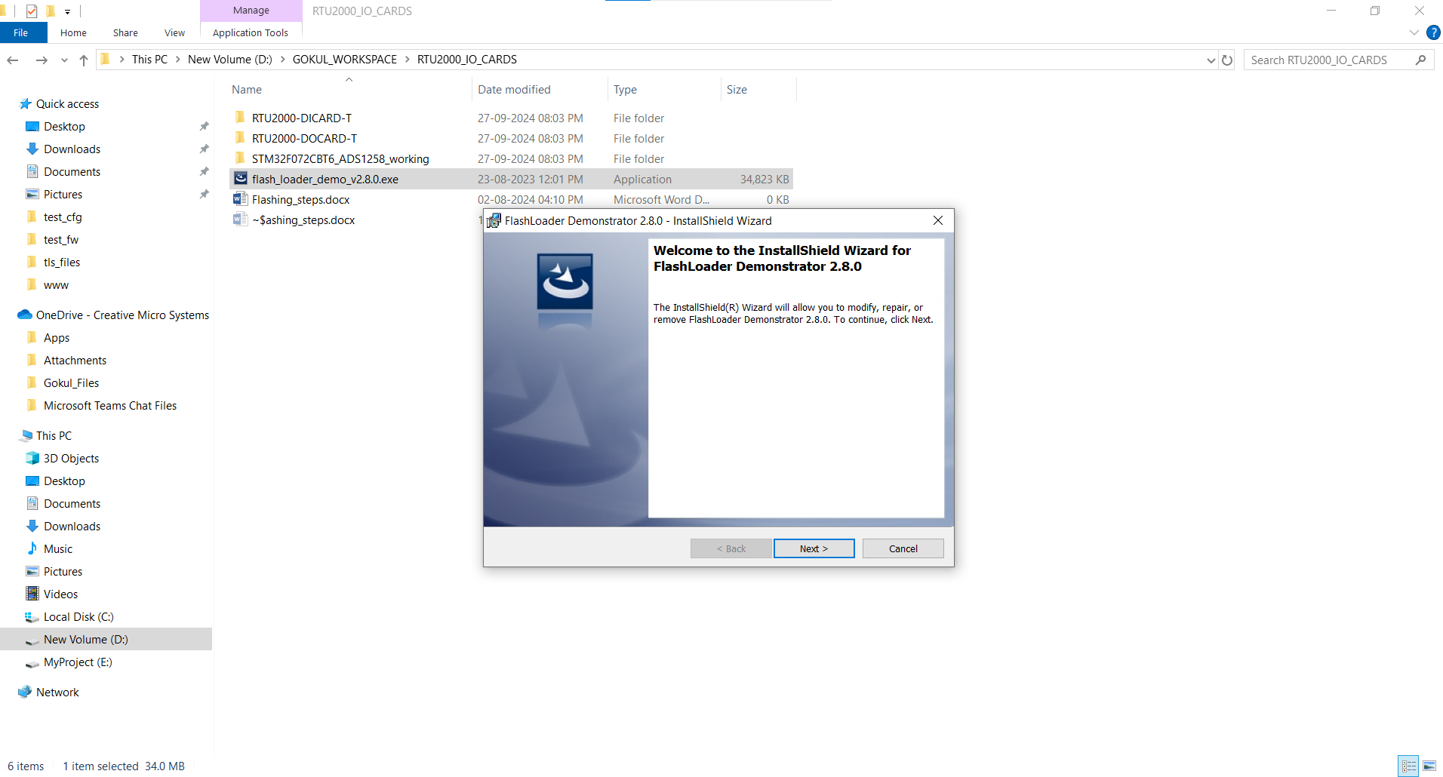

Figure 1

STEP 2:

After installing [flash_loader_demo_v2.8.0.exe] , now click and open the Demonstrator GUI.

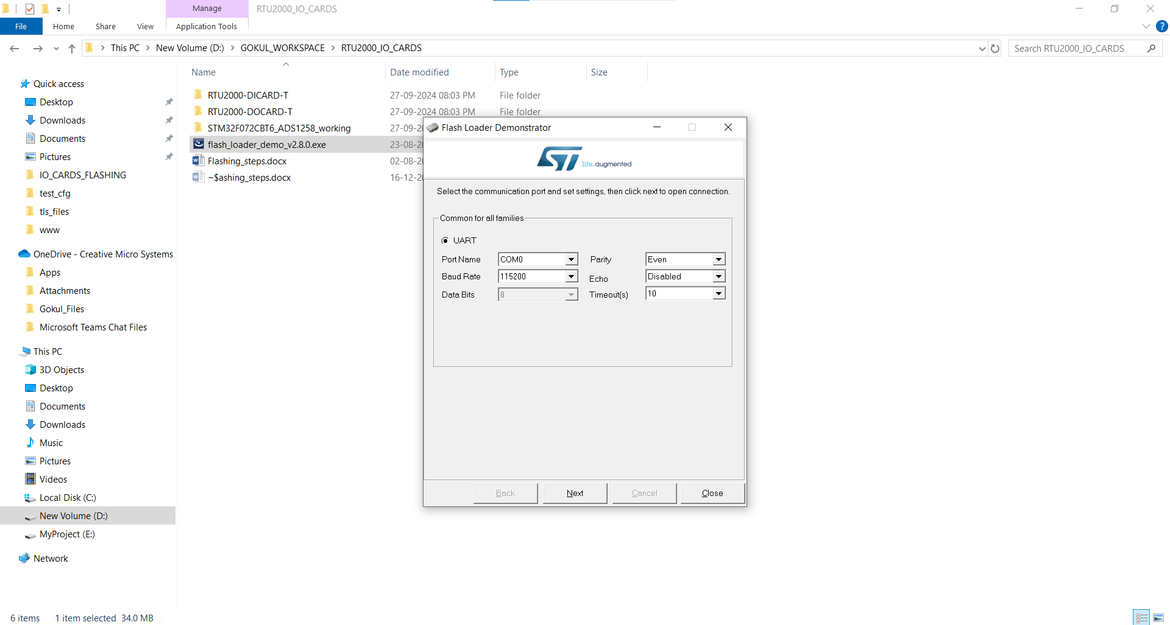

Figure 2

STEP 3:

Set the com port, baud rate and the other parameters as shown in the image below.

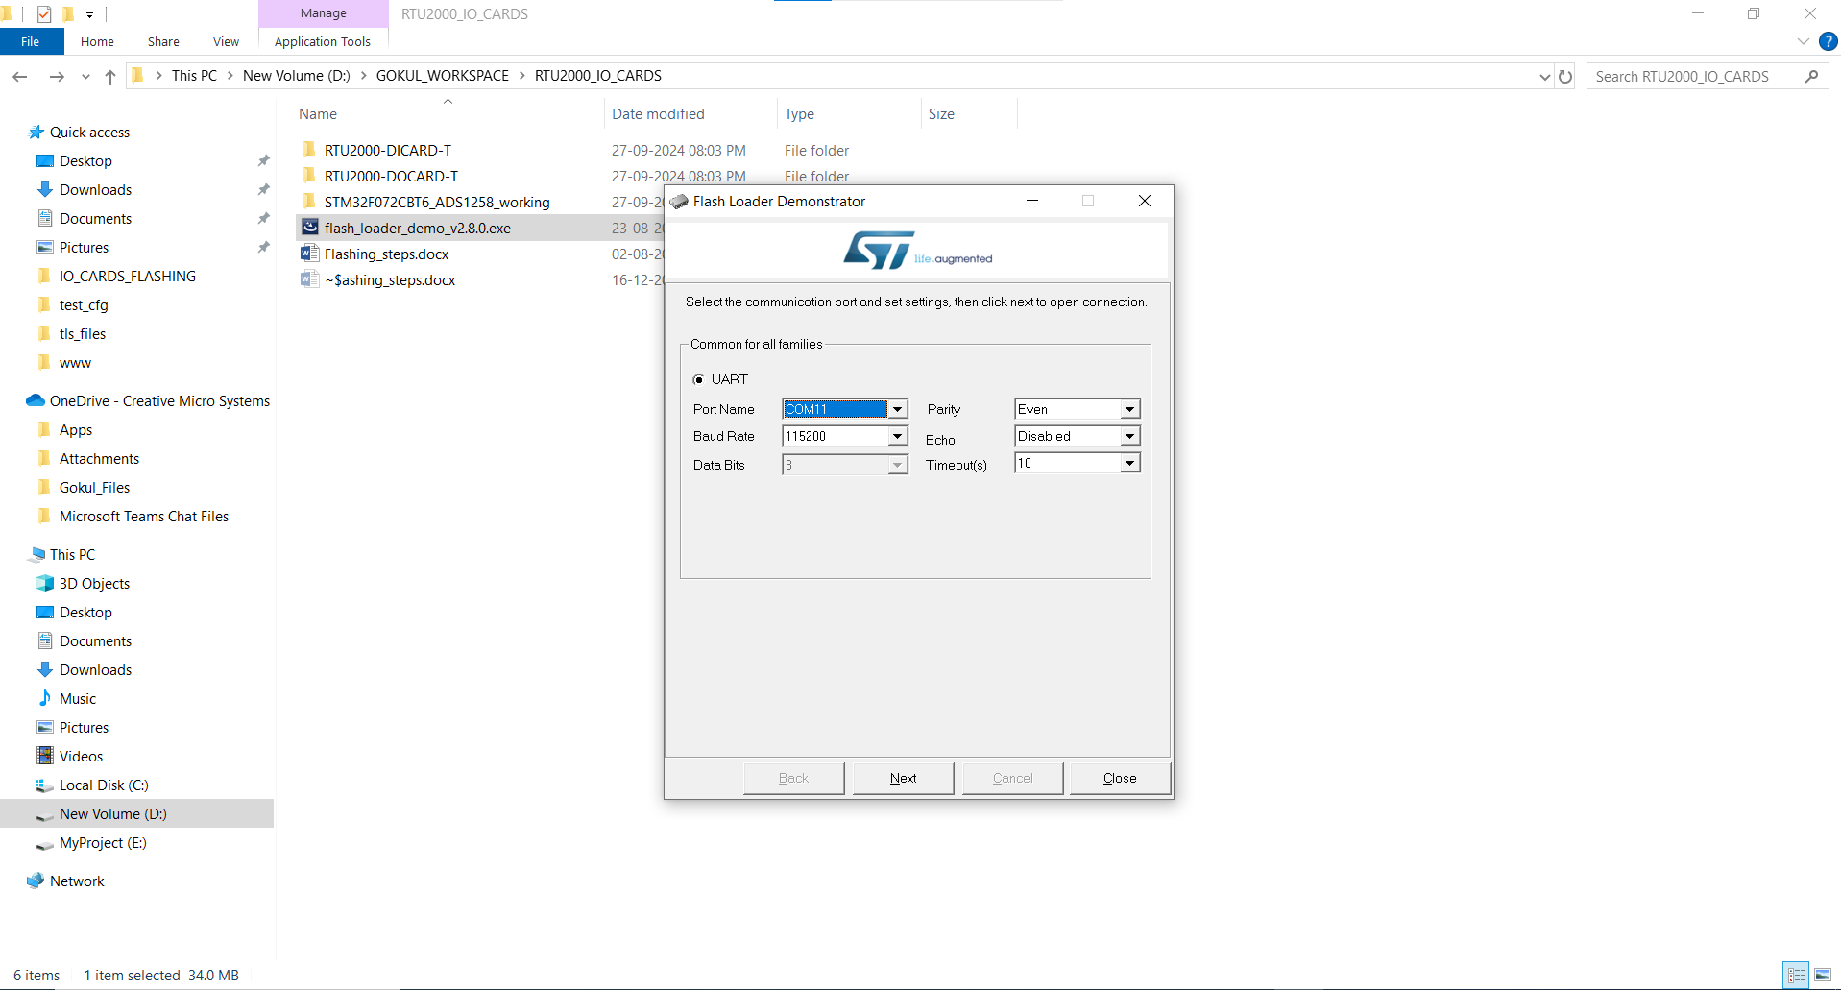

Figure 3

STEP 4:

Before clicking the next button, ensure that the card is in boot mode.

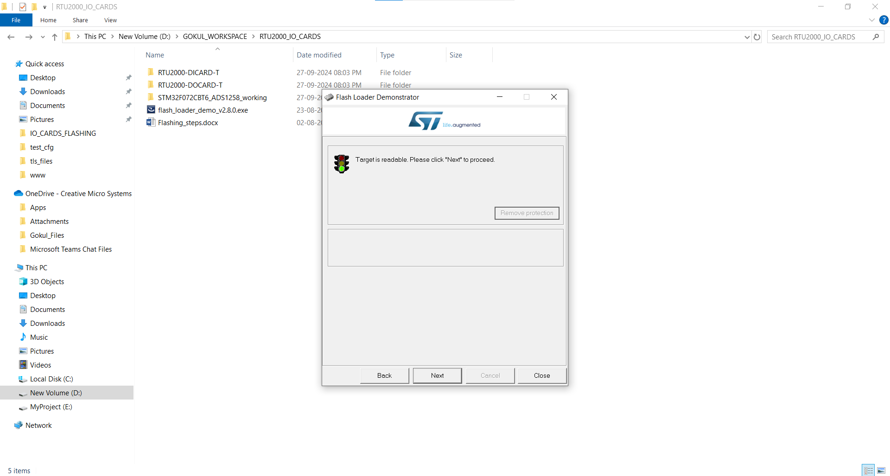

Figure 4

Click the next button

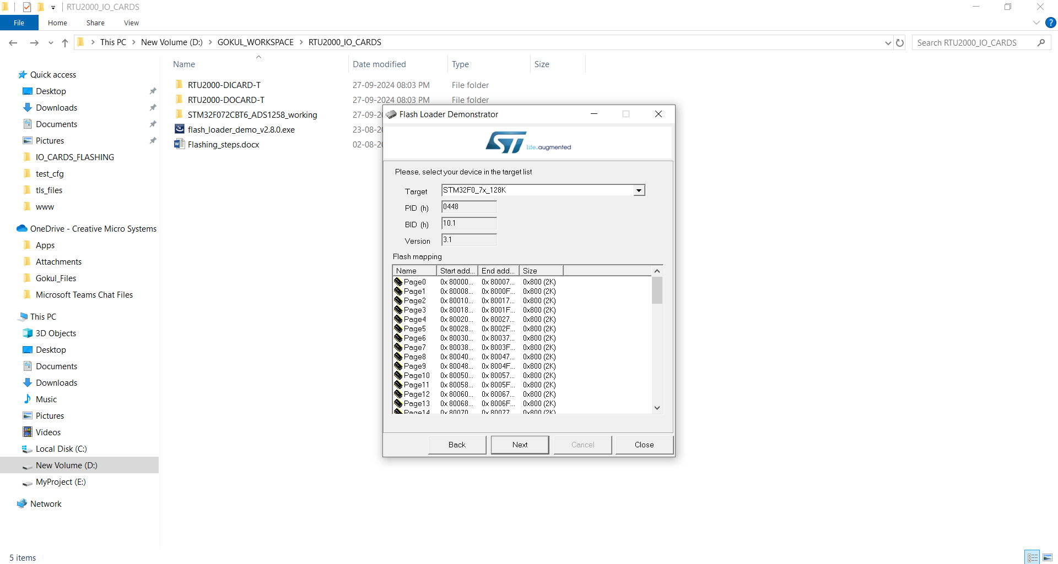

Figure 5

STEP 5:

After clicking the next button shown in the above image, then choose [ Download to device] option .

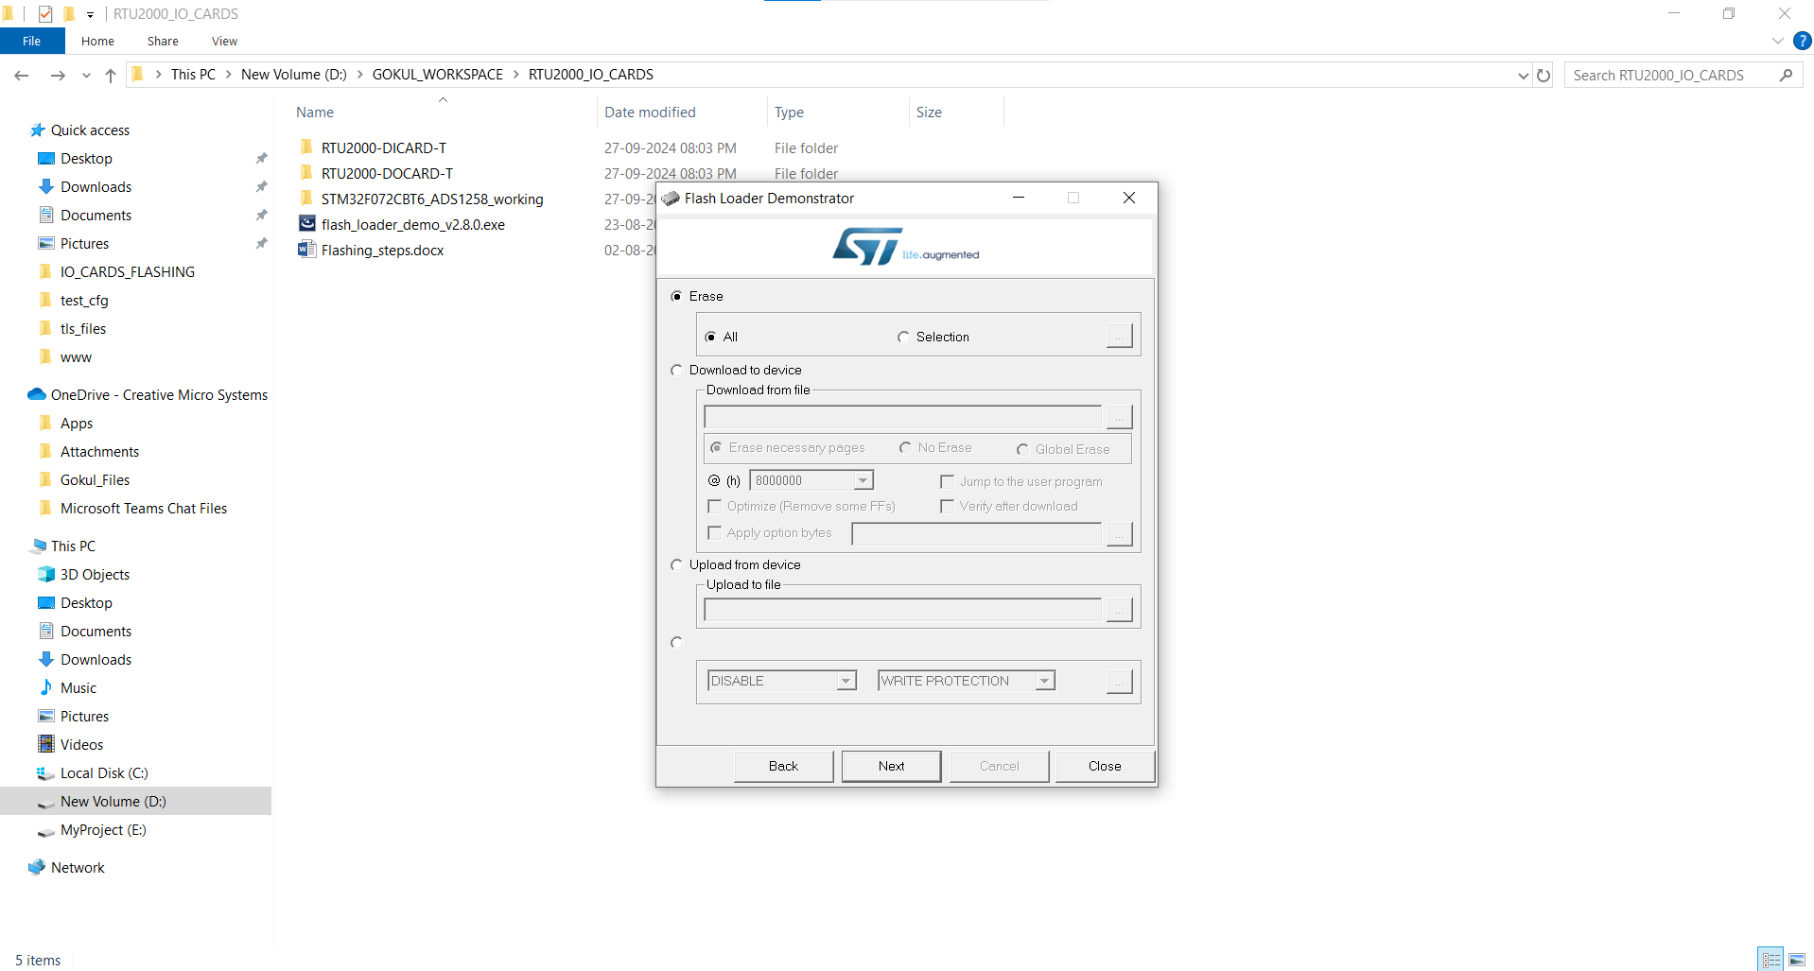

Figure 6

Select the appropriate bin file .

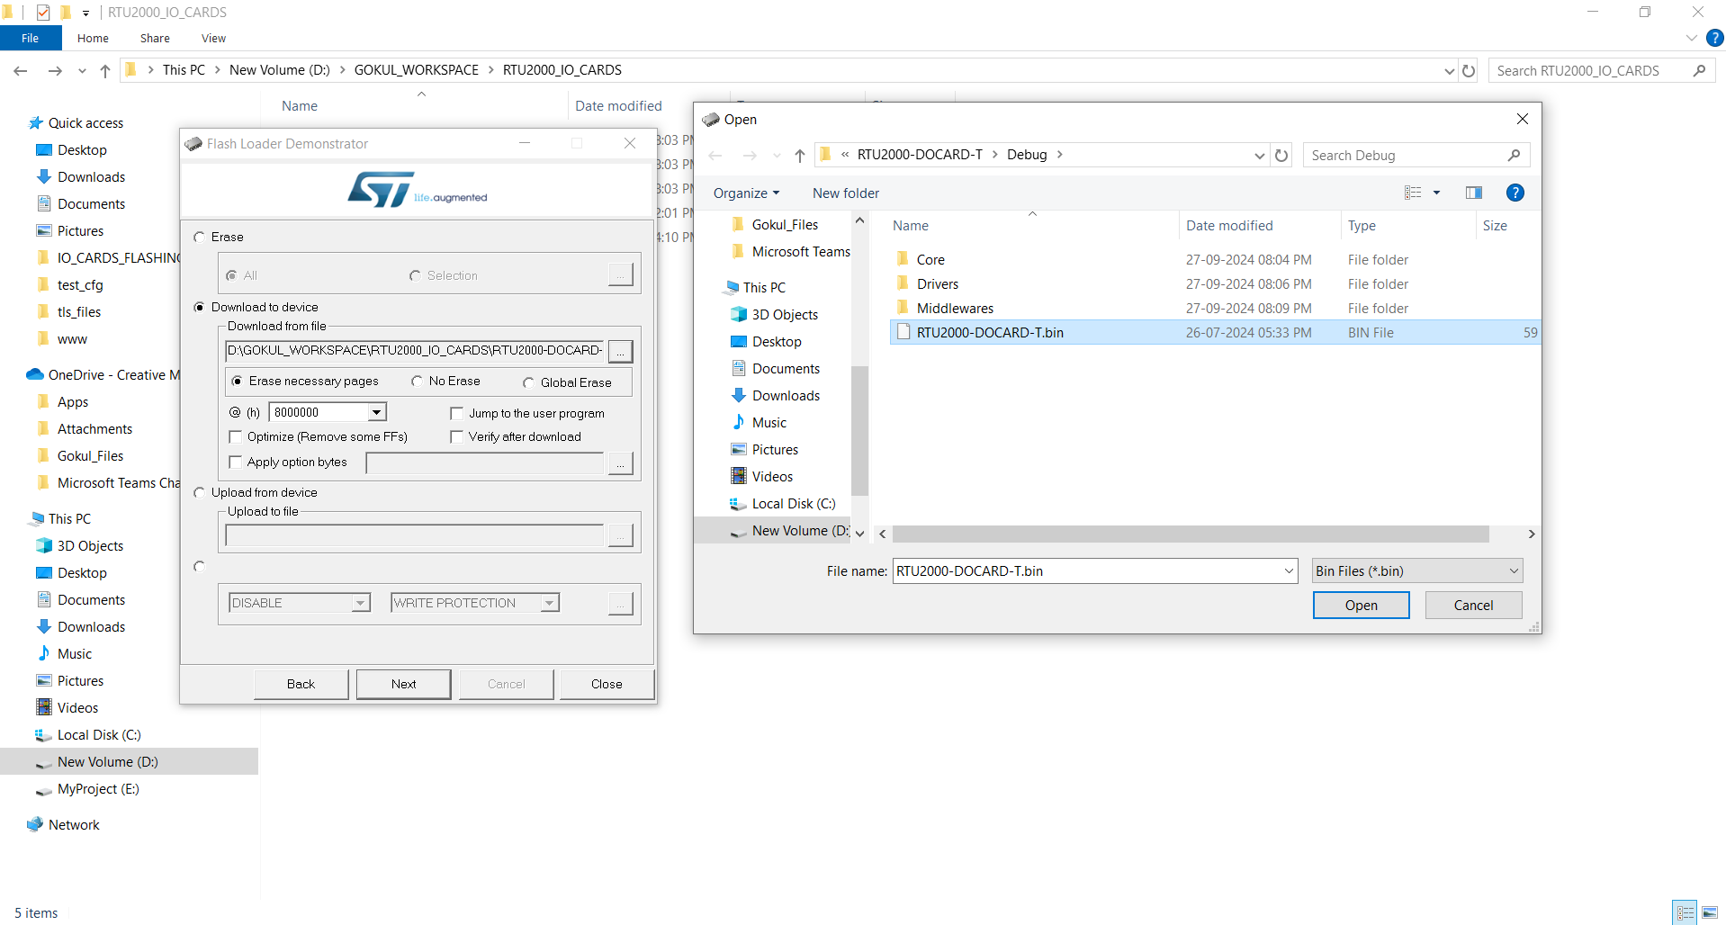

Figure 7

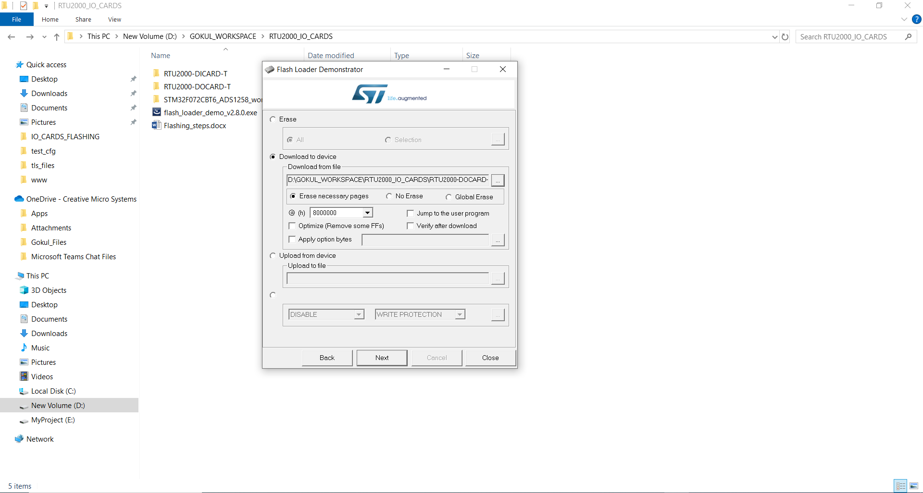

Figure 8

STEP 6:

Click next button to complete the process.

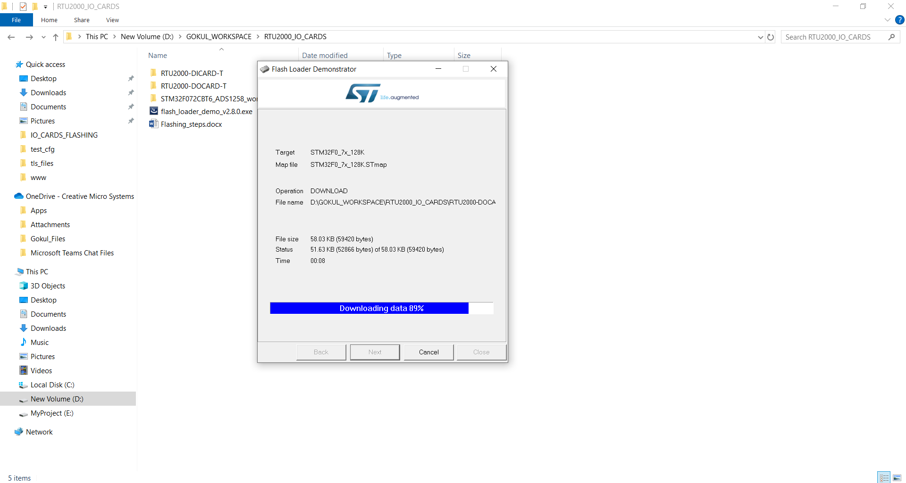

Figure 9

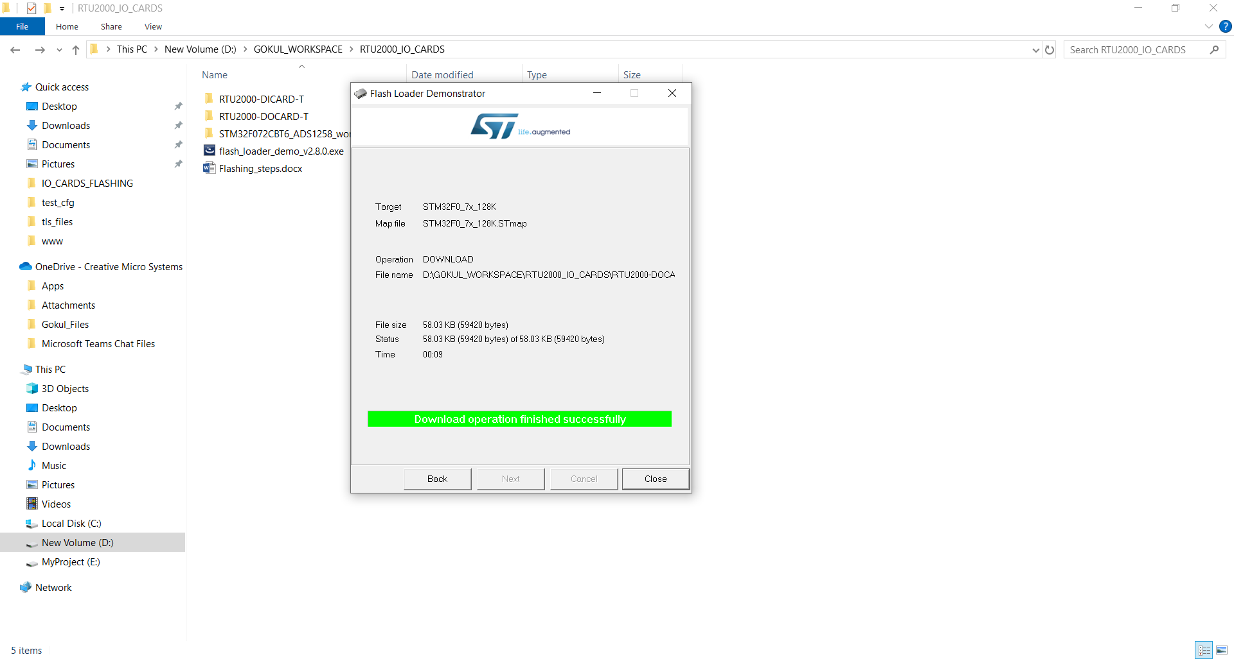

Figure 10