Assignment 1

Code:

public class Student {

    private String studentName;

    private String collegeName;

    private int studentID;

    public static void main(String[] args) {

        System.out.println("Successful");

    }

}

Output:

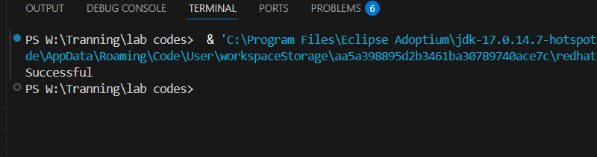

Assignment 2

Error getting:

public class Employee {

    protected int id;

    protected int age;

    protected String name;

    protected boolean isPermanent;

    public static void main(String[] args) {

        Employee emp = new Employee();

        emp.age = 35.5;

        emp.age = (int) 35.5;

        System.out.println("Successfully started");

    }

}

Output:



Error Solved :

public class Employee {

    protected int id;

    protected int age;

    protected String name;

    protected boolean isPermanent;

    public static void main(String[] args) {

        Employee emp = new Employee();

        // emp.age = 35.5;

        emp.age = (int) 35.5;

        System.out.println("Successfully started");

    }

}

Output:

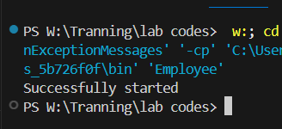

Assignment 03

Code:

package com.anudip.learning;

public class Person {

    String name="Piyush Bhadade";

    int age=19;

    int salary=100000;

    public static void main(String[] args) {

        System.out.println("test successul");

    }

}

Output:

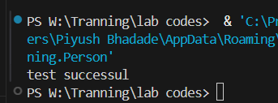

Path change Error:

