Diskvert
Storage Devices

04th December 2025

PREPARED BY

M.Talha

S.no | Student id | Name | Email
1 | 1670774 | Mr .Talha | Mrtalha511@gmail.com
2 |  | Fareha
3 |  | Ghazanfer Shezad


Table of Contents
04th December 2025
PREPARED BY 1
Talha 1
4
Background and Necessity for the Website 4
Storage devices, such as HDDs, SSDs, and external drives, are critical components in modern computing. Users frequently require clear, reliable, and comparative information to make informed decisions about their storage needs. Traditional sources often lack comprehensive, up-to-date, and easily navigable comparisons.. 4
Proposed Solution (Project Name: StorageFlex - Assuming a name) 4
Purpose of the Document 4
Scope of the Project 5
Constraints 5
Future Scope 6

Background and Necessity for the Website

Storage devices, such as HDDs, SSDs, and external drives, are critical components in modern computing. Users frequently require clear, reliable, and comparative information to make informed decisions about their storage needs. Traditional sources often lack comprehensive, up-to-date, and easily navigable comparisons.

The necessity for this simple static web application stems from the need to offer an organized, easily accessible, and informative resource dedicated solely to different types of storage devices.

Proposed Solution

The proposed solution, DiskVert, is a basic, static web information hub focusing on Storage Devices. The application aims to provide a clear and structured overview of various storage technologies, their specifications, and buying options.

Purpose of the Document

The purpose of this document is to outline the structure and non-functional requirements for the development of the Storage Devices web application.

Scope of the Project
The scope of this project is to develop a static, responsive web application consisting of 7 distinct pages: Home, Product, Compare, Support, Where to Buy, About, and Contact Us.
The application will feature content related to storage devices, including product information, comparisons, and links to purchasing locations.
Out of Scope:
Dynamic Functionality: Since the website is built entirely on HTML and CSS, any dynamic features like user registration, login, databases, forms processing, or search functionality are beyond the scope of this project.
E-commerce/Transactions: No payment, ordering, or delivery functionality will be implemented.

Constraints
The DiskVert website must adhere to the following constraints:
Technology Constraint: The entire application must be built using only HTML and CSS (Static Content).
Compatibility: The application must be compatible with major web browsers (e.g., Chrome, Firefox, Safari, and Edge).
Responsiveness: It must be fully responsive, ensuring a seamless user experience on both desktop and mobile devices.

SCREENSHOTS
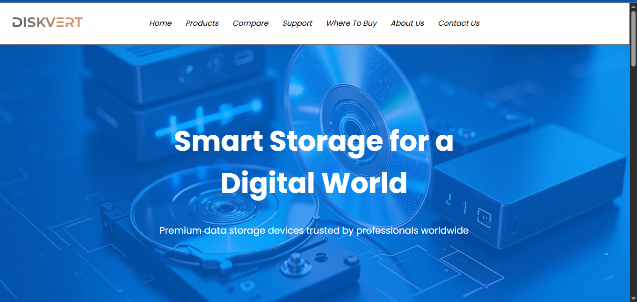

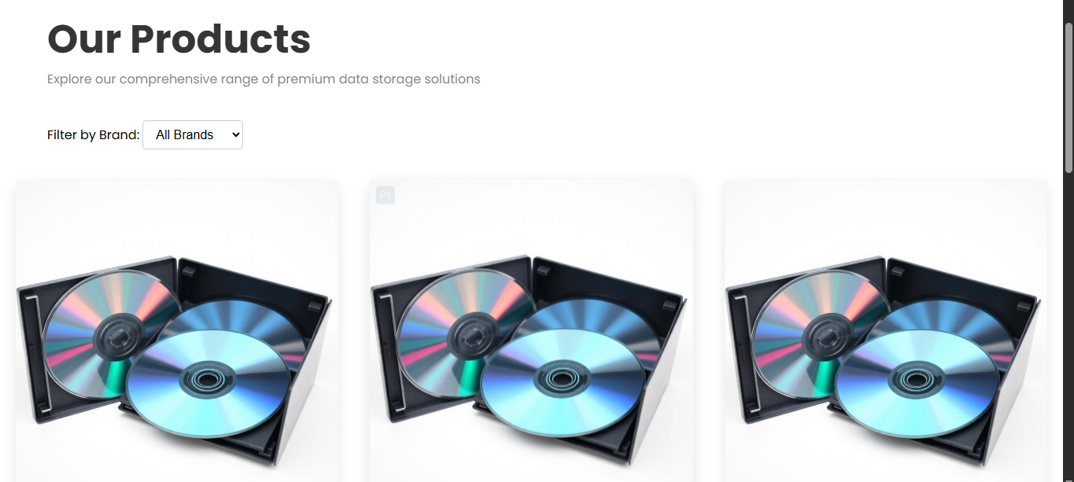

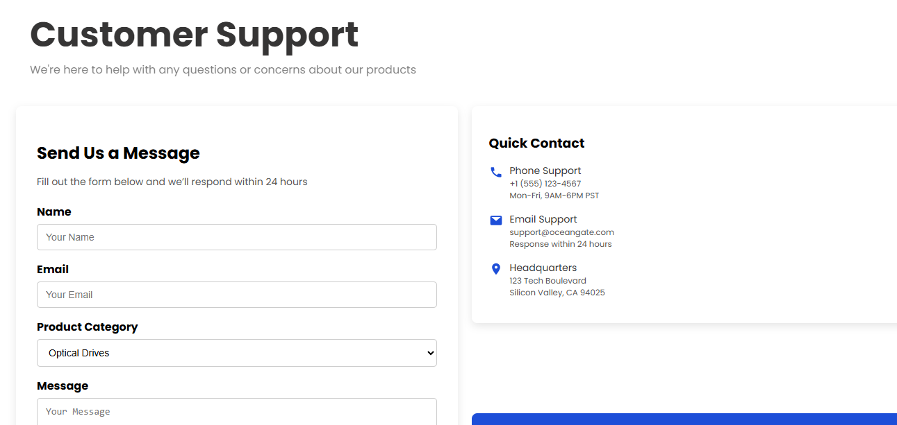

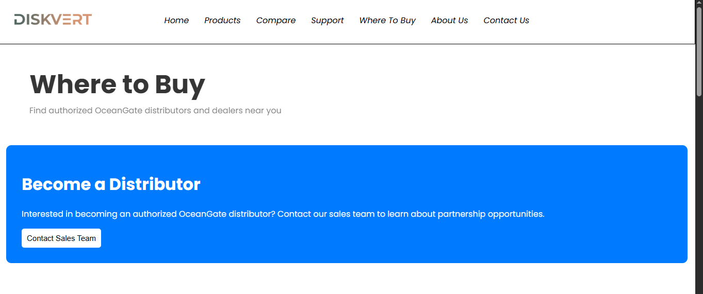

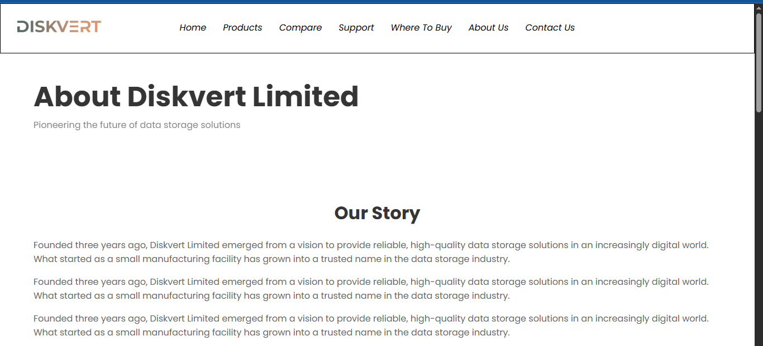

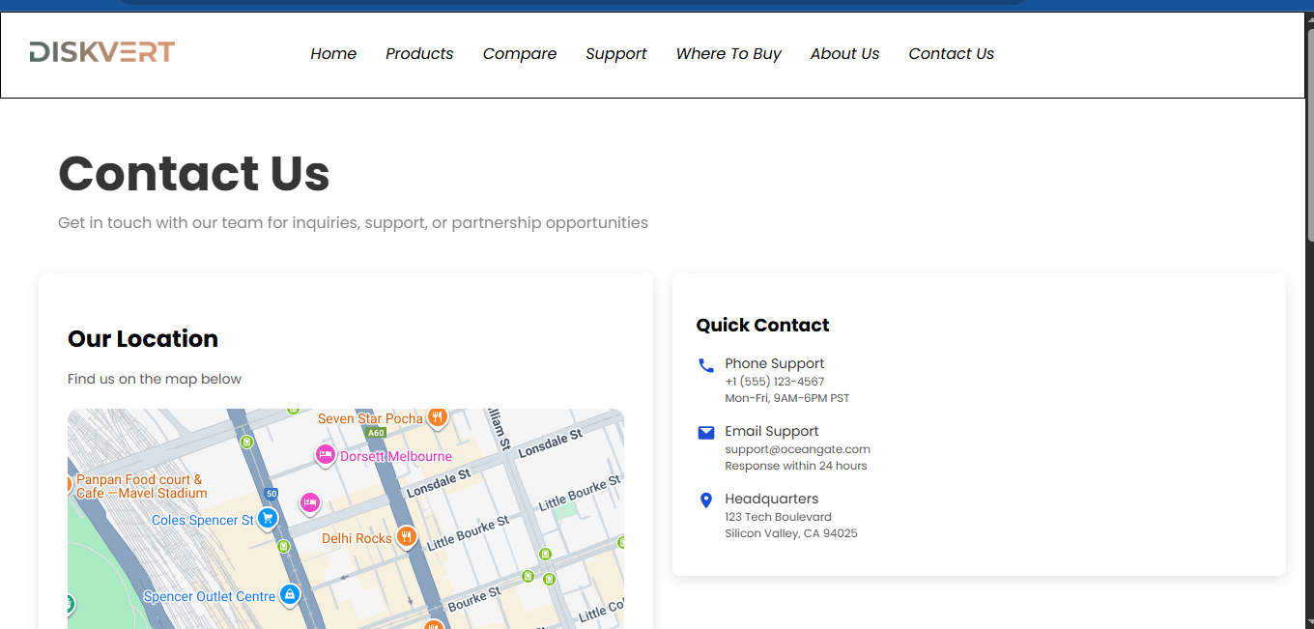

Thank you

