 | Patuakhali Science and Technology University  Faculty of Computer Science and Engineering

CIT 320 :: Software Development Project-II
Project Report

Project Title : ProshnoBank
Submission Date : June 2026

Submitted By,  Hridoy Chandra Sarker  ID : 2102019,  Reg : 10146,  Semester : 5  (Level-3, Semester-2) | Submitted To,  1. Md Mahbubur Rahman  Associate Professor,  Department of Computer Science and Information Technology,  Patuakhali Science and Technology University.  2. Md Atikqur Rahaman  Professor,  Department of Computer Science and Information Technology,  Patuakhali Science and Technology University.

Contents
1. Abstract | 3
2. Objectives | 3
3. Problem Statement | 3
4. Related Work | 3
4.1 Scope | 4
5. Key Features | 4
6. Methodology | 5
6.1. Technology Stack | 5
6.2. Design Principles | 5
6.4 Database Design | 5-6
7. Visual Models | 6
7.1. ERD (Entity Relationship Diagram) | 6
7.2. System Architecture Diagram | 7
7.3. Timeline (Gantt Chart) | 7
8. B2B & B2C Model | 8-9
9. UI Mockups | 9-12
10. Future Plans | 12
11. Conclution | 12
12. References | 12
13. Weekly Report | 13

1. Abstract
ProshnoBank (প্রশ্নব্যাংক) is a comprehensive, all-in-one online examination and learning platform built specifically for Bangladeshi students and educators. The platform provides a unified environment where students preparing for SSC, HSC, university admission, and job examinations can practice with unlimited tests, enroll in structured batches, resolve academic doubts, and track their performance through detailed analytics. Simultaneously, teachers and coaching centers can create and upload questions, conduct live and scheduled exams, manage students, run batch programs, and share exam links — all through a subscription-based model without needing a separate platform.

Built on a modern technology stack with React (Next.js), Supabase (PostgreSQL), and deployed on Vercel, ProshnoBank delivers a fast, responsive, and bilingual (Bengali-first) experience accessible from any device. The live platform is available at proshnobank.app.

2. Objectives
- Provide students with unlimited practice exams covering SSC, HSC, university admission, and job preparation subjects.
- Enable teachers and coaching centers to create, manage, and distribute exams without technical expertise.
- Implement real-time live exam events with leaderboards and competitive rankings.
- Offer structured batch management, enrollment, and progress tracking.
- Facilitate a doubt resolution system where students can ask questions and receive expert answers.
- Deliver a subscription-based SaaS model with tiered plans for students and institutions.
- Build a performance analytics dashboard for both students and administrators.

3. Problem Statement
The Bangladeshi ed-tech landscape is highly fragmented. Students must juggle multiple apps — one for practice questions, another for live exams, a third for batch enrollment, and yet another for doubt resolution. Many existing solutions are either expensive, limited in language support, or require institutions to build their own platforms.

Key pain points addressed by ProshnoBank:
- No single platform covers SSC, HSC, admission, and job preparation together in Bengali.
- Coaching centers cannot easily digitize their operations without significant investment.
- Free or affordable solutions lack features like negative marking, OMR grading, or live exam formats.
- Students have no structured way to identify weaknesses and track improvement over time.

4. Related Work
Several platforms exist in the online learning and examination space. However, none provide a Bengali-first, all-in-one solution tailored for the Bangladeshi education system.

Platform | Category | Limitations
10 Minute School | B2C EdTech (BD) | Focuses on video lectures; lacks structured MCQ exam engine with live exams and OMR grading.
Shikho | B2C EdTech (BD) | Video-centric; no teacher/coaching center dashboard or batch management.
Pathao Edu | B2C (BD) | Limited to specific subjects; no question bank upload by teachers.
Quizlet | B2C Global | Flashcard-based learning; no MCQ exam engine, live events, or negative marking.
Table 1: Comparison of Existing Related Platforms
ProshnoBank bridges the gap by providing a unified, Bengali-first platform that combines structured MCQ practice, live competitive exams, batch management, and doubt resolution — all in a single subscription-based product.

4.1 Scope
ProshnoBank is developed as a web-based platform using Next.js 15, ensuring it is accessible from any device with a browser (Windows, macOS, Linux, Android, iOS). The platform targets two primary user groups: students preparing for SSC, HSC, university admission, and job examinations; and teachers/coaching centers seeking to digitize their operations.

The project scope includes:
- Full-stack web application with server-side rendering and PWA support.
- Role-based access control: Student, Teacher, and Admin.
- Subscription-based SaaS model with free and premium tiers.
- Bilingual interface (Bengali-first, English-supported).
- Comprehensive MCQ question bank with subject, topic, chapter, and difficulty filtering.
- Live exam events, batch management, doubt resolution, and performance analytics.
- Future mobile app (React Native) and browser extension support.

5. Key Features

5.1 Student Features
- Unlimited practice exams with customizable difficulty (Easy / Medium / Hard), subject, topic, and chapter filtering.
- Live exam participation with real-time countdown, leaderboard, and prize announcements.
- Batch enrollment to access curated exam series prepared by teachers.
- Doubt submission system — post subject-wise academic doubts with status tracking (Open / In Progress / Resolved).
- Detailed performance dashboard: accuracy, score history, subject-wise strengths & weaknesses, and rank.
- Bookmarks for saving important questions and exam templates.
- Access to a PDF library for SSC, HSC, admission, and job-related study materials.

5.2 Teacher & Coaching Center Features
- Question bank management — create MCQ questions with options, correct answer, explanation, subject, topic, chapter, and difficulty level.
- One-click exam creation from stored questions, with support for negative marking and custom duration.
- Live exam event scheduling with configurable start times and participant management.
- Batch creation and management with seat limits, pricing, and enrollment tracking.
- Upload and share exam papers (PDFs) with students.
- Student performance monitoring and progress analytics at batch and individual levels.
- Shareable exam links for distribution outside the platform.

5.3 Platform-Wide Features
- Bilingual interface (Bengali-first, English-supported) with a responsive PWA-ready design.
- Role-based access control: Student, Teacher, Admin.
- Subscription management with monthly/yearly billing, discount codes, and usage tracking.
- Leaderboard and ranking system for competitive motivation.
- OMR grading support (for premium plans).

6. Methodology
The development of ProshnoBank follows an Agile methodology with iterative sprints. Requirements are gathered from students, teachers, and coaching centers to ensure the platform addresses real needs. The project is structured in weekly delivery cycles, allowing continuous feedback and improvement.

6.1. Technology Stack
The technology stack is optimized for performance, type safety, and rapid deployment on a serverless infrastructure.

Layer | Technology | Purpose
Frontend Framework | Next.js 15 (React) | Server-rendered UI, App Router, PWA
Language | TypeScript | Type safety across frontend & backend
Styling | Tailwind CSS + Shadcn/ui | Responsive, accessible UI components
Database | PostgreSQL (via Supabase) | Relational data storage with Row-Level Security
Authentication | Supabase Auth | JWT-based authentication & role management
File Storage | Supabase Storage | PDF and image file hosting
Backend API | Next.js Server Actions + Route Handlers | Serverless data operations
Deployment | Vercel | Global CDN, edge functions, CI/CD pipeline
Table 3: Technology Stack for ProshnoBank

6.2. Design Principles
- Bengali-First Interface: The UI is designed with Bengali as the primary language, ensuring accessibility for all target users.
- Mobile-First Responsive Design: Tailwind CSS ensures the layout adapts perfectly from mobile screens to large desktop monitors.
- Server-Side Rendering (SSR): Next.js renders pages on the server for speed and SEO, ensuring content is visible instantly.
- Accessibility: Adhering to WCAG guidelines using accessible primitives from Shadcn/ui (Radix UI).
- Security: Row Level Security (RLS) enforced at Supabase ensures data isolation between users and roles.
- Progressive Web App (PWA): Installable on mobile and desktop for a near-native experience.

6.3. Database Design
Table | Description
profiles | Stores user profile: name, email, phone, institution, class level, avatar, and registration type.
user_roles | Maps users to their role (student, teacher, admin) for RBAC enforcement.
question_bank | Core question store with subject, topic, chapter, difficulty, MCQ options, correct answer, and explanation.
exam_templates | Defines reusable exam configurations: title, category, question count, duration, marks, subjects breakdown, and embedded question IDs.
exam_attempts | Records every student exam session: answers, score, time taken, negative marking details, and accuracy metrics.
live_exam_events | Schedules live competitive exams tied to an exam template, with status (upcoming / starting-soon / live) and participant count.
exam_batches | Teacher-created batch programs with pricing, seat limits, duration, status, and category linkage.
batch_enrollments | Student enrollment records for batches, including payment reference and expiry tracking.
doubts & doubt_answers | Student-submitted academic doubts with teacher/peer answers, best-answer marking, and helpfulness votes.
student_progress | Per-subject/topic accuracy and attempt counts for each student, used to compute strengths and weaknesses.
user_stats_cache | Aggregated statistics per user (total exams, average score, accuracy, study hours, rank) for fast dashboard rendering.
subscription_plans & user_subscriptions | SaaS tier definitions and per-user subscription status, billing cycle, and cancellation tracking.
exam_categories & subjects & chapters | Hierarchical classification: category → subject → chapter → chapter_topics, used for filtering and navigation.
bookmarks | User-saved questions and exam templates for quick revisiting.
pdf_library & proshnobank_pdfs | Curated PDF study materials organized by category (SSC, HSC, admission, chakri).
billing_history & discount_codes | Payment records and promotional discount code management.

7. Visual Models

7.1. ERD (Entity Relationship Diagram)
The database schema is designed using PostgreSQL with Row Level Security enforced at the Supabase layer. The schema supports multi-tenancy (student / teacher / admin) with proper foreign key constraints, JSONB for flexible data, and UUID primary keys.

profiles  user_id: UUID PK  email, name, phone  institution, class_level  avatar, role |  | question_bank  question_id: UUID PK  subject, topic, chapter  difficulty, options  correct_answer, explanation |  | exam_templates  template_id: UUID PK  title, category  duration, marks  question_ids[] |  | exam_attempts  attempt_id: UUID PK  user_id: UUID FK  template_id: UUID FK  score, accuracy, time_taken
exam_batches  batch_id: UUID PK  teacher_id: UUID FK  title, pricing, seats  status, category |  | doubts  doubt_id: UUID PK  user_id: UUID FK  subject, question  status: Open/Resolved |  | live_exam_events  event_id: UUID PK  template_id: UUID FK  start_time, status  participant_count |  | subscriptions  sub_id: UUID PK  user_id: UUID FK  plan_id: UUID FK  status, billing_cycle
Figure 1: Entity Relationship Diagram of ProshnoBank

7.2. System Architecture Diagram
ProshnoBank follows a modern serverless architecture leveraging the Next.js App Router. The client communicates with the backend exclusively through Next.js Server Actions and API Route Handlers, which in turn interact with Supabase for database operations, authentication, and file storage.

User  (Browser/PWA) | → | Vercel Edge  Network | → | Next.js  App Router | → | Server Actions  & Route Handlers | → | Supabase  PostgreSQL + RLS |  | Supabase  Auth Service
 |  |  |  | ↓ |  |  |  | ↓
Auth Middleware  (Supabase JWT) |  |  |  | React Server  Components |  | Supabase  Storage (PDFs)
↑
Student  Client |  | Teacher  Dashboard |  | Admin  Panel |  | Live Exam  Engine |  | Analytics &  Dashboard

Role-Based Access Control (Student / Teacher / Admin) enforced via Supabase RLS
Figure 2: System Architecture & Data Flow of ProshnoBank

7.3. Timeline (Gantt Chart)
The timeline is divided into 7 weekly sprints, focusing on the full-stack development lifecycle.

Task | W1 | W2 | W3 | W4 | W5 | W6 | W7
Requirement Analysis & Setup | ✓ | ✓
DB Schema (Supabase/Drizzle) |  | ✓ | ✓
Auth + RBAC + Student Features |  |  | ✓ | ✓
Teacher & Batch Management |  |  |  | ✓ | ✓
Live Exams & Analytics |  |  |  |  | ✓ | ✓
Subscription & Billing (SaaS)
Testing, Polish & Deployment |  |  |  |  |  | ✓ | ✓
Table 4: Development Timeline (Gantt Chart) of ProshnoBank

8. B2B & B2C Model
ProshnoBank serves both B2C (Business-to-Consumer) and B2B (Business-to-Business) markets simultaneously, enabling a diverse revenue model and broad market reach.

8.1. B2C Model — Students
Individual students subscribe directly to ProshnoBank to access practice exams, live events, doubt resolution, and analytics. The freemium model ensures low barriers to entry while premium tiers drive revenue.

Feature | Free Student | Basic (Monthly) | Student Premium (Yearly)
Practice Exams | Limited (10/month) | Unlimited | Unlimited
Live Exam Participation | 0 | 5/month | Unlimited
Doubt Submissions | 3/month | 20/month | Unlimited
Batch Enrollment | No | Yes (1 active) | Yes (unlimited)
PDF Library Access | Limited | Full | Full
Performance Analytics | Basic | Full | Full + Predictions
OMR Grading | No | No | Yes
Pricing (BDT) | Free | ~149/month | ~999/year
Table 5: B2C Subscription Tiers for Students

8.2. B2B Model — Teachers & Coaching Centers
Coaching centers and individual teachers subscribe to institutional plans that allow them to digitize their entire operations — from question bank creation to student management and batch enrollment — without building their own platform.

Feature | Teacher Basic | Coaching Standard | Coaching Pro
Question Upload Limit | 500 questions | 5,000 questions | Unlimited
Active Exam Templates | 20 | 100 | Unlimited
Live Exam Events/month | 5 | 20 | Unlimited
Batch Programs | 2 active | 10 active | Unlimited
Student Accounts Managed | Up to 100 | Up to 500 | Unlimited
Custom Branding / White-label | No | No | Yes
OMR Sheet Upload & Grading | No | Yes | Yes
Shareable Exam Links | Yes | Yes | Yes + Custom URL
Dedicated Support | Email | Priority Email | Dedicated Manager
Pricing (BDT/month) | ~499 | ~1,499 | ~3,999
Table 6: B2B Subscription Tiers for Teachers & Coaching Centers

8.3. B2B vs B2C — Market Comparison
The following table summarizes how ProshnoBank is positioned against existing B2B and B2C competitors in the Bangladeshi and global ed-tech market:

Dimension | ProshnoBank (B2C) | ProshnoBank (B2B) | 10 Min School | Shikho | Google Classroom
Target Audience | Students (SSC–Job) | Coaching Centers & Teachers | Students | Students | Schools/Teachers
Bengali Support | Full (Primary) | Full (Primary) | Full | Full | No
MCQ Exam Engine | Yes (Advanced) | Yes (Advanced) | Basic | Basic | No
Live Exam Events | Yes | Yes | No | No | No
Batch Management | Enroll as student | Full creation & management | No | No | Limited
Doubt Resolution | Yes | Monitor & answer | No | No | No
Negative Marking | Yes | Configurable | No | No | No
White-labeling | N/A | Yes (Pro) | No | No | No
Offline/PWA | Yes | Yes | Partial | Partial | No
Pricing Model | Freemium/Subscription | B2B Subscription | Freemium | Freemium | Free
Table 7: B2B vs B2C Market Comparison

9. UI Mockups
The ProshnoBank interface is designed with a Bengali-first, mobile-responsive approach. Below are the key screens of the platform, available live at proshnobank.vercel.app.

Student Dashboard
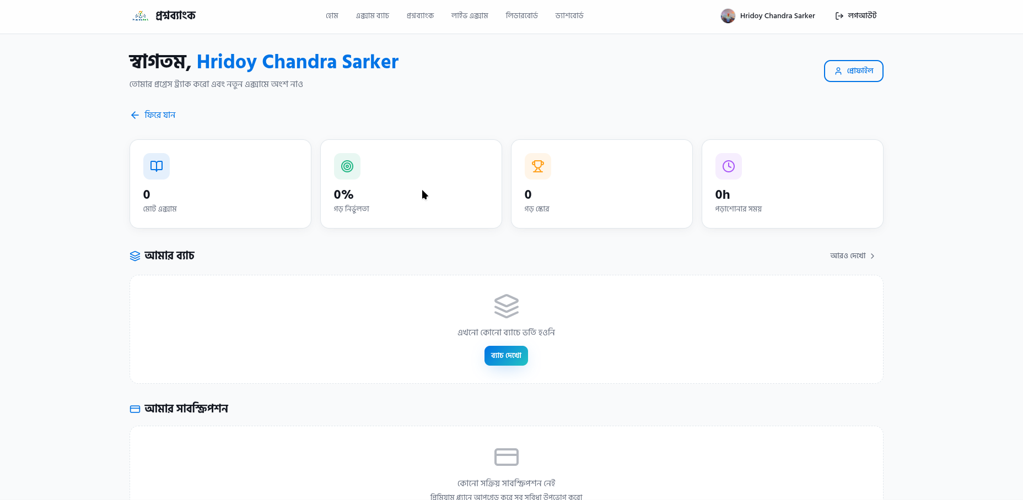Figure 3: Student Dashboard — Exam History & Stats
Teacher / Coaching Center Dashboard
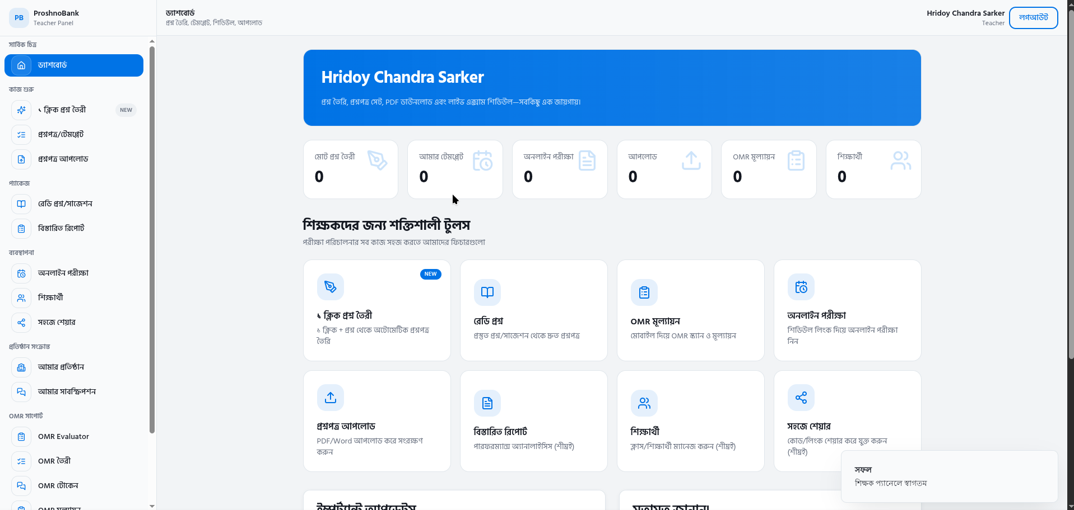Figure 4: Teacher / Coaching Center Dashboard

Subscription & Pricing Page
ProshnoBank — Choose Your Plan
Feature | Free | Student Premium | Coaching Pro
Practice Exams | Unlimited | Unlimited | Unlimited
Live Exams | 0 | Unlimited | Unlimited
Doubt Submissions | 3/month | Unlimited | Full Access
Batch Enrollment | No | Yes | Create & Manage
OMR Grading | No | No | Yes
Price (BDT) | Free | 999/year | 1,999/month

Figure 5: Subscription & Pricing Page
Live Exam Interface
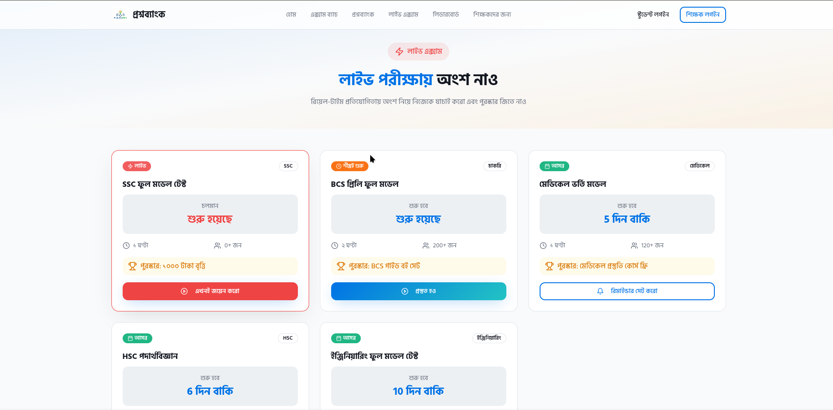
Figure 6: Live Exam Interface with Timer, Question, and Explanation

Admin Panel
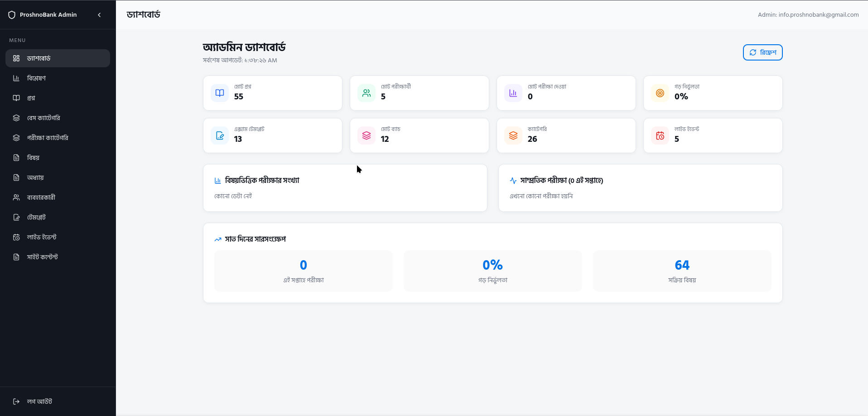
Figure 7: Admin Panel
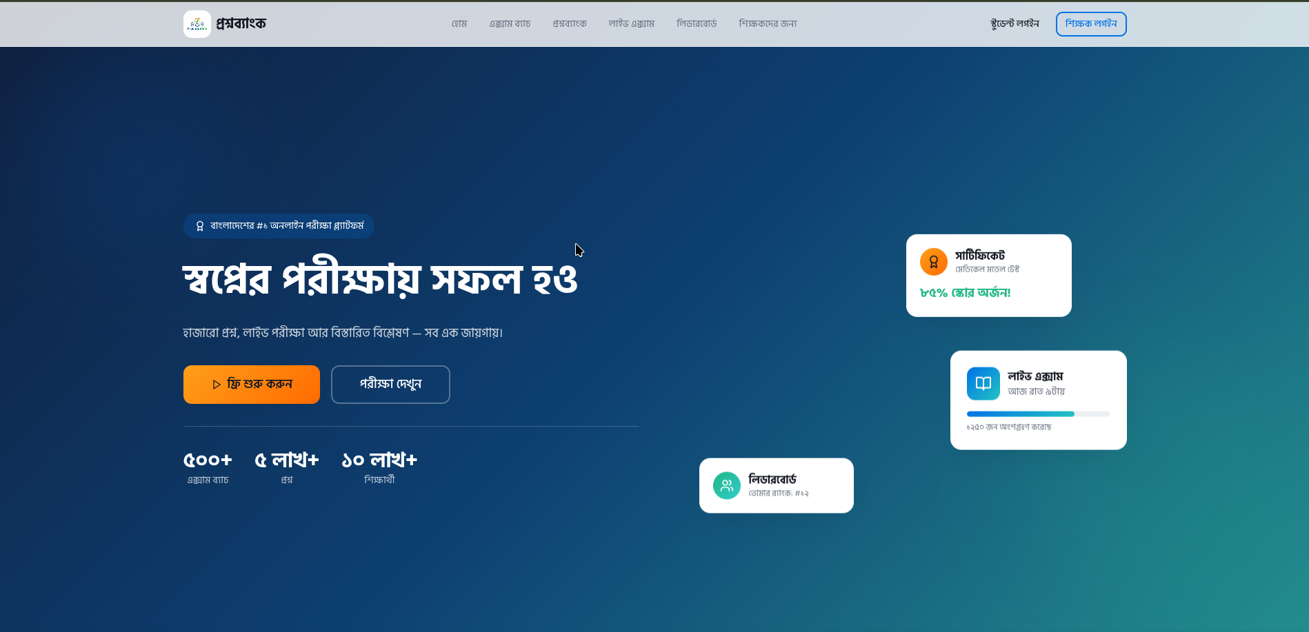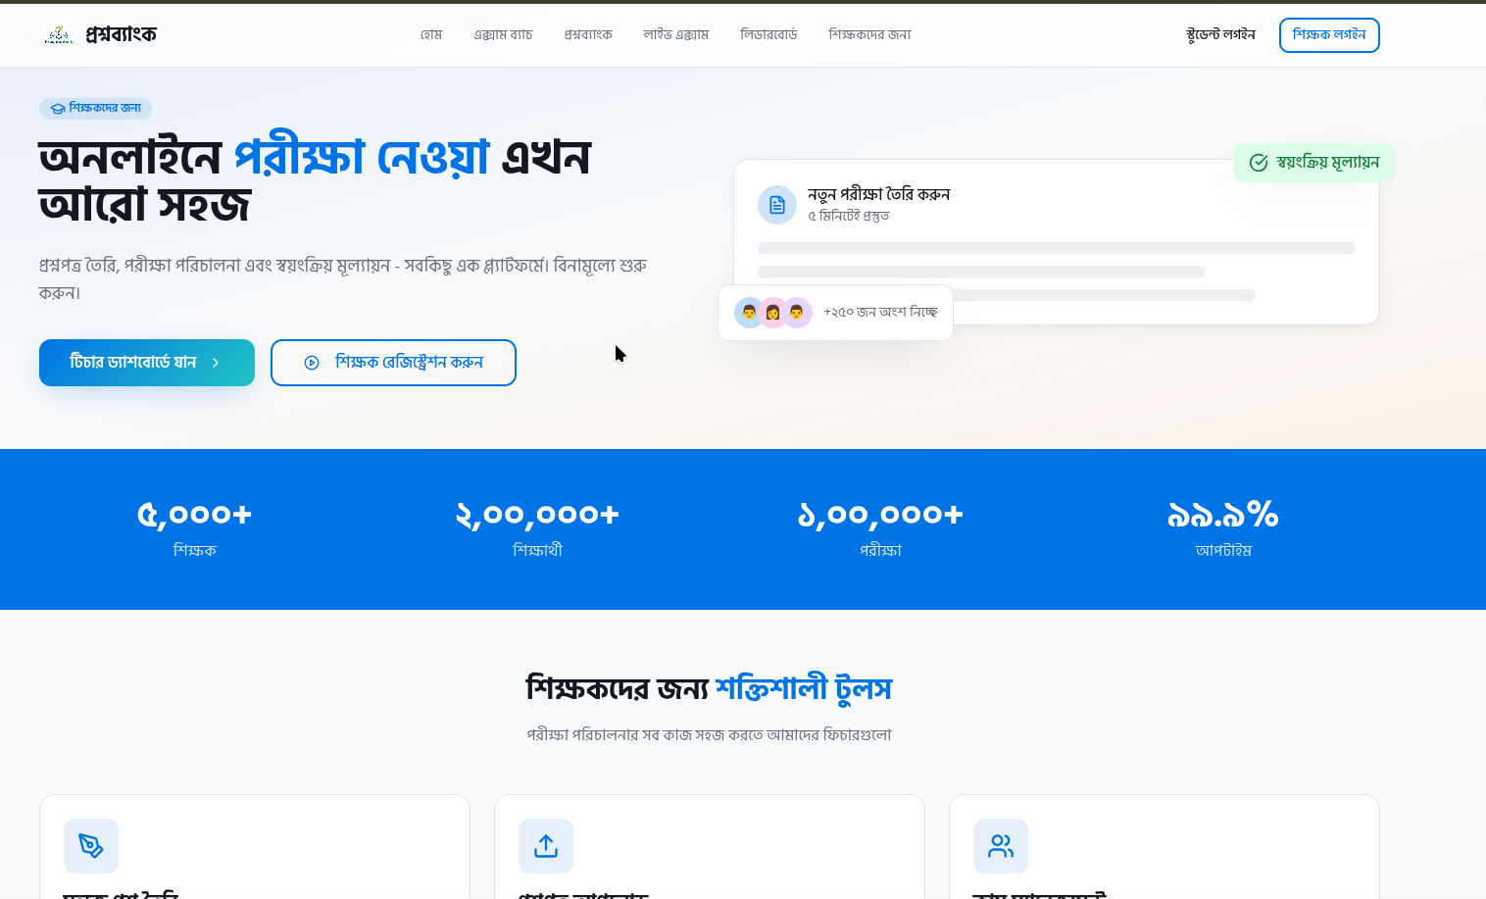
Exam System:
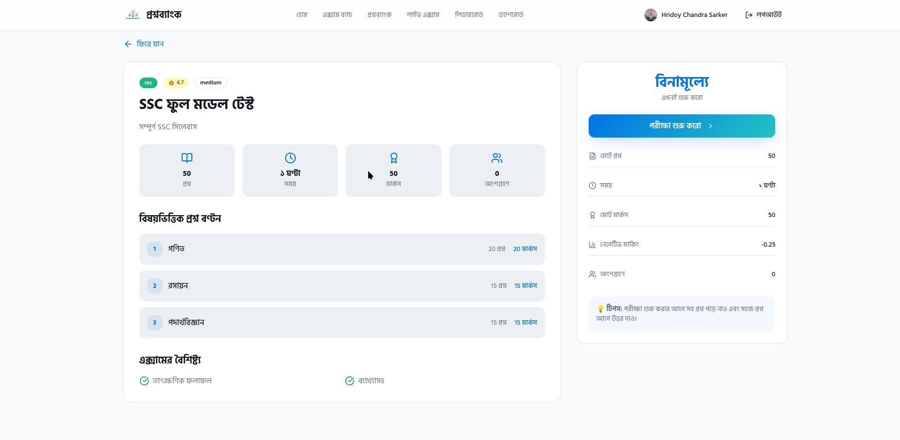
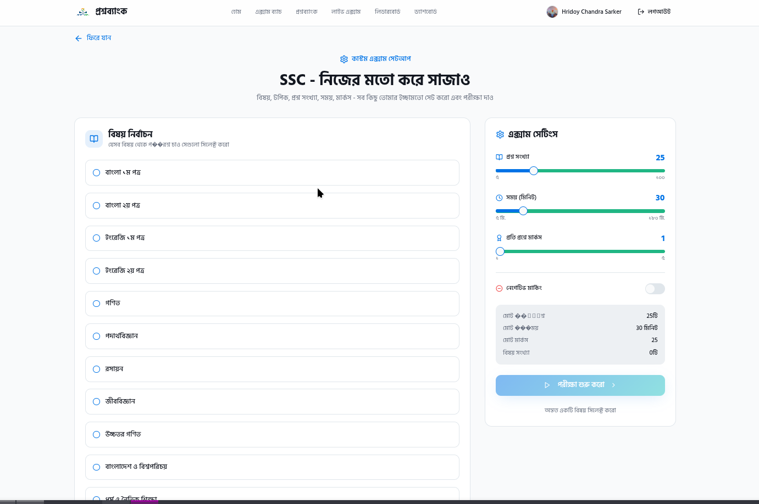

10. Future Plans
- AI-Powered Question Generation: Integrate an LLM to auto-generate MCQ questions from teacher-provided topics or uploaded documents.
- Mobile Application (React Native): Extend the web platform to native iOS and Android apps for offline exam access.
- OMR Scanner Integration: Allow teachers to upload scanned OMR sheets for automated grading.
- Video Lectures & Notes: Add a content management system for short-form video lessons tied to specific chapters.
- Group Study Rooms: Real-time collaborative doubt resolution with voice/text support.
- Institutional White-labeling: Allow coaching centers to run ProshnoBank under their own brand domain.
- Advanced AI Analytics: Predictive performance modeling to suggest personalized study plans.

11. Conclution
The expected outcome is a fully functional, production-grade online examination and learning platform deployed at proshnobank.vercel.app. The platform provides a superior user experience for students preparing for SSC, HSC, university admission, and job examinations, while simultaneously empowering teachers and coaching centers to digitize their operations through a scalable SaaS model.
ProshnoBank demonstrates a fully functional platform with real users, live exam events, and a growing question bank — ready for production deployment and user acquisition across Bangladesh.

12. References
[1] ProshnoBank Live Platform: https://proshnobank.vercel.app
[2] Next.js Documentation: https://nextjs.org/docs
[3] Supabase Documentation: https://supabase.com/docs
[4] Tailwind CSS: https://tailwindcss.com
[5] Shadcn/ui Component Library: https://ui.shadcn.com
[6] Vercel Deployment Platform: https://vercel.com
[7] 10 Minute School: https://10minuteschool.com
[8] Shikho: https://shikho.com

13. Weekly Report
No. | Date | Objective | Status | Remarks
1 |  | Project proposal  • Initial research on existing B2C & B2B platforms  • Defining objectives and scope  • Designing B2B/B2C model and tiers
2 |  | Environment and navigation setup  • Setting up Next.js development environment  • Designing app structure with App Router  • Creating basic UI components with Shadcn/ui
3 |  | Auth + Student core features  • Implementing Supabase Auth with RBAC  • Building student dashboard and exam browsing  • Integrating MCQ question bank schema
4 |  | Teacher & batch management  • Implementing question bank upload by teachers  • Building batch creation and enrollment system  • Setting up exam template creation workflow
5 |  | Live exams & doubt resolution  • Implementing real-time live exam events  • Building doubt submission and resolution system  • Adding leaderboard and ranking features
6 |  | Subscription & analytics  • Implementing SaaS subscription tiers (B2B & B2C)  • Building performance analytics dashboard  • Adding PDF library and OMR grading
7 |  | Final Testing & Deployment  • Conducting testing across devices and browsers  • Fixing bugs and performance issues  • Deploying to Vercel and finalization

