**SDET**

**Client Server Applications**

Types of Client/Server Architecture

* Two Tier Architecture
* Three Tier Architecture
* N Tier Architecture or Multi Tier Architecture

C:\Program Files (x86)\Microsoft Office\MEDIA\CAGCAT10\j0205582.wmf Two Tire Architecture

**C:\Program Files (x86)\Microsoft Office\MEDIA\CAGCAT10\j0205582.wmf** 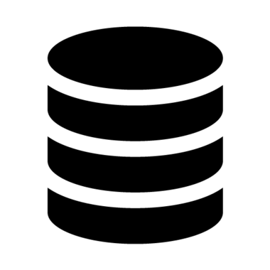 Three Tier Architecture

Multi Layer Architecture

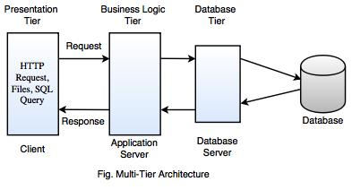

**Enterprise Application Automation**