**XML**

**Basics**

**eXtensible Mark-up Language (XML)**

* XML is "Programing Language & Platform Independent Language" which helps to store and transport data
* Different Applications which are developed using different technologies can Transfer the Data among themselves with the help of XML
* As the name implies it's an extension of HTML & hence XML looks similar to HTML but it’s not a HTML
* XML has User-defind Tags. XML tags are also called as "elements"
* XML Elements are "Case Sensitive"
* XML is "Strictly Typed" Language hence,

- For every element data, “data-type” should be defined,

- every opening element should have corresponding closing element and

- also XML elements must be properly nested/closed

**Ex:**

<employee>

<name>Praveen</name>

</employee>

**Note:-**

In the above example first you should closed </name> & then </employee> but in HTML it’s not mandatory. For example, <B><U><I>My Text</U></I></B> works perfectly fine

* Below line is called as "XML prolog", which is optional. If it exists, it must be the First Line of XML

<?xml version="1.0" encoding="UTF-8" ?>

* The syntax of XML comment is similar to that of HTML

<!-- This is a comment -->

* File extension of XML is ".xml"
* MIME type (Content Type) of XML is "application/xml"

**1. XML Structure**

* Like HTML, XML follows a Tree Structure
* An XML tree starts at a "root element" and branches from "root element" will have "child elements"
* XML Consists of "Only One" root element which is parent of all other elements

"child elements" can have "sub elements / child elements"

* Structure

<root>

<child>

<subchild>.....</subchild>

</child>

</root>

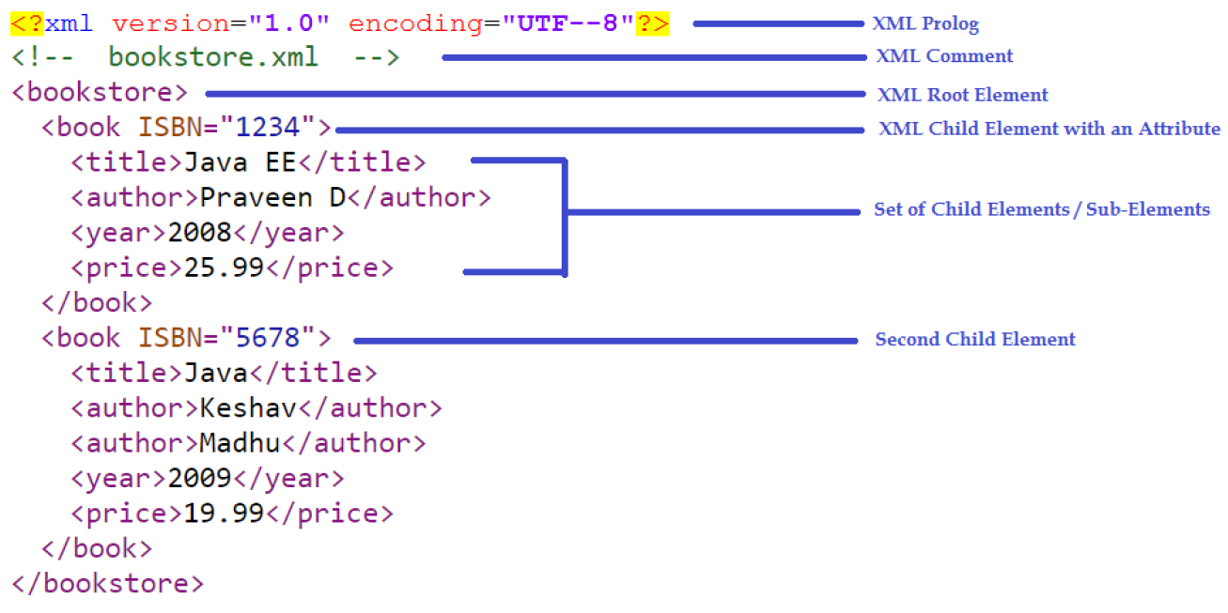

**2. Entity References**

▪ Some characters have a special meaning in XML. If you place a character like "<" inside an XML element, it will generate an error because it represents the start of a new element

**Ex:** <message>salary<1000</message>

* To avoid this error, we can replace the "<" character with an "entity reference" as shown below

<message>salary **&lt;** 1000</message>

* There are 5 pre-defined entity references in XML:

&lt; < less than

&gt; > greater than

&amp; & ampersand

&apos; ' apostrophe

&quot; " quotation mark

**3. PCDATA: Parsed Character Data**

▪ Text between start-element and end-element is called as PCDATA which will be examined by the parser

**Example:-**

<employee>Praveen</employee>

The string "Praveen" is considered as PCDATA

**4. CDATA: Character Data**

* W.K.T special characters (such as "<", "&") must be referenced through pre-defined entities
* If XML data contain many special characters, it is cumbersome to replace all of them. Instead we can use "CDATA (character data) section"
* A CDATA section starts with the following sequence:

<![CDATA[

and ends with the next occurrence of the sequence:

]]>

All characters enclosed between these two sequences are interpreted as characters

* The XML parsers ignores all the mark-up within the CDATA section.

**Example: -**

<employee>Praveen</employee>

the start and end "employee" elements are interpreted as mark-up. However, if written like this:

<![CDATA[ <employee>Praveen</employee> ]]>

then the parsers interprets the same as if it had been written like this:

**&lt;**employee**&gt;**Praveen**&lt;**/employee**&gt;**

**5. XML Elements**

* XML element is everything from (including) the element's start tag to (including) the element's end tag
* An element can contain:

1. data

2. Attributes

3. other elements OR

4. All of the above

* In the above example

- <title>, <author>, <year>, and <price> have text content

- <bookstore> and <book> have element contents

- <book> has an attribute (ISBN="------")

* An element with no content is said to be "empty". In XML, we can indicate an empty element like this

<element></element>

OR

<element />

* Empty elements can have attributes <book ISBN="5678" />
* If data present between elements consist of white spaces then they are considered in XML. However HTML truncates multiple white-spaces to one single white-space

**6. XML Elements Naming Rules**

- they are case-sensitive

- they cannot contain spaces

- they must start with a letter or underscore

- they are cannot start with the letters like xml or XML or Xml etc.,

- they can contain letters, digits, hyphens, underscores, and periods

- Any name can be used, no words are reserved (except xml)

**Best Naming Practices**

* Avoid "." and ":"
* Create descriptive names, like

<person>, <firstname>, <lastname>

* Create short and simple names, like

<book_title> not like this: <the_title_of_the_book>

* Non-English letters are perfectly legal in XML but avoid them

**7. XML Attributes**

* Like HTML, XML elements can also have attributes
* Attributes are designed to contain data related to a specific element
* XML Attributes Must be Quoted either single or double quotes can be used

**Ex:**

<person gender="female">

OR

<person gender='female'>

* If the attribute value itself contains double quotes then we can use single quotes

**Ex:**

<person name='Praveen "Bangalore" D'>

OR

<person name='Praveen **&quot;**Bangalore**&quot;** D'>

**8. XML Elements v/s Attributes**

**Example 1:-**

<person gender="male">

<name>Praveen</name>

</person>

**Example 2:-**

<person>

<gender>male</gender>

<name>Praveen</name>

</person>

**Note:**

- In Example 1 gender is an attribute &

- In Example 2 gender is an element

- Both examples provide the same information

- There are no rules about when to use attributes or when to use elements in XML

**When to avoid XML Attributes?**

* Attributes cannot contain multiple values but Elements can
* Attributes cannot contain tree structures but Elements can
* Attributes are not easily expandable for future changes but Elements can

**9. XML Schema's**

* W.K.T XML helps us to store & transfer the data
* When sending data from one application to an another, it is essential that both applications have the same "expectations / agreement" about the content/data
* for example, A date like "03-11-2004"

- in some countries, be interpreted as 3rd November and

- in other countries as 11th March

* With XML Schemas, the sender application can describe the data in a way that the receiver application will understand
* Schema is nothing but a "Structure". It is a formal description of structure of an XML.

- i.e., which elements are allowed,

- which elements must be present,

- which elements are optional,

- the sequence and relationship of the elements, etc.,

* For example,

- abc@gmail.com is a Valid Email ID. However

- abc#gmail is Invalid because there is "NO @ and ."

- hence email schema looks something like some-name@domain-name.com

* Schema "does not validate the data" instead "it validates the structure"
* There are two ways to define a Schema for XML

1. Document Type Definition (DTD)

2. XML Schema Definition (XSD)

**1) XML Document Type Definition (DTD)**

* A DTD defines the structure and the legal elements and attributes of an XML document
* An application can use a DTD to verify that XML data is valid
* There are 2 ways to declare the DTD

1. An Internal DTD Declaration

2. An External DTD Declaration

* An Internal DTD Declaration has the following syntax:

<!DOCTYPE root-element [

declarations

]>

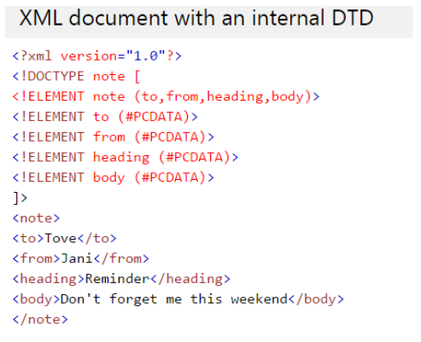

A DTD can also be stored in an external file. An XML can reference an external DTD via the following syntax:

<!DOCTYPE root-element SYSTEM "DTD-filename">

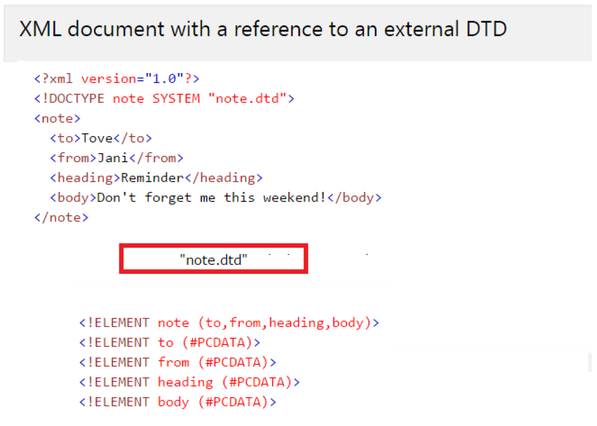

**XML Schema Definition (XSD)**

▪ XSD also describes the structure, legal elements and attributes for an XML

▪ It defines,

- the elements and attributes that can appear in XML

- the number of and also the order of child elements

- data types for elements and attributes

- default and fixed values for elements & attributes

▪ One of the greatest strength of XML Schemas is the support for data types

▪ For Example, the following is an example of a date declaration in XSD:

<xs:element name="start-date" type="xs:date"/>

it defines the structure/format of the Date as "YYYY-MM-DD"

An element in XML might look like <start-date>2002-09-24</start-date>

▪ Another great strength about XML Schemas is that they are written in XML

▪ Hence XSD's are extensible so, we can

- Reuse Schema in other Schemas

- Create your own data types derived from the standard types

- Reference multiple schemas in the same document

**NOTE:**

- Functionality wise both XSD & DTD similar in nature but XSD's are more sophisticated compared to DTD

- In other words, DTD provides less control on XML structure whereas XSD provides more control

- Hence XSD's preferred over DTD's

- Without an XSD/DTD, an XML need only follow the rules for being well-formed

- With an XSD/DTD, an XML must adhere to additional constraints placed upon the names and values of its elements and attributes in order to be considered valid

**10. Differences between DTD & XSD**

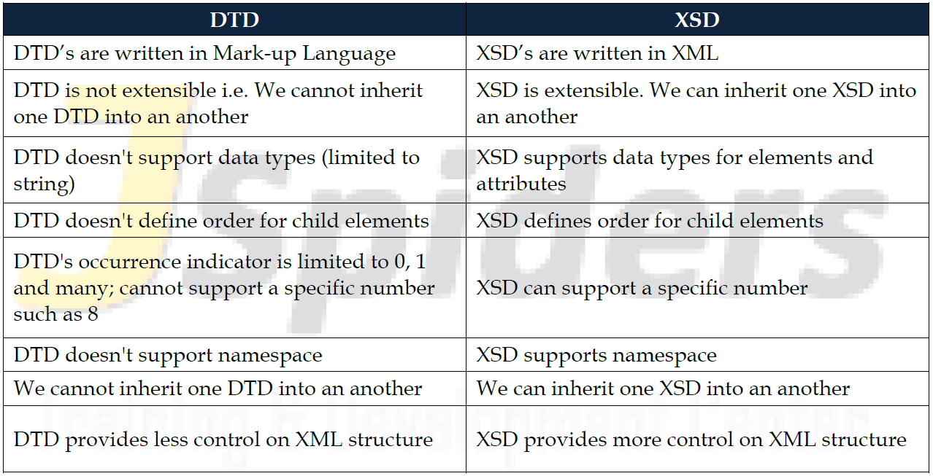

**Parsing XML Documents (XML Parsers)**

▪ To process the data contained in XML documents, we need to write a application program (in any programming language such as Java/C/C++, etc)

▪ The program makes use of an XML parser to tokenize and retrieve the data from the XML documents

▪ An XML parser is the software that sits between the application and the XML documents to shield the application developer from the details of the XML syntax.

▪ The parser reads a raw XML document, ensures that is well-formed, and may validate the document against a DTD or XSD