Deep Neural Network based Stable Digital Predistortion with Augmented terms for Power Amplifier
Leave Author List blank for your initial paper submission. IWS will be rigorously enforcing the
double-blind reviewing requirements. (style: IWS Author List)
Leave Affiliation List blank for your initial paper submission. (style: IWS Affiliation List)

Abstract—This paper proposes a deep neural network based digital predistortion (DPD), which introduces augmented real-valued time-delay terms into the input layer. We use the Exponential Linear Unit (ELU) activation in the hidden layer neurons instead of the Sigmoid, aiming to mitigate the gradient vanishing problem. The proposed model undergoes extensive experiments on a SLCG power amplifier driven by wideband signals ranging from 80MHz to 200MHz. The results demonstrate the nonlinear compensation capabilities of ARVTD-DNN are superior to Polynomial DPD and RVTDFNN-DPD by approximately 5-7 dB for the adjacent channel leakage ratio and by about 3 dB for the normalized mean square error. And the proposed DPD has lower computational complexity and faster convergence speed than Deep-RVTDFNN. Moreover, the proposed DPD can compensate the adverse effects when the main transistor in the SLCG operates in the third quadrant.

Index Terms—5G mobile communication, Digital predistortion, Artificial Neural Network, ARVTDNN, Exponential Linear Unit, Switchless Class-G power amplifier.
- Introduction
To improve the linearity of power amplifiers (PAs), digital predistortion (DPD) is widely used in modern wireless communication system. With the increase of modulation bandwidth and Peak-to-Average Power Ratio (PAPR) of signals in communication systems, such signals are more sensitive to the nonlinear characteristics of PA, leading to severe distortion and efficiency degradations. Now, Numerous Polynomial Model-based DPDs have been proposed, such as Volterra, Memory-Polynomial (MP) and Dynamic Deviation Reduction (DDR)[1], etc. In recent years, with the development of Artificial Neural Networks (ANNs), many researchers have turned their attention to incorporating NNs into DPDs, achieving rich outcomes[2]-[6]. Typical NNs algorithms include real-valued focused time-delay NNs (RVTDFNN)[2][3] that focus on the I/Q signal and its past time value, and augmented real-valued time-delay NNs (ARVTDNN)[4] that introduce the envelopes of input signal into the input layer.
The above paper focused on the shallow NN. Recently, the outstanding performance of deep NNs (DNNs) in fields like image recognition and classification has attracted the interests of PA modeling researchers[9]. Additionally, the continuous innovation of high-efficiency PA architectures has brought challenges in the linearization of PAs. Switchless Class-G PA (SLCG) is a new type of wideband efficiency enhancement technology. In comparison with Doherty PA, which operates only in the first quadrant, SLCG involves modulation in two quadrants. Moreover, when operating in the third quadrant, the working state of the main transistor in SLCG is influenced by harmonic impedance. Therefore, under the large-bandwidth modulated signals, the rapid variation of harmonic impedance with frequency will affect the operation of the main transistor, resulting in strong memory effects and nonlinear characteristics in SLCG.
In this paper, we proposed an ARVTD-DNN-DPD, which utilized ELU instead of Sigmoid. Through the discussion of the nonlinear characteristics of SLCG and the experimental results of applying this algorithm to SLCG, it can be observed that compared to traditional Polynomial-DPD and NNs-DPD, the proposed DPD is capable of improving the ACLR and NMSE of the PA output signal by 5-7dB and 2-3dB, respectively, under a modulated bandwidth of 200MHz signal.
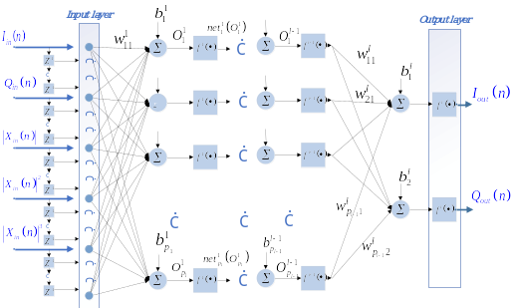
Fig. 1. The proposed augmented real-valued time-delay deep neural network.
- THE PROPOSED DPD
Fig. 1. illustrates the proposed ARVTD-DNN. It uses the Exponential Linear Unit (ELU) activation instead of the Sigmoid activation.
In the proposed model, at any moment in the training of the neural network, the sample sequence at the input layer is a vector of the order 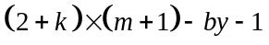
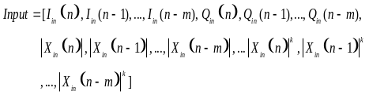 (1)
Where 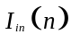 and 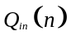 are the input orthogonal signals, and 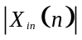 is the envelope term, is nonlinear order of the envelope introduced at input layer (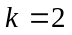 in this paper). The delayed response is achieved by using 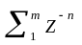as the delay operator, where 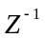is the unit delay operator that yields its delayed version 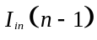 when operating on .
Training process of this network is the same as RVTDFNN[3]. The backpropagation algorithm used in this paper is the LM algorithm[7].
Fig. 2. Activations of Sigmoid, ReLU and ELU.
In [2]-[6], the activations of neurons in these NNs are Sigmoid (See Fig. 2.), which is mathematically equivalent to hyperbolic tangent given as
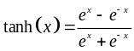 (5)
However, the use of the Sigmoid in DNNs may lead to the gradient vanishing problem[8]. In [9], the ReLU was employed as a replacement for the Sigmoid to address the mentioned problem and achieved better compensation performance. However, in the reverse modeling process of PAs, for the purpose of achieving time alignment between input and output signals and speeding up the training of NNs, the signals used for modeling (both input and output) are Gain-normalized. During testing, we observed a significant issue known as neuron death in DNNs using ReLU as the activation when these normalized data were used. This problem arises because there are a number of negative values in the normalized samples, which causes the ReLU to shut down, leading to neuron death and ultimately causing the network training to fail[10]. In this paper, we introduce the Exponential Linear Unit (ELU)[11] to replace the Sigmoid. ELU overcomes the gradient vanishing problem and also avoids the neuron death associated with the use of ReLU as an activation.
The formula for the ELU activation (See Fig. 2.) is as follows, where is the hyperparameter whose value is 1 in this paper.
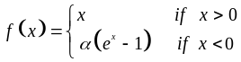 (6)
- Experimental results & discussion

TABLE I

PERFORMANCE OF DPDs
BW | Model | Num of Neurons | ACLR (L/U)(dBc) | ACPR (L/U)(dBc) | NMSE (dB) | EVM (%)
200MHz | w/o DPD | — | -23.4 / -26.0 | -26.9 / -29.4 | — | 11.2
200MHz | ML | — | -31.2 / -34.9 | -33.9 / -35.9 | -27.8 | 4.3
200MHz | DDR | — | -40.4 / -40.7 | -40.1 / -41.2 | -35.8 | 2.3
200MHz | RVTDFNN-S | 17 | -42.5 / -43.8 | -42.3 / -43.4 | -35.9 | 2.3
200MHz | RVTDFNN-D | 122 | -47.1 / -46.9 | -46.1 / -45.6 | -37.7 | 1.9
200MHz | PROPOSED | 82 | -47.1 / -48.7 | -47.0 / -48.9 | -39.0 | 1.7

For measurement and experimental validation purposes, the proposed ARVTD-DNN-DPD is implemented on the MATLAB. The mentioned DPD methods were compared for linearization performance on a SLCG (See Fig. 4.) operating in the 1-3GHz range with memory effects driven by a wideband signal whose saturated output power is 36.6 dBm and the drain efficiency is 30% [12]. Fig. 3. illustrates the results of applying a memoryless (ML) DPD to the SLCG under a 64QAM signal with a PAPR of 7.5dB and a modulation bandwidth of 10MHz. We observe, before ML DPD, that the PA provides an average power of around 30dBm, with an average efficiency of 35-48%, EVM of 2.5-7.2%, and ACPR of -29 to -35dBc. After applying ML DPD, EVM and ACPR can be reduced to less than 3% and less than -45dBc, respectively. This indicates that the PA can obtain good linearity under low-bandwidth modulation signals.
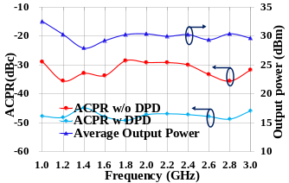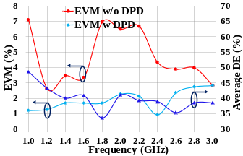
Fig. 3. The performance of SLCG under 10MHz-bandwidth signals.
Above five DPD methods adopt an indirect learning structure. Fig. 5. illustrates the measurement setup and the predistortion implementation process.
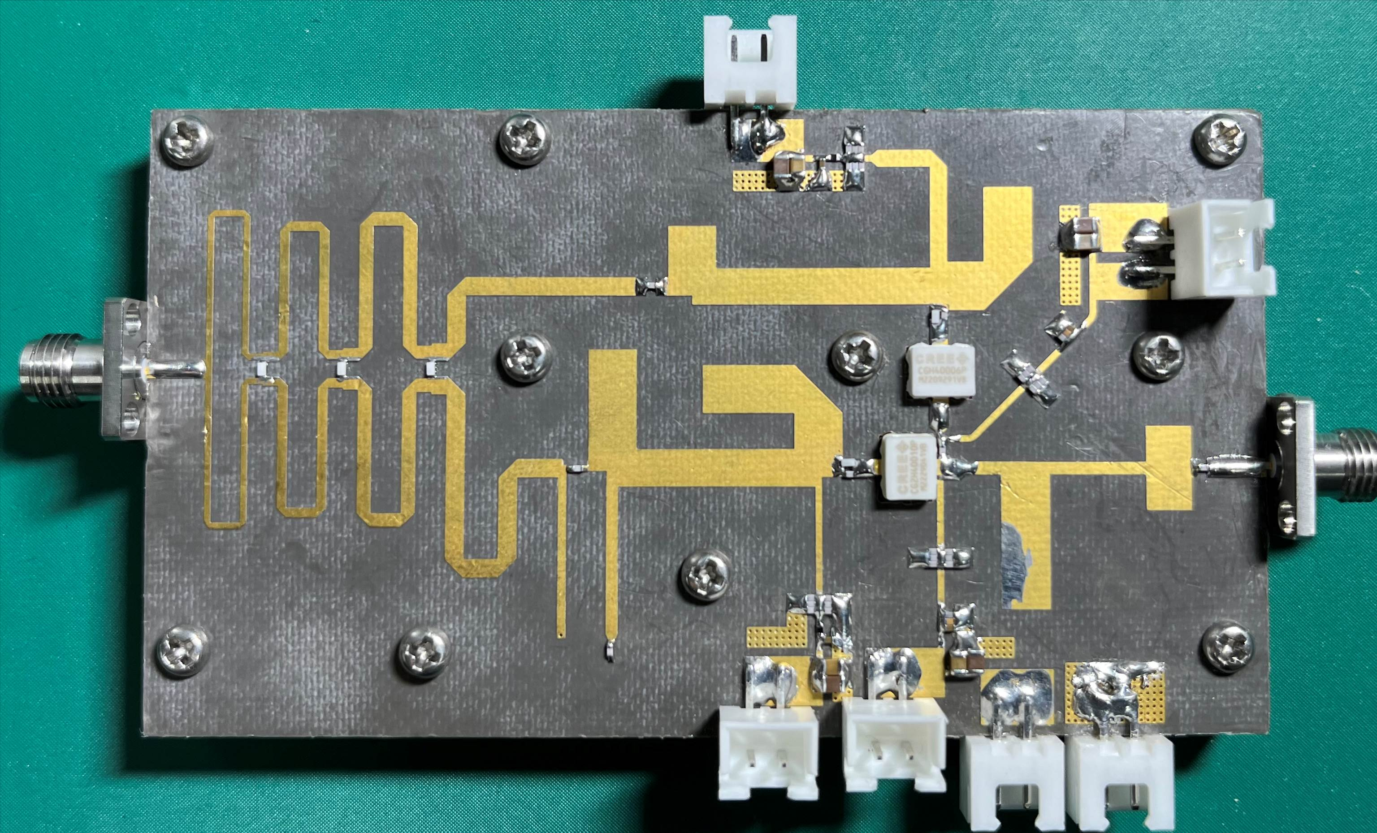
Fig. 4. The SLCG PA used in the experiments in this paper.
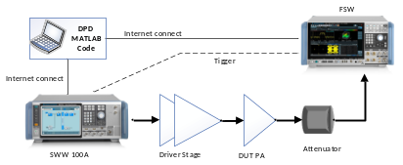
Fig. 5. The measurement setup and the predistortion implementation process.
The RVTDFNN-DPD employs shallow and deep versions with 17 neurons and 122 neurons respectively, and the number of delay taps is set to 4, according to [3][9]. The proposed DPD has 4 delay taps, 8 hidden layers (L=8), each with 10 neurons, and uses ELU as the activation. The number of samples for DPD is 9000 in each case. The output layer has 2 neurons with a linear activation.
The DPD results for a 200MHz-bandwidth 256QAM signal applied to the SLCG PA are presented in Table I and Fig. 6.
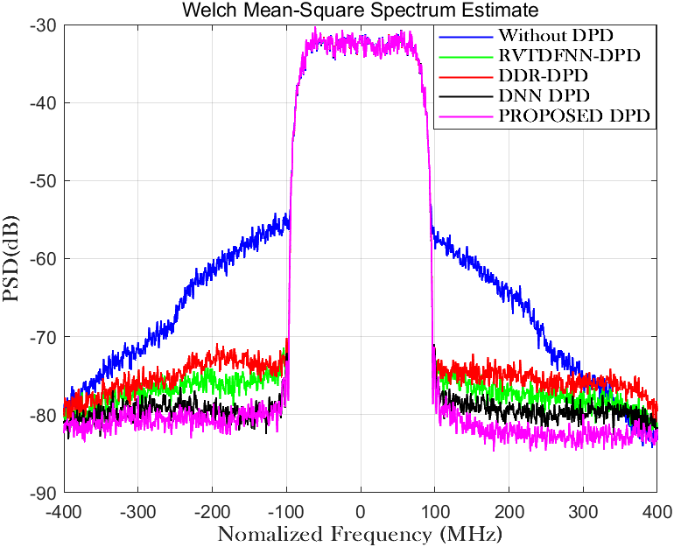
Fig. 6. Power spectral density in each case.
To further validate its linearization ability of the proposed model under large modulation bandwidth, its performance was experimentally measured under the signals with bandwidths of 80MHz to 200MHz (See Fig. 7.). It can be observed that the proposed model, compared to polynomial DPD and NNs-DPD, exhibits better adaptability to the linearization requirements under large bandwidth signal conditions.
- Conclusion
This paper proposes the ARVTD-DNN-DPD model, employing the ELU activation to replace the ReLU activation in DNN to avoid the neuron death. Experimental verification using an SLCG PA demonstrates that the proposed DPD maintains excellent linearization performance and enhanced robustness in the case of large bandwidth. Compared to traditional polynomial DPD and NNs-DPD, it shows a 5-8dB improvement in ACLR and ACPR, and about a 3dB improvement in NMSE. And the proposed DPD has lower computational complexity and faster convergence speed than Deep-RVTDFNN. Meanwhile, under the drive of large-bandwidth modulation signals, the proposed DPD can compensate the adverse effects (higher nonlinear characteristics and memory effects) caused by the rapid frequency-dependent variation of harmonic impedance when the main transistor in the SLCG operates in the third quadrant. Under the drive of large-bandwidth signals exceeding 140MHz, polynomial DPD and NNs-DPD loses its linearization capability, while the proposed DPD continues to perform effective linearization.
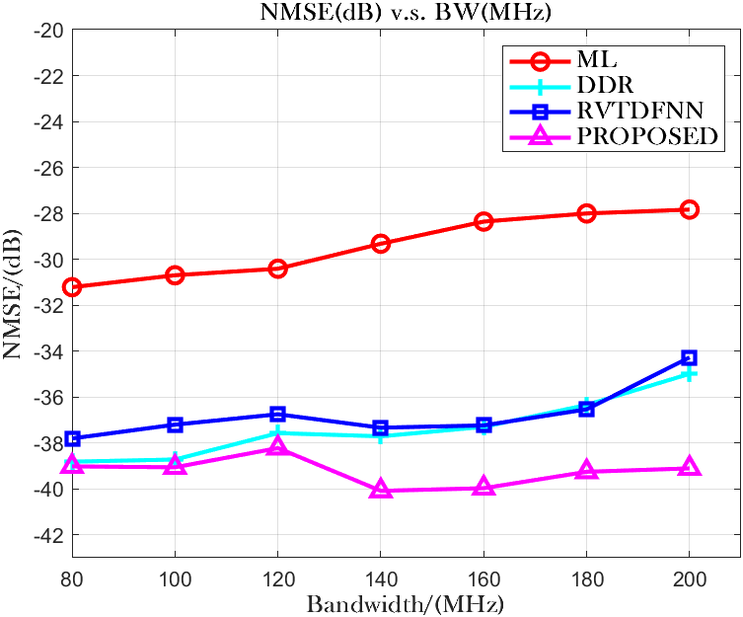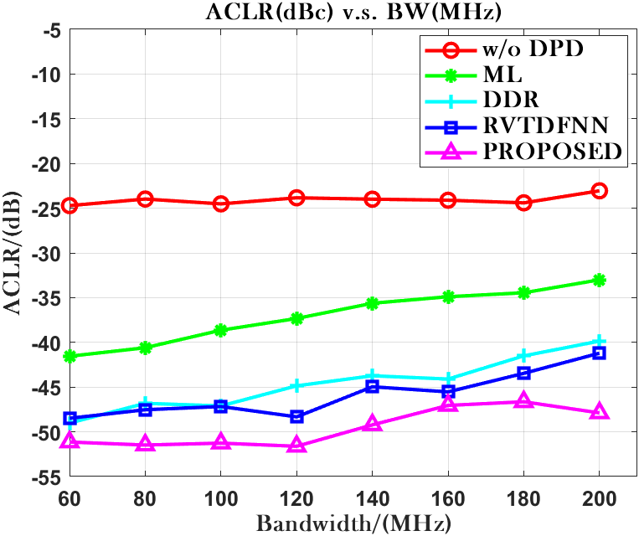
Fig. 7. Performance in NMSE(left) and ACLR(U)(right) v.s. BandWidth.

References
[1] Ghannouchi, Fadhel M. Behavioral Modelling and Predistortion of Wideband Wireless Transmitters. Hoboken: John Wiley & Sons Inc., 2015. Print.
[2] T. Liu, S. Boumaiza, and F. Ghannouchi, “Dynamic behavioral modeling of 3G power amplifiers using real-valued time-delay neural networks,” IEEE Trans. Microw. Theory Tech., vol. 52, no. 3, pp.1025–1033, Mar. 2004.
[3] Rawat, M., K. Rawat, and F.M. Ghannouchi. “Adaptive Digital Predistortion of Wireless Power Amplifiers/Transmitters Using Dynamic Real-Valued Focused Time-Delay Line Neural Networks.” IEEE transactions on microwave theory and techniques 58.1 (2010): 95–104. Web.
[4] Wang, Dongming et al. “Augmented Real-Valued Time-Delay Neural Network for Compensation of Distortions and Impairments in Wireless Transmitters.” IEEE transaction on neural networks and learning systems 30.1 (2019): 242–254. Web.
[5] Danh Luongvinh and Youngwoo Kwon, "Behavioral modeling of power amplifiers using fully recurrent neural networks," IEEE MTT-S International Microwave Symposium Digest, 2005., Long Beach, CA, USA, 2005, pp. 1979-1982, doi: 10.1109/MWSYM.2005.1517131.
[6] P. Jaraut, M. Helaoui, W. Chen, M. Rawat, N. Boulejfen and F. M. Ghannouchi, "Review of the Neural Network based Digital Predistortion Linearization of Multi-Band/MIMO Transmitters," 2021 IEEE MTT-S International Wireless Symposium (IWS), Nanjing, China, 2021, pp. 1-3, doi: 10.1109/IWS52775.2021.9499466.
[7] Hagan, M.T., and M.B. Menhaj. “Training Feedforward Networks with the Marquardt Algorithm.” IEEE transactions on neural networks 5.6 (1994): 989–993. Web.
[8] S. Haykin, Neural Networks: A Comprehensive Foundation. UpperSaddle River, NJ: Prentice-Hall, 1999.
[9] Hongyo, Reina, Yoshimasa Egashira, and Keiichi Yamaguchi. “Deep Neural Network Based Predistorter with ReLU Activation for Doherty Power Amplifiers.” 2018 Asia-Pacific Microwave Conference (APMC). IEICE, 2018. 959–961. Web.
[10] Lu Lu,Yeonjong Shin,Yanhui Su George E. Karniadakis.(2019).Dying ReLU and Initialization: Theory and Numerical Examples..CoRR
[11] Djork-Arné Clevert,Thomas Unterthiner Sepp Hochreiter.(2015).Fast and Accurate Deep Network Learning by Exponential Linear Units (ELUs)..CoRR
[12] X. Fang, R. Chen and J. Shi, "Switchless Class-G Power Amplifiers: Generic Theory and Design Methodology Using Packaged Transistors," in in IEEE Transactions on Microwave Theory and Techniques, accepted, doi: 10.1109/TMTT.2024.3351852.

