Deep Neural Network based Stable Digital Predistortion with Augmented terms for Switchless Class-G Power Amplifier
Leave Author List blank for your initial paper submission. IWS will be rigorously enforcing the
double-blind reviewing requirements. (style: IWS Author List)
Leave Affiliation List blank for your initial paper submission. (style: IWS Affiliation List)

Abstract—In this paper, an augmented real-valued time-delay based deep neural network (ARVTD-DNN) digital pre-distortion (DPD) technique is proposed. It utilizes the ELU activation instead of Sigmoid to mitigate the gradient vanishing issue and accelerate the NN training. For validation, its linearization effects on an SLCG PA that excited by a 256QAM signal with various modulation bandwidths (swept from 20MHz to 200MHz) are carefully compared with other existing DPD algorithms. This comparison reveals that, while the effects of other DPD methods generally decreases with the rise of signal modulation bandwidth, the proposed method is able to maintain an optimal linearization outcome that varies little vs. bandwidth. In particular, when applied under the signal with a modulation bandwidth of 200MHz, the proposed DPD method can further reduce the adjacent channel power ratio and the normalized mean square error of the PA output signal by 5-7dB and 3-4dB, compared to other polynomial/NN-based DPD methods. This demonstrates the superiority of the proposed technique in linearizing the nonlinear PA under wideband modulated signal excitations.

Index Terms—Digital pre-distortion, deep neural network, wideband modulation, exponential linear unit, switchless class-G power amplifier.
- Introduction
(文章没有加入致谢)Digital pre-distortion (DPD) is a crucial technique for modern wireless communication systems where the ever-increasing signal modulation bandwidth and Peak-to-Average Power Ratio (PAPR) make transmitting signals extremely sensitive to the nonlinear characteristics of the RF power amplifier (PA). Consequently, various DPDs have been proposed to linearize the PA, maintain signal quality and improve overall system efficiency. These include many polynomial-based methods, such as Memory-Polynomial (MP) and Dynamic Deviation Reduction (DDR) [1] techniques. Recently, the concept of artificial Neural Networks (NNs) has been introduced into DPD techniques, achieving excellent outcomes [2]-[6]. Typical NN algorithms include real-valued focused time-delay NNs (RVTDFNN)[2][3] and augmented real-valued time-delay NN (ARVTDNN)[4] where the former utilizes the real valued I/Q and their delays as the input of NN and the latter further introduces the envelope signal into the input vector.
While the above techniques focused on the shallow NN, recently, the success of deep NNs (DNNs) in image recognition and classification has made DNN a promising solution for nonlinear PA linearization [9]. In addition, the innovation in PA back-off efficiency enhancement (BEE) technique also brings new challenges for PA linearization. Switchless Class-G (SLCG) PA is a recently developed BEE technique which adopts two quadrant modulation (TQM). When comparing to other load modulated BEE techniques (e.g. Doherty PA) that only involve operation in the 1st quadrant, the SLCG PA might exhibit higher level of memory effect as the TQM makes the output impedance of the 3rd quadrant operated main transistor sensitive to harmonic impedances. As the harmonic impedances naturally vary strongly versus frequency, the SLCG PA might exhibit notable memory effects that are difficult to model when excited with wideband signals.
This paper presents an ARVTD-DNN-DPD method and discusses its application to the SLCG PA. The proposed DNN DPD method utilizes the exponential linear unit (ELU) function instead of the sigmoid one to fulfill the activation of the hidden layer neurons, so as to eliminate the gradient vanishing problems and accelerates network training. Through discussing the nonlinear characteristics of the SLCG PA and comparing the linearization results obtained by applying the proposed and other DPD techniques to the SLCG PA, it can be observed that, the proposed one is capable to offer the best linearization effect where the ACPR and NMSE of the PA output signal was improved by 5-7dB and 3-4dB, respectively, compared to traditional Polynomial DPD and NN-DPD, under the
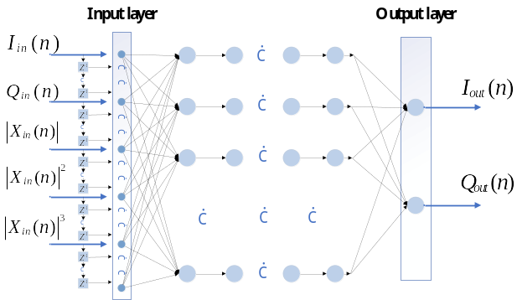
Fig. 1. The proposed augmented real-valued time-delay deep neural network.
- THE PROPOSED DPD
Fig. 1. illustrates the proposed ARVTD-DNN, whose input signal contains the current and past samples of the Cartesian I/Q components 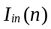 and 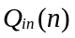 along with the augmented envelope terms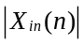:
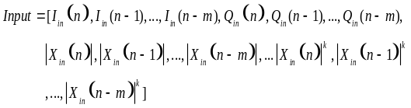 (1)
Where 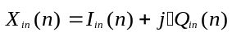, and k is nonlinear order of 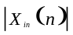, and is the memory depth of the input vector (In this paper 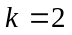 and 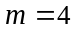). The delayed response (In Fig. 1.) is achieved by using 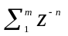as the delay operator, where 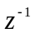is the unit delay operator that yields its delayed version 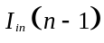 when operating on 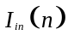.
While the proposed DNN adopts same forward propagation algorithm as [2]-[6] and uses Levenberg-Marquart (LM) [7] algorithm for back-propagation, and it utilizes a different activation for the hidden layer neurons.
Conventional shallow NN DPD techniques usually adopt sigmoid function (i.e. hyperbolic tangent function) for the activation of the hidden layer neurons. However, this leads to gradient vanishing problem in the DNN training [8]. In [9], the ReLU [i.e. the half-wave rectifying function 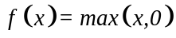] was employed to replace sigmoid to address the above problem. However, modern digital modulation schemes adopted in wireless communication system generate large amounts of I/Q signals with negative values. The training using these negative valued I/Q samples would results in negative input for the ReLU and makes ReLU inactive and output 0, which ultimately causes the failure of the network training [10]. To mitigate this issue, this work introduces the Exponential Linear Unit (ELU) as the activation, which takes the form of (3), to replace the sigmoid:
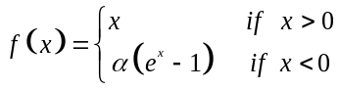 (3)
Where is the hyperparameter whose value is 1 in this paper. By replacing the negative axis of ReLU with an exponential term, ELU does not suffer from activation (Sigmoid) saturation when the neuron input is positive, and it still produces a non-zero output when the neuron input is negative. Therefore, ELU overcomes the gradient vanishing problem and also avoids network training failure by using ReLU in DNN when there are many negative training samples.
Fig. 2. illustrates the results of applying the ML-DPD to the SLCG PA under a 64QAM signal with a PAPR of 7.5dB and a modulation bandwidth of 10MHz. We observe, before ML DPD, that the PA provides an average power of around 30dBm, with an average efficiency of 35-48%, EVM of 2.5-7.2%, and ACPR of -29 to -35dBc. After applying ML DPD, EVM and ACPR can be reduced to less than 3% and less than -45dBc, respectively. This indicates that the SLCG PA can obtain good linearity under low-bandwidth modulation signals.
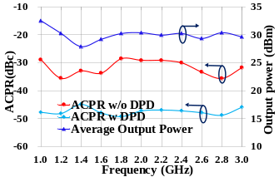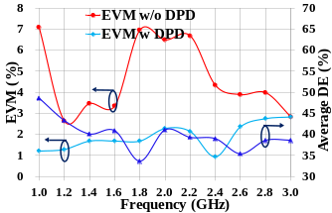
Fig. 2. The performance of SLCG under 10MHz-bandwidth signals.
However, when excited by wideband modulated signals, the operation of the main transistor of SLCG PA in the 3rd quadrant may result in strong memory effects and nonlinearities, increasing the difficulty of linearization. Therefore, more advanced DPD methods are required.
- Experimental results & discussion

TABLE I

PERFORMANCE OF DPDs
BW | Model | Num of Neurons | Mean-ACLR (dBc) | Mean-ACPR (dBc) | NMSE (dB) | EVM (%)
200MHz | w/o DPD | — | -21.0 / -25.3 | -24.3 / -27.3 | — | 14.4
200MHz | ML | — | -32.3 / -36.3 | -33.6 / -36.2 | -25.9 | 4.4
200MHz | DDR | — | -41.6 / -42.3 | -39.4 / -41.3 | -35.9 | 2.0
200MHz | RVTDF-SNN | 17 | -42.6 / -43.8 | -41.9 / -43.8 | -36.6 | 1.6
200MHz | ARVTDFNN | 17 | -43.3 / -43.8 | -43.3 / -44.5 | -38.7 | 1.9
200MHz | RVTDF-DNN | 122 | -43.5 / -46.0 | -43.4 / -46.2 | -38.9 | 1.8
200MHz | PROPOSED | 82 | -47.3 / -48.5 | -46.8 / -48.8 | -40.2 | 1.2

For experimental validation, the proposed DPD technique, using the indirect learning algorithm, is implemented on the MATLAB and used to linearize the SLCG PAs driven by a large bandwidth signal. Fig. 3. illustrates the schematic diagram of the DPD structure and the employed SLCG PA. The SLCG PA operate in the 1-3GHz range, whose saturated output power is 36.6-38.7 dBm and 6dB back-off saturated drain efficiency (DE) of 45.4-51.2% [11].
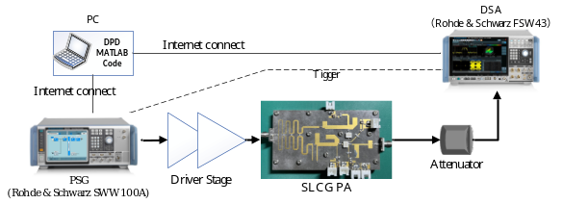
Fig. 3. The measurement setup and the predistortion implementation process.
In this paper, the SLCG PA were driven by 256QAM signals with the modulation bandwidth varying from 20MHz to 200MHz. The employed DPD methods include traditional polynomial DPD, shallow/deep-RVTDFNN (RVTDF-S/DNN) based DPD, ARVTDNN-DPD and the proposed DPD techniques. The RVTDFNN-DPD employs shallow and deep versions with 17 neurons and 122 neurons respectively, and the number of delay taps is set to 4. These configurations are derived from the approaches outlined in [3] and [9]. ARVTDNN is extended version of shallow-RVTDNN by adding two of augmented envelope terms. The proposed DPD has 4 delay taps, 8 hidden layers, each with 10 neurons, 2-order augmented envelope terms and uses ELU as the activation. The number of samples for DPD is 9000 in each case. The output layer has 2 neurons with linear activations.
The DPD techniques results for the SLCG PA driven by a 200MHz-bandwidth 256QAM signal are presented in Table I and Fig. 4. Compared to traditional polynomial DPD and the ARVTDFNN based DPD, it shows a 5-7dB improvement in ACLR and ACPR, and around a 3-4dB improvement in NMSE. Additionally, the proposed DPD has lower computational complexity and faster convergence speed than RVTDF-DNN DPD.
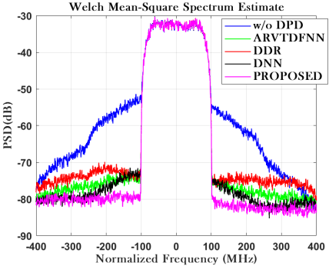
Fig. 4. Power spectral density in each case.
Fig. 5. illustrates that as the signal modulation bandwidth scans from 20MHz to 200MHz, the proposed DPD, in comparison to traditional polynomial DPD and shallow NN-DPD (including RVTDFNN and ARVTDNN), maintains a good linearization capability even with increasing bandwidth. Its ACLR consistently stays below -47dBc. In contrast, under the drive of large bandwidth signals, specifically above 140MHz, polynomial DPD and RVTDFNN-DPD lose their linearization capabilities, with ACLR exceeding -44dBc.
- Conclusion
This paper proposes the ARVTD-DNN-DPD technique, employing the ELU activation to replace the Sigmoid in DNN to avoid the gradient vanishing problem and speed up the training of NN. Experimental verification using an SLCG PA demonstrates that the proposed DPD maintains excellent linearization performance and enhanced robustness in the case of large bandwidth. Compared to traditional polynomial DPD and the ARVTDNN-DPD, it shows a 5-7dBc improvement in ACLR and ACPR, and around a 3-4dB improvement in NMSE. Additionally, the proposed DPD has lower computational complexity and faster convergence speed than deep-RVTDFNN DPD. Meanwhile, under the drive of large-bandwidth signals exceeding 140MHz, the polynomial DPD and RVTDFNN based DPD lose their linearization capability, while the proposed DPD continues to perform effective linearization, with ACLR consistently below -47dBc. These highlight the advantages of the proposed ARVTD-DNN-DPD technique in linearizing SLCG PA driven by large bandwidth signals.
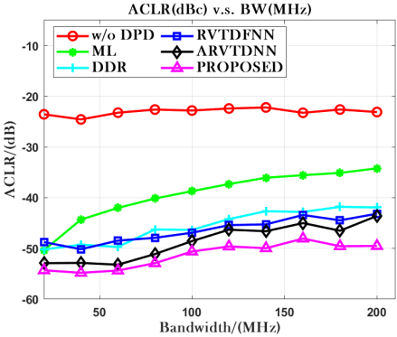
Fig. 5. Performance in NMSE(left) and ACLR(U)(right) v.s. BandWidth.

References
[1] Ghannouchi, Fadhel M. Behavioral Modelling and Predistortion of Wideband Wireless Transmitters. Hoboken: John Wiley & Sons Inc., 2015. Print.
[2] T. Liu, S. Boumaiza, and F. Ghannouchi, “Dynamic behavioral modeling of 3G power amplifiers using real-valued time-delay neural networks,” IEEE Trans. Microw. Theory Tech., vol. 52, no. 3, pp.1025–1033, Mar. 2004.
[3] M. Rawat, K. Rawat and F. M. Ghannouchi, "Adaptive Digital Predistortion of Wireless Power Amplifiers/Transmitters Using Dynamic Real-Valued Focused Time-Delay Line Neural Networks," in IEEE Transactions on Microwave Theory and Techniques, vol. 58, no. 1, pp. 95-104, Jan. 2010, doi: 10.1109/TMTT.2009.2036334.
[4] Wang, Dongming et al. “Augmented Real-Valued Time-Delay Neural Network for Compensation of Distortions and Impairments in Wireless Transmitters.” IEEE transaction on neural networks and learning systems 30.1 (2019): 242–254. Web.
[5] Danh Luongvinh and Youngwoo Kwon, "Behavioral modeling of power amplifiers using fully recurrent neural networks," IEEE MTT-S International Microwave Symposium Digest, 2005., Long Beach, CA, USA, 2005, pp. 1979-1982, doi: 10.1109/MWSYM.2005.1517131.
[6] P. Jaraut, M. Helaoui, W. Chen, M. Rawat, N. Boulejfen and F. M. Ghannouchi, "Review of the Neural Network based Digital Predistortion Linearization of Multi-Band/MIMO Transmitters," 2021 IEEE MTT-S International Wireless Symposium (IWS), Nanjing, China, 2021, pp. 1-3, doi: 10.1109/IWS52775.2021.9499466.
[7] M. T. Hagan and M. B. Menhaj, "Training feedforward networks with the Marquardt algorithm," in IEEE Transactions on Neural Networks, vol. 5, no. 6, pp. 989-993, Nov. 1994, doi: 10.1109/72.329697.
[8] S. Haykin, Neural Networks: A Comprehensive Foundation. UpperSaddle River, NJ: Prentice-Hall, 1999.
[9] Hongyo, Reina, Yoshimasa Egashira, and Keiichi Yamaguchi. “Deep Neural Network Based Predistorter with ReLU Activation for Doherty Power Amplifiers.” 2018 Asia-Pacific Microwave Conference (APMC). IEICE, 2018. 959–961. Web.
[10] Lu Lu,Yeonjong Shin,Yanhui Su George E. Karniadakis.(2019).Dying ReLU and Initialization: Theory and Numerical Examples..CoRR
[11] X. Fang, R. Chen and J. Shi, "Switchless Class-G Power Amplifiers: Generic Theory and Design Methodology Using Packaged Transistors," in in IEEE Transactions on Microwave Theory and Techniques, accepted, doi: 10.1109/TMTT.2024.3351852.

