Deep Neural Network based Stable Digital Predistortion with Augmented terms for Switchless Class-G Power Amplifier
Leave Author List blank for your initial paper submission. IWS will be rigorously enforcing the
double-blind reviewing requirements. (style: IWS Author List)
Leave Affiliation List blank for your initial paper submission. (style: IWS Affiliation List)

Abstract—This paper proposes an augmented real-valued time-delay deep neural network (ARVTD-DNN) based digital predistortion (DPD) technique, utilizing the ELU activation instead of Sigmoid to expedite convergence and mitigate the gradient vanishing problem. Various DPD techniques were conducted on a Switchless Class-G (SLCG) power amplifier (PA), with the input signal modulation bandwidth ranging from 20MHz to 240MHz. The results demonstrate an increasing challenge in linearizing the SLCG PA due to growing memory effects and nonlinear characteristics with the widening signal bandwidth. While, compared to traditional polynomial DPD and RVTDFNN-DPD, the proposed DPD technique further reduces adjacent channel leakage ratio (ACLR) and normalized mean square error (NMSE) by approximately 5-7dB and 3-4dB respectively. Moreover, comparing to the Deep-RVTDFNN-DPD technique, the proposed algorithm reduces complexity of network and accelerates training speed. These highlight the advantages of the proposed DPD in linearizing SLCG PA driven by large bandwidth signals.

Index Terms—5G mobile communication, Digital predistortion, Deep Neural Network, ARVTDNN, Exponential Linear Unit, Switchless Class-G power amplifier.
- Introduction
Digital predistortion (DPD) techniques are crucial for modern wireless communication systems where the ever-increasing signal modulation bandwidth and Peak-to-Average Power Ratio (PAPR) makes transmitting signal extremely sensitive to the nonlinear characteristics of PA, leading to signal quality and efficiency degradation.
Various Polynomial-based DPDs have been proposed. These include Volterra, Memory-Polynomial (MP) and Dynamic Deviation Reduction (DDR)[1], etc. Recently, the concept of Artificial Neural Networks (ANNs) has been introduced into DPD techniques, achieving rich outcomes[2]-[6]. Typical NNs algorithms include real-valued focused time-delay NNs (RVTDFNN)[2][3] and augmented real-valued time-delay NN (ARVTDNN)[4].
While the above techniques focused on the shallow NN, recently, the success of deep NNs (DNNs) in image recognition and classification has made DNN a promising solution for nonlinear PA modeling[9]. In addition, the innovation in PA back-off efficiency enhancement (BEE) technique also brings new challenges for PA linearization. Switchless Class-G (SLCG) PA is a recently developed BEE technique which adopts two quadrant modulation (TQM). When comparing to other load modulated BEE techniques (e.g. Doherty PA) that only involve operation in the 1st quadrant, the SLCG PA might exhibit higher level of memory effect as the TQM makes the output impedance of the 3rd quadrant operated main transistor sensitive to harmonic impedances which naturally vary strongly versus frequency. Therefore, when excited by wideband modulated signals, the operation of the main transistor in the 3rd quadrant may result in strong memory effects that are difficult to model.
This paper presents an ARVTD-DNN-DPD which utilizes ELU instead of Sigmoid as the activation of the hidden layer neurons, so as to eliminate the gradient vanishing problems encountered in DNN training and accelerates network training speed. Through the discussion of the nonlinear characteristics of the SLCG PA and the experimental results of applying various DPD techniques to the SLCG PA, it can be observed that, when driven the PA by a 200MHz 256QAM modulated signal, the proposed one is capable to offer superior linearization effect that improves the ACLR and NMSE by 5-7dB and 3-4dB, respectively, compared to traditional Polynomial DPD and NN-DPD.
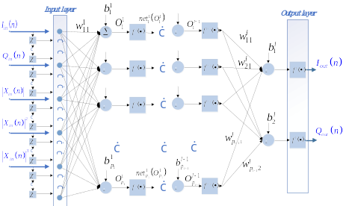
Fig. 1. The proposed augmented real-valued time-delay deep neural network.
- THE PROPOSED DPD
Fig. 1. illustrates the proposed ARVTD-DNN, whose input signal contains the current and past samples of the Cartesian I/Q components 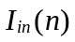 and 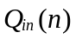 along with the envelope-dependent terms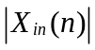. At any moment of the training sequence, the corresponding input signal vector is expressed as
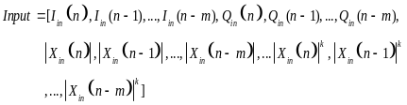 (1)
Where 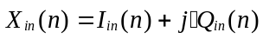, and is nonlinear order of 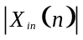 (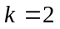 in this paper), and is the memory depth of the input vector (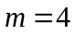 in this paper). The delayed response is achieved by using 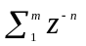as the delay operator, where 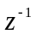is the unit delay operator that yields its delayed version 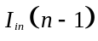 when operating on 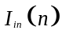.
The forward propagation is the same as the description in articles [2]-[6]. The backpropagation algorithm employed in this paper is the Levenberg-Marquart algorithm [7].
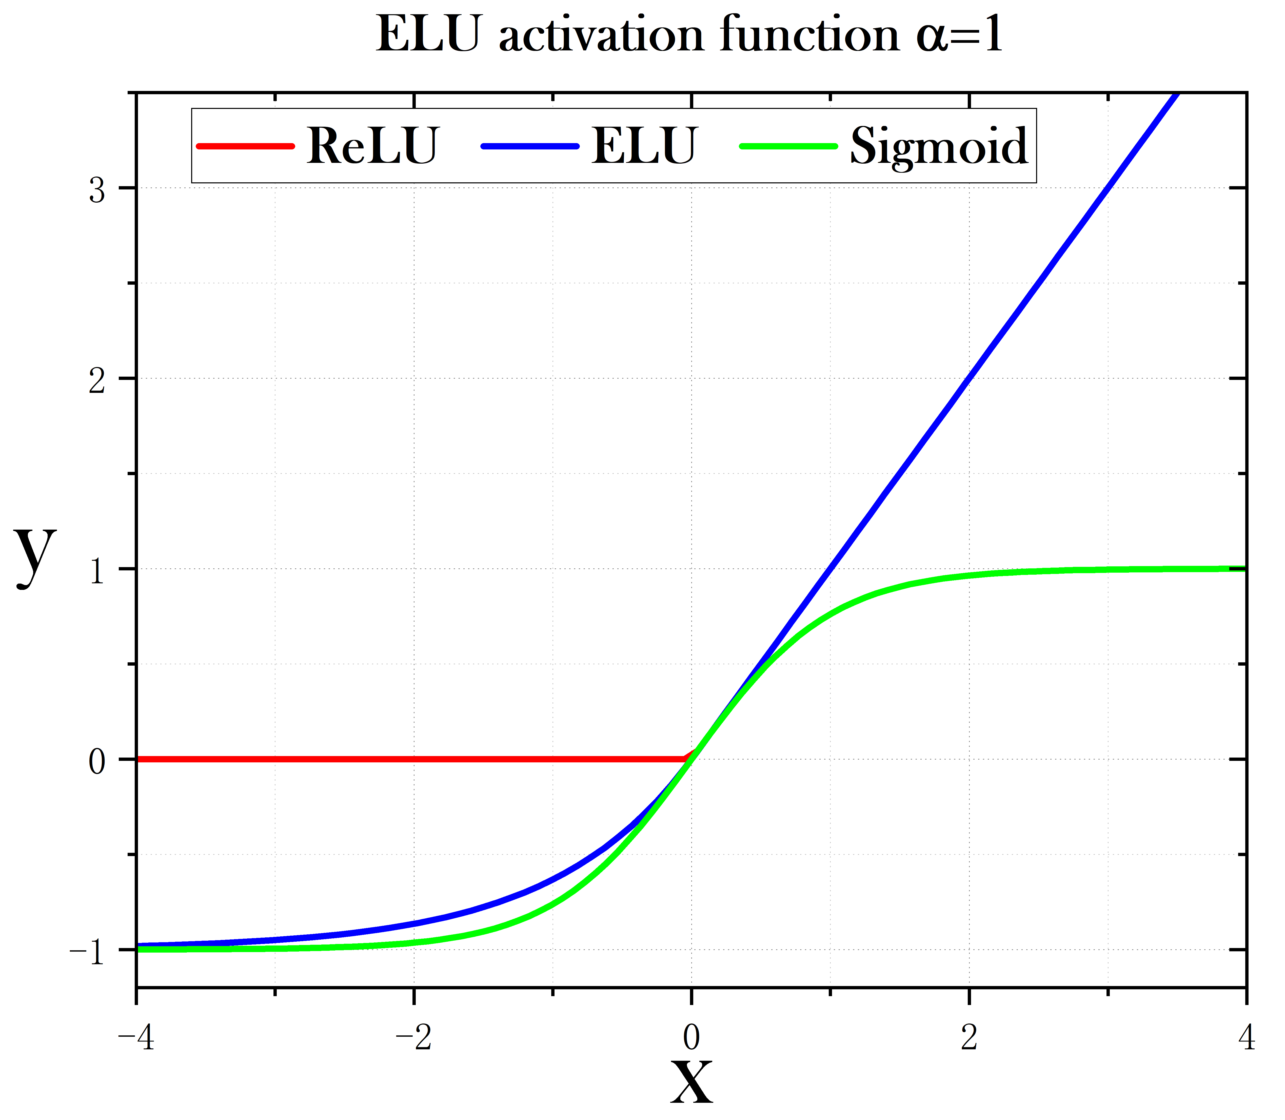
Fig. 2. Activations of Sigmoid, ReLU and ELU.
In [2]-[6], the activations of neurons in these techniques are Sigmoid (See Fig. 2.), which is mathematically equivalent to hyperbolic tangent given as
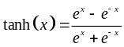 (2)
However, the use of the Sigmoid in DNNs may lead to gradient vanishing problem[8]. In [9], the ReLU was employed as a replacement for the Sigmoid to address the mentioned problem and achieved better compensation performance. However, in the reverse modeling process of PAs, for the purpose of achieving time alignment between input and output signals and speeding up the training of NNs, the signals used for modeling (both input and output vectors) are Gain-normalized. During testing, we observed a significant issue known as neuron death in DNNs using ReLU as the activation when these normalized samples were used. This problem arises because there are a number of negative values in the normalized samples, which causes the ReLU to shut down, leading to neuron death and ultimately causing the network training to fail[10]. In this paper, we introduce the Exponential Linear Unit (ELU)[11] to replace the Sigmoid. ELU overcomes the gradient vanishing problem and also avoids the neuron death associated with the use of ReLU as an activation.
The formula for the ELU activation (See Fig. 2.) is as follows, where is the hyperparameter whose value is 1 in this paper.
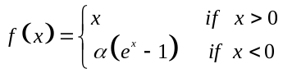 (3)
- Experimental results & discussion

TABLE I

PERFORMANCE OF DPDs
BW | Model | Num of Neurons | ACLR (L/U)(dBc) | ACPR (L/U)(dBc) | NMSE (dB) | EVM (%)
200MHz | w/o DPD | — | -21.0 / -25.3 | -24.3 / -27.3 | — | 14.4
200MHz | ML | — | -32.3 / -36.3 | -33.6 / -36.2 | -25.9 | 4.4
200MHz | DDR | — | -41.6 / -42.3 | -39.4 / -41.3 | -35.9 | 2.0
200MHz | RVTDNN | 17 | -42.6 / -43.8 | -41.9 / -43.8 | -36.5 | 1.6
200MHz | RVTDF-DNN | 122 | -43.5 / -46.0 | -43.4 / -46.2 | -38.9 | 1.8
200MHz | PROPOSED | 82 | -49.2 / -49.8 | -48.3 / -49.3 | -40.0 | 1.2

Fig. 3. illustrates the results of applying the ML-DPD to the SLCG PA under a 64QAM signal with a PAPR of 7.5dB and a modulation bandwidth of 10MHz. We observe, before ML DPD, that the PA provides an average power of around 30dBm, with an average efficiency of 35-48%, EVM of 2.5-7.2%, and ACPR of -29 to -35dBc. After applying ML DPD, EVM and ACPR can be reduced to less than 3% and less than -45dBc, respectively. This indicates that the SLCG PA can obtain good linearity under low-bandwidth modulation signals.
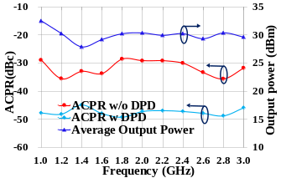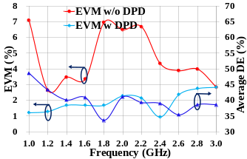
Fig. 3. The performance of SLCG under 10MHz-bandwidth signals.
For measurement and experimental validation purposes, the proposed ARVTD-DNN-DPD technique, adopting the indirect learning structure, is implemented on the MATLAB, which . The mentioned DPD methods, including ML-DPD, DDR-DPD, shallow-RVTDFNN (RVTDF-SNN) based DPD, deep-RVTDFNN (RVTDF-DNN) based DPD and the proposed DPD techniques, were compared for linearization performance on the SLCG PA (See Fig. 5.) operating in the 1-3GHz range with memory effects driven by wideband signals whose saturated output power is 36.6 dBm and the drain efficiency is 30% [12].
The RVTDFNN-DPD employs shallow and deep versions with 17 neurons and 122 neurons respectively, and the number of delay taps is set to 4[3][9]. The proposed DPD has 4 delay taps, 8 hidden layers (L=8), each with 10 neurons, and uses ELU as the activation. The number of samples for DPD is 9000 in each case. The output layer has 2 neurons with linear activations.
Above all DPD methods adopt an indirect learning structure. Fig. 4. also illustrates the measurement setup and the predistortion implementation process.
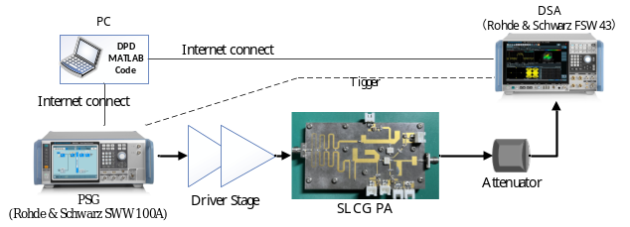
Fig. 4. The measurement setup and the predistortion implementation process.
The DPD results for a 200MHz-bandwidth 256QAM signal applied to the SLCG PA are presented in Table I and Fig. 5.
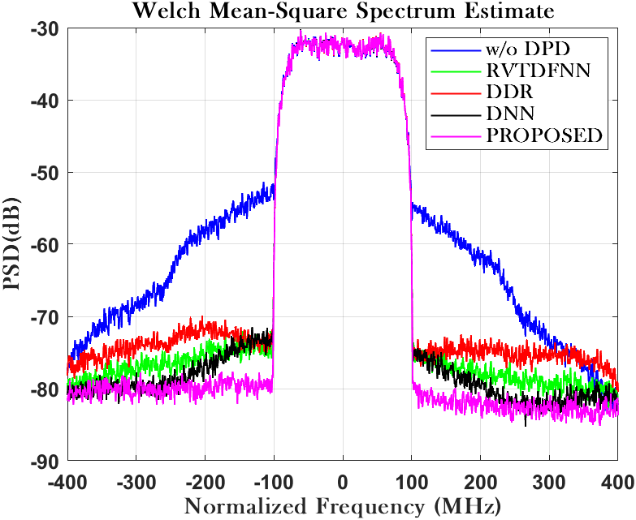
Fig. 5. Power spectral density in each case.
To further validate its linearization ability of the proposed DPD under large modulation bandwidth, its performance was experimentally measured under the signals with bandwidths of 20MHz to 240MHz (See Fig. 6.). It can be observed that the proposed model, compared to polynomial DPD and the RVTDFNN based DPD, exhibits better adaptability to the linearization requirements under large bandwidth signal conditions.
- Conclusion
This paper proposes the ARVTD-DNN-DPD technique, employing the ELU activation to replace the ReLU in DNN to avoid the neuron death and speed up the training of NN. Experimental verification using an SLCG PA demonstrates that the proposed DPD maintains excellent linearization performance and enhanced robustness in the case of large bandwidth. Compared to traditional polynomial DPD and the RVTDFNN based DPD, it shows a 5-7dB improvement in ACLR and ACPR, and around a 3-4dB improvement in NMSE. Additionally, the proposed DPD has lower computational complexity and faster convergence speed than RVTDF-DNN DPD. Meanwhile, under the drive of large-bandwidth signals exceeding 140MHz, the polynomial DPD and RVTDFNN based DPD lose their linearization capability, while the proposed DPD continues to perform effective linearization. These highlight the advantages of the proposed ARVTD-DNN-DPD technique in linearizing SLCG PA driven by large bandwidth signals.
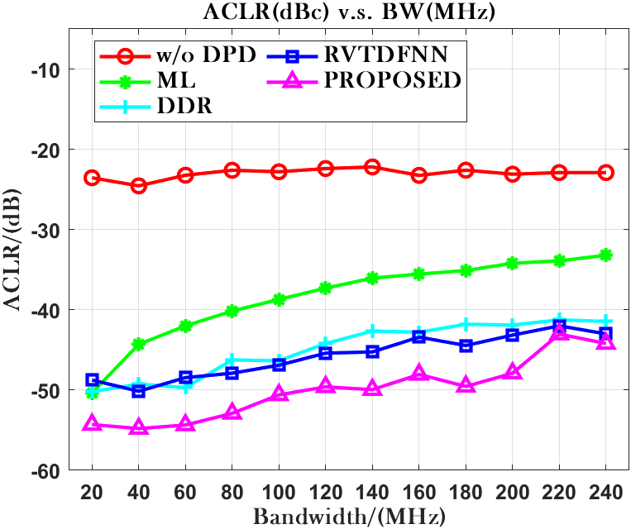
Fig. 6. Performance in NMSE(left) and ACLR(U)(right) v.s. BandWidth.

References
[1] Ghannouchi, Fadhel M. Behavioral Modelling and Predistortion of Wideband Wireless Transmitters. Hoboken: John Wiley & Sons Inc., 2015. Print.
[2] T. Liu, S. Boumaiza, and F. Ghannouchi, “Dynamic behavioral modeling of 3G power amplifiers using real-valued time-delay neural networks,” IEEE Trans. Microw. Theory Tech., vol. 52, no. 3, pp.1025–1033, Mar. 2004.
[3] Rawat, M., K. Rawat, and F.M. Ghannouchi. “Adaptive Digital Predistortion of Wireless Power Amplifiers/Transmitters Using Dynamic Real-Valued Focused Time-Delay Line Neural Networks.” IEEE transactions on microwave theory and techniques 58.1 (2010): 95–104. Web.
[4] Wang, Dongming et al. “Augmented Real-Valued Time-Delay Neural Network for Compensation of Distortions and Impairments in Wireless Transmitters.” IEEE transaction on neural networks and learning systems 30.1 (2019): 242–254. Web.
[5] Danh Luongvinh and Youngwoo Kwon, "Behavioral modeling of power amplifiers using fully recurrent neural networks," IEEE MTT-S International Microwave Symposium Digest, 2005., Long Beach, CA, USA, 2005, pp. 1979-1982, doi: 10.1109/MWSYM.2005.1517131.
[6] P. Jaraut, M. Helaoui, W. Chen, M. Rawat, N. Boulejfen and F. M. Ghannouchi, "Review of the Neural Network based Digital Predistortion Linearization of Multi-Band/MIMO Transmitters," 2021 IEEE MTT-S International Wireless Symposium (IWS), Nanjing, China, 2021, pp. 1-3, doi: 10.1109/IWS52775.2021.9499466.
[7] Hagan, M.T., and M.B. Menhaj. “Training Feedforward Networks with the Marquardt Algorithm.” IEEE transactions on neural networks 5.6 (1994): 989–993. Web.
[8] S. Haykin, Neural Networks: A Comprehensive Foundation. UpperSaddle River, NJ: Prentice-Hall, 1999.
[9] Hongyo, Reina, Yoshimasa Egashira, and Keiichi Yamaguchi. “Deep Neural Network Based Predistorter with ReLU Activation for Doherty Power Amplifiers.” 2018 Asia-Pacific Microwave Conference (APMC). IEICE, 2018. 959–961. Web.
[10] Lu Lu,Yeonjong Shin,Yanhui Su George E. Karniadakis.(2019).Dying ReLU and Initialization: Theory and Numerical Examples..CoRR
[11] Djork-Arné Clevert,Thomas Unterthiner Sepp Hochreiter.(2015).Fast and Accurate Deep Network Learning by Exponential Linear Units (ELUs)..CoRR
[12] X. Fang, R. Chen and J. Shi, "Switchless Class-G Power Amplifiers: Generic Theory and Design Methodology Using Packaged Transistors," in in IEEE Transactions on Microwave Theory and Techniques, accepted, doi: 10.1109/TMTT.2024.3351852.

