
II INSTITUTE OF AERONAUTICAL ENGINEERING
(Autonomous)
Dundigal, Hyderabad - 500 043

Electrical and Electronics Engineering

Name | B.Akash
Roll No | 25951A0516
Program | B.Tech
Semester | I Semester
Class | CSE-A
Regulation | R-25
Course Title | Basic Electrical and Electronics Engineering
Course Code | AEEE01
AAT-II | Assignment

Q1) A 200V DC shunt motor takes a total current of 100 A and runs at 750 rpm. The resistance of the armature winding and of shunt field winding is 0.1 and 40 ?, respectively. Compute (i) the torque developed by the armature, and (ii) copper losses. If the friction and iron losses amount to 1500 W, also calculate (iii) shaft power, (iv) shaft torque, and (v) efficiency
Answer:
Given:
- Supply voltage, $V=200\text{ V}$
- Total line current, $I_{L}=100\text{ A}$
- Speed, $N=750\text{ rpm}$
- Armature resistance, $R_{a}=0.1 Ω$
- Shunt field resistance, $R_{sh}=40 Ω$
- Friction + iron losses = 1500 W

Step 1: Shunt field current
$$I_{sh}=\frac{V}{R_{sh}}=\frac{200}{40}=5\text{ A}$$

Step 2: Armature current
$$I_{a}=I_{L}-I_{sh}=100-5=95\text{ A}$$

Step 3: Back emf
$$E_{b}=V-I_{a}R_{a} \\ E_{b}=200-(95×0.1)=200-9.5=190.5\text{ V}$$

(i) Torque developed by armature
Mechanical power developed:
$$P_{dev}=E_{b}I_{a}=190.5×95=18097.5\text{ W}$$
Angular speed:
$$ω=\frac{2πN}{60}=\frac{2π×750}{60}=78.54\text{ rad/s}$$
Torque developed:
$$T_{dev}=\frac{P_{dev}}{ω} \\ T_{dev}=\frac{18097.5}{78.54}≈230.5\text{ N\backslash cdotpm}$$
Torque developed = 230.5 N·m

(ii) Copper losses
Armature copper loss:
$$P_{Cu,a}=I_{a}^{2}R_{a}={95}^{2}×0.1=902.5\text{ W}$$
Shunt copper loss:
$$P_{Cu,sh}=VI_{sh}=200×5=1000\text{ W}$$
Total copper loss:
$$P_{Cu,total}=902.5+1000=1902.5\text{ W}$$
Copper losses = 1902.5 W

(iii) Shaft power
$$P_{shaft}=P_{dev}-\text{rotational losses}$$
Rotational losses = friction + iron = 1500 W
$$P_{shaft}=18097.5-1500=16597.5\text{ W}$$
Shaft power = 16.597 kW

(iv) Shaft torque
$$T_{shaft}=\frac{P_{shaft}}{ω} \\ T_{shaft}=\frac{16597.5}{78.54}≈211.5\text{ N\backslash cdotpm}$$
Shaft torque = 211.5 N·m

(v) Efficiency
Input power:
$$P_{in}=VI_{L}=200×100=20000\text{ W} \\ η=\frac{P_{shaft}}{P_{in}}=\frac{16597.5}{20000}=0.8299 \\ η≈82.99\%$$

Q2) A 120 V DC shunt motor draws a current of 200 A. The armature resistance is 0.02 Ohm, and shunt field resistance of 30 Ohm Find the back EMF. If the lap-wound armature has 90 slots with 4 conductors per slot, at what speed will the motor run, when the flux per pole is 0.04 Wb?
Answer:
Given:
- Supply voltage, $V=120\text{ V}$
- Line current, $I_{L}=200\text{ A}$
- Armature resistance, $R_{a}=0.02 Ω$
- Shunt field resistance, $R_{sh}=30 Ω$
- Number of slots = 90
- Conductors per slot = 4
- flux/pole = $ϕ=0.04\text{ Wb}$
- Lap wound → Number of parallel paths, $A=P$(unknown but will cancel out)

Step 1: Shunt field current
$$I_{sh}=\frac{V}{R_{sh}}=\frac{120}{30}=4\text{ A}$$

Step 2: Armature current
$$I_{a}=I_{L}-I_{sh}=200-4=196\text{ A}$$

Step 3: Back EMF
$$E_{b}=V-I_{a}R_{a} \\ E_{b}=120-(196×0.02) \\ E_{b}=120-3.92=116.08\text{ V}$$ Back EMF = 116.08 V

Step 4: Total number of armature conductors
Slots = 90
Conductors/slot = 4
$$Z=90×4=360\text{ conductors}$$

Step 5: EMF equation for a DC motor
$$E_{b}=\frac{PϕZN}{60A}$$
Where
- $P=$number of poles
- $A=P$for lap winding
→ So P cancels out.
Thus equation becomes:
$$E_{b}=\frac{ϕZN}{60}$$
Solve for speed $N$:
$$N=\frac{60E_{b}}{ϕZ}$$
Substitute values:
$$N=\frac{60×116.08}{0.04×360}$$
Compute denominator:
$$0.04×360=14.4$$
Compute numerator:
$$60×116.08=6964.8$$
Now:
$$N=\frac{6964.8}{14.4}=483.67\text{ rpm}$$

Q3) Classify types of DC generators and explain in detail the various losses of DC generator.
Answer:

Classification of DC Generators
DC generators are classified based on how the field winding is excited.

1. Separately Excited DC Generator
- Field winding is supplied by an external DC source.
- Field current is independent of armature current.
- Used in laboratories and electroplating.

2. Self-Excited DC Generator
In this type, the field winding receives current from the generator’s own armature.
Self-excited generators are further classified into:

(a) Series Wound DC Generator
- Field winding is connected in series with the armature.
- Field current = armature current.
- Produces high current at low speed; used in traction.

(b) Shunt Wound DC Generator
- Field winding is connected in parallel (shunt) with the armature.
- Field current is small and almost constant.
- Used in battery charging and lighting.

(c) Compound Wound DC Generator
Has both series and shunt field windings.
Two types:
- Cumulative Compound
  - Shunt and series fluxes aid each other → stronger field.
  - Used for lighting & power supply.
- Differential Compound
  - Series flux opposes shunt flux → weaker field.
  - Rarely used because it is unstable.

II. Losses in a DC Generator
Losses reduce efficiency. Total losses are classified into four main categories:

1. Copper Losses (I²R Losses)
These occur due to current flowing in the windings.
Types:
(a) Armature Copper Loss
$$P_{aCu}=I_{a}^{2}R_{a}$$
(b) Field Copper Loss
- Shunt field loss:
$$P_{sh}=VI_{sh}$$
- Series field loss:
$$P_{se}=I_{a}^{2}R_{se}$$
(c) Brush Contact Loss
Due to voltage drop at brushes (usually 1–2 V).
Copper losses increase with load, so they are variable losses.

2. Iron Losses (Core Losses)
Occur in the armature core due to rotation in the magnetic field.
Two types:
(a) Hysteresis Loss
Due to repeated magnetization/demagnetization.
$$P_{h}=ηB_{max}^{1.6}fV$$
Reduced by using silicon steel.

(b) Eddy Current Loss
Induced currents in the armature core produce heat.
$$P_{e}∝B^{2}f^{2}t^{2}$$
Reduced by laminating the core.
Iron losses are constant losses (almost independent of load).

3. Mechanical Losses
These include:
(a) Friction Losses
- Bearing friction
- Brush friction
(b) Windage Losses
- Air resistance due to rotating armature
Q4) A full wave bridge rectifier having load resistance of 100? is fed with 220V, Assuming the diodes are ideal, Find the following terms, DC output voltage Rectifier efficiency Peak inverse voltage
Answer:
Peak (maximum) value of the input
$$V_{m}=V_{rms}\sqrt{2}=220\sqrt{2}≈311.13\text{ V}$$

2) DC (average) output voltage $V_{dc}$
For an ideal full-wave bridge,
$$V_{dc}=\frac{2V_{m}}{π}$$
So
$$V_{dc}=\frac{2×311.13}{π}≈198.0\text{ V}$$

3) Rectifier efficiency $η$
Using the usual definition $η=\frac{P_{dc}}{V_{rms}I_{rms}}$(i.e. DC power delivered divided by the product $V_{rms}I_{rms}$) and the standard result for an ideal full-wave rectifier, the maximum theoretical efficiency is
$$η=\frac{8}{π^{2}}≈0.8106≈81.06\%$$
(You can also derive this from $V_{dc}=\frac{2V_{m}}{π}$and $I_{rms}=V_{m}/(\sqrt{2}R)$.)

4) Peak inverse voltage (PIV) for each diode
For a bridge rectifier each diode must withstand a reverse voltage equal to the peak of the source:
$$\text{PIV}=V_{m}≈311.13\text{ V}$$
(Compare: in a centre-tapped full-wave arrangement each diode would see $2V_{m}$PIV — but in a bridge each diode sees only $V_{m}$.)

- Final answers
- DC output voltage $V_{dc}$≈ 198.0 V
- Rectifier efficiency $η$≈ 81.1 %
- Peak inverse voltage (PIV) ≈ 311.1 V

Q5) For a transistor circuit having ?= 0.98, ICBO = ICO =5 ?A, and IB =100 ?A, find IC and IE.
Answer:
- Current gain (common base):
$$α=0.98$$
- Leakage current:
$$I_{CBO}=I_{CO}=5 μA$$
- Base current:
$$I_{B}=100 μA$$
We must find:
- Collector current $I_{C}$
- Emitter current $I_{E}$

Step 1: Use transistor current relation
For a transistor:
$$I_{C}=αI_{E}+I_{CBO}$$
Also, from current relation:
$$I_{E}=I_{B}+I_{C}$$
Substitute into first equation:
$$I_{C}=α(I_{B}+I_{C})+I_{CBO} \\ I_{C}=αI_{B}+αI_{C}+I_{CBO}$$
Rearrange:
$$I_{C}-αI_{C}=αI_{B}+I_{CBO} \\ I_{C}(1-α)=αI_{B}+I_{CBO}$$

Step 2: Substitute values
$$1-α=1-0.98=0.02 \\ I_{C}(0.02)=(0.98)(100μA)+5μA \\ I_{C}(0.02)=98μA+5μA=103μA \\ I_{C}=\frac{103μA}{0.02} \\ \boxed{I_{C}=5150 μA=5.15 mA}$$

Step 3: Find emitter current
$$I_{E}=I_{B}+I_{C} \\ I_{E}=100μA+5150μA=5250μA \\ \boxed{I_{E}=5.25 mA}$$

Final Answer
Quantity | Value
Collector current $I_{C}$ | 5.15 mA
Emitter current $I_{E}$ | 5.25 mA

Q6) Recall base width modulation in bipolar junction transistor.
Answer:
Base width modulation, also called the Early effect, refers to the reduction in the effective base width of a BJT when the collector–base junction reverse bias increases.

Explanation
In a BJT:
- The collector–base junction is reverse biased during normal operation.
- When the collector voltage increases, the depletion region at the collector–base junction widens.
- This widened depletion layer extends into the base region, thereby:
  - Reducing the effective base width
  - Allowing more charge carriers to reach the collector
As a result, the collector current increases slightly even when base current remains constant.

Q7) Sketch the small signal equivalent circuit of CE amplifier?
Answer:
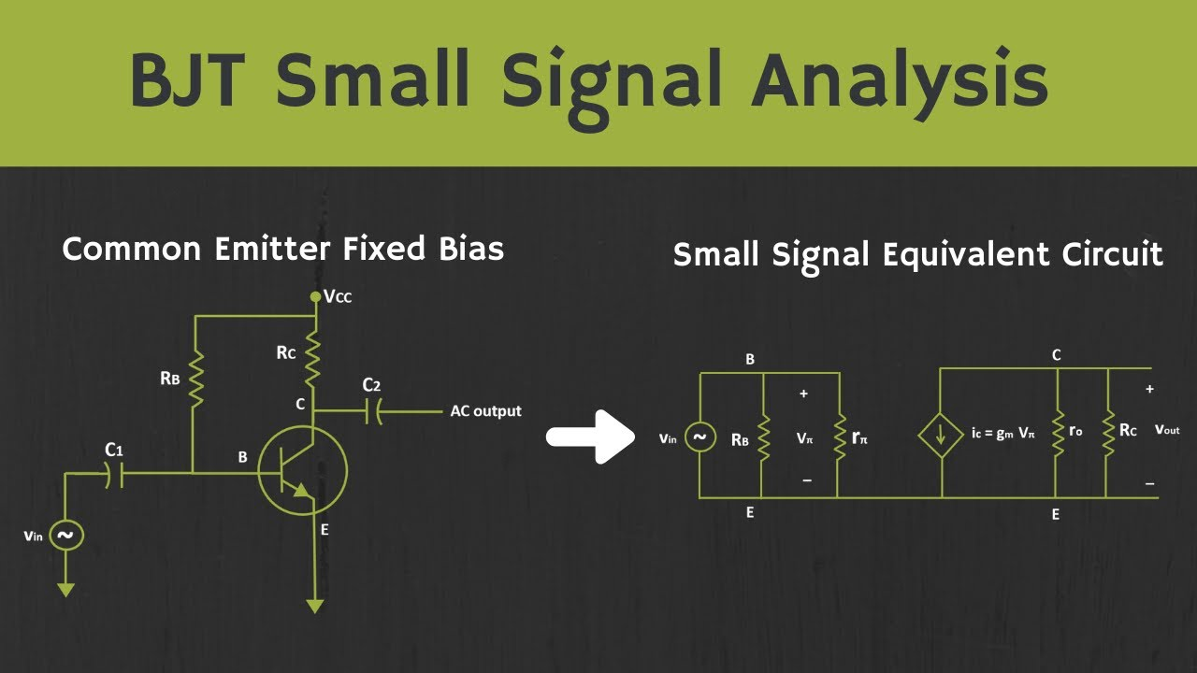

Q8) Sketch the small signal model of BJT Amplifier circuit.
Answer:
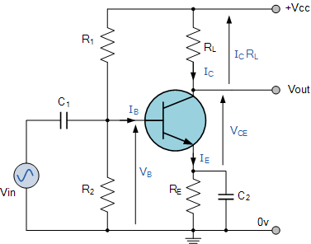

Q9) Draw a CB Amplifier and its Hybrid equivalent circuit? Solve the expressions for AIS, AV S and AP for Common Collector amplifier using H parameter model.

Answer:
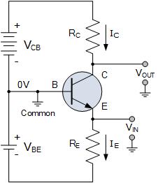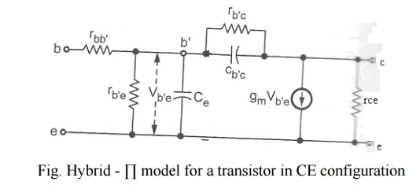
Small-signal h-parameter model (CE model used in CC connection)
For CE h-model:
- Between base and emitter: input resistance $h_{ie}$
- From collector to emitter: dependent current source $h_{fe}i_{b}$
Since in CC configuration the collector is at AC ground, the current source effectively pushes current into the emitter node.
Approximate relations (neglect $h_{re}$and $h_{oe}$):
- $i_{c}≈h_{fe}i_{b}$
- $i_{e}=i_{c}+i_{b}≈(h_{fe}+1) i_{b}$
Let:
- $R_{L}$= load at emitter
- $R_{S}$= source resistance

2.3 Input resistance seen at base
The emitter current flows through $R_{L}$. The equivalent input resistance at base:
$$R_{in(base)}≈h_{ie}+(h_{fe}+1) R_{L}$$
Intuition: the load at emitter is “seen” at base multiplied by the factor $\left(h_{fe} + 1\right)$.
If the source has resistance $R_{S}$, then the total seen by the source is:
$$R_{in(total)}=R_{S}+R_{in(base)}$$

2.4 Voltage gain $A_{VS}=\frac{V_{L}}{V_{S}}$
- Source voltage divider:
$$v_{b}=V_{S}⋅\frac{R_{in(base)}}{R_{S}+R_{in(base)}}$$
- Emitter voltage (output) is approximately the same as base minus small $v_{be}$. Using the h-model:
$$v_{e}≈v_{o}=\frac{(h_{fe}+1)R_{L}}{h_{ie}+(h_{fe}+1)R_{L}} v_{b}$$
So:
$$A_{VS}=\frac{V_{L}}{V_{S}}=\frac{v_{o}}{V_{S}}≈\underset{\text{source divider}}{\underset{⏟}{\frac{R_{in(base)}}{R_{S}+R_{in(base)}}}}×\underset{\text{local emitter follower gain}}{\underset{⏟}{\frac{(h_{fe}+1)R_{L}}{h_{ie}+(h_{fe}+1)R_{L}}}}$$
In practice, for a good emitter follower:
- $(h_{fe}+1)R_{L}≫h_{ie}$
- $R_{in(base)}≫R_{S}$
So:
$$A_{VS}≈1$$
(That’s why CC is called a voltage follower.)

2.5 Current gain $A_{IS}=\frac{I_{L}}{I_{S}}$
Let:
- $I_{S}$= current from source
- $I_{L}$= current in load $R_{L}$
Approximate relations:
- Load current: $I_{L}=\frac{V_{L}}{R_{L}}=\frac{v_{o}}{R_{L}}≈i_{e}$
- Emitter current: $i_{e}≈(h_{fe}+1)i_{b}$
Source current:
- Source current $I_{S}$flows into base network and effectively supplies base + emitter currents; but from small-signal viewpoint, majority of that is emitter current (for high h_fe). For approximate analysis, we can write:
$$A_{IS}=\frac{I_{L}}{I_{S}}≈\frac{(h_{fe}+1) i_{b}}{I_{S}}$$
Relating to resistances: with some algebra (treating entire base/emitter network as a load on the source), one gets:
$$A_{IS}≈\frac{(h_{fe}+1) \frac{R_{in(base)}}{R_{S}+R_{in(base)}}}{1}$$
In high-gain practical case:
- $R_{in(base)}≫R_{S}$
So:
$$A_{IS}≈(h_{fe}+1)$$
So the emitter follower gives:
- Large current gain ≈ $\left(β + 1\right)$
- Voltage gain ≈ 1

2.6 Power gain $A_{P}$
By definition:
$$A_{P}=\frac{P_{out}}{P_{in}}=\frac{V_{L}I_{L}}{V_{S}I_{S}}=A_{VS}⋅A_{IS}$$
So:
$$A_{P}≈A_{VS}×A_{IS}≈1×(h_{fe}+1)≈(h_{fe}+1)$$
(More accurately, plug in the full expressions for $A_{VS}$and $A_{IS}$above.)
Summary for Common Collector (Emitter Follower) using h-parameters
Using CE h-parameters ($h_{ie},h_{fe}$):
- Input resistance at base:
$$R_{in(base)}≈h_{ie}+(h_{fe}+1)R_{L}$$
- Voltage gain (with source):
$$A_{VS}=\frac{V_{L}}{V_{S}}≈\frac{R_{in(base)}}{R_{S}+R_{in(base)}}⋅\frac{(h_{fe}+1)R_{L}}{h_{ie}+(h_{fe}+1)R_{L}}≈1(\text{for practical design})$$
- Current gain:
$$A_{IS}=\frac{I_{L}}{I_{S}}≈(h_{fe}+1)(\text{practically})$$
- Power gain:
$$A_{P}=\frac{P_{out}}{P_{in}}=A_{VS}⋅A_{IS}≈(h_{fe}+1)$$
These are exactly the results examiners like:
CC amplifier → high input resistance, low output resistance, high current & power gain, voltage gain ≈ 1.

Q10) Draw a CE Amplifier and its Hybrid equivalent circuit? Solve the expressions for AI , AV , Zi and AP for Common Emitter amplifier using H parameter model.

Answer:


Deriving $A_{I}$, $A_{V}$, $Z_{i}$, and $A_{P}$for CE Amplifier
We’ll assume:
- Collector sees an effective AC load $R_{C}E=R_{C}∥R_{L}$.
- Emitter is AC-grounded (bypassed emitter resistor).
- Use CE h-parameter set: $h_{ie},h_{fe},h_{re},h_{oe}$.
- Input is applied at base; output at collector.
Let:
- $i_{1}=$input current (base current)
- $i_{2}=$output current (collector current)
- $v_{1}=$input voltage (between base and emitter)
- $v_{2}=$output voltage (collector to emitter; emitter at AC ground)
h-parameter relations (CE):
$$\begin{matrix}v_{1} & =h_{ie}i_{1}+h_{re}v_{2} \\ i_{2} & =h_{fe}i_{1}+h_{oe}v_{2}\end{matrix}$$
At the collector:
$$v_{2}=v_{o}=-i_{2}R_{CE}$$
(the minus sign because current entering the top of $R_{CE}$gives a negative voltage at the collector node w.r.t ground).

2.1 Current gain $A_{I}=\frac{i_{2}}{i_{1}}$
From:
$$i_{2}=h_{fe}i_{1}+h_{oe}v_{2}$$
But $v_{2}=-i_{2}R_{CE}$, so:
$$i_{2}=h_{fe}i_{1}-h_{oe}i_{2}R_{CE}$$
Bring $i_{2}$terms together:
$$i_{2}(1+h_{oe}R_{CE})=h_{fe}i_{1}$$
So:
$$\boxed{A_{I}=\frac{i_{2}}{i_{1}}=\frac{h_{fe}}{1+h_{oe}R_{CE}}}$$
Simplified (usually in exams): if $h_{oe}R_{CE}≪1$,
$$\boxed{A_{I}≈h_{fe}}$$
(i.e. current gain ≈ transistor β).

2.2 Voltage gain $A_{V}=\frac{v_{2}}{v_{1}}$
We already have:
$$v_{2}=-i_{2}R_{CE} \\ v_{1}=h_{ie}i_{1}+h_{re}v_{2}$$
Using the expression for $i_{2}$:
$$i_{2}=\frac{h_{fe}}{1+h_{oe}R_{CE}}i_{1}$$
So:
$$v_{2}=-R_{CE}⋅\frac{h_{fe}}{1+h_{oe}R_{CE}}i_{1}=-\frac{h_{fe}R_{CE}}{1+h_{oe}R_{CE}}i_{1}$$
Now $v_{1}$:
$$v_{1}=h_{ie}i_{1}+h_{re}v_{2}=h_{ie}i_{1}+h_{re}\left( − \frac{h_{fe}R_{CE}}{1+h_{oe}R_{CE}}i_{1}\right) \\ v_{1}=i_{1}\left[h_{ie} − \frac{h_{re}h_{fe}R_{CE}}{1+h_{oe}R_{CE}}\right]$$
Thus:
$$A_{V}=\frac{v_{2}}{v_{1}}=\frac{-\frac{h_{fe}R_{CE}}{1+h_{oe}R_{CE}}i_{1}}{i_{1}\left[h_{ie} − \frac{h_{re}h_{fe}R_{CE}}{1+h_{oe}R_{CE}}\right]}$$
Cancel $i_{1}$and simplify:
$$\boxed{A_{V}=\frac{v_{2}}{v_{1}}=- \frac{h_{fe}R_{CE}}{h_{ie}(1+h_{oe}R_{CE})-h_{re}h_{fe}R_{CE}}}$$
Common exam simplification: for most practical BJTs,
- $h_{re}≈0$
- $h_{oe}R_{CE}≪1$
Then:
$$A_{V}≈-\frac{h_{fe}R_{CE}}{h_{ie}}$$
or:
$$\boxed{A_{V}≈-\frac{h_{fe}(R_{C}∥R_{L})}{h_{ie}}}$$
That’s the famous CE amplifier with large AV and 180° phase inversion.

2.3 Input impedance $Z_{i}=\frac{v_{1}}{i_{1}}$
From:
$$v_{1}=h_{ie}i_{1}+h_{re}v_{2}$$
Using $v_{2}=A_{V}v_{1}$, but it’s easier to use $v_{2}$in terms of $i_{1}$we already had:
$$v_{2}=-\frac{h_{fe}R_{CE}}{1+h_{oe}R_{CE}}i_{1}$$
Then:
$$v_{1}=h_{ie}i_{1}+h_{re}\left( − \frac{h_{fe}R_{CE}}{1+h_{oe}R_{CE}}i_{1}\right) \\ v_{1}=i_{1}\left[h_{ie} − \frac{h_{re}h_{fe}R_{CE}}{1+h_{oe}R_{CE}}\right]$$
So:
$$\boxed{Z_{i}=\frac{v_{1}}{i_{1}}=h_{ie}-\frac{h_{re}h_{fe}R_{CE}}{1+h_{oe}R_{CE}}}$$
Simplified (common exam assumption): $h_{re}≈0$, so:
$$\boxed{Z_{i}≈h_{ie}}$$
(i.e. input impedance ≈ transistor’s h_ie.)
If there is a source resistance $R_{S}$or base bias network, then the total input impedance seen by source will be:
$$Z_{in,total}≈R_{S}+Z_{i}\text{(or with bias resistors in parallel as appropriate)}$$

2.4 Power gain $A_{P}$
Power gain:
$$A_{P}=\frac{P_{out}}{P_{in}}=\frac{V_{o}I_{o}}{V_{i}I_{i}}=\left(\frac{V_{o}}{V_{i}}\right)\left(\frac{I_{o}}{I_{i}}\right)=A_{V}⋅A_{I}$$
So, using our expressions:
$$\boxed{A_{P}=A_{V}⋅A_{I}=\left[ − \frac{h_{fe}R_{CE}}{h_{ie}(1+h_{oe}R_{CE})-h_{re}h_{fe}R_{CE}}\right]⋅\left[\frac{h_{fe}}{1+h_{oe}R_{CE}}\right]}$$
Simplified for exams, with $h_{re}≈0,h_{oe}R_{CE}≪1$:
$$A_{V}≈-\frac{h_{fe}R_{CE}}{h_{ie}},A_{I}≈h_{fe}$$
So:
$$\boxed{A_{P}≈A_{V}⋅A_{I}≈-\frac{h_{fe}^{2}R_{CE}}{h_{ie}}}$$
(Sign usually ignored for power gain; magnitude is what matters.)

Exam-style Summary (Common Emitter, using h-parameters)
With $R_{C}E=R_{C}∥R_{L}$and neglecting $h_{re}$, $h_{oe}$:
- Current gain
$$\boxed{A_{I}≈h_{fe}}$$
- Voltage gain
$$\boxed{A_{V}≈-\frac{h_{fe}(R_{C}∥R_{L})}{h_{ie}}}$$
- Input impedance
$$\boxed{Z_{i}≈h_{ie}}$$
- Power gain
$$\boxed{A_{P}≈A_{V}⋅A_{I}≈-\frac{h_{fe}^{2}(R_{C}∥R_{L})}{h_{ie}}}$$
These are exactly the forms teachers and examiners expect when they say:
“Solve expressions for $A_{I},A_{V},Z_{i}$, and $A_{P}$of CE amplifier using h-parameter model.”

