Группа: R3137

Выполнил: Пробыйголова Даниил

Вариант: 313716

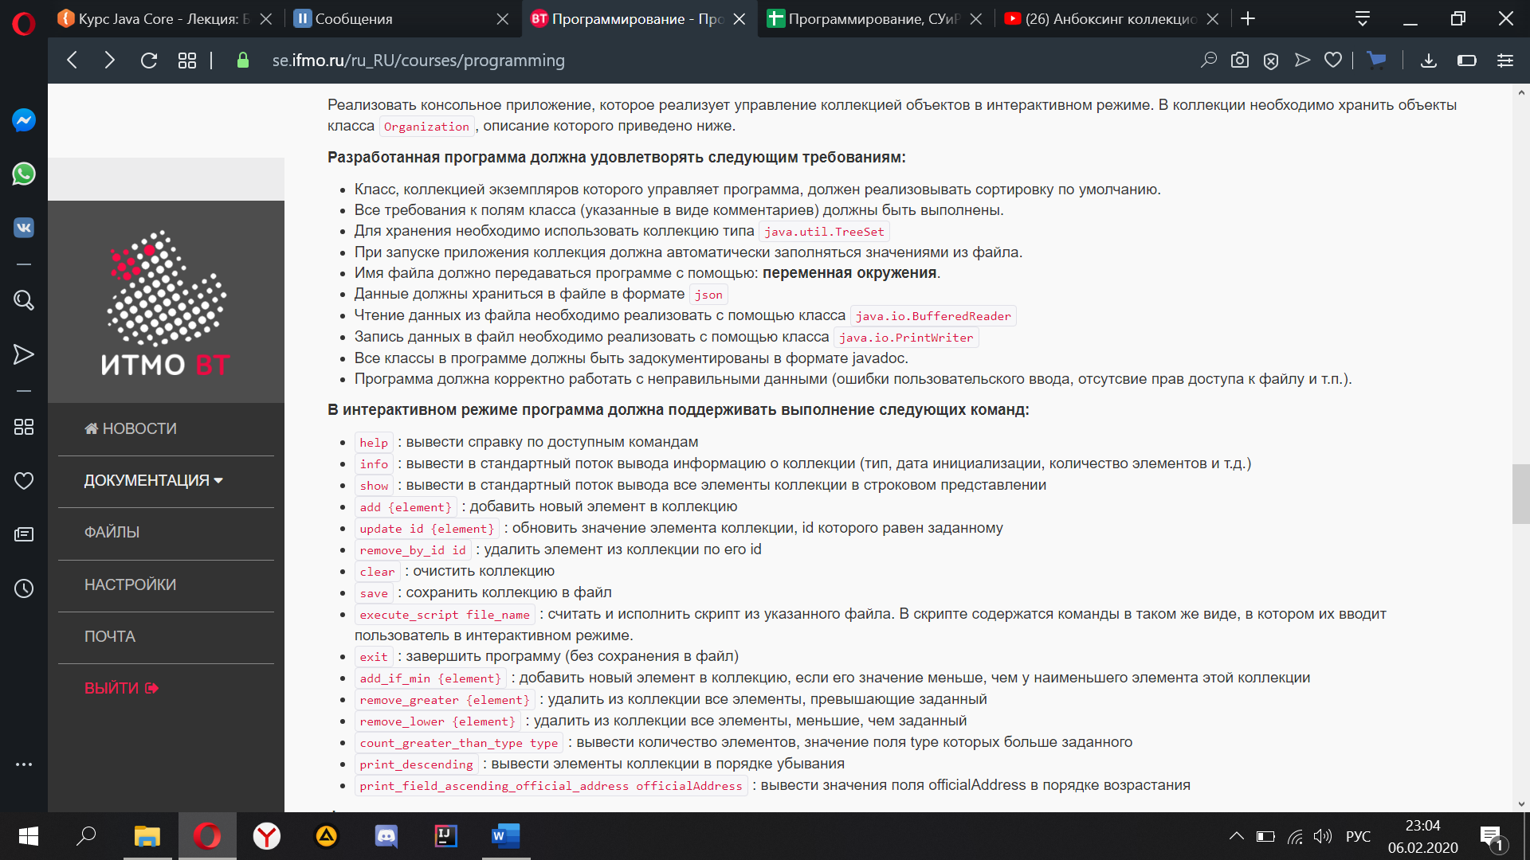Задание:

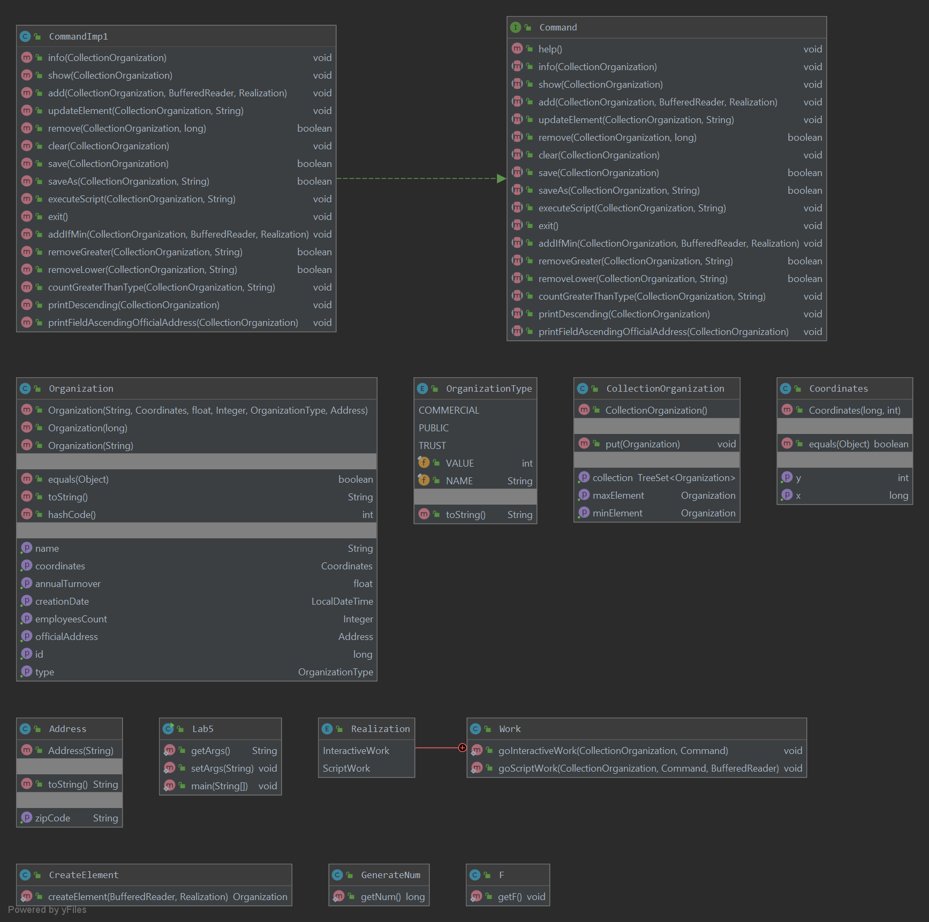UML:

Класс содержащий main(String[] args) :

import java.io.*;  
  
*/**  
 * this class starts the program  
 */*public class Lab5 {  
  
 private static String *address* = null;  
 public static String getArgs(){  
 return *address*;  
 }  
 public static void setArgs(String s){  
 *address* = s;  
 }  
  
 */**  
 *Creates a new object of the CollectionOrganization class.  
 *Created collection with objects from the file whose address is passed in the args variable[0]  
 \** ***@param*** *args address of thew file  
 \** ***@see*** *CollectionOrganization  
 \** ***@see*** *Work  
 */* public static void main(String[] args) {  
 try {  
 *setArgs*(args[0]);  
 } catch (ArrayIndexOutOfBoundsException e) {  
 System.*out*.println("нет переменных окружения");  
 }  
 CollectionOrganization collectionOrganization = new CollectionOrganization();  
 try {  
 FileInputStream fis = new FileInputStream(*getArgs*());  
 ObjectInputStream oos = new ObjectInputStream(fis);  
 Organization or;  
 while ((or = (Organization) oos.readObject()) != null)  
 collectionOrganization.put(or);  
  
 } catch (EOFException e) {  
  
 } catch(NullPointerException e){  
  
 }catch (IOException e){  
 System.*out*.println("Файл не найден");  
 }catch (ClassNotFoundException e){  
 System.*out*.println("переданный файл содержит объект, тип которого отличается от Organization");  
 }  
  
 Work.*goInteractiveWork*(collectionOrganization, new CommandImp1());  
  
 }// execute_script C:/Users/Daniil/Desktop/Универ/Прога/lab5/File/start.json  
}