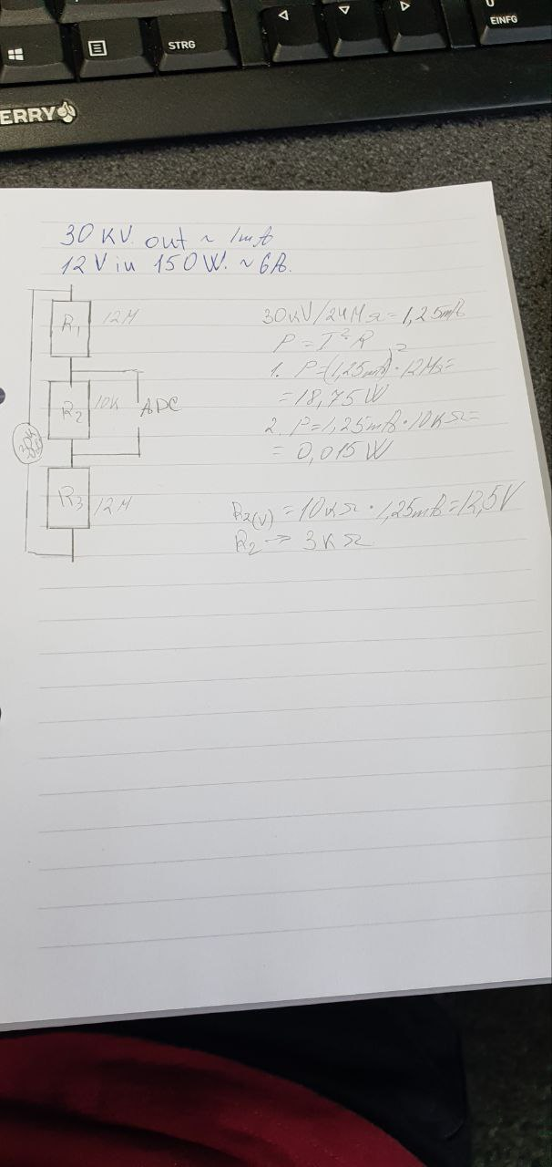

$V_{out}$ = 30kV

$V_{in}$ = 24V $A_{in}$ = 6.25A P = 150W

P = $I^{2}·R$

$I_{tot}$ = 30kV/200Mῼ = 150µA

$P_{1}=P_{3}$ = ${(150 µA )}^{2}$ $·$ 100Mῼ = 2.25W

$P_{2}$ = ${(150 µA )}^{2}·$ 10kῼ = 225µW

$V_{R1}$ = 150 µA $·$ 100Mῼ = 15V

$V_{R2}$ = 150 µA $·$ 10kῼ = 1.5V