

**Name** Communications Report 2014

**Writer** Robert Gabriel

**Lecturer** June O’Reilly

**Why the report was written** This Report was written to give evidence of what I accomplished over this semester in communications.

**When it was submitted** 09/12/2104

**Contents**

**Terms of Reference**:

(1) to provide a written account of work completed;

(2) to supply evidence of work completed;

(3) to assess your own performance and that of the groups you were in; (4) to display logical ability and attention to detail in the presentation of the report.

**Executive Summary** (summary of what you had to do for this module and what’s in the report)

**Soapbox Solos** (bullet-pointed summary of what you did) Final version here also.

**Email Duos:** final version in correct order (yours highlighted)

A bullet-pointed summary of what work you did is needed here.

**Debating Trios** (yours highlighted) A bullet-pointed summary of what you did is needed here.

**Email Communications**

**Other Communication Media**

**Schedule of Meetings Held**

**Performance Assessment**

**References**

**Appendices ABC**

# Executive Summary

## Soap Box

For this soapbox presentation. I was given the task to take something I hate and to rant or bitch about it for 10mins in front of the class. My soapbox was about the public education and the handling of people with dyslexia.. With this assignment, I had to see how my presentation skills were like and public speaking. I had to practise over and over again in front of a mirror. I then had to do the presentation in front of my lecturer June O'Reilly and the class..

## 

## Email Assignment

With this assignment, I had to write a letter(email) of complaint to my partner Tracey Nixon pretending to be a lecture over a small problem and blow in completely out of control. With this assignment, Tracey would then reply with a response.

## Debate Assignment

For this assignment I was in a group of Threes, Darren White, Michael Mahoney and Myself. We had to come up with a topic which was should the internet be censored and debate it front of the class. You had to do an introduction about the topic, the for the motion points, against, a three min interaction, questions and answers and then a final votes and comments on it by the mc. This had a lot of pressure on me as I had to Darren's part as well.

## Class Report

In class lectures , we were taught about different types of debating and speeches techinles. I also got feedback from june at different times about how to perform and speak better.

# Soapbox Bullet Points

What I did was

1. Picked different topics I hated
2. Said them to June.
3. We agreed on **funding for dyslexia in primary and secondary school.**
4. I wrote the first draft
5. Got it peered reviewed in the web class.
6. Practiced in front of the mirror .
7. Made another draft
8. Practiced tips June had said in class
9. Wrote final draft and got it spelled checked and reviewed.
10. Practiced it again
11. Performed it on the class.
12. Wrote the cue cards.
13. Did it in front of the class.

# Soapbox Script

Hello Everyone for people who don't know me, My name is Robert Gabriel and I'm from Web 3 in the computer department. The topic I'm going to talk (bitch) about is funding for dyslexia in primary and secondary school.

Every year, hundreds of children go through school with some sort of learning disability, such as dyslexia, not being able to read or write the same way everyone else. My problem with this is that schools only have the funding for one child a year to get tested for dyslexia. How can a school choose which child gets tested? Every tested student is entitled to readers, laptops, extra time in exams and spelling and grammar wavers in exams. Who makes this call? Which child gets tested over another? It sickens me that we are charged more money in taxes, but none of it is going back to the increasingly overcrowded schools and special needs students who are falling through the cracks.

The reason I have strong feelings about funding for people with dyslexia is that I always found

reading and writing difﬁcult. I didn't get tested in primary school because the school kept

dismissing my problems and the same thing happened in secondary school until two of my

teachers told my parents that I would be best dropping out of school after the Junior Certiﬁcate Pre-exams and told the class I didn't earn my pre-results.

My parents were unhappy to say the least and they caused a fuss, so I got tested. I ended up

getting the support I needed and my grades shot up . Life became sweeter for me when I entered a programming competition and won my school 5 thousand euros. I then went on to win several huge awards and work for major companies. The teacher who told my parents I should drop out apologised to me in from of the whole school.

However, every day, the question goes through my mind: what if I was never tested? How different would my life have been? Are there any children currently in the situation I endured, going through the same thing, but not being tested. Sadly there is still not enough funding for schools and the children who need it and this leaves me speechless with anger.

Thank you very much .

Robert Gabriel : R00102430

# Email due Orginal

Dear Ms Tracey Nixon,

My Name is Robert Gabriel (R00102430), I am currently a student at CIT studying computer science with web development (Web 3). I am sending you this letter, in the hope that you could rectify an issue not just for myself, but also for the greater, younger entrepreneurs and inventors studying at CIT. It has to do with the lack of pure American style candy in the local CIT shop.

As an entrepreneur/inventor in CIT, I first hand can attest to the benefits of consuming the chemically colored, sugar and energy filled, carbohydrate busting, freedom fighting American candy. The likes of Reese's cups, Jolly Ranchers and Big Reds offer these benefits unlike the candy brands within Europe that are strictly controlled by the European Food Safety Authority. I'm sad to say that these candies seem to be missing in CIT shop shelves. The reason for my request is that chemicals in the pure American candy give the same effect of LSD without the stigma. The sugar LSD effect allows the mind to expand beyond the limiting walls of thought, the same walls which we are taught to overcome in the current school system when it comes to problem solving and creative thinking. It annoys me that we do not have the opportunity to use this sugar high as inspiration for new ideas and businesses. Are you limiting us so that we don't leave college to start a business? If so, what is the point of the relationship with the Rubicon and innovation?

This is an issue of the greatest of importance and should be addressed at the earliest convenience of the staff of CIT, I live in hope that a solution can be devised so that more American candy will reach the shelves of the CIT shop. I hope this problem can be resolved before it affects CIT’s and the student's reputation and relationship with companies after graduating.

Warm regards

Robert Gabriel

Chairperson of the Idea Hub

“Taking LSD was a profound experience, one of the most important things in my life. LSD shows you that there’s another side to the coin, and you can’t remember it when it wears off, but you know it. It reinforced my sense of what were important—creating great things instead of making money, putting things back into the stream of history and of human consciousness as much as I could.” Steve Job

Email Improved

Dear Ms Tracey Nixon,

My Name is Robert Gabriel (R00102430). I am currently a student at CIT studying computer science with web development (Web 3). I am sending you this letter in the hope that you could rectify an issue not just for myself, but also for the younger entrepreneurs and inventors studying at CIT. It has to do with the lack of pure American style candy from in the local CIT shop.

As an entrepreneur/inventor in CIT, I first-hand can attest to the benefits of consuming the chemically colored, sugar and energy filled, carbohydrate busting, freedom fighting American candy. The likes of *Reese's cups*, *Jolly Ranchers* and *Big Reds* offer these benefits, unlike the candy brands within Europe that are strictly controlled by the European Food Safety Authority. I'm sad to say that these candies seem to be missing from CIT shop shelves.

The reason for my request is that chemicals in the pure American candy give the same effect of LSD without the stigma. The sugar LSD effect allows the mind to expand beyond the limiting walls of thought, the same walls which we are taught to overcome in the current school system when it comes to problem-solving and creative thinking. It annoys me that we do not have the opportunity to use this sugar high as inspiration for new ideas and businesses. Are you limiting us so that we don't leave college to start a business? If so, what is the point of the relationship with the Rubicon and the idea of innovation?

This is an issue of the greatest of importance and should be addressed at the earliest convenience by the staff of CIT, I live in hope that a solution can be devised so that more American candy will reach the shelves of the CIT shop. I hope this problem can be resolved before it affects CIT’s and the student's reputation and relationship with companies after graduating. I look forward to your response.

Warm regards

Robert Gabriel

Chairperson of the Idea Hub

“Taking LSD was a profound experience, one of the most important things in my life. LSD shows you that there’s another side to the coin, and you can’t remember it when it wears off, but you know it. It reinforced my sense of what were important—creating great things instead of making money, putting things back into the stream of history and of human consciousness as much as I could.” Steve Job

# Debate Argument: What I did .

* Researched the project
* Tried multiple times to get Darren.
* Took Darrens part on as well after he dropped out without telling us.
* Wrote two speeches.
* Praised with Michael.
* Wrote drafts of the power point.
* Practiced with Michael
* Discussed with Michael the flow of the debate.
* I did the was the mcing ,and the opposite motion.

# 

# 

# 

# Debate Argument

**Motion:** That the internet should be censored.

## Robert Gabriel WEB3 - MC

**Introduction**

Hello, everyone and welcome here today to the Batcave look alike. My Name is Robert Gabriel and I will be your Mc today for the motion The internet should be censored. I'm also joined here today by Michael Mahony who is for the motion and My identical twin brother also called Robert Gabriel.

**History about topic**

So First can I get a raise of hands for the people who know who the man behind me is. Oh for the people who don't know the man behind me is called Julian Assange. He is the founder of famous website called WikiLeaks. The website international, online, non-profit, journalistic organisation which publishes secret information, news leaks, and classified media from anonymous sources. It can into the public eye in 2010 when a USA marine upload the tragic files, where it show videos and documents of the USA killing innocent people and testing weapons. The media was and wasn't reporting on it, fox news famously not reporting everything about. Julian Assange was forced to feel the USA.

Another person called Edward Snowden also had another faith were he released more files to WikiLeaks. The files he released he got from working as NSA the national security agency it support and had access to files stating how and why the USA where listing into their people's phones, internet history and more. He also had to leave the country. He's currently living in Russia with a 5 year visa.

So should the people have access to this information or is it censorship.

**Flow of today and Voting**

Today Michael and Darren will make points for and against the reasoning on this. Before they start can I get a show of hands on if people think the internet should be censored.

**\*Gets amount of votes, write on board\***

So before we start I ask people to turn their phones, pages etc on silent or off. Also please no taking.

So Please welcome Michael on stage who is for the internet being censored.

Thank you Michael, can we give Micheal round of applause.

Now that we have heard from Michael on why the internet should be censored. Can we give a warm welcome my twin Robert on why the internet shouldn't be censored .

Thank you Robert, can we give Robert round of applause also.

So to get a debate going, how do you each thinking about the fact that millions are stole every day online?

Now that Darren and Michael has gotten their points across. We will open the floor to Questions and answers for both parties. Please raise your hand and I will pick people to ask. Everyone will get there questions answers.

*Ask questions here.*

Okay that's perfect , now the questions and answers are finished,

Can I get another show of hands on which people think? If their minds have been changed?

*Takes votes*

Thank you for everyone for coming today. I hope everyone has a great day.

**Motion:** That the internet should be censored.

## Robert Gabriel WEB3 - Oppose the Motion

**Introduction**

Thank you, Robert.

My name is Robert, and As Robert Said I'm against the motion that the internet should be censored.

**Too Much Government Control**

My first point is Too Much Government Control. What is meant by this? Like discussed earlier, The Government doesn't always make the right choice. Who or what should be in charge of what people or people can see. Going back to the Edward Sweden, choices the governments make are not allows for the best. In a larger scale, who should make these choose. It will become a power struggle, where innocent websites will be flagged for no reason and the public will have to suffer. Who has the right to say what is banned and what isn't.

**Laws that are already there**

For my second point, I look towards to laws that are already there. Laws against things like inciting crime and child pornography. Not by censoring the internet at the risk of infringing on innocent people's speech. Us as people have the right to say whatever we want online, why should new laws be brought in online when the laws that are there at the moment are not working. The internet has been called its own country in past papers. You cannot control it but better to embrace it.

**Blatant violation of Internet privacy and freedom of press**

I would like for my third point, bring your attending to the fact its a blatant violation of Internet privacy and freedom of press. That if the internet was censored it would violate our freedom to express ourselves online not matter what the topic. All you have to do is look toward North Korea, to why it's a bad idea. In North Korea, all media are censored, the people have no idea what is going on, all they think is their leader is perfect and the north America is the center of hell. It's wrong and people should have the right to all information to matter what. Just look at what Edward Snowden did, it gave awareness to privacy on the internet.

**People asking for help / Turkey's wars. & Conculsion**

My last and final point is short but strong, Being able to help and change the world and getting your message out, for example, the use of this during Turkey's wars.

For people who don't know what happened twitter was used by civilians to send messages of help to the outside world about what the Turkish government was doing. These messages started to get censored until the civilians started to code their messages. There messages spread and got out, it highlighted the censorship but it also allowed for them to get help.

It can only be imagined how else this might have turned out if there messages where never come out. How could the internet be unreasoned.

Thank you very much, these were by four points.

## Debate Argument

## Cue Cards : Oppise

Welcome

1. My Name is Robert Gabriel
2. I’m Against the motion.
3. I have 4 points.

Point one

1. Too Much Government Control.
2. Julian Addison
3. Edward sdown
4. Innocent websites

Point Two

1. laws that our already there
2. Not by censoring the internet at the risk of infringing on innocent people's speech
3. new laws ?
4. You cannot control it but better to embrace it.

Point Three

1. blatant violation of Internet privacy and freedom of press
2. North korea
3. people should have the right to all information
4. edward snowden did

Point Four

1. Turkey unrest , uprising
2. Twitter for freedom of speech
3. Turkey Censoring tweets about it.
4. Getting the message out.
5. How could it turn out.

# 

None for the Mc

# Email Communications

|  |  |  |  |
| --- | --- | --- | --- |
|  |  |  |  |
|  | | |

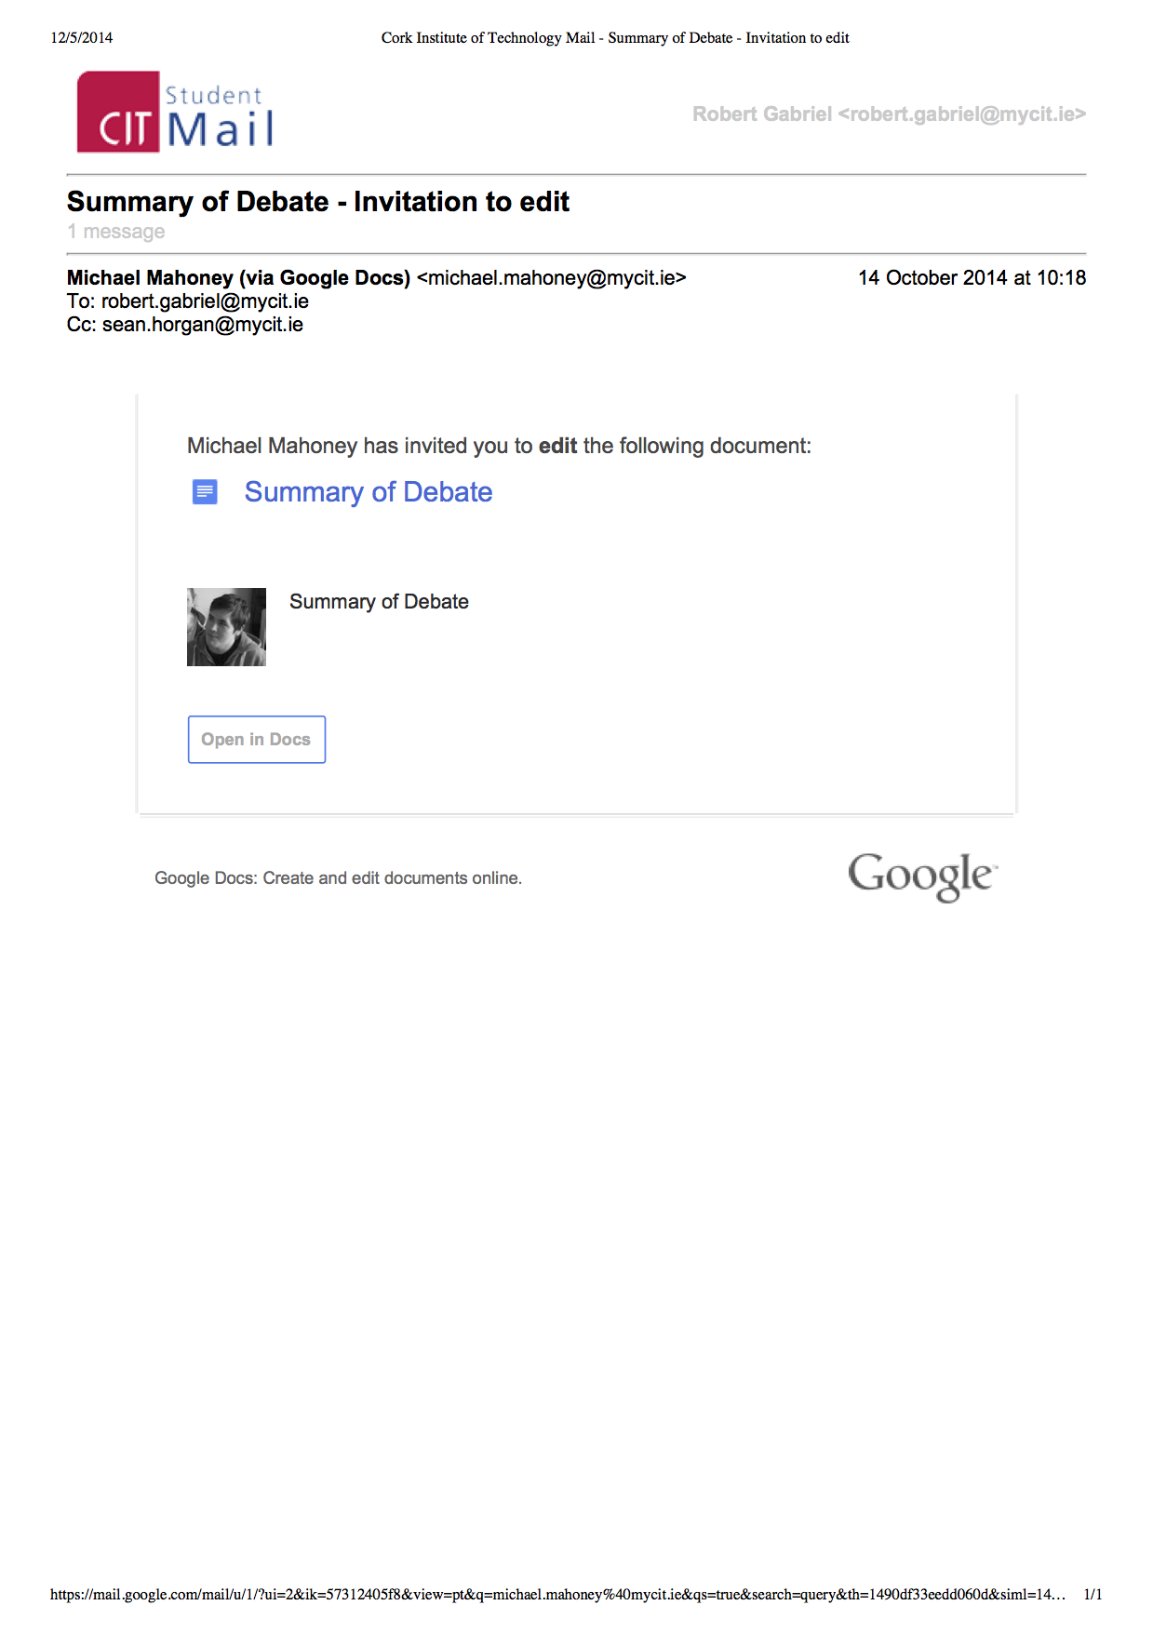

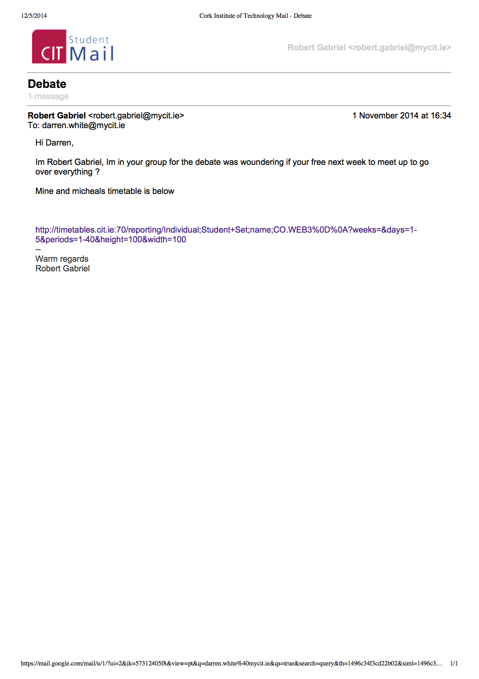

|  |
| --- |
|  |

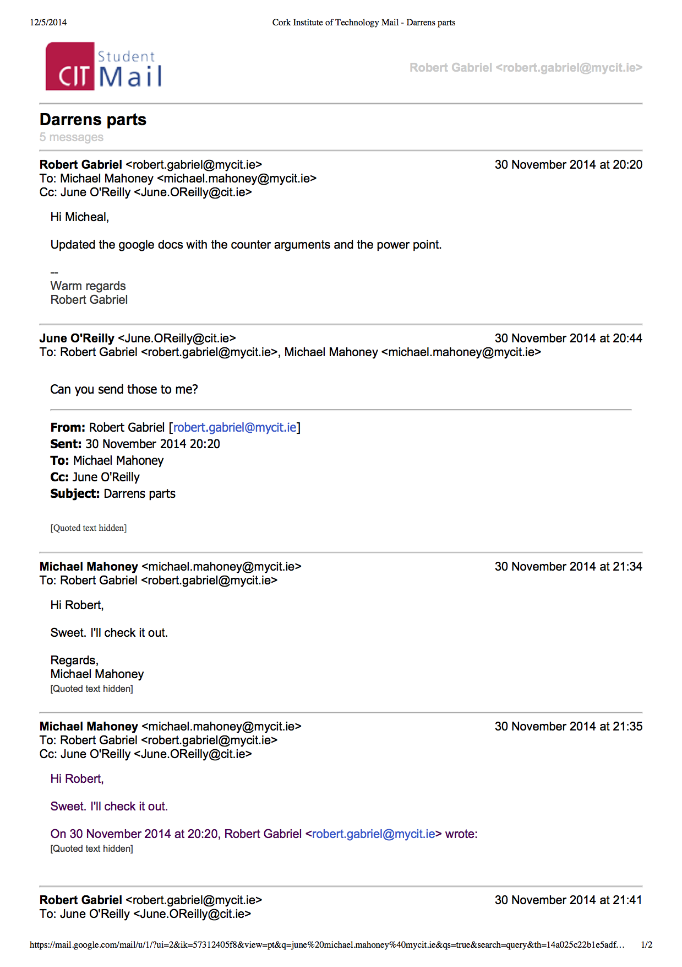

|  |  |
| --- | --- |
|  |  |
|  | |
|  | |

# Other Communications Media

|  |  |
| --- | --- |
| Google Docs | Google Slide Show |
| **4 December, 17:24**  Robert Gabriel  3 December, 14:29  Robert Gabriel  1 December, 13:59  Robert Gabriel  30 November, 20:18  Robert Gabriel  28 November, 11:28  Michael Mahoney  28 November, 10:57  Michael Mahoney  Robert Gabriel  28 November, 10:54  Robert Gabriel | **Today, 00:03**  Robert Gabriel  30 November, 20:14  Robert Gabriel  23 November, 00:57  Robert Gabriel  18 November, 09:55  Robert Gabriel  12 November, 12:47  Darren White  Robert Gabriel  11 November, 14:38  Michael Mahoney  Robert Gabriel  4 November, 19:14  Robert Gabriel  2 November, 18:37  Robert Gabriel  2 November, 12:58  Robert Gabriel  1 November, 16:51  Robert Gabriel  29 October, 12:28  Robert Gabriel  29 October, 11:26  Robert Gabriel  28 October, 12:00  Darren White  28 October, 10:53  Michael Mahoney  25 October, 13:12  Michael Mahoney  19 October, 15:17  Michael Mahoney  15 October, 15:46  Michael Mahoney  14 October, 10:51  Michael Mahoney  Robert Gabriel  14 October, 10:19  Michael Mahoney |
| https://docs.google.com/presentation/d/1rgf6a4kgp3nx5XjMNh8v3h2FMIEqu1Z10IvjtBerbKE/edit?usp=sharing | https://docs.google.com/a/mycit.ie/document/d/1oQUjBmLd-rmtH_Y366IRX3umcGKLj99EQH2VSp-0CHE/edit?usp=sharing |

**Schedule of Meetings Held**

Note : Because Michael and Robert are in the same class, we just talked after class.

**Meeting One**

**Date:** 08/10/2014

**Meeting Place:** F1.2

**Attended:** Michael Mahoney, Robert Gabriel, Sean Horgan

**Details:** Our group was formed today and we went straight into discussing what motion we would debate. We decided on the motion “that the the internet should be censored”. We also decided on our roles; Robert is the MC, Michael is to support and Sean is to oppose.

**UPDATE:** Sean is no longer doing Communications. Our third member is now Darren White.

**Meeting Two**

**Date: 28/10/2014**

**Meeting Place:** IT1.3

**Attended:** Michael Mahoney, Robert Gabriel, Darren White

Details: Today was to be the first day in which we meet the mystery wrapped in an enigma that is Darren White. The room was occupied so we decided to meet just outside the room instead. After some waiting Darren appeared to us. We introduced ourselves and decided on what must be done for our first rehearsal that day.

And just like that he was gone. it was all of 3 mins we spent with him

**Meeting Three**

**Date:** 28/10/2014

**Meeting Place:** IT1.3

**Attended:** Michael Mahoney, Robert Gabriel

**Details:** We discussed possible options to go without Darren. We thought of sock puppets, balloons with smiley faces and more.

We also reviewed the scripts and talked about the layout. There is rumor of sandwiches which made us work faster and harder.

**UPDATE:** Robert is doing mc and optimise

**Meeting Four & Five & Six**

**Date:** 28/10/2014

**Meeting Place:** IT1.3

**Attended:** Michael Mahoney, Robert Gabriel

**Details:** Meetings Four, five and six are a lot alike, where we practiced and changed are presentations based on the feedback we got from June. We discussed different way we can do the debate. Who should go first. What to wear and so on.

We also talked about different jokes and topics.

## Notes from Debates

**Water charges**

There is no more broadcast licences.

Why should we follow germany , when it the government that can't be trusted,

**Hookers**

Dont you think the laws would help against rape and the like if it was allowed ?

Wheres the proof this wouldn't work ?

**Weed cannabis**

Where are you getting your figures from ? (Note theses are not making sense )

**Death Penalty**

How about both of you feel if your family member was about to be put to death.

**Video Games are good for you**

What your thoughts on videos being banned , should that be allowed if there both good and bad for you ?

**Beer on campus**

This is for the person for, wouldn't it be best to test it on a slow roll out, and not to have to spirits, Don't you think thats correct way to go about it .

**Mobile phones,**

This is for againt , this is correct , mobile phones are not running it . The times have changed , for the better , why its simply replacing the tv. They have said this problem every time a new gadget comes away.

## Power point





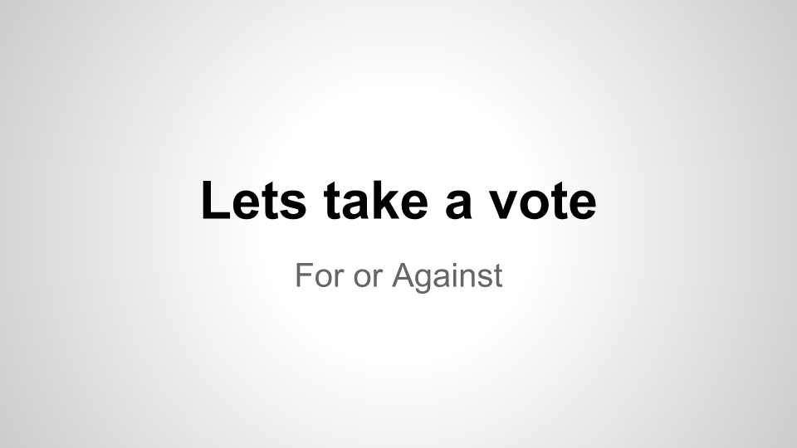

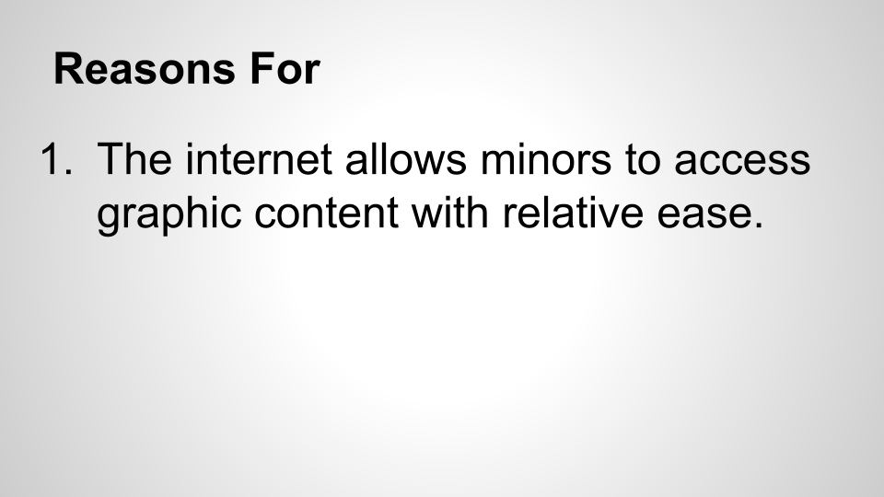

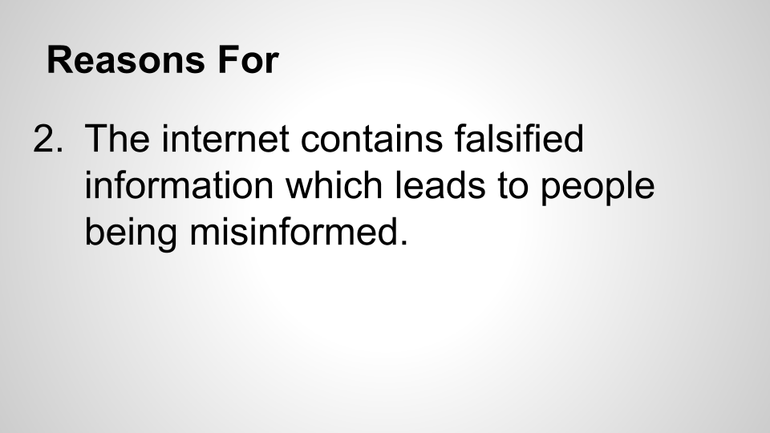

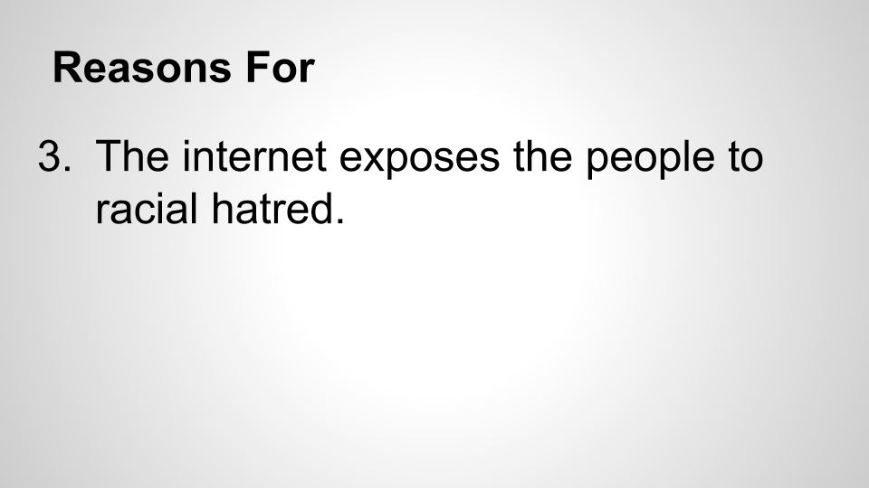

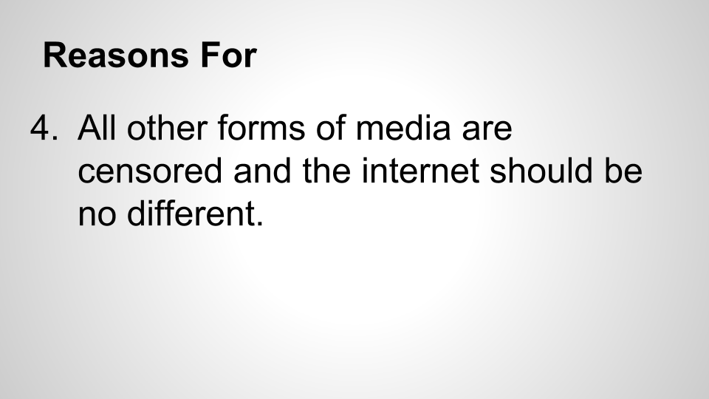

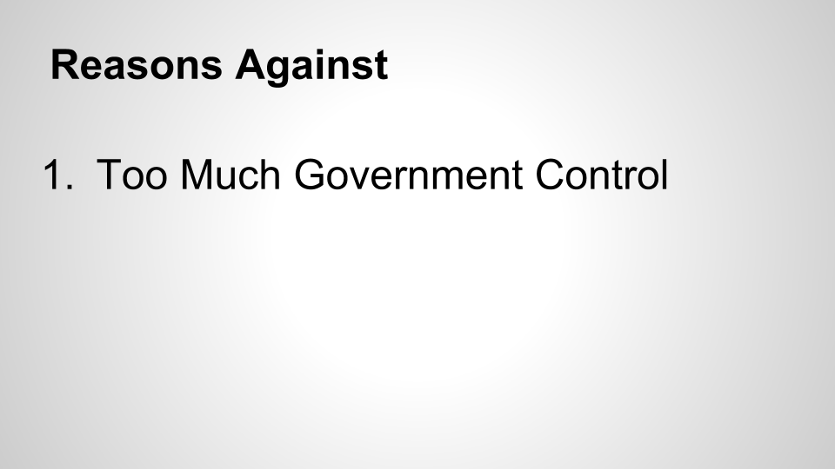

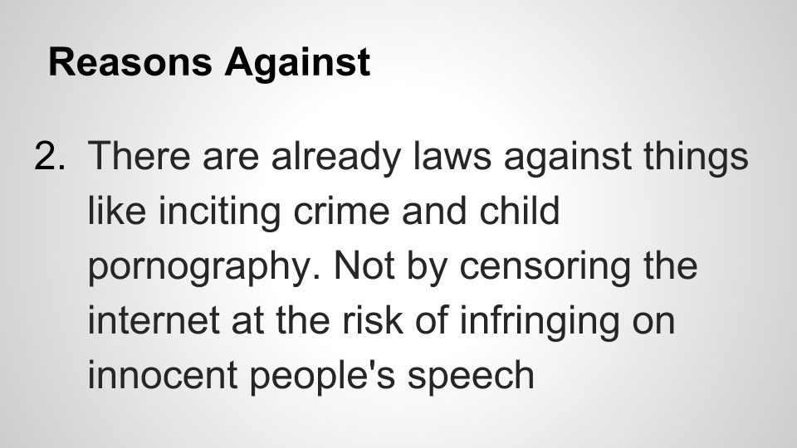

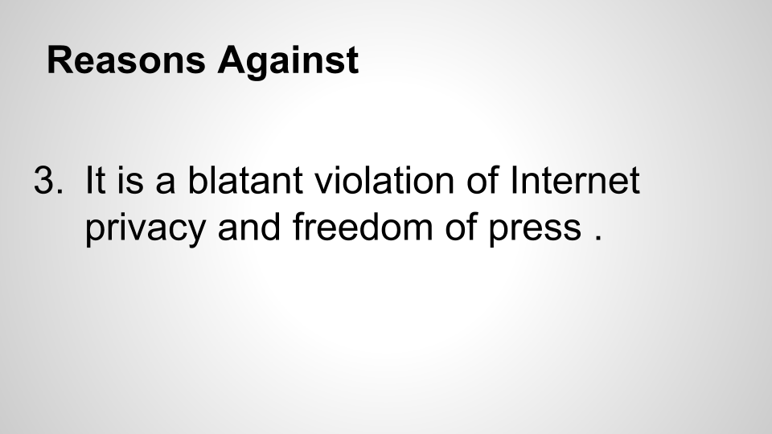

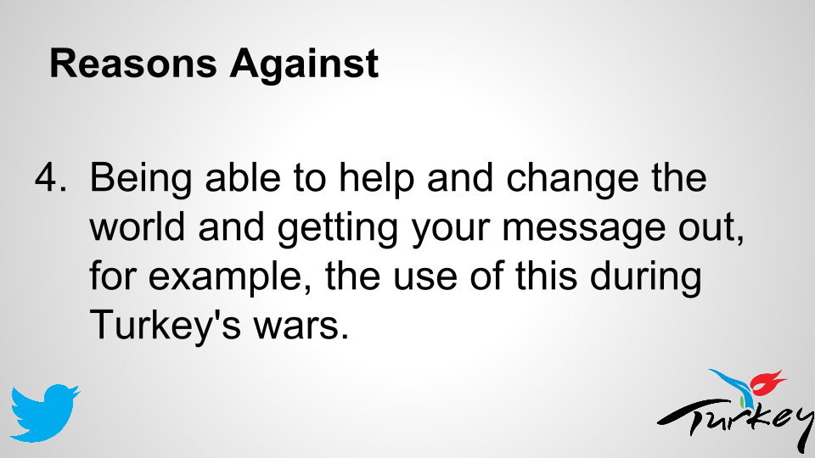







# Performance Assessment

For a Performance assessment is hard to write about fairly , Buy what I can say about it is I gained a lot of experience when participating in this module as I had to learn a lot of new interesting things from making new friends , getting used to public speaking and writing essays even with the dyslexia. I learnt the importance of communications through email, for one it's important to respond which I got better at as the weeks went on. Two it's also a record of people talking. It helped me discuss and improve on thinking on the spot and how to handle a crowd in huge numbers.

Overall I gained great experience, even if it was just getting to know my team members better and working as a group. I would recommend picking this topic but making it exciting.

With the extra pressure of having two speeches and writing made it more difficult than normal , but overall i would give myself 78% for the reason , I did a lot of research, practicing , but I did make mistakes though the module and improved on them , like speaking and involving the crowd. I stepped up for the sake of the group when needed, which put a lot of pressure on myself at the last moment and took Darren's part on. The sandwiches were amazing. I asked questions to June , and got feedback when needed.

Overall I loved the module and do think my score for this should be between 68 - 78 %. As there are places I could have improved on, but the things I learnt from this module and Michael agrees helped us in the Third-year group project presentation and made it way easier for us. That alone helped us practice and Improve on our presentations and public speaking.