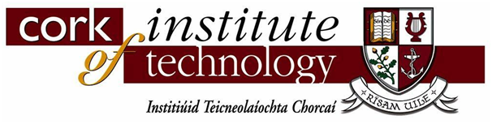

Do we need the cit logo ?



CrossTrainr

By

Team CrossTrainr

|  |
| --- |
|  |
|  |

About CrossTrainr

Team CrossTrainer consists of four students from Cork Institute of Technology (CIT), who all have a passion for technology and innovation. This is the second year that three of us have entered the Innovation Category in the Imagine Cup. Last year we entered with a rendering search engine that eliminated buffering of videos and images and came second in the Innovation Category in Dublin. This was a massive achievement for us as a team and for our college as we were the first team from CIT to enter the competition. This year we have worked hard and hope to progress further in the competition.

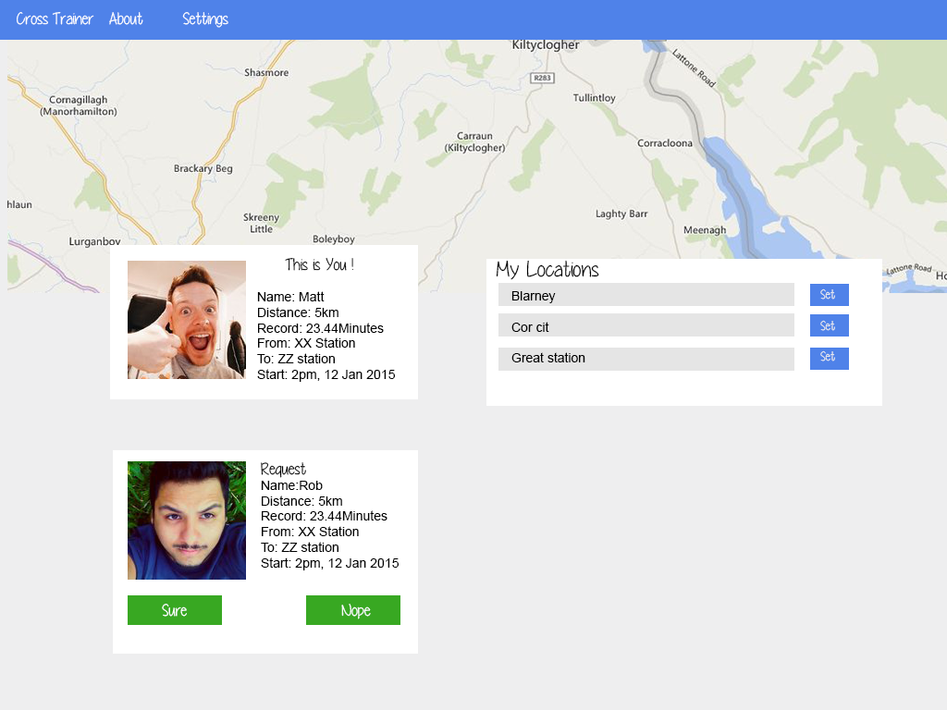

Team Profile



Robert Gabriel

Robert is a 21 year old student from Cork, in his second year of web development in Cork Institute of technology. He has been entering and building software since the age of 15. He has won all Ireland titles for programming, been the youngest to win college enterprise competitions and has worked for several multinational companies.Robert has completed two, 5km road races and one toughathon race which are described later in the document



Libor Kampas

Libor is a 30 year old mature student from Cork city, currently in his third year of Software Engineering in Cork Institute of Technology. His main programing language is Java. He has some experience in Perl scripting. He enjoys cycling and cross-country skiing. Libor believes participitation in competitions such as the imagine cup are a great way to meet new people and increase his knowledge and experience.

***Piotr Kawalec***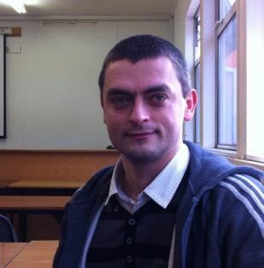

I am mature student from Cork. At the moment I am attending third year of Web Development in Cork Institute of Technology. I have interests in many different technologies, especially these related to www. Beside the college life I enjoy cycling and riding motorbike while discovering new interesting places. Being a part of the imagine cup competition is definitely challenging task that can bring a lot of valuable experience.

Matt Donovan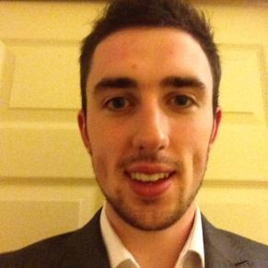

Matt is our business development manager. Studying Business Information Systems in Cork Institute of Technology with a passion for business and tech start-ups, this role suits him perfectly. Matt learned a lot from entering the Imagine Cup last year. This year he believes we are entering the competition with a clearer, stronger business concept and revenue stream that we will hopefully progress us further in this year’s competition. Any questions you may have on our business concept or any of the business elements you may contact him on 087-2380056 or matthew.donovan@mycit.ie

About CrossTrainr

CrossTrainr is a new and exciting mobile application that is going to be the next disruptive technology in the personal fitness and exercise market. CrossTrainr is designed to connect everyone from the casual walker to the elite marathon runner through our innovative platform.

CrossTrainr was born, like many other ideas, through frustration. Our lead programmer Robert was training for the ever popular military-style obstacle course events which generally consist of a 16 to 19km course across multiple countryside terrains with various obstacles along the way such as fire, water, electricity and heights. These events require very good fitness and training over an extended period of time. Robert was completing the event with three friends but due to work and college commitments, found it very hard to train together. Anyone that has ever trained for long distance running or endurance will agree that training with someone can be much easier than training alone. It is through Roberts’s frustration for training alone that CrossTrainr was born.

CrossTrainr is designed to connect people in similar geographical areas with similar fitness abilities and interested to complete training and exercise together. The application is based on profiles and requests. Each member of CrossTrainr has a profile containing the users’ first name, age, gender, sport speciality, achievements, profile picture and previous running statistics that can be synced from fitness bands and accessories such as Jawbone.

Once the user sets up their profile they can then send out a request for a BuddyTrainr. This request will be sent out to other CrossTrainr users within a predetermined geographical area. An example of a request would be as follows,

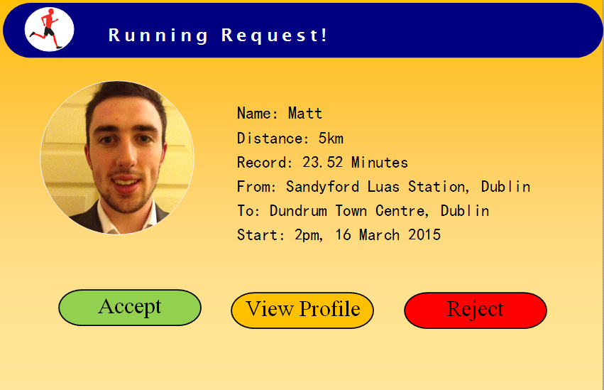

As you can see from the above example, CrossTrainr users are given three options. To accept, view the other users profile to review information or to reject the request. We believe it is very important for users to see each other’s record times in order to decide if the user would be a suitable match for you in terms of speed/time. If the user decides to accept the other users request then the user that send the request is give the option to accept or reject also.

Once both users accept the request they will be given the option to get interactive directions to the start point via Bing maps. The users complete their run and then, as in the case above, when they approach Dundrum Town Centre, the app will detect they are approaching the end of the journey and alert both users to a juice bar, coffee shop etc. nearby such as below.

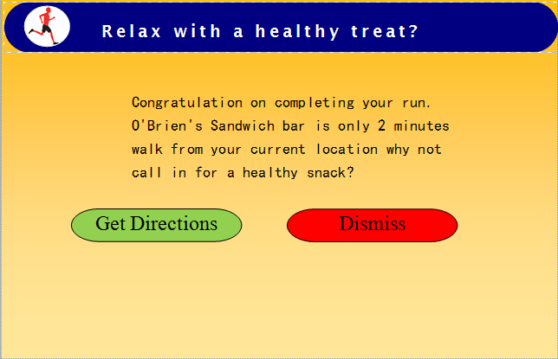

We believe that the social aspect of this app will be as important as the exercise and fitness element. By suggesting, a health conscious snack for after the exercise activity the two users can get to know one another better and maybe even spark as long term friendship.

From a business model point of view, the businesses that feature on our application will pay an advertising fee based on views. The application will record how many times their businesses advertisement has been displayed directly to our users and will be bill accordingly. Once our advertising customers and users increase, we will have the opportunity to offer tailored advertising targeting the businesses target market through the information collected from our user profiles.

Technical background

The way Cross trainer is built is using serveral web langugues , these inlude Html5, javascript,node.js css and php and Mysql backend and boot strap.

The front end was done by Piotr and Libor, they were using Microsoft Matrix to develop the website look. They used the material design Ui Developed by Google that allows the user to get feed back upon there changes and requests. The beinfits of which can be seen with the use of Within the material environment, virtual lights illuminate the scene and allow objects to cast shadows. A key light creates directional shadows, while an ambient light creates consistent, soft shadows from all angles.All shadows in the material environment are cast by these two light sources. Shadows are the absence of light resulting from the occlusion of these light sources by sheets of material at various positions along the z-axis. More on this can be seen here and here <http://www.google.com/design/spec/what-is-material/environment.html#environment-light-shadow>

Material design uses fundamental tools that have come from the world of print design, like baseline grids and a common set of structural grids that work across various pages. The layout is designed to scale across different screen sizes and will help facilitate UI development and ultimately help you create scalable apps.

The layout guidelines also encourage apps to have a consistent look and feel by using the same visual elements, structural grids, and general spacing rules across platforms and screen sizes. Structural and visual consistency creates an environment for the user that is recognizable across products, which provides users with a high level of familiarity and comfort.

<http://www.google.com/design/spec/layout/principles.html>



The background was done by Robert, he designed it by using a custom PHP framework, that handles the requests from the app (the users location) that allows the information to sent and saved quicker. We did a lot of testing of the information back and front. We used a windows azure server, cause that allowed us to connect into the different APIs of services easier. On a more technical area the app is created and developed with the use of node web kit , which allows use to develop the one app in HTML and compile it into IOS windows phone and Android along with the normal windows desktop apps. Cause of the page limit in this document please see the video and the GitHub account.All code is up on github.com. At the moment, it is able to run on any web browser, but depending when your reading this there will be windows phone and ios support along with others.

https://github.com/nwjs/nw.js/

Bringing to Market

CrossTrainr will be brought to make through Microsoft’s Windows App Store, Apple’s App Store and Google’s play store. We hope that by making the application available through as many platforms as possible it will enable us to reach a large target market and audience.

For year one we plan to use Ireland as a text bed to work out bugs and test various methods of entering the market. The application enables users to walk, run and cycle initially with the prospect of expanding to assemble teams for sports such as soccer and tennis in areas of high population. Once we have completed extensive testing we plan to bring the application to market in Ireland in July 2015. This will be achieved through a partnership with various large national events with a proposed launch in conjunction with the Ring of Kerry charity cycle. The Ring of Kerry charity is a one-day event with 10,000 cyclists completing the picturesque route. By achieving partnerships with such an event, we hope that the cyclists would find our application beneficial for their training. As well as the Ring of Kerry Charity cycle, we hope to achieve a partnership with Operation Transformation. This national weight loss program takes the country by storm every January. This partnership would allow people following the progress of leaders to meet similar people for walks, runs and cycles to achieve their weight loss target. As the application will still only be finding its feet, we don’t expect to make a profit in year one

In year two, we plan to turn our sights to the US by backing the New York and Boston City Marathons. These world famous events would provide the perfect launch pad into the United States by providing us with an audience of at least 86,000 runners and thousands more supports. If this partnership is managed correctly, it could make or break our success in the United States after all, first impressions last. In year two, we hope to be turning a marginal profit in Ireland but expect to be still making a loss overall loss due to the large investment required to launch in the United States

In year three, we will expand across Europe. We expect to have a solid foothold in a number of cities in the US. By year three we hope be making a marginal profit overall as the US market grows.