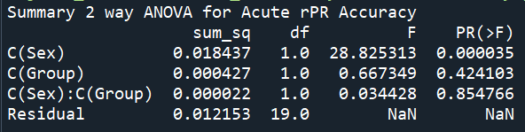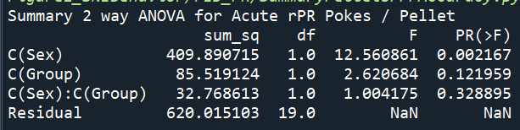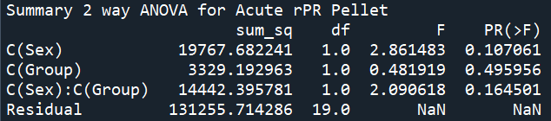

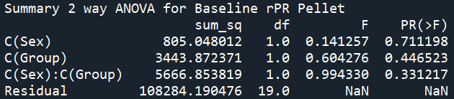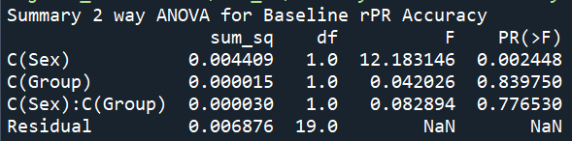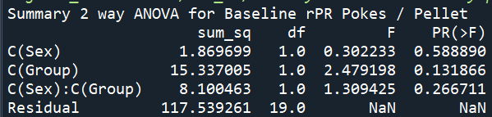
runcell(3, 'C:/Users/meagh/Box/CreedLabBoxDrive/Jeremy/SNI_Dopamine_Paper/Figure1_SNIBehavior/FED_PR/SummaryPelletsPPPAccuracy.py')
Summary 2 way ANOVA for Chronic rPR Accuracy
sum_sq df F PR(>F)
C(Sex) 4.763860e-03 1.0 6.050396 1.772166e-02
C(Group) 2.762845e-02 1.0 35.089837 3.768117e-07
C(Sex):C(Group) 2.892057e-07 1.0 0.000367 9.847921e-01
Residual 3.621871e-02 46.0 NaN NaN

runcell(3, 'C:/Users/meagh/Box/CreedLabBoxDrive/Jeremy/SNI_Dopamine_Paper/Figure1_SNIBehavior/FED_PR/SummaryPelletsPPPAccuracy.py')
Summary 2 way ANOVA for Chronic rPR PokesPerPellet1
sum_sq df F PR(>F)
C(Sex) 869.317878 1.0 5.488727 0.023520
C(Group) 1739.848073 1.0 10.985109 0.001797
C(Sex):C(Group) 2.531993 1.0 0.015987 0.899936
Residual 7285.591333 46.0 NaN NaN

runcell(3, 'C:/Users/meagh/Box/CreedLabBoxDrive/Jeremy/SNI_Dopamine_Paper/Figure1_SNIBehavior/FED_PR/SummaryPelletsPPPAccuracy.py')
Summary 2 way ANOVA for Chronic rPR PokesPerPellet2
sum_sq df F PR(>F)
C(Sex) 884.558152 1.0 5.372039 0.024964
C(Group) 1709.490354 1.0 10.381962 0.002340
C(Sex):C(Group) 5.283753 1.0 0.032089 0.858619
Residual 7574.344184 46.0 NaN NaN

