1844358

|  |  |  |  |  |  |
| --- | --- | --- | --- | --- | --- |
| **Test Case Id: 1** | | **Test Purpose: Test that students are able to take a summative assessment** | | | |
| **Environment: Written in Python 3.7.1 on Windows 10** | | | | | |
| **Test Case Steps: Local machine time is set to April 1st, 2019 12:00 pm** | | | | | |
| Step No | Procedure | | | Response | Pass/Fail |
| 1 | Login to student’s account with account details (fig1):  Username: student  Password: password | | | Login success | Pass |
|  |  | | | Display menu for students, which displays the summative test provided (fig2) | Pass |
| 2 | Select Summative test named Summative with deadline (2019-04-01 18:30) | | | Display Summative test (fig3) | Pass |
| 2 | Select summative test | | | Summative test correctly shows | Pass |
| 3 | Select:  A for Question 1  B for Question 2  A for Question 3  C for Question 4  Press Submit | | | Summative test should be submitted. | Pass |
|  |  | | | Score and feedback is correctly shown (fig4) | Pass |
|  |  | | | Answers are NOT shown | Pass |
|  |  | | | No retry is given | Pass |
| 5 | Press back | | | Display menu for students | Pass |
|  |  | | | Summative test provided is NOT available to student (fig5) | Pass |
| 6 | Logout of student’s account | | | Logout success, displays login menu | Pass |
| 7 | Login again to student’s account with account details (fig1):  Username: student  Password: password | | | Login success | Pass |
|  |  | | | Display menu for students (same as fig5) | Pass |
|  |  | | | Summative test provided is NOT available to students | Pass |
|  |  | | |  |  |
|  |  | | |  |  |
|  |  | | |  |  |
|  |  | | |  |  |
|  |  | | |  |  |
|  |  | | |  |  |
| **Comments: All Steps Passes** | | | | | |
| **Related Tests:** | | | | | |
| **Author: Lee Shing Chung** | | | **Checker: Nomair** | | |

(fig1)

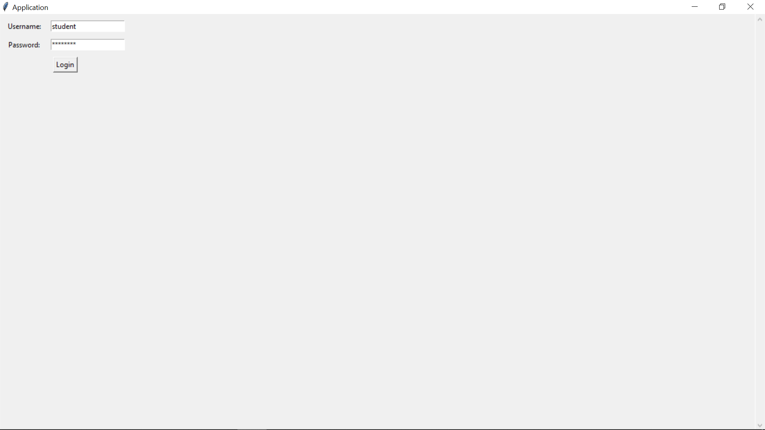

(fig2)

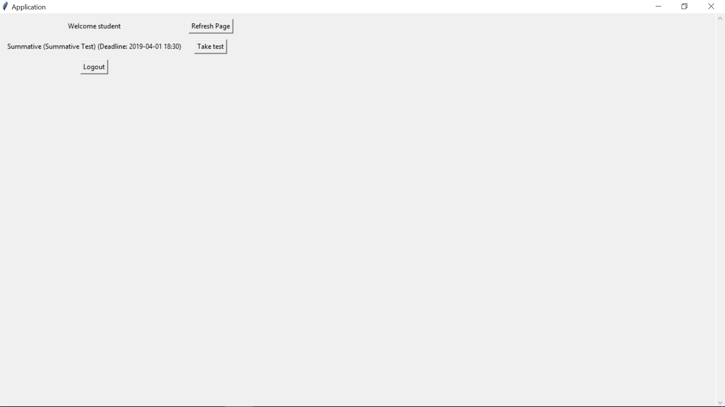

(fig3)

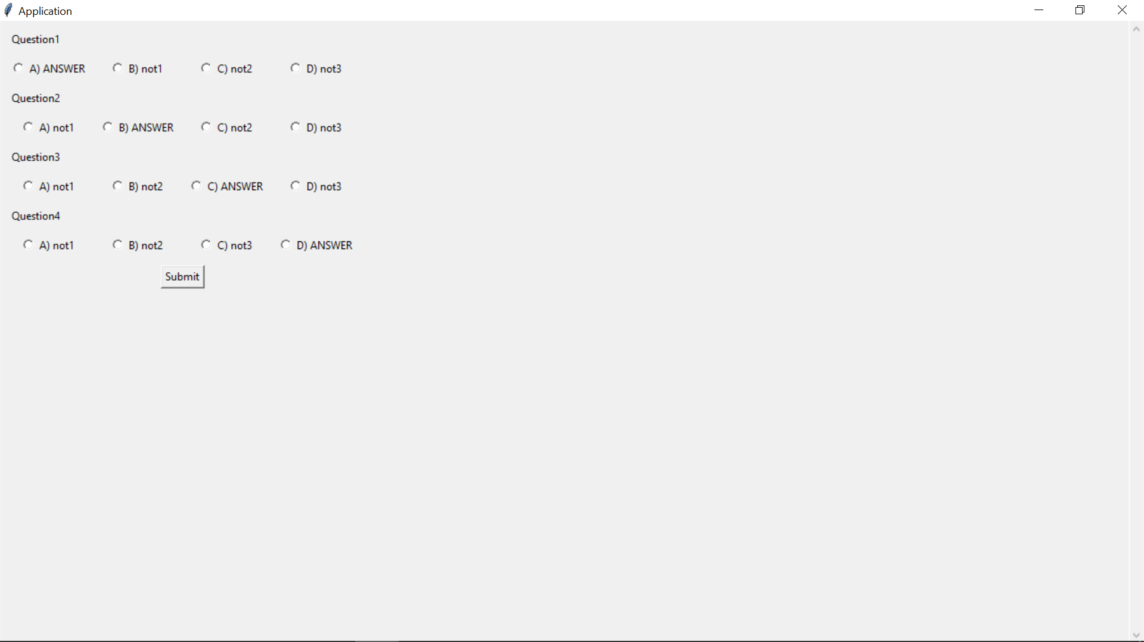

(fig4)

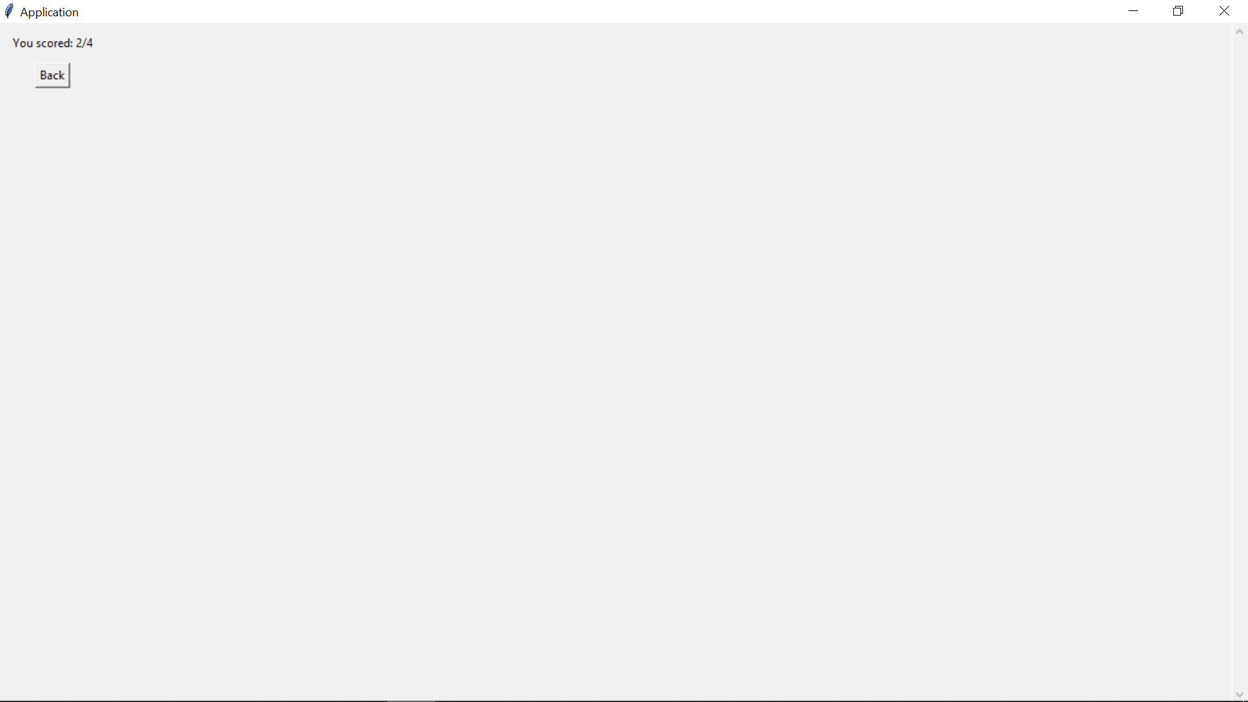

(fig5)

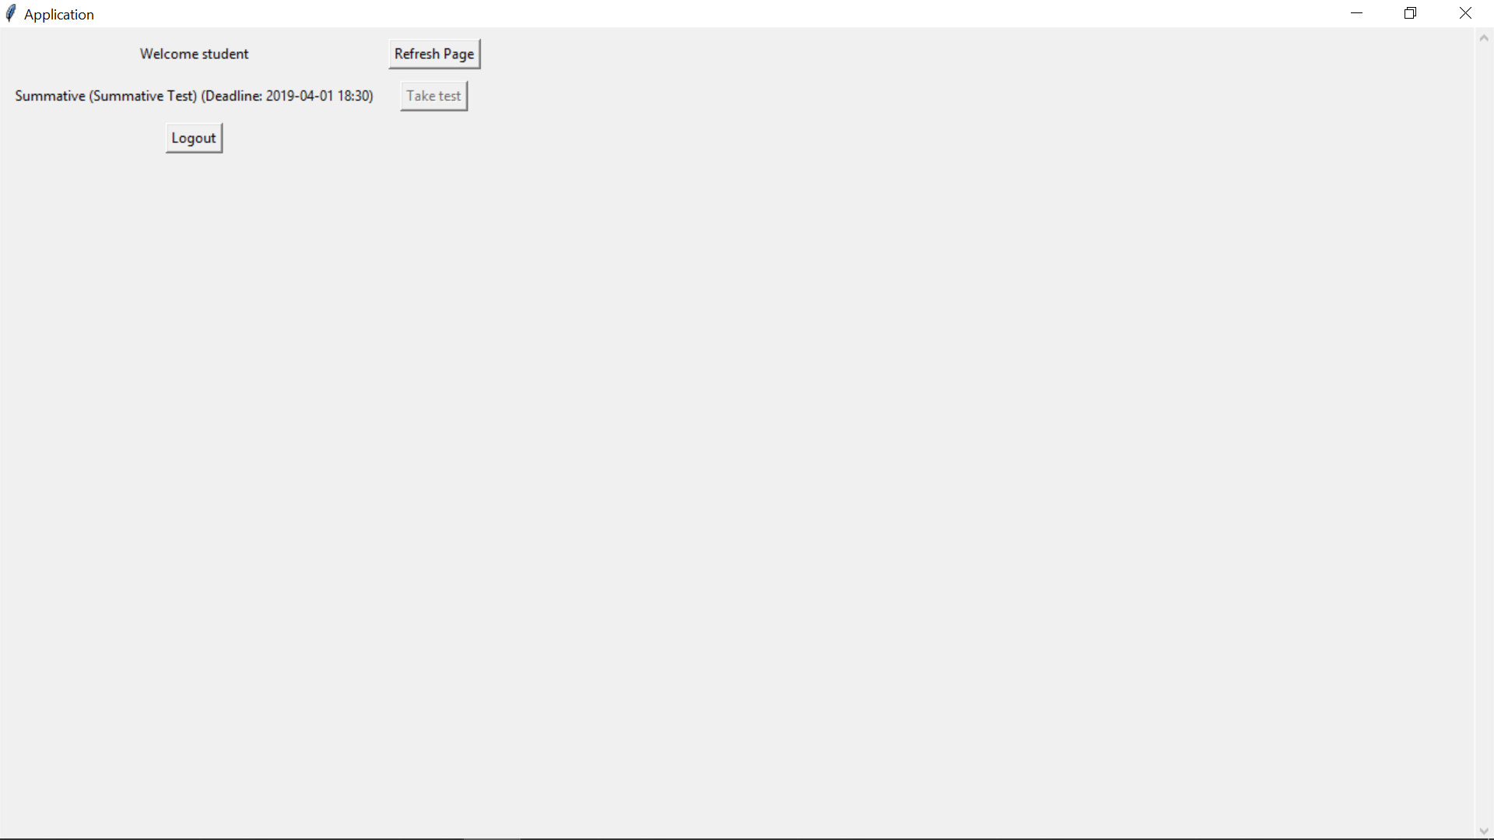

1727968

|  |  |  |  |  |  |
| --- | --- | --- | --- | --- | --- |
| **Test Case Id: 1** | | **Test Purpose: Test that students are able to take a summative assessment correctly** | | | |
| **Environment: Written in Python 3.7.1 on Windows 10** | | | | | |
| **Preconditions: Ensure Local System Time is set after the summative test Deadline** | | | | | |
| **Test Case Steps:** | | | | | |
| Step No | Procedure | | | Response | Pass/Fail |
| 1 | Login to Lecturer account | | | Login success | Pass |
|  |  | | | Display option for student records | Pass |
|  |  | | | Display the summative test provided | Pass |
| 2 | Select student records | | | Returns the list of students | Pass |
|  |  | | | Returns average score for all Students who have taken summative tests | Pass |
| 3 | Select a specific student to view their score | | | Returns the specific students score for the summative test | Pass |
|  |  | | | “back” button is provided and returns to the previous screen | Pass |
| **Comments:** | | | | | |
| **Related Tests:** | | | | | |
| **Author: Solomon Banks** | | | **Checker: Roy (Lee Shing Chung)** | | |

1832269

|  |  |  |  |  |  |
| --- | --- | --- | --- | --- | --- |
| **Test Case Id: 3** | | **Test Purpose: Lecturer is able to create an Assessment** | | | |
| **Environment: Written in Python 3.7.1 on Windows 10** | | | | | |
| **Preconditions: System is on Login window** | | | | | |
| **Test Case Steps:** | | | | | |
| Step No | Procedure | | | Response | Pass/Fail |
| 1 | Login into lecturer’s account using:  Username: lecturer  Password: password  (fig1) | | | Login Success | Pass |
|  |  | | | Display page for lecturer (fig2) | Pass |
|  |  | | | Display Create Assessment Button(fig2) | Pass |
| 2 | Select Create Assessment Button | | | Open Create Assessment window(fig3) | Pass |
| 3 | Fill out form without selecting assessment type & using incorrect format for deadline (fig4)  Press Finish | | | Warning window opens asking to specify assessment type(fig5) | Pass |
| 4 | Select Assessment type  Press Finish | | | Warning window opens asking to check deadline(fig6) | Pass |
| 5 | Change deadline entry to correct format Press Finish | | | Success window opens  Test is Created (fig7) | Pass |
| 6 | Press Ok | | | Returns to Lecturer Page(fig2) | Pass |
| 7 | Press Logout | | | Logout Success | Pass |
|  |  | | | Display Login Page(fig1) | Pass |
| 8 | Login to student’s account using:  Username: student  Password: password  (fig8) | | | Login Success | Pass |
|  |  | | | Displays Student Page (fig9) | Pass |
|  |  | | | Created Assessment is shown (fig9) | Pass |
|  |  | | |  |  |
|  |  | | |  |  |
|  |  | | |  |  |
|  |  | | |  |  |
|  |  | | |  |  |
|  |  | | |  |  |
|  |  | | |  |  |
| **Comments: all steps pass** | | | | | |
| **Related Tests:** | | | | | |
| **Author: Nomair** | | | **Checker: Roy (Lee Shing Chung)** | | |

**Fig1:**

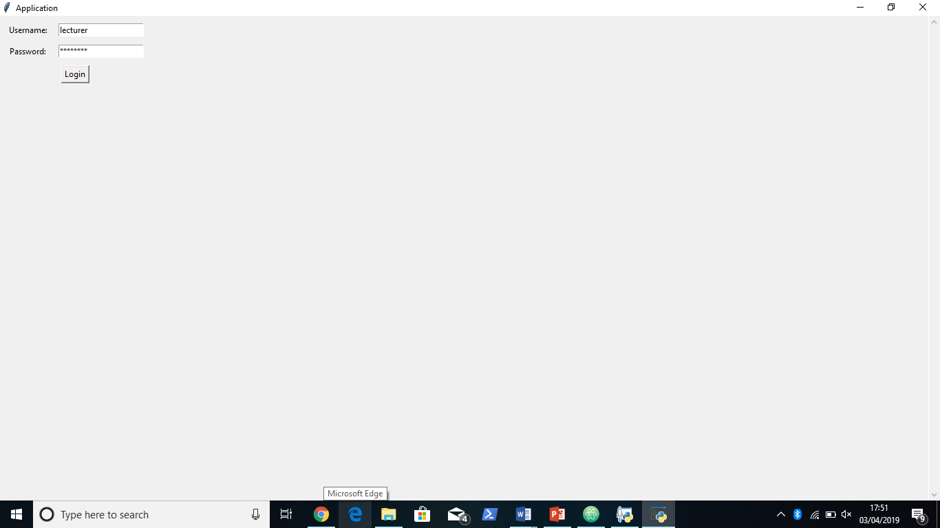

**Fig2:**

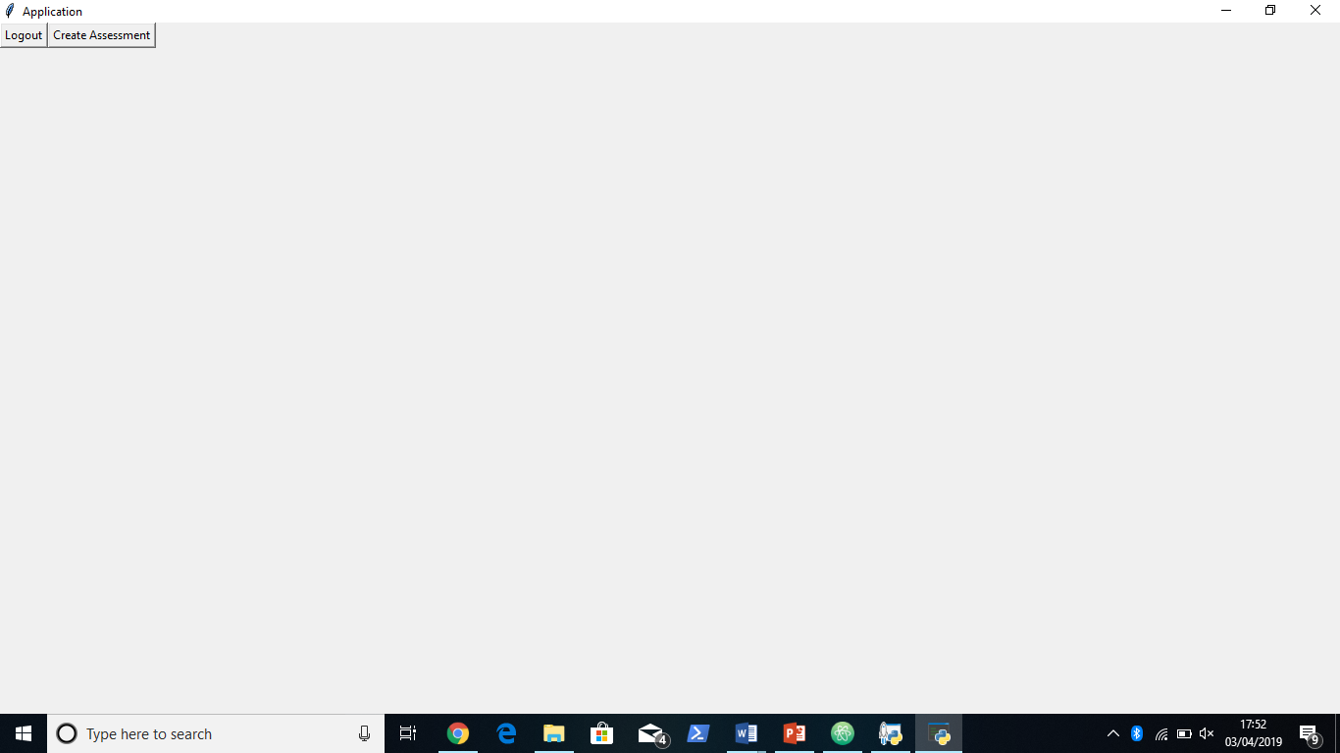

**Fig3:**

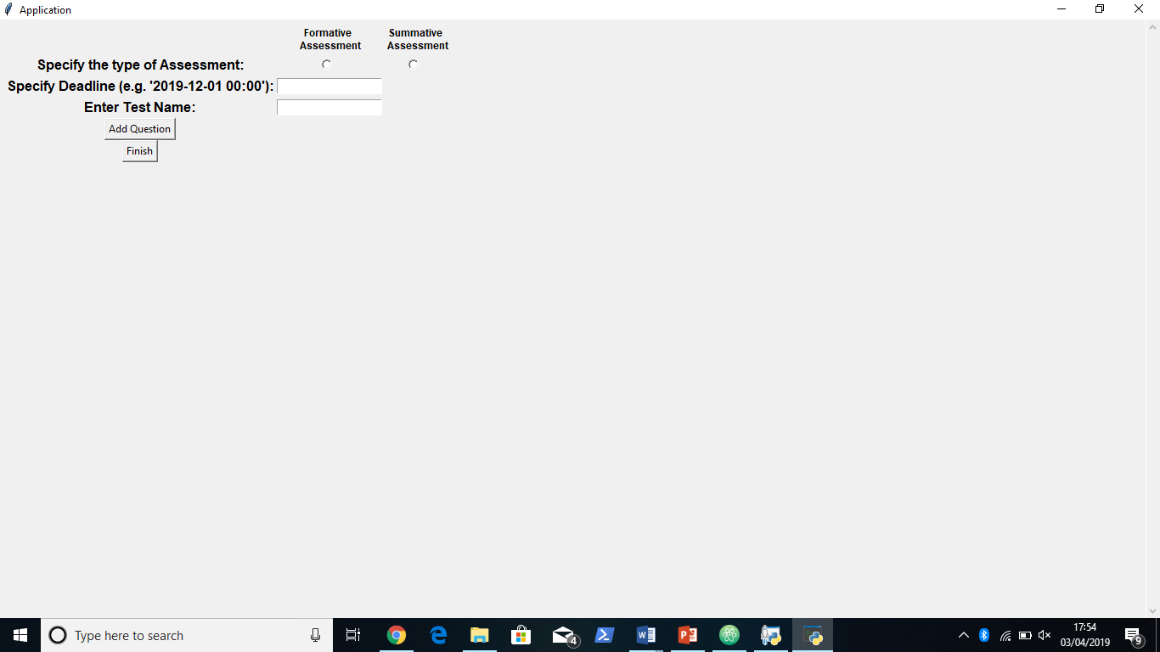

**Fig4:**

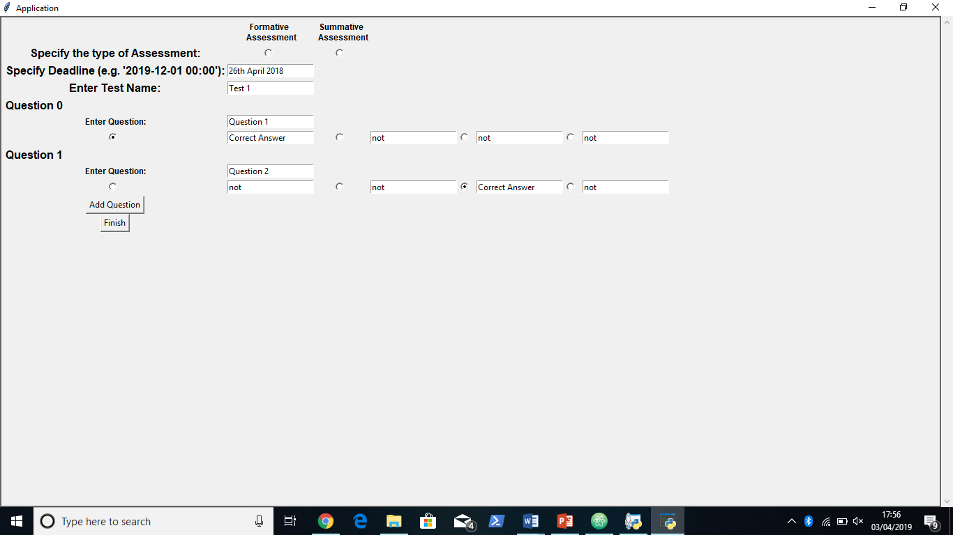

**Fig5:**

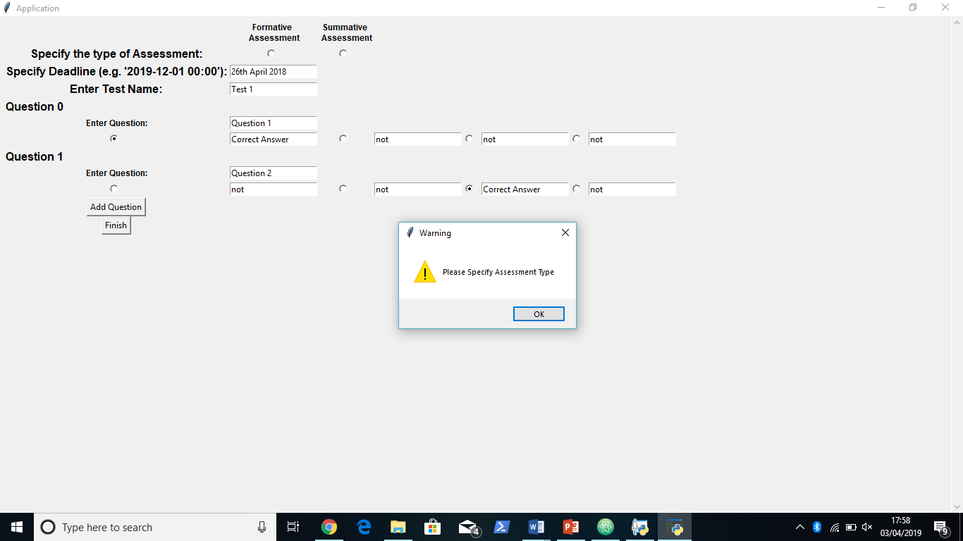

**Fig 6:**

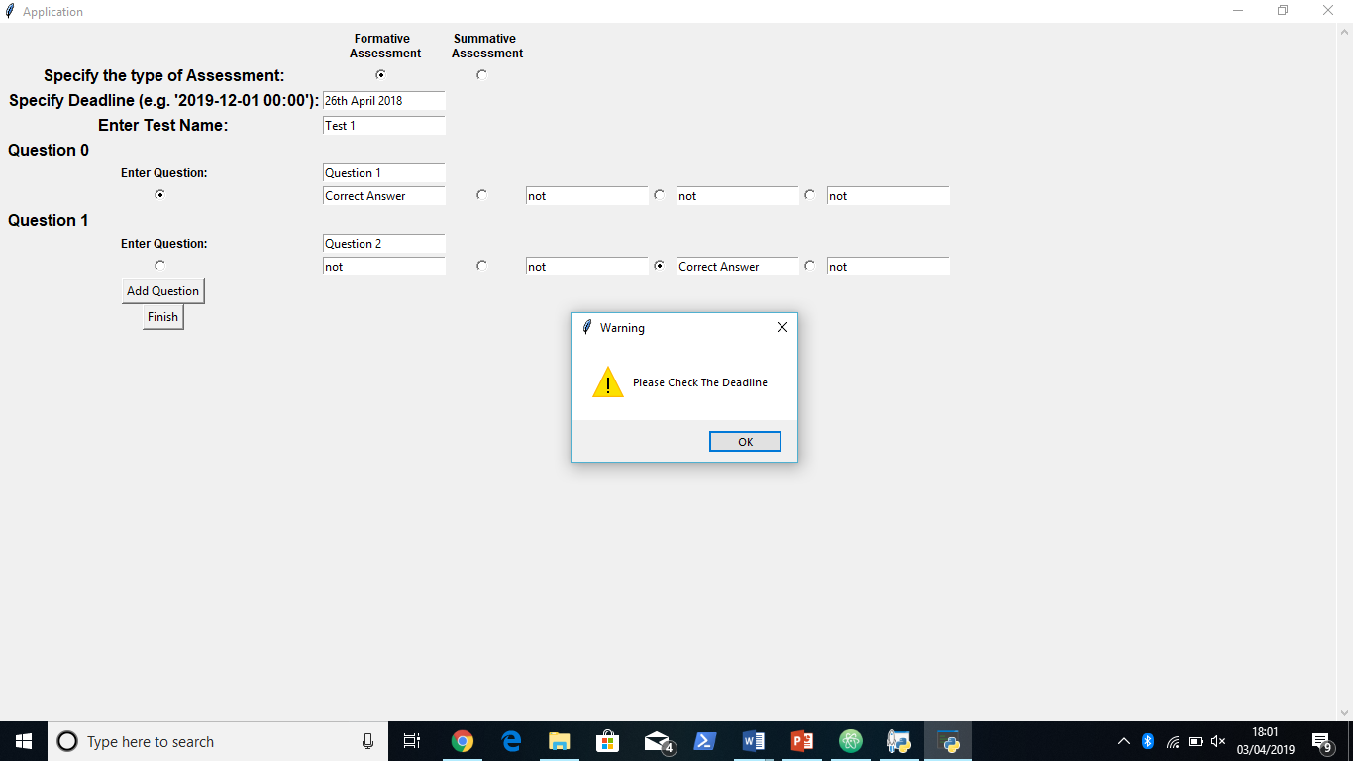

**Fig7:**

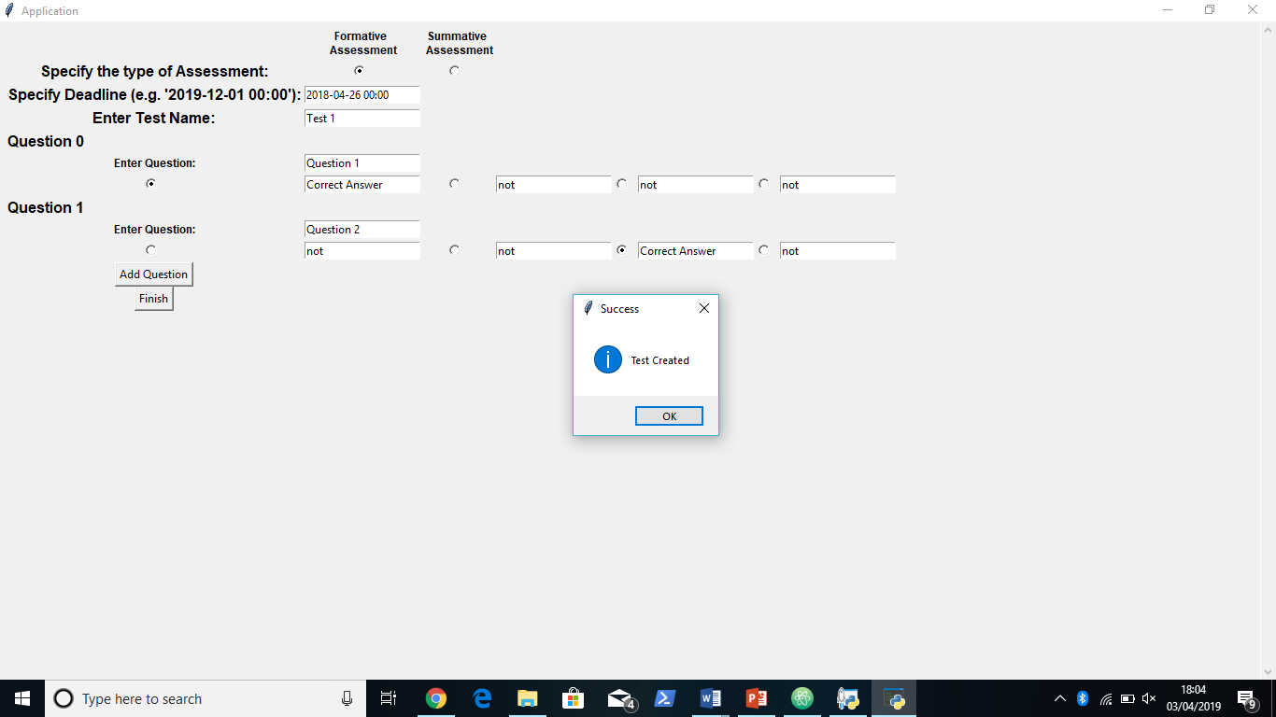

**Fig8:**

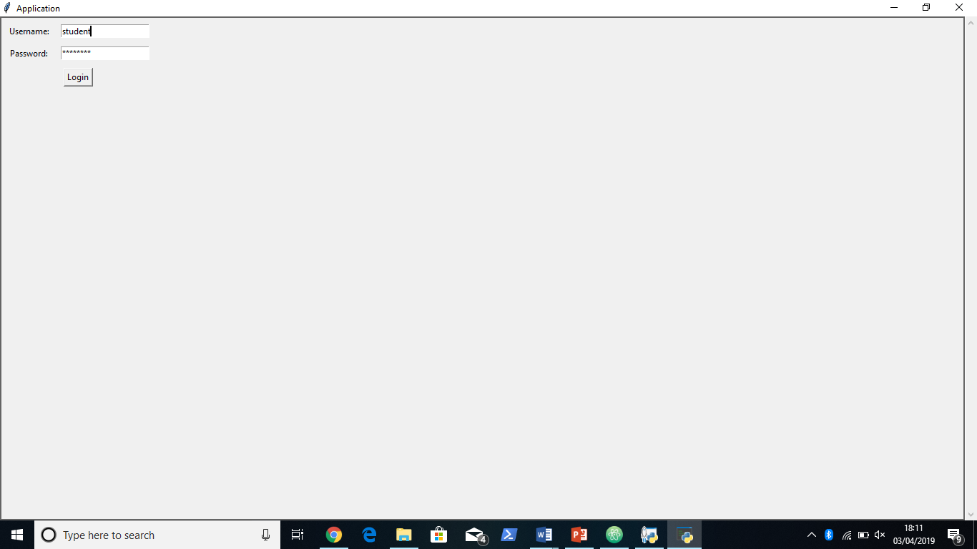

**Fig 9**

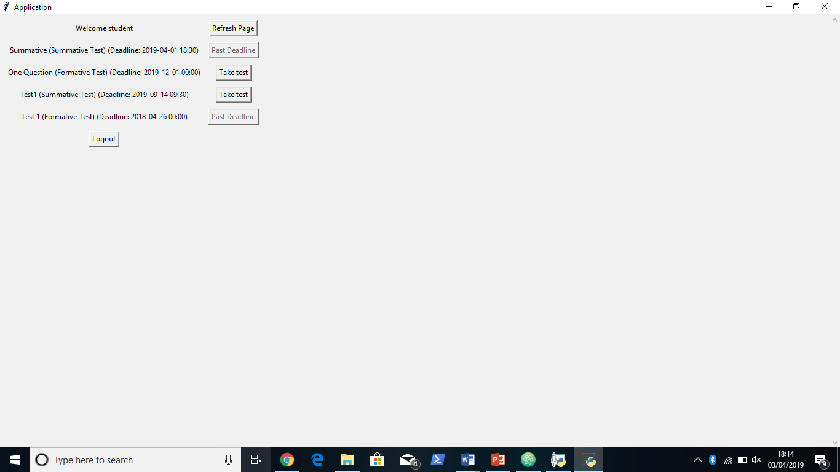

1744066

|  |  |  |  |  |  |
| --- | --- | --- | --- | --- | --- |
| **Test Case Id: 6** | | **Test Purpose: Check that a lecturer is able to modify a test** | | | |
| **Environment: Written in Python 3.7.1 on Windows 10** | | | | | |
| **Preconditions: There should be an existing test to modify. If a test doesn’t exist, one must be created first** | | | | | |
| **Test Case Steps:** | | | | | |
| Step No | Procedure | | Response | | Pass/Fail |
| 1 | Login to lecturer’s account by entering lecturer into the username field and password in the password field | | Login success  Display menu for lecturer | | Pass |
| 2 | Select the modify tests button | | The modify test page has been displayed | | Pass |
| 3 | Modify ‘test modified’ by clicking on the modify test button to the right of the test’s name | | Display individual test modification page | | Pass |
| 4 | Change the test’s name to ‘test1’ by typing it in place of the current name. | |  | | Pass |
| 5 | Change the correct answer to ‘a4’ by selecting the button to the left of a4 | |  | | Pass |
| 6 | Save the changes by clicking Finish | | Pop up displayed informing the test has been modified | | Pass |
| 7 | Click OK | | User is taken back to the lecturer home page | | Pass |
| 8 | Check test has been updated by following instructions 2 and 3 (The modified test should be listed as test1). | |  | | Pass |
|  |  | | Modified details are shown    Success! | | Pass |
|  |  | |  | |  |
|  |  | |  | |  |
| **Comments:** | | | | | |
| **Related Tests:** | | | | | |
| **Author: Ben Griffiths** | | | | **Checker: Roy (Lee Shing Chung)** | |

1824353

|  |  |  |  |  |  |
| --- | --- | --- | --- | --- | --- |
| **Test Case Id: 4** | | **Test Purpose: Test whether the student is enable to take a formative assessment and receive feedback.** | | | |
| **Environment: Written in Python 3.7.1 on Windows 10** | | | | | |
| **Preconditions: Ensure formative test is provided to the student.** | | | | | |
| **Test Case Steps:** | | | | | |
| Step No | Procedure | | Response | | Pass/Fail |
| 1 | Login to student’s account  Input data:  Username: student  Password: password | | Login success | | Pass |
|  |  | | Display menu for students | | Pass |
| 2 | Select formative test | | Formative test correctly shows | | Pass |
| 3 | Select correct answer for all answers but the last one and press submit.  Answers to input:  Q1: A  Q2: B  Q3: C  Q4: C | | Formative test answers should be recorded by the system. | | Pass |
|  |  | | Feedback is correctly shown after every attempt. | | Pass |
|  |  | | Answer is NOT shown | | Pass |
|  |  | | Retry is given, press entry and retake the test until the system won’t let you anymore. | | Pass |
| 5 | Press back | | Display menu for students  The formative test, take test button will be disabled because the user has taken the test all three times. | | Pass |
| 6 | Press view scores on the formative test just taken. | | Display the correct answers. | | Pass |
| 7 | Logout of system. | | Logout successful and returns to login screen | | Pass |
| **Comments:** | | | | | |
| **Related Tests:** | | | | | |
| **Author: Sophie Wells** | | | | **Checker: Roy (Lee Shing Chung)** | |

|  |  |  |  |  |  |
| --- | --- | --- | --- | --- | --- |
| **Test Case Id: 5** | | **Test Purpose: Test that the lecturer can view results and statistics based off the student’s test results** | | | |
| **Environment: Written in Python 3.x on Windows 10** | | | | | |
| **Preconditions: run.py has been executed** | | | | | |
| **Test Case Steps:** | | | | | |
| Step No | Procedure | | | Response | Pass/Fail |
| 1 | Login to lecturer’s account  Username: “lecturer”  Password: “password” | | | Login success | Pass |
|  |  | | | Display menu for lecturers | Pass |
| 2 | Select the “view” button next to “view test” | | | This screen appears. | Pass |
| 3 | Select the View Test button next to the Formative label | | | The app successfully displays the average score of all the students. As both of the results were 3/4 the average was 3.0/4 | Pass |
| 4 | Press back | | | Back to this screen | Pass |
| 5 | Click “view” button again | | | Here again | Pass |
| 6 | Click “view test” button next to summative modified label | | | Successfully displays average of all results. As there is only one result, this is just 2.0/4 | Pass |
|  |  | | |  |  |
|  |  | | |  |  |
|  |  | | |  |  |
|  |  | | |  |  |
| **Comments: all pass** | | | | | |
| **Related Tests:** | | | | | |
| **Author: Joseph Creek** | | | **Checker: Roy (Lee Shing Chung)** | | |