**How to setup Github and Github Desktop to share documents: A quick overview:**

* If you have not an account :

🡺 Sign up to Github via its website: you need to retain your username and e-mail

* If you have an account:

🡺 Good, give me your username so that I can add you on the MODEL3D repository (where the files are gathered)

🡺 Once I have invited you to come in into the repository, you have to confirm on your e-mail

After you accepted the invitation, you can get to the main screen of Github, it should ressemble this:

🡺 On the left part, there is a list of your (shared) repositories, click on Creelle/MODEL3D

Your screen should look like this :

This is the main screen of the repository, you can add a file by clicking on Add file.

In order to share the content of the repository, we will use Github Desktop. This makes the link between the website and your computer.

* Install Github Desktop :

Go to this website and download the executable.exe : <https://desktop.github.com/>

Run the .exe and setup your account (this application will ask you for your Github username or e-mail to link the account)

Now that you have Github Desktop, a folder Github is created in your documents:

🡺 Go chequ if this folder is created

* Open the repository MODEL3D in github desktop:

🡺 go back to the github website on the MODEL3D page and click on the green button Code :

🡺 Click on open with Github Desktop : This should appear

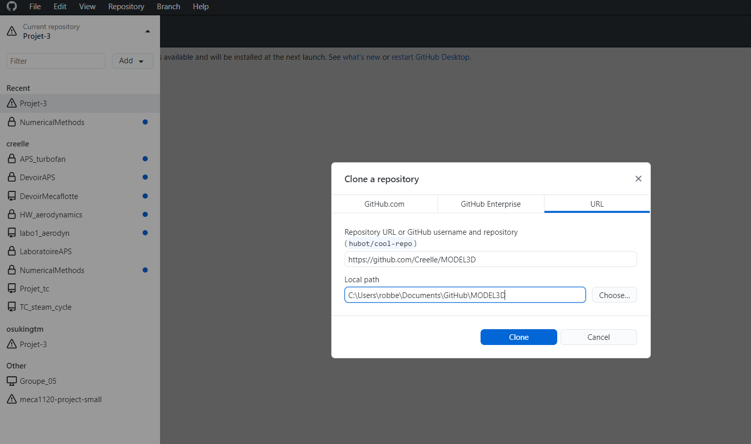🡺 Click on clone, this will create a folder MODEL3D in the Github folder in your documents and download all the files linked to the repository

🡺 Check if those files are there:

* Modify and share a file :

Before you start any work: Open Github desktop and click on **fetch origin**: This will look in the cloud if other members have changed before you, if so click on **pull,** this will update the files with the changes of the other members

🡺 Work on your file, do what you want (Do something stupid just to see how it works)

🡺 Once you are finished you will have to push the new content to the other members:

🡺 Return on github desktop, it will automatically detect the changes you made :

🡺 First click on **fetch origin** this is not mandatory but it is to check if no other commits were made while you were working on your file

🡺 Now click **on commit to main** button in blue in the left bottom corner (You should also write something down in the text corner)

🡺 Once you have clicked on **Commit to main** : this should appear :

🡺 Click on **push origin,** this will distribute your changes to the other members

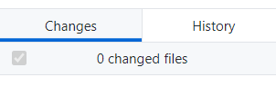🡺 You can check the history of the commits in the history tab:

🡺 This should appear:

🡺 If the history takes into account your changes than everything works fine

* Conflict resolution:

A good reflex is to often refresh by clicking **on fetch origin.** Commit errors can occur when people are working on the same file at the same time If so, the branch will be the one which pushes its changes first and thus create errors when the other wants to push (since the file has drastically changes). However, if this happens, it is always possible to revert a commit in the history tab.

**If you have any trouble to set up call me!**

**Creelle Robbe.**