**Dokumentation**

Arbeitsauftrag 03

**Aufgabe 1:** Hauptprogramm

using System;

using System.Linq;

namespace Flexible_Datenstrukturen

{

class Program

{

static void Main(string[] args)

{

Run(@"C:\Tmp\students.dat");

Console.ReadKey(true);

}

static void Run(string filepath)

{

string[] lines = System.IO.File.ReadAllLines(filepath);

foreach (string line in lines)

{

string name;

float avg;

AverageCalc(line, out name, out avg);

Console.WriteLine("{0} = {1}", name, avg);

}

}

static void AverageCalc(string line, out string name, out float average)

{

if (!line.Contains(':'))

{

name = null;

average = -1;

return;

}

average = 0;

name = line.Substring(0, line.IndexOf(':'));

string[] grades = line.Substring(line.IndexOf(':')).Split(',');

int correctGrades = 0;

for (int i = 0; i < grades.Length; i++)

{

string grade = grades[i].Trim();

if (!grade.Contains('='))

{

continue;

}

string[] splittedGrade = grade.Split('=');

if (splittedGrade.Length < 2)

{

continue;

}

float num = 0;

if (!float.TryParse(splittedGrade[1], out num))

{

Console.WriteLine("Warning: Invalid Grade '{0}' at student '{1}' in class '{2}'", splittedGrade[1], name, splittedGrade[0]);

correctGrades--;

}

correctGrades++;

average += num;

}

if (correctGrades != 0)

{

average /= correctGrades;

}

else

{

average = 0;

}

average = (float)Math.Round(average, 2);

}

}

}

**Aufgabe 2:** Testfälle

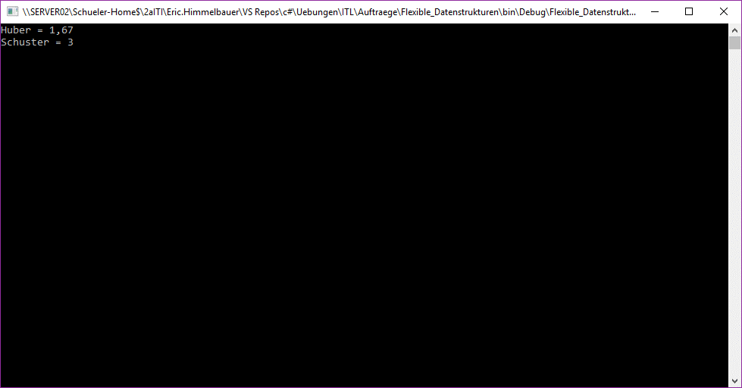Testfall 1:

Huber: APMH=1, INF=2, PGTL=2

Schuster: APMH=3, INF=3, PGTL=3

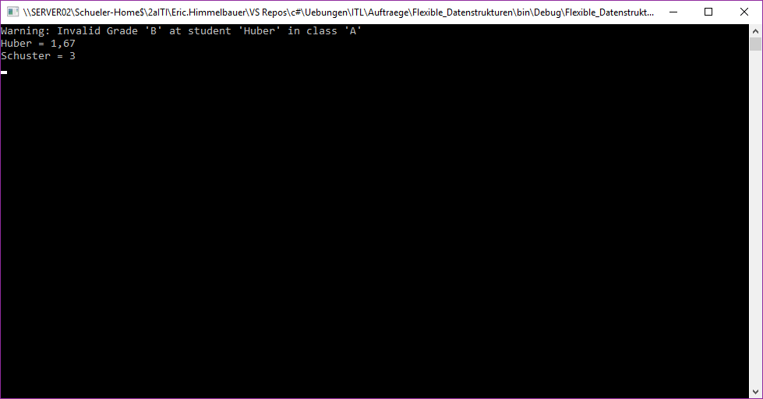Testfall 2:

Huber: APMH=1, INF=2, PGTL=2, A=B

Schuster: APMH=3, INF=3, PGTL=3

Testfall 3:

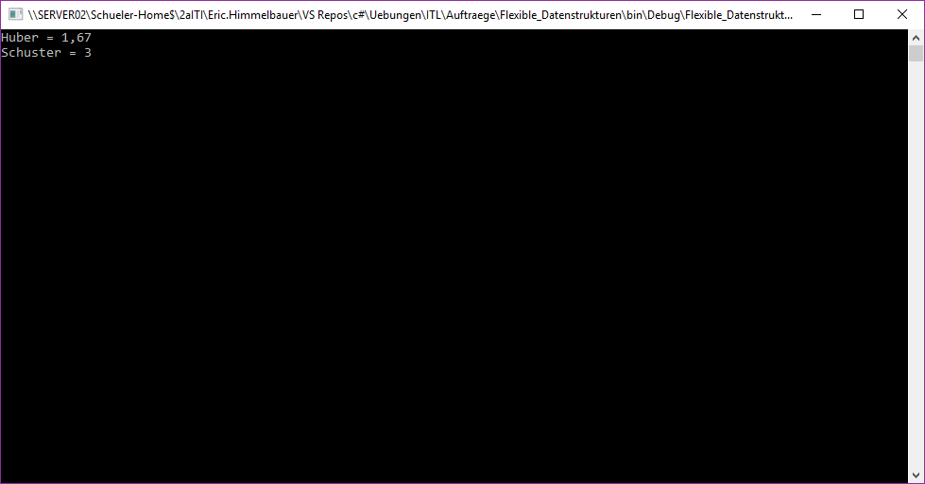

Huber: APMH=1, INF=2, PGTL=2,,,,

Schuster: APMH=3, INF=3, PGTL=3,,

Testfall 4:

Huber:

Schuster:

