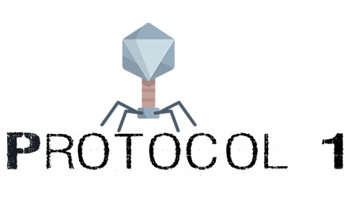

Introduction
This document describes the concept, process and works of Protocol 1, our submission for InformatiCup2020.

2.Planning
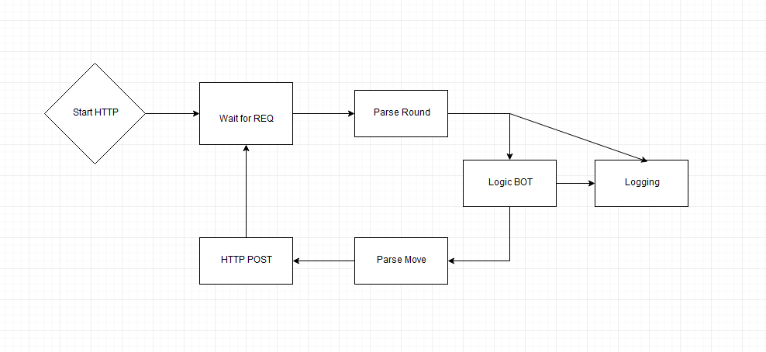
In early concept meetings, we originally decided to split up the project in 3 major phases. Before we would write any actual part of the program, we tried to analyze the rounds as best as we could using a prototype that consisted of little more than a webservice and logging to a text file. After we had gathered sufficient data, we set out to create a framework, in which we would later create the actual logic in.
We used various tools, which will be described more in depth at a later point, to plan out how our framework should look like. We designed it with OOP principles in mind, but also tried to keep it as simple and extensible as possible.
Once we started implementing the actual logic, we had already incorporated a few different logging and visualization methods, which made planning and creating the logic easier.

Software Architecture
While we had initially thought about applying our knowledge of Agile development, learned in previous semesters, we ended up using a standard waterfall model. While we had several reasons for that, the biggest concern was the fact that we would now know beforehand if we had enough time to even work on the project in a given week, which would have made planning sprints and goals almost impossible.

Language
For our language in this project, we chose Java. This had little to do with the fact that we thought Java had some kind of inherit advantage for this project. In fact, as we later found out, the opposite was true, which will be discussed in our conclusion. The simple matter that every team member was required to learn Java in the past semesters, made sure we all started on equal footing. Besides that, we were all quite familiar with Object Orientated Programming and knew the tools and ecosystem well.

Tools used
On a very basic level, we chose Intellij IDEA as our development IDE. We had all previously worked with it, and it allowed us to sync up settings and code styles.
As for dependency management, we chose Gradle. It allows us to automatically download and set up dependencies, as well as compiling and distributing the finished program. It was mainly chosen because of Max’s prior usage and the fact that it integrated nicely with our Continuous Integration, which we originally hosted on Max’s server. Later on, gradle also allowed us to basically create a docker container from our java source code, without having to do any kind of dependency management inside of the docker ecosystem. We also made use of gradles inbuilt support for Junit tests, which allowed us to seamlessly test and compile our program via CI.
During the early stages, we had a Jenkins Continuous Integration server setup to provide not only testing and compiling from our github repository automatically, but also to run various plugins related to code quality, test coverage and coding style. This was later discontinued due to reasons discussed in the conclusion section.

Libraries
To not re-invent the wheel, we chose a select few key libraries to aid us in development:

Gson – by Google
Gson is a Java JSON to Java parser. Since Java doesn’t natively provide any type of JSON parsing, we had to rely on third party libraries to accomplish the task. We mainly chose Gson because of it’s ease of use and its great amount of documentation and tutorials. Since this project was not a performance or latency sensitive application, we did not compare further.

SparkJava
SparkJava is a mico framework for web applications. While most other web frameworks tried to do it all, this one only provides the bare minimum functions. Perfect for receiving and sending POST requests. While it is also capable of serving static files, due to time constraints we didn’t end up making use of this feature to serve charts via html, but it will briefly be discussed at a later point.
We also used various other libraries, mostly for logging, command line arguments and to visualize data in charts. If you are interested, feel free to check out the build.gradle file in our main repository, it contains all used libraries.

Early/Theoretical concepts
??????

Analysis
Early analyzing was mainly done through text logging. The main idea was the get the general data structure down, and then get to a point where we had logged all events, pathogens and various other data there was. After a quick lesson in “How to write a .bat file”, we ran through a few thousand seeds to make sure we had seen all static events and pathogens. After that, the idea was to systematically answer different moves, and observe their effect on a static seed. This lead us to discover almost all of the data we would end up needing, so we moved on to create our framework before doing more sophisticated analysis.

Building the framework
We modeled our framework according to the data we found during the analysis phase. Our goal was to keep it as simple as we could, to allow for later additions and changes. We create a POST route using SparkJava, sent the incoming JSON string through our Gson Parser, which creates Java Objects with the same structure as the “round” string. This allows us to further work with the data in a more Object Orientated fashion, more suitable to Java.
Early in the framework design, we also made sure to negotiate different API Interfaces, so different team members could work on different parts of the framework without stepping on each others toe. These Interfaces served as contracts between classes so that we could encapsulate our different sections of the framework, while still maintaining compatibility between implementation changes.
As for coding convention, the only thing that should stand out is our heavy use of the build pattern. For a trivial amount of boilerplate code (which we automated using a IntelliJ IDEA Builder plugin), we not only had the advantage of clear indication of how our classes were constructed, it also provides unrivaled ease of use constructing these objects. This is especially useful when a team member has written a section of the framework, which needs to be used by a different member. Lastly, it also gives us an easy and less error prone way of creating these objects for the purpose of unit testing.

