Vision Project

(DC227524) ETHAN, ZHANG JIAYANG

(DC227268) DIEGO, HUANG WU

Our code repository <https://github.com/Creepia/Vision_project.git>

# Introduction

In this project, we finished three types of tasks as below.

## Generating Image Pyramids

In this part, we would generate the Gaussian pyramids and Laplacian pyramids for gray images or color images then represent them in the required format.

## Hybrid Images

In this part, we would input two images and hybrid the first image’s low frequency and the second image’s high frequency, which are from Gaussian pyramids and Laplacian pyramids, into a hybrid pyramid. Then we would reconstruct the result image from the Nth layer of the hybrid pyramid.

## Blend Images

In this part, we would input two images and blend them into a new image with the method of blurring them in a pyramid. The left part of the result image is from the first images and right part is from the second image. We can use the window parameter to adjust the blending area. In addition, we could also use a mask to blend two images.

In the second part, we would show the all image results and the flowchart for the program to do each task would be shown in the third part.

# Results

Then we show all the image results for each task from next page.

## Generating Image Pyramids

### Classical Image – Lenna (Gray)

#### Gaussian Pyramid

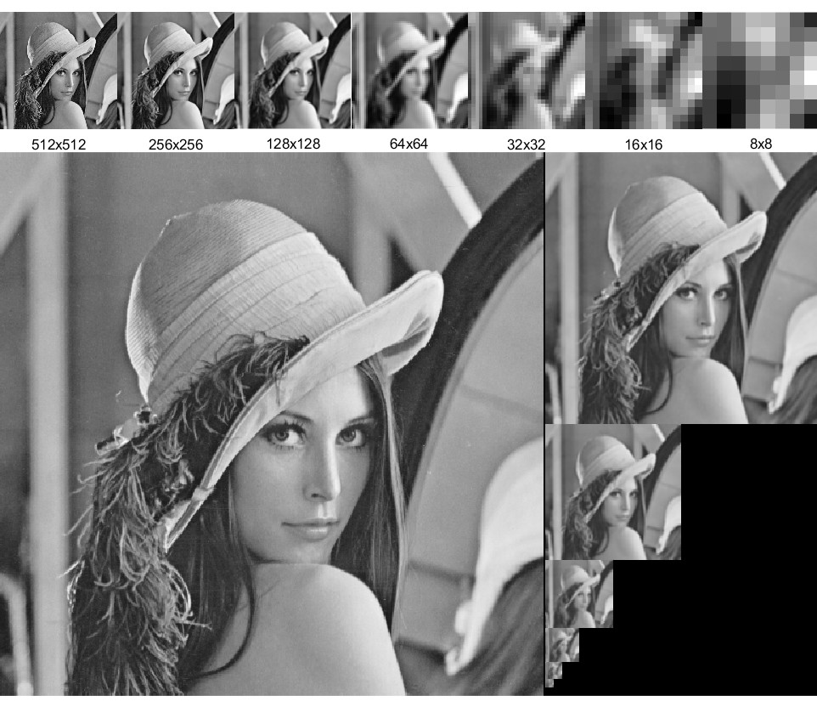

### Laplacian Pyramid

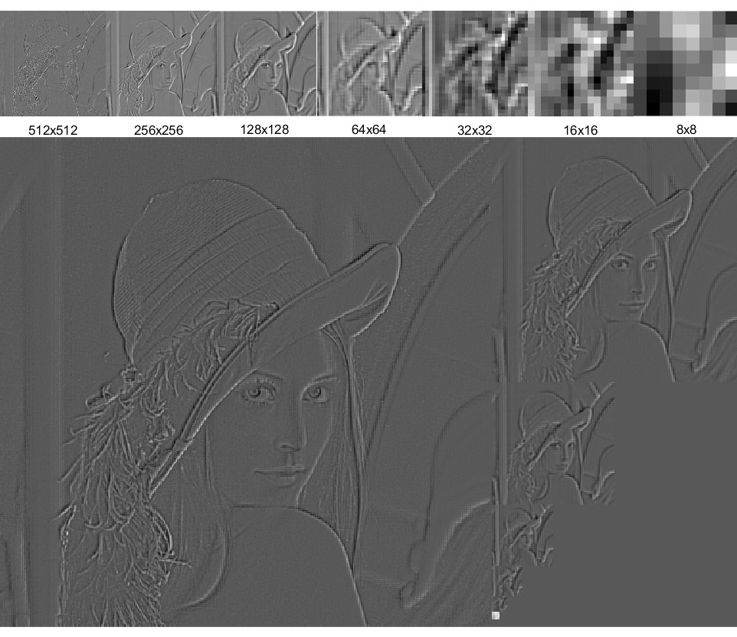

### Character Icon – Emu (Color)

#### Gaussian Pyramid

#### Laplacian Pyramid

### Satellite Image – Earth (Color)

#### Gaussian Pyramid

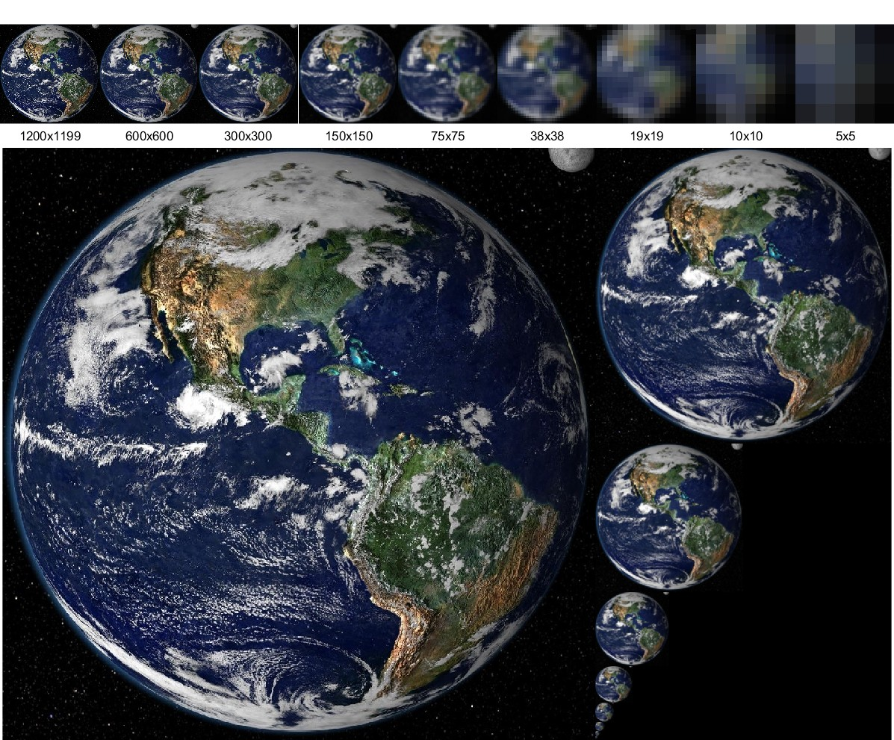

#### Laplacian Pyramid

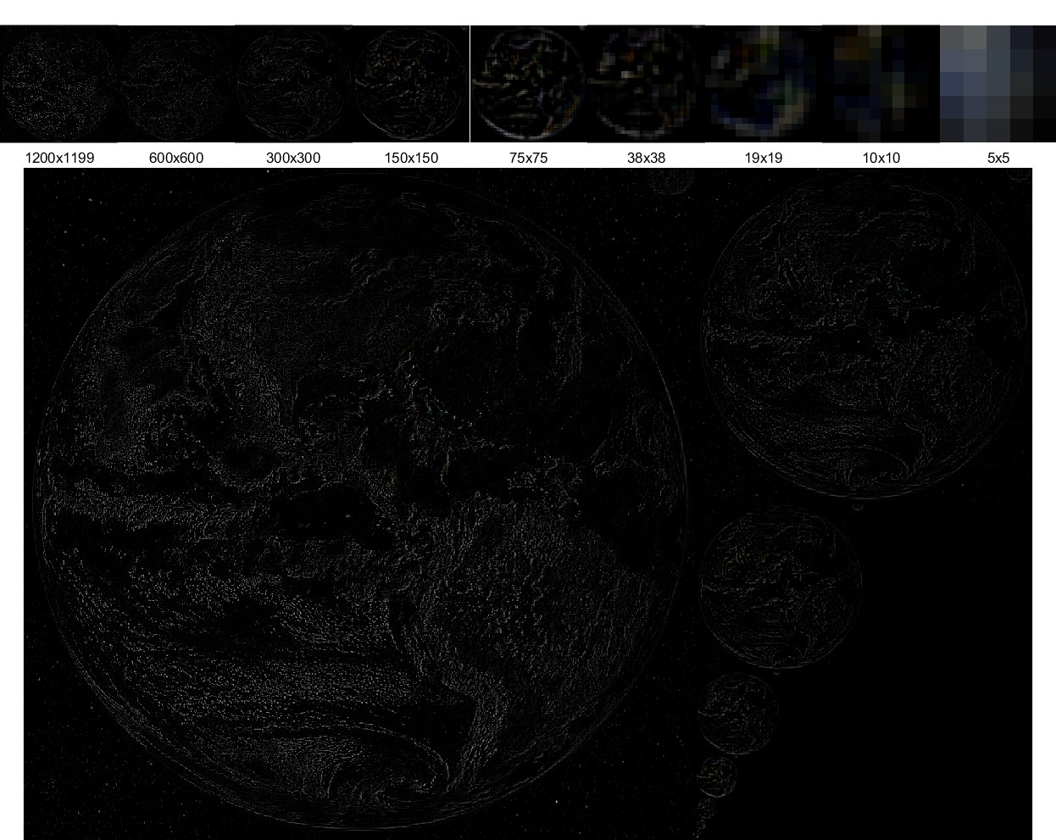

## Hybrid Images

### Character Icons – Miku & Nene

#### Original Input Images

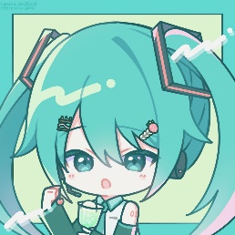

#### Hybrid Pyramid

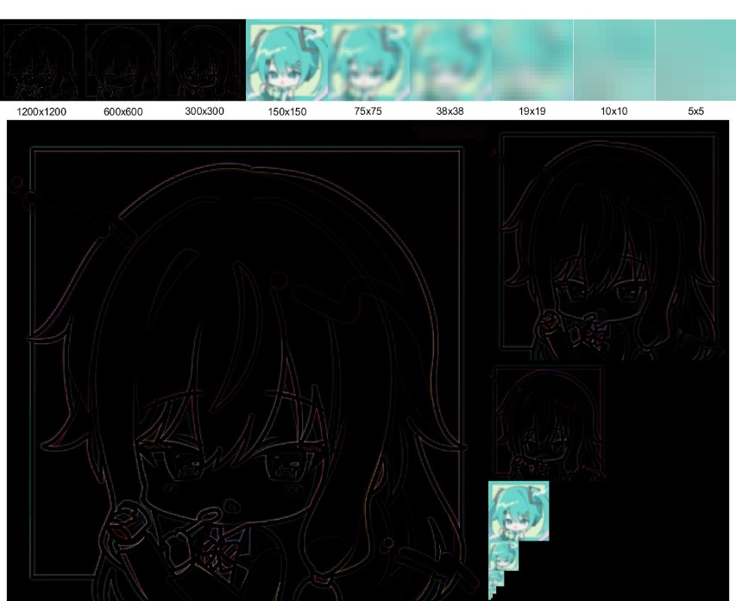

#### Result in different scaling

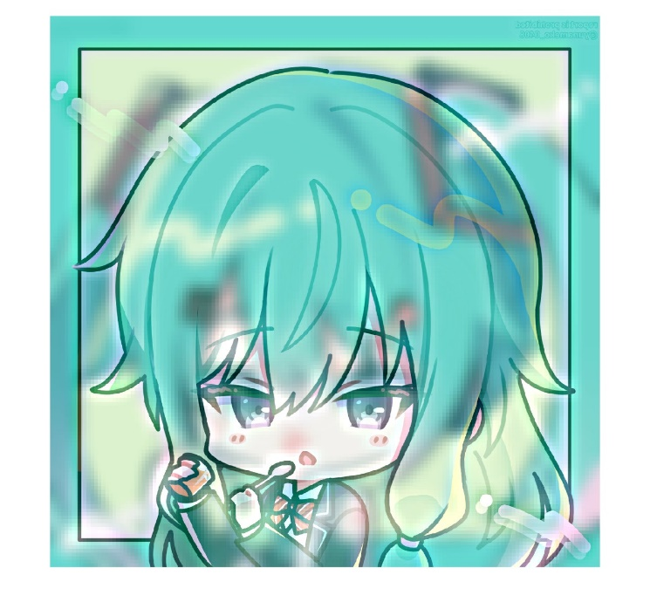

Parameters: N=4, Gaussian kernel size=11, sigma=5.

(We used a horizontal flip to match the facing direction)

### Basketball & Earth

#### Original Input Images

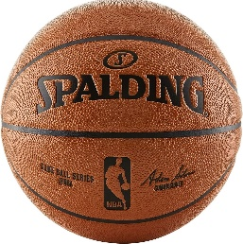 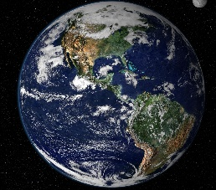

#### Hybrid Pyramid

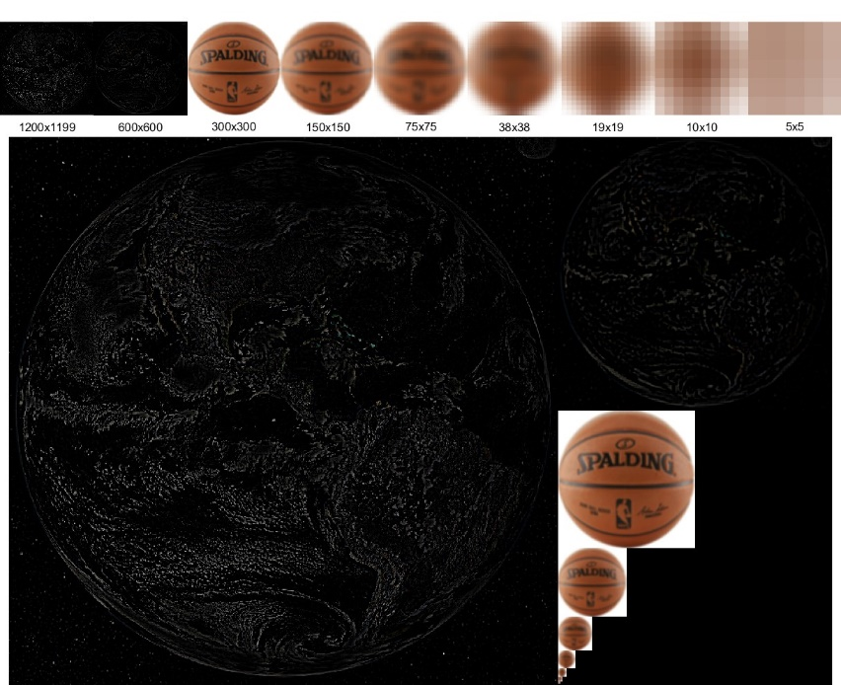

#### Result in different scaling

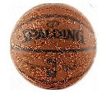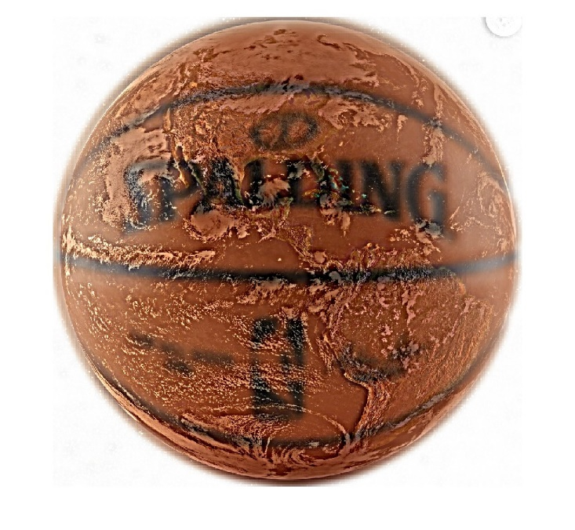

Parameters: N=3, Gaussian kernel size=13, sigma=5.

(We used a cropping and resizing to match the resolution and position of the objects)

### Characters – Chiikawa & Hachiwari

#### Original Input Images

 

#### Hybrid Pyramid

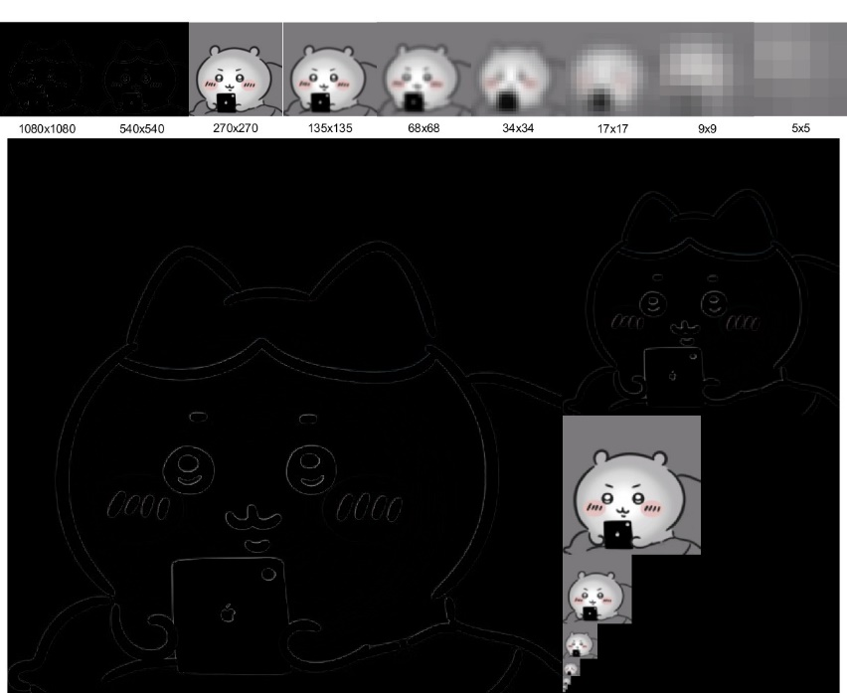

#### Result in different scaling



Parameters: N=3, Gaussian kernel size=7, sigma=3.

### Emotion Icons – Smile & Angry

#### Original Input Images

 

#### Hybrid Pyramid

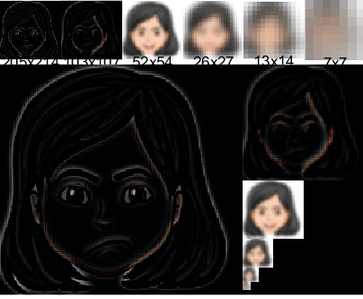

#### Result in different scaling

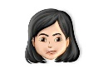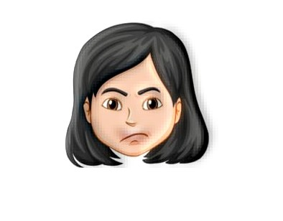

Parameters: N=3, Gaussian kernel size=9, sigma=3.

## Blending

### Characters – Usagi & Chii (Left-Right)

#### Original Input Images

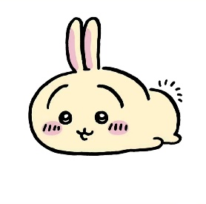 

#### Blend Pyramid

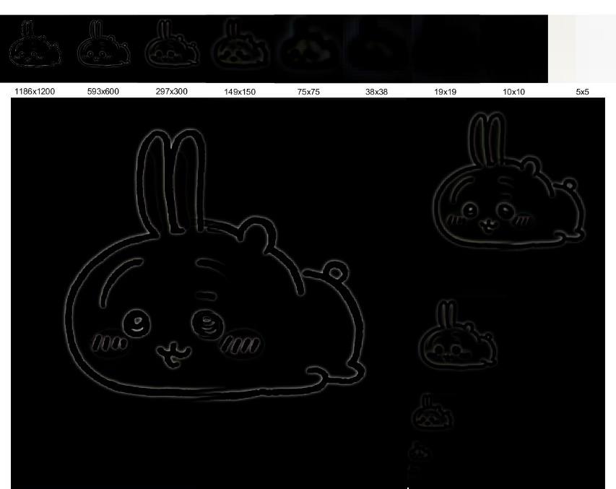

#### Result

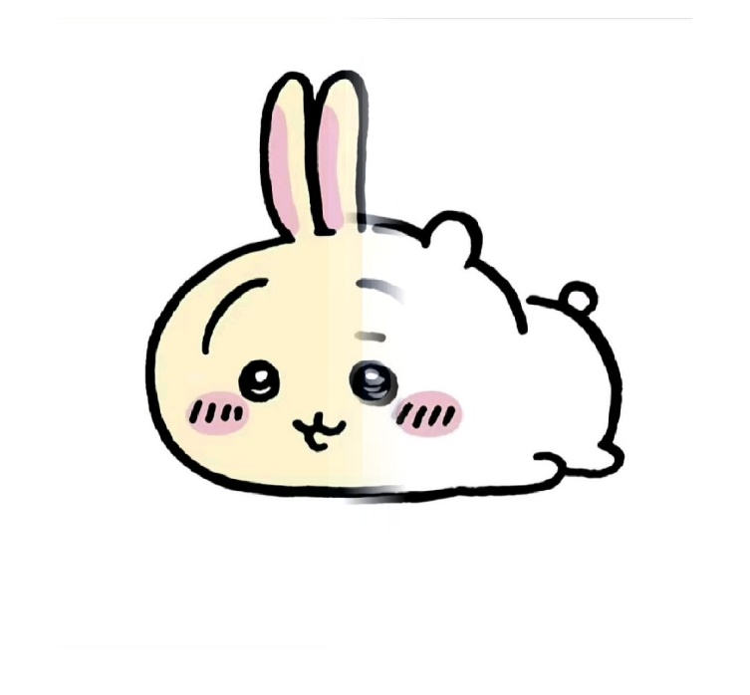

Parameters: Gaussian kernel size=25, sigma=5, window=[0.45 0.55].

### Castle Scenes – Scene1 & Scene2 (Regional)

#### Original Input Images

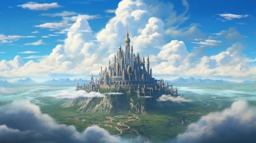 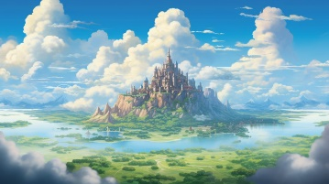 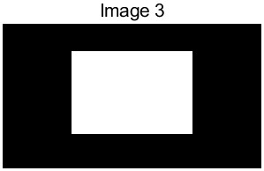

#### Blend Pyramid

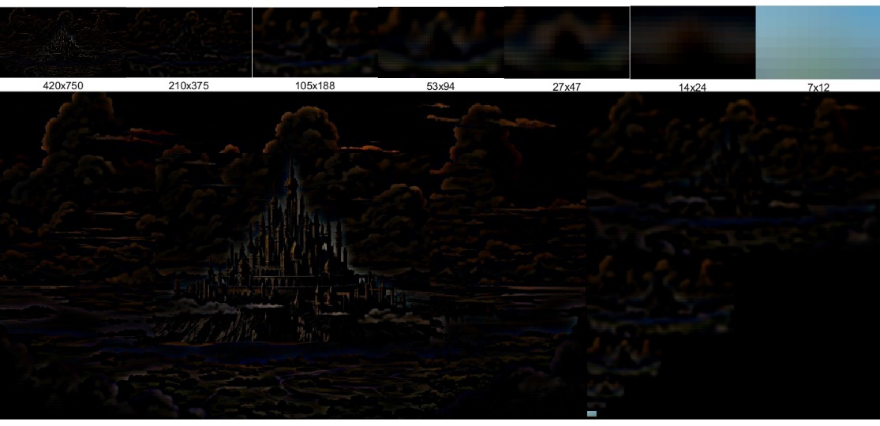

#### Result

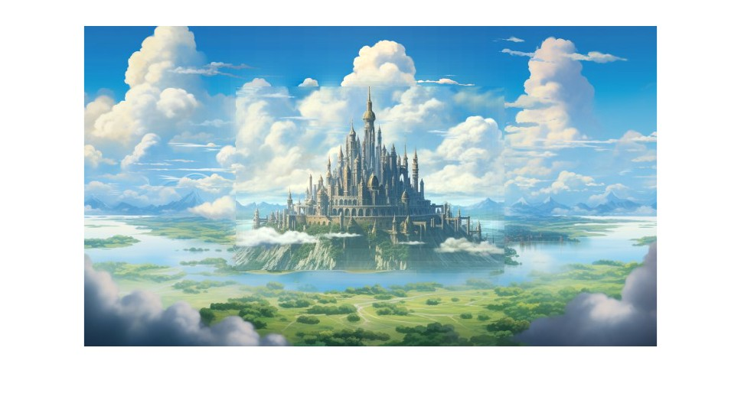

Parameters: Gaussian kernel size=25, sigma=5.

# Flow Chart

## Generating Image Pyramids

## Hybrid Images

## Blend Images