**LATTICE METHODOLOGIES**

Def. **Lattice:** partially ordered set of points.

**COX-ROSS-RUBISTEIN MODEL**

1. **Price tree generation:** the spot price follows a recombinant binomial tree. At each step, the underlying moves up/down by a factor

$u=e^{σ\sqrt{δt}}$ $d=\frac{1}{u}= e^{- σ\sqrt{δt}}$ by NA: 0 < d < (1+r) < u

At the end of n subperiods, the underlying stock price is: $S_{t}=S_{o}u^{j}d^{n-j}$. Assuming the underlying is lognormal: $\log\left(\frac{S_{t}}{S_{o}}\right)\sim N\left(μt, σ\sqrt{t}\right).$ u and d are set in such a way that the moments of the binomial distribution match the moments of the normal distribution.

1. **Compute option value at each FINAL NODE**
2. **Compute option value at each EARLIER NODE until valuation date**

The fair price of the option in the expected value under Q of its future payoff, discounted by r.

$$π=f-∆S$$

Choose delta so that the portfolio is risk-free: $∆=\frac{f_{u}-f_{d}}{S_{u}-S_{d}}$

Therefore $π_{o}= π_{u}e^{-r δt}$

Value of the option at each earlier node: $f_{0}=e^{-r δt}(qf_{u}+\left(1-q\right)f_{d})$

Where the risk neutral probability is: $q=\frac{e^{r δt}-d}{u-d }$

**AMERICAN PUT OPTION**

Payoff $ψ\left(S_{t}\right)=\max{(K-S_{t}, 0)}$

Price: $\max_{t ∈τ}{E^{Q}[e^{-rt}ψ\left(S_{t}\right)]}$, where $τ:set of stopping times$

Going backwards from maturity to valuation date, at each step we must check for early exercise.

The optimal exercise price is the first date in which the *intrinsic value* of the option is > than the *continuation value*.

$$T^{*}=\min\left(j≥0:ψ\left(S_{j}\right)≥E^{Q}\left[e^{-r ∆t}P_{j+1} | S_{j}\right]\right)$$

$$Price= max(ψ\left(S_{j}\right),{E^{Q}\left[e^{-r ∆t}P_{j+1} | S_{j}\right]) }$$

**MONTE CARLO SIMULATIONS**

When we have a model, there are 3 ways to solve for the price:

1. **Integral: $P= e^{-rt}\int{Payoff*density}dx= e^{-rt}\int{{(S\left(T\right)-K)}^{+}\frac{1}{2π}e^{\frac{-x^{2}}{2}}}dx$**

Solve with numerical approximation: quadrature methods.

1. **Monte Carlo Simulations**: expectation under *Q* of the payoff of the contract under different simulated scenarios.
2. **Solve the PDE**

**FEYNMAN-KAC THEOREM**

Establishes a link between PDE and Monte Carlo: the solution on the PDE can be seen as an expectation:

$v\left(x,t\right)=E\left[e^{-\int_{t}^{T}{k\left(s\right)ds}}ϕ\left(X\left(T\right)\right)| X\left(t\right)=x\right]$ where $ϕ\left(X\left(T\right)\right)=terminal condition$

**MONTE CARLO METHODS**

X random variable with distribution $P_{X}$. We wish to estimate**: $Θ=E[X]$**

Take a set of *iid* random variables: $x_{1}, x_{2},…, x_{n}$ with distribution $P_{X}.$ Then, we can use $\hat{Θ}$ as an approximation of $Θ$.

${\hat{Θ}}_{n}= \sum_{i=1}^{n}{\frac{x_{i}}{n}}$ mean**:** E[ ${\hat{Θ}}_{n}]= Θ$ variance: Var[${\hat{Θ}}_{n}]= \frac{Var(X)}{n}$

${\hat{Θ}}_{n}$ converges to $Θ$ when n $→∞$

* **Law of Large Numbers: $\lim_{n→∞}{P(|Θ-{\hat{Θ}}_{n}|}≥ ε)=0$**
* **Central Limit Theorem : $\frac{n{\hat{Θ}}_{n}-nΘ}{\sqrt{n}σ}→N(0,1)$**

The **error of the Monte Carlo** is: ${\hat{Θ}}_{n}-Θ$ $→$*N(0, $\frac{\hat{σ^{2}}}{n})$ S*tandard error : $\frac{\hat{σ}}{\sqrt{n}}$. Convergence rate: O($n^{-\frac{1}{2}}$)

**Confidence interval**: $Θ ∈\left({\hat{Θ}}_{n}± z_{\frac{δ}{2}}\frac{\hat{σ}}{\sqrt{n}}\right)$, with z = $ϕ^{-1}(1-δ)$

**Random generator:** *Inverse transformation method*

1. Random sampling from uniform U([0,1]) and obtain *u.*
2. Find a transformation ***F*** of U, which must be: monotonically increasing and bijective. ***F*** is the inverse of a CDF. F is the CDF: $F^{-1}=F$

Compute**: F(x) = *u***

1. Take **x** as the random number drawn.

Multidimensional extension: if we have to simulate multiple risk factors at the same time:

* INDEPENDENT: apply inverse transformation to each risk factor: $X_{i}=F^{-1}\left(u_{i}\right)$
* CORRELATED: solve the following system for $X_{i}$

$$F_{i1}\left(x_{i1}\right)= u_{1}$$

$$F_{i2}\left(x_{i2}|x_{i1}\right)= u_{2}$$

$$F_{iK}\left(x_{iK}|x_{i1}, …,x_{i(k-1)} \right)= u_{K}$$

**VARIANCE REDUCTION**

Procedure used to increase the precision of the estimate that can be obtained for a given number of iterations. Since the confidence interval is: $Θ ∈\left({\hat{Θ}}_{n}± z_{\frac{δ}{2}}\frac{\hat{σ}}{\sqrt{n}}\right)$. We want to find a new variable that has:

* Same expectation
* Smaller variance, that determines a smaller confidence interval.

1. **Antithetic variables**

Given X: random variable and g(x) monotone function, we want to estimate $Θ=E[g(X)]$

The antithetic variable estimator is:

$${\hat{Θ}}_{AV}= \frac{g\left(x_{1}\right)+ g\left(x_{2}\right) }{2}$$

Where $x_{1}$ and $x_{2}$ are:

* Sampled from the distribution of X,
* Negatively correlated
* $E\left[{\hat{Θ}}_{AV}\right]=E\left[ \frac{g\left(x_{1}\right)+ g\left(x_{2}\right) }{2}\right]=E\left[g\left(X\right)\right]$ same expectation
* $Var\left[ \frac{g\left(x_{1}\right)+ g\left(x_{2}\right) }{2}\right]=\frac{1}{2}( Var\left(g\left(x_{1}\right)\right)+ Var\left(g\left(x_{2}\right)\right)+2 cov(g\left(x_{1}\right), g\left(x_{2}\right))$ < $Var\left(g\left(x\right)\right)$ because cov < 0.

1. **Control variables**

Given X rv, we aim to estimate $Θ=E\left[g\left(X\right)\right]$

***f(x): control variable***

* Quite similar to g(x). i.e. underlying or closed form solution for the price.
* E[f(x)] is known
$${\hat{Θ}}_{CV}=\frac{1}{n} \sum_{i=1}^{n}{g\left(x_{i}\right)+ α\left(f\left(x_{i}\right)-E\left[f\left(x\right)\right]\right)}$$

* E[${\hat{Θ}}_{CV}$] = E[g(x)]: same expectation
* Var[${\hat{Θ}}_{CV}$] $=Var(g\left(x)\right)+ α^{2}Var\left(f\left(x\right)\right)+2 α Cov(f\left(x\right), g\left(x\right))$

Since we want Var[${\hat{Θ}}_{CV}$] $<Var(g\left(x)\right)$, we minimize Var[${\hat{Θ}}_{CV}$] with respect to alpha

$$foc : \min_{α}{Var\left[{\hat{Θ}}_{CV}\right]=2α Var\left(f\left(x\right)\right)+2 Cov\left(f\left(x\right), g\left(x\right)\right)=0 }$$

$$α=- \frac{Cov(f\left(x\right), g\left(x\right))}{Var(f\left(x\right))}$$

1. Choose control variable *f*
2. Run a fast MC to estimate the covariance and the expected value of f (if unknown)
3. Run MC to compute the price.

**CONTINUOUS PROCESS SAMPLING**

To sample solutions of an SDE: $dX\left(t\right)=μ\left(x,t\right)dt+σ\left(t,x\right)dW\left(t\right)$:

1. Simulate the process at a discrete set of times: create a *time grid* over the interval [0,T], splitting it into $∆t$-sized intervals. The starting state $x_{o}$ is known.
2. Interpolate to produce a continuous-time trajectory.
3. **EXACT TRANSFORMATION:** the exact transition density must be known for any pair of consecutive times.
 $$p\left(t,x;s,y\right)=P\left(X\left(t\right)=x \right| X\left(s\right)=y)$$

  1. Create time grid.
   2. For i in 1…N, sample $x_{i}=p(t_{i}, x_{i};t_{i-1}, x_{i-1})$
   3. Return ${\left\{x_{i}\right\}}_{i=1…N }$ as sample of the process X on [0,T]

Example: Vasicek: normal transition density (moments of the distribution can be easily computed from the parameters of the model).

1. **EXACT SOLUTION:** the strong solution of an SDE is explicit if it can be expressed ad analytic functional G of time t and random noise until time t: $X\left(t\right)=G(t, W_{0,t})$
   1. Create time grid.
   2. For i in 1…N, sample random noise $W\left(t_{i}\right)$
   3. Return ${\left\{x_{i}\right\}}_{i=1…N }=G(t_{i}, \left\{W\left(t_{1}\right),…, W\left(t_{i}\right)\right\}$ as sample of the process X on [0,T].

Example: Geometric Brownian Motion $dX\left(t\right)=X\left(t\right)(rdt+σdW(t)$

Exact solution in known: $X\left(t\right)=x_{o}e^{\left(r-\frac{σ^{2}}{2}\right)t+σW\left(t\right)}$

Discretize: $X_{i+1}=X_{i} e^(\left(r-\frac{σ^{2}}{2}\right)∆t+σ\sqrt{∆t}z_{i}$

Where $z_{i}=random sampling from N(0,1)$

1. **APPROXIMATE THE DYNAMICS**, by discretizing the SDE:

* **Euler Scheme: $X_{i+1}=X_{i}+μ\left(t_{i}, X_{i}\right)∆t+ σ\left(t_{i}, X_{i}\right)\sqrt{∆t}z_{i}$**
* **Milstein Scheme: $X_{i+1}=X_{i}+μ\left(t_{i}, X_{i}\right)∆t+ σ\left(t_{i}, X_{i}\right)\sqrt{∆t}z_{i}+\frac{1}{2}σ^{'}\left(X_{i}\right)σ\left(X_{i}\right)∆t(z_{i}^{2}-1)$**

**CEV MODEL- constant elasticity of variance**

$$dX\left(t\right)=μX\left(t\right)dt+σX{\left(t\right)}^{β}dW(t)$$

**HESTON MODEL- stochastic volatility**

$$dX\left(t\right)=μX\left(t\right)dt+ \sqrt{v\left(t\right)}X\left(t\right)dW_{1}\left(t\right)$$

$$dv\left(t\right)=α\left(σ-v\left(t\right)\right)dt+ξ\sqrt{v\left(t\right)}dW_{2}(t)$$

Where $dW_{1}\left(t\right)dW_{2}\left(t\right)=ρ$

Feller condition: $if 2ασ>ξ^{2} →then the process is strictly positive$

**JUMP PROCESSES**

$$J\left(t\right)= \sum_{j=1}^{N(t)}{Y_{j} }$$

* $Y_{j}$**:** determines the jump SIZE. It’s generated through an assigned distribution (i.e. Normal).
* $N(t)$**: COUNTING PROCESS:** number of jumps that have occurred until time t.

Poisson: $f_{N\left(t\right)}\left(n\right)= \frac{e^{-λt}{\left(λt\right)}^{n}}{n!}$

$T_{i}:interarrival times \sim exp(λt)$

$τ_{i}:jump times \sim U[0,T]$

**Simulations:**

* 1. **CONDITIONAL SIMULATION:**

1. Simulate number of jumps occurring in [0,T]: N(t) $\sim Poisson(λt)$
2. Simulate the exact location of the jumps: $τ_{i}\sim U[0,T]$
3. Return: jump times and poisson realizations
   1. **COUNTDOWN SIMULATION:**
4. Sample jumps in sequential order: $T_{i}\sim Exp\left(λt\right)$
5. Find location of jumps: $τ_{i}=τ_{i-1}+T_{i}$
6. Return: number of jumps and exact location

**MIXED JUMP-DIFFUSION MODELS**

$$dX\left(t\right)=μ\left(x,t\right)dt+σ\left(t,x\right)dW\left(t\right)+η\left(t, X\left(t^{-}\right)\right)dJ(t)$$

Discretization: idea:

* Sample jump part of the process
* Simulate diffusive part with Euler Scheme
* Add the jumps to the diffusive part

**Euler scheme: $X_{i+1}=X_{i}+μ\left(t_{i}, X_{i}\right)∆t+ σ\left(t_{i}, X_{i}\right)\sqrt{∆t}z_{i}+η\left(t_{j+1}, X_{\left(j+1\right)}\right)Y_{i}$**

Algorithm

1. Generate random jump times: $τ_{i}$
2. For j = 0 : (N-1)
   * simulate $z_{i}$
 $X_{j+1}=X_{j}+μ\left(t_{j}, X_{j}\right)∆t+ σ\left(t_{j}, X_{j}\right)\sqrt{∆t}z_{i}$ $if$ * a jump occurs in *(j+1):*
     + Simulate the jump size $Y_{i}$, from a distribution

$X_{j+1}=X_{j+1}+η\left(t_{j+1}, X_{j+1}\right)Y_{i}$

**NUMERICAL SOLUTION OF EQUATION**

Solve: *f(x) = 0*

1. **BISECTION METHOD**

If *f* is:

* 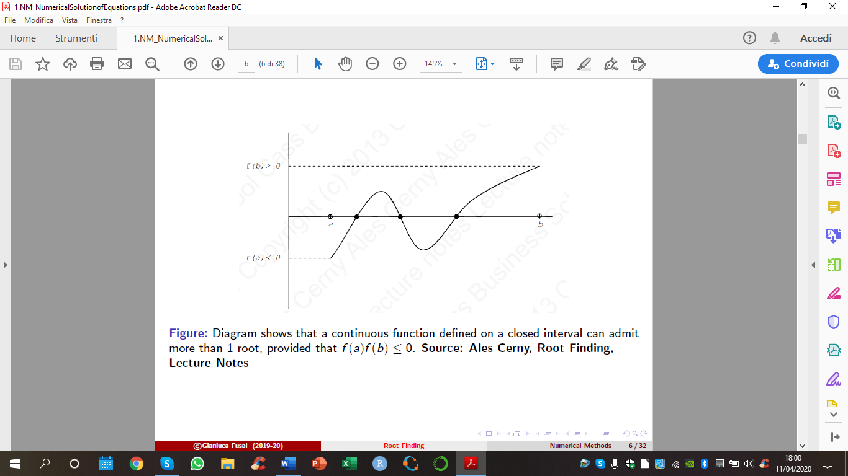Continuous on [a,b]
* $f\left(a\right)f\left(b\right)≤0:$ opposite signs at the endpoints

then, $∃ c ∈\left[a,b\right] such that f\left(c\right)=0$

If there are *n roots:*

* Even roots: you find them with *probability = 0*
* Odd roots: you fine them with *equal probabilities*

ALGORITHM:

1. **Halve** the original interval → $c_{k}=\frac{a_{k}+b_{k}}{2}$
2. If $f\left(a_{k}\right)f\left(c_{k}\right)<0$ → the new interval is: $[a_{k}, c_{k}]$

If $f\left(a_{k}\right)f\left(c_{k}\right)>0$ → the new interval is: $[ c_{k}, b_{k}]$

1. The iterations stop when a preassigned level of tolerance is obtained:|b – a |

**Convergence: $\left|b_{k}-a_{k}\right|=\frac{\left|b_{o}-a_{o}\right|}{2^{k}}$**

If we want a 1-digit precision: ${|b}_{k}-a_{k}|=\frac{1}{10} |b_{o}-a_{o}|$

$K=\frac{ln10}{ln2 }$ → slow convergence

1. **NEWTON-RAPHSON METHOD**

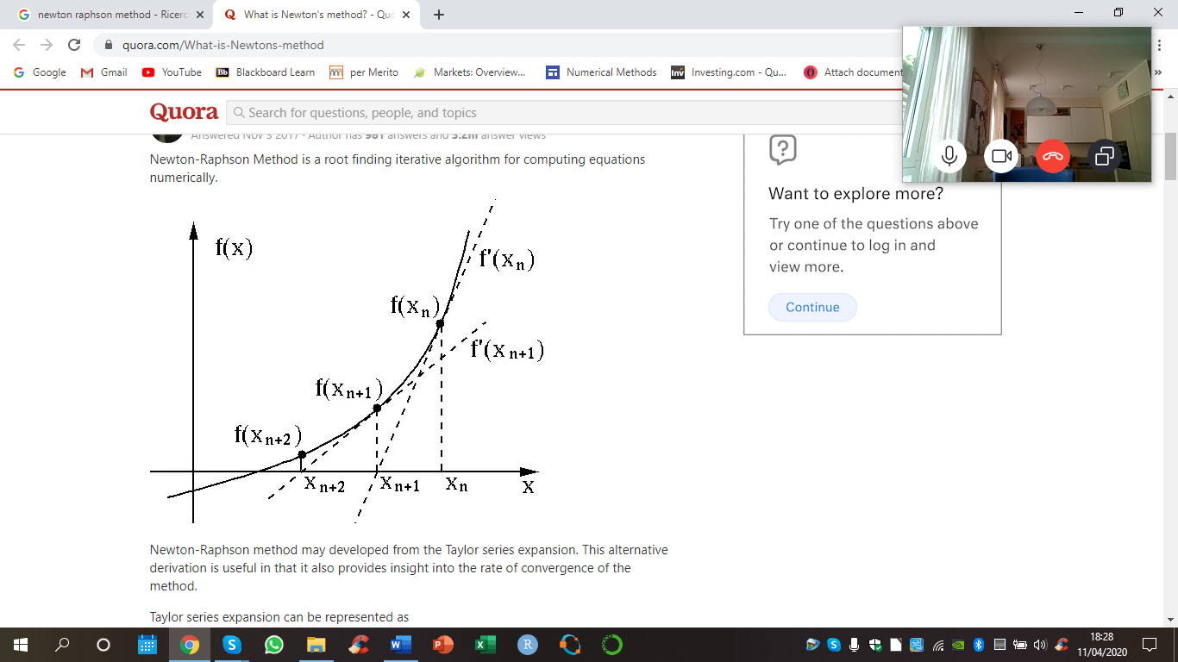*f(x)*: continuous and differentiable.

1. Starting point: $x_{o}$
2. Exploit *first order Taylor expansion* of *f* around *xk*.
3. Iterations stop when $\frac{f\left(x_{k}\right)}{f'(x_{k})}$ is small

**Convergence Conditions:**

$f'\left(x\right)≠0$

$f^{''}\left(x\right) continuous$

$x_{o} starting point sufficiently close to root r: \left|x_{o}-r \right|<δ$

Then, all the iterations also satisfy: $\left|x_{k}-r \right|<δ$

There exist a constant c, such that: $\left|x_{k+1}-r \right|<c\left(δ\right) {\left|x_{k}-r\right|}^{2}$ → **quadratic converge**

1. **SECANT METHOD**

Numerical approximation of the derivative: backward method

$$x_{k+1}=x_{k}-f\left(x_{k}\right)\frac{(x_{k}-x_{k-1})}{f\left(x_{k}\right)-f(x_{k-1})}$$

**Superlinear convergence: $\left|x_{k+1}-r \right|<c\left(δ\right) {\left|x_{k}-r\right|}^{2}$**

**Derivatives approximation: FINITE DIFFERENCES**

* **FORWARD METHOD: $f^{'}\left(x\right)= \frac{f\left(x+h\right)-f(x)}{h}$**
* **CENTRED METHOD: $f^{'}\left(x\right)= \frac{f\left(x+h\right)-f(x-h)}{2h}$**
* **BACKWARD METHOD: $f^{'}\left(x\right)= \frac{f\left(x\right)-f(x-h)}{h}$**

**MODEL CALIBRATION**

Choosing the parameter set Θ that minimizes the distance between: cross-section of model quantities and market observables.

$$\hat{Θ}= \underset{Θ}{argmin}{|\left|Y^{MOD}\left(Θ\right)-Y^{MKT}|\right|}$$

1. **Non linear least squared regression**

$$Y_{j}^{MKT}=Y_{j}^{MOD}\left(Θ\right)+ε_{j}$$

NLLS estimator is asymptotically normally distributed: $\hat{Θ}$- $\hat{Θ} \sim N(0,\frac{σ^{2}}{n} Q^{-1})$

Where Q is consistent estimate of the asymptotic Variance-Covariance matrix:

$$Q=\frac{s^{2}}{n}{\left(H^{'}H\right)}^{-1}$$

$$- s^{2}=\frac{1}{n-k }\sum_{i=1}^{n}{\hat{ε_{i}^{2}} , where \hat{ε_{i}}=y_{i}-h(X_{i}, }\hat{Θ})$$

$- H_{m}\left(i,j\right)=\frac{dh}{dΘ_{j}}$: Jacobian matrix (matrix of partial derivatives with respect to the parameter set)

1. **Quadratic loss function** to be minimized in order to estimate the parameters:

Mean-squared error = $MSE_{P}= \sum_{i=1}^{N}{w_{i}{\left(P_{i}^{MOD}\left(Θ\right)-P_{i}^{MKT}\right)}^{2}}$

Percentage mean-squared error = $PMSE_{P}= \sum_{i=1}^{N}{w_{i}{\left(\frac{P_{i}^{MOD}\left(Θ\right)-P_{i}^{MKT}}{P_{i}^{MKT}}\right)}^{2}}$

**NELSON-SIEGEL MODEL**



$$R_{NS}= β_{o}+\left(β_{1}+\frac{β_{2}}{k}\right)\frac{(1-e^{-τK})}{τk }-\frac{β_{2}}{k}e^{-τk}$$

$β_{o}=long term rate \lim_{τ→∞}{R_{NS}= β_{o}}$

$β_{1}=weight attached to the short term component$ $\lim_{τ→0}{R_{NS}= β_{o}}+ β_{1}$

$β_{2}=weight attached to the medium term component$

$k =point of beginning of decay$

The set of parameters is chosen in such a way that:

$$\hat{θ}= \min_{θ}{\sum_{i=1}^{n}{{\left(R_{NS}-R_{MKT}\right)}^{2}}}$$

**NEWTON’S METHOD: minimization of a function**

Locally approximate the function *f* with a quadratic function. Exploit Second order Taylor expansion:

$$f\left(x\right)\sim f\left(x_{k}\right)+∇f\left(x_{k}\right)\left(x-x_{k}\right)+\frac{1}{2}(x-x_{k})'H(x_{k})(x-x_{k})$$

* $∇f\left(x_{k}\right):$ GRADIENT VECTOR: vector of first order partial derivatives
* $H\left(x_{k}\right):$ HESSIAN MATRIX: matrix of second order partial derivatives

1. ***First order condition: $∇f{\left(x_{k}\right)}^{'}+H\left(x_{k}\right)\left(x-x_{k}\right)=0$***
$$x_{k+1}= x_{k}-{\left(H\left(x_{k}\right)\right)}^{-1}∇f{\left(x_{k}\right)}^{'}=x_{k}-\frac{f^{'}\left(x_{k}\right)}{f^{''}(x_{k})}$$

2. ***Second order condition***

$∇ =0$

* H positive definite

**Convergence:** if we start sufficiently close to the minimum, the convergence is **quadratic.**

$$\left|x_{k+1}-x^{*}\right|≤c{\left|x_{k}-x^{*}\right|}^{2}$$

We can define a general class of algorithms:

$$x_{k+1}= x_{k}-α_{k}M∇f{\left(x_{k}\right)}^{'}$$

* $α_{k}$**:** search parameter
* **M:**
  + If M = ${\left(H\left(x_{k}\right)\right)}^{-1}$, Newton Method
  + If M = 1, Steepest Descent Method

**NUMERICAL INTEGRATION**

**NEWTON-COTES INTEGRATION**

1. Fix the abscissas: spit interval into evenly spaced subintervals → $h=\frac{b-a}{m}$
2. Approximate the function with an interpolating polynomial: $p_{n}\left(x_{i}\right)=f(x_{i})$
3. The integral is the sum of the integrals computed in each subinterval:
$$I_{n,m}\left(f\right)=h \sum_{j=1}^{m-1}{\sum_{i=1}^{n}{f_{i,j}w_{i,j}}}$$

4. **RECTANGLE RULE:** sample the function at the beginning of each subinterval

$I_{0,m}=h \sum_{j=1}^{m-1}{f(x_{j})}$ convergence: order 1

1. **MIDPOINT RULE:** sample the function in the middle of each subinterval

$I_{1,m}=h \sum_{j=1}^{m-1}{f\left(\frac{x_{j+1}+x_{j}}{2} \right)}$ convergence: order 2

1. **TRAPEZOID RULE:** convergence: order 2

$$I_{1,m}=\frac{h}{2} \sum_{j=1}^{m-1}{\left({f(x}_{j})+{f(x}_{j+1})\right)=h \left(\frac{1}{2}f\left(x_{1}\right)+f\left(x_{2}\right)+…+f\left(x_{m-1}\right)+\frac{1}{2}f\left(x_{m}\right)\right)}$$

**GAUSSIAN QUADRATURE**: automatically selects n abscissas and n weights. Convergence of order **2n -1**

$I_{n}=\sum_{i=1}^{n}{w_{i} f\left(x_{j}\right)}$

**ADAPTIVE QUADRATURE:** integrate f(x) using 2 integration methods $I_{1}$ and $I_{2}$. Split the interval until the difference between the two approximation is small enough: $\frac{ {|I}_{1}-I_{2}|}{|I_{1}|}<tol$.

**IMPLIED VOLATILITY**

**SKEWNESS PREMIUM:** percentage deviation of OTM call prices from OTM put prices: $SK\left(x\right)=\frac{c(S,T;X_{c})}{p(S,T;X_{p})}-1$

|  |  |  |
| --- | --- | --- |
| **SK < 0** | **SK = 0** | **SK > 0** |
| **LEVERAGE effect:**   * Positive returns, $↓$ volatility * Negative returns, $↑$ volatility |  | **INVERSE LEVERAGE effect:**   * Positive returns, $↑$ volatility * Negative returns, $↓$ volatility |
| **LEFT skew** | **SYMMETRIC - leptokurtic** | **RIGHT skew** |
| **Skew** | **Smile** | **Skew** |
| **CEV $$β<1$$** | **CEV $$β=1$$** | **CEV $$β>1$$** |
| **HESTON $$ρ<0$$** | **HESTON $$ρ= 0$$** | **HESTON $$ρ>0$$** |
| **JUMP PROCESS**  Negative jumps | **JUMP PROCESS**  No jumps (or 0 expected value) | **JUMP PROCESS**  Positive jumps |

**SHIMKO APPROACH**

1. Solve Black-Scholes for implied volatility.
2. Approximate the implied volatility curve with a quadratic interpolation: OLS regression
$$\hat{σ}\left(K\right)=a+bK+cK^{2}$$

3. Generate the corresponding option prices using $\hat{σ}\left(K\right)$ with Black and Scholes.
4. Obtain the implied density: *Breeden and Litzenberger Approach:*

* Implied CDF: $\frac{dc}{dK}$
* Implied DENSITY $= \frac{∂^{2}c}{∂K^{2}}$

**OPTION PRICING with INTEGRATION**

$S_{X}=E_{t}^{Q}[G\left(S_{T}\right)]$ = $\int{G\left(x\right)f_{S_{T}}\left(x\right) dx}$ = $\int{payoff*density dx}$

**Payoff**

$european CALL → G\left(S_{T}\right)={\left(S_{T}-K\right)}^{+}$

$european PUT → G\left(S_{T}\right)={\left({K-S}_{T}\right)}^{+}$

**Density:** under BS $S_{T}$ follows Geometric Brownian Motion: $S_{T}$ is lognormal

**Price**

$$c_{t}=e^{-r\left(T-t\right)}\int_{K}^{+∞}{\left(X_{T}-K\right) f_{lognormal}dX}$$

$$c_{t}=e^{-r\left(T-t\right)}\int_{logK}^{+∞}{\left(e^{X_{T}}-K\right) f_{normal}dX}$$