**TEORIA Theory of Valuation**

|  |  |
| --- | --- |
| **Under P** | **Under Q** |
|  |  |

**NO ARBITRAGE ANALYSIS**

**Def. ARBITRAGE:** self-financing strategy having:

* Zero or negative cost:
* Positive payoff at maturity: with P [] > 0

**EQUIVALENT MARTINGALE MEASURE**

The market is NA iff there exists a probability measure *Q,* equivalent to *P*, such that *Q is a risk neutral* probability measure:

* qQ is risk neutral if the discounted gain process of S ( ) is a Q-martingale.

The presence of the drift makes it impossible for to be a martingale under P.

By Girsanov Theorem, there exists a Q P, determined by the market price of risk , such that:

Where

* Is a non standard Brownian Motion under P, but there exists a probability measure, equivalent to P (same set of null events), under which
* is a Standard Brownian Motion under Q. Such probability measure is given by Girsanov.

Under Q, the discounted gain process of S is a Martingale (NO DRIFT)

* **FIRST FUNDAMENTAL THEOREM of ASSET PRICING**

If there **exists** a probability measure **Q** risk neutral the market is **NA.**

*(by Girsanov Q exists if exists).*

* **SECOND FUNDAMENTAL THEOREM of ASSET PRICING**

If there exists a **UNIQUE** probability measure **Q** risk neutral the market is **NA + COMPLETE.**

*(by Girsanov Q is unique if exists and is unique).*

*Complete market (same number of non-redundant securities and risk factors) = any European derivative can be replicated.*

**Corollary:** BS market is NA + COMPLETE.

In BS for every derivative security there is one and only one no-arbitrage price.

**NA pricing in BS**

The initial market (B and S) is NA + COMPLETE. Add a European derivative: payoff X and price .

We have to find that preserves NA in the extended market.

→By **Law of One Price:** the price of the derivative must be equal to the cost of buying the replicating strategy, because they determine the same cash flows.

We obtain the **risk neutral evaluation formula**: the NA price is the conditional expected value, under the martingale measure Q of the discounted payoff at maturity.

(t) =

**BS PDE – classical derivation: HEDGING PORTFOLIO**

HEDGING PORTFOLIO: portfolio that the seller of the derivative has to implement in order to end up with a locally riskless position:

With *h* such that the portfolio is:

* **Self-financing** . (Fare Ito di F)
* **Locally riskless**: under P, we want to define h such that the Brownian Motion (source of risk) is cancelled. Therefore, by setting the diffusion coefficient to 0, we obtain

h =

Once you have obtained the PDE, the pricing function F is obtained with *Feynman-Kac Theorem.*

**MULTIDIMENSIONAL BLACK-SCHOLES**

Basket of risky securities:

* : vector of independent Brownian Motions:
* Volatility matrix:

We want to assign to each log-return,

*Var = Corr*

Therefore, we can set: *Cholesky Decomposition*

**SBUELZ**

**UNDERLYING STOCK:** Total return of the stock over the next instant:

=

* : risk premium
* : absorbing boundary

**CASH-AT-HIT-CLAIMS (B-in)**

Payoff: 1 euro the first time the stock hits the barrier B.

* Barrier: exogenous and prespecified at a constant level. No finite maturity.

*Pricing*

*Educated guess****: V(S,B) =***

* 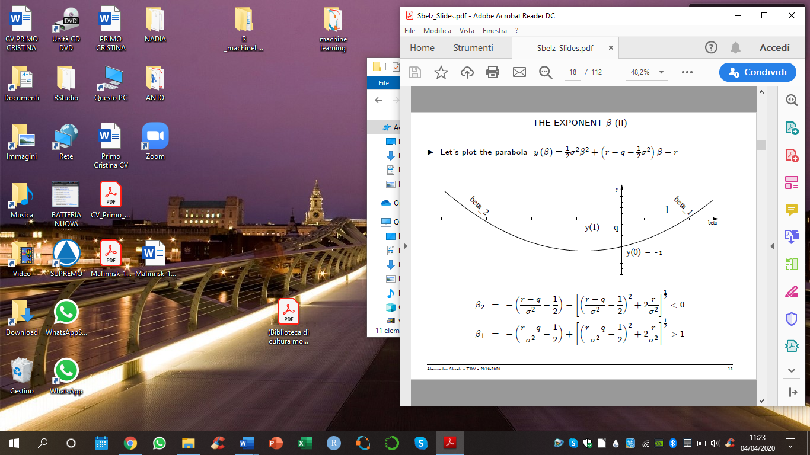Compute and and substitute them into the BS PDE
* Obtain a quadratic equation in

Solve for : 2 solutions

* + - > 0 if B > S
    - < 0 if B < S

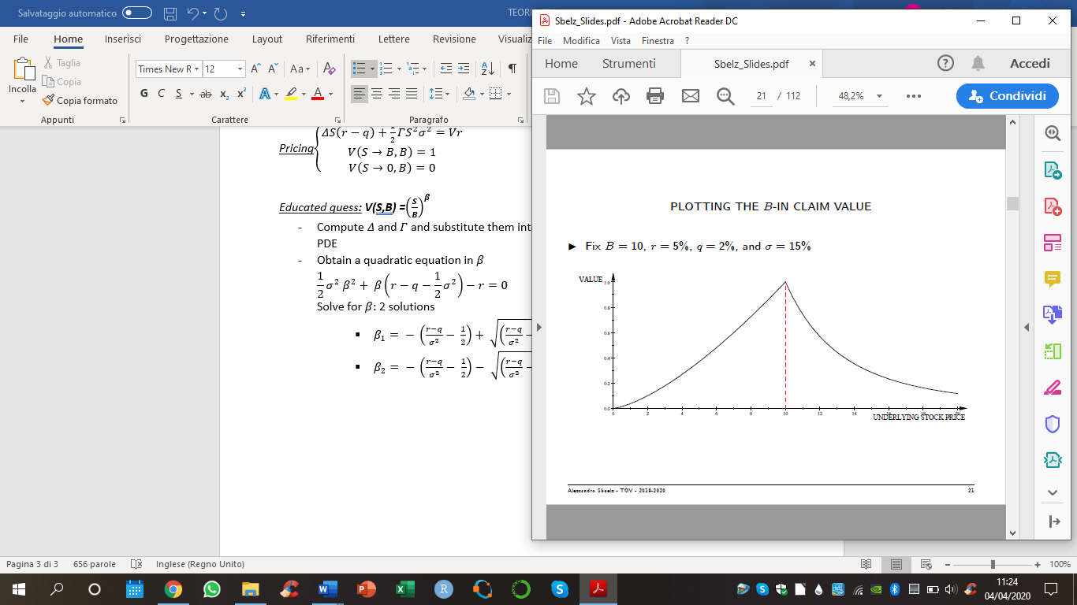

|  |  |  |
| --- | --- | --- |
|  | B > S | B < S |
|  |  |  |
| r |  |  |
| q |  |  |

**PERPETUAL AMERICAN CALL**

Endogenous barrier,

|  |  |
| --- | --- |
|  | B > S |
|  |  |
| r |  |
| q |  |

trade off between Payoff (U – K) and Present value.

Plot value of the call against U, and take the maximum

DYNAMICS under P:

Risk premium = > 0

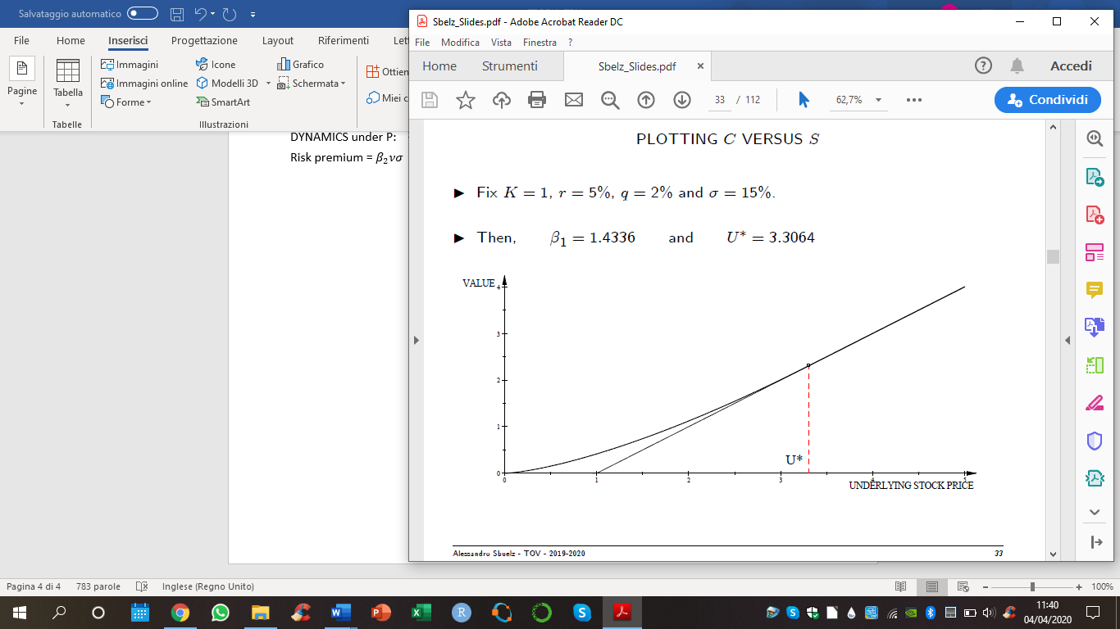

**PERPETUAL AMERICAN PUT**

Endogenous barrier,

|  |  |
| --- | --- |
|  | B < S |
|  |  |
| r |  |
| q |  |

trade off between Payoff (K -L) and Present value.

Plot value of the put against L, and take the maximum

DYNAMICS under P:

Risk premium = < 0 → insurance service

