Installation

Step 1: The first thing to do is set up your Ubuntu Server. Type command below sudo apt install apache2 to install Apache HTTP on Ubuntu server.

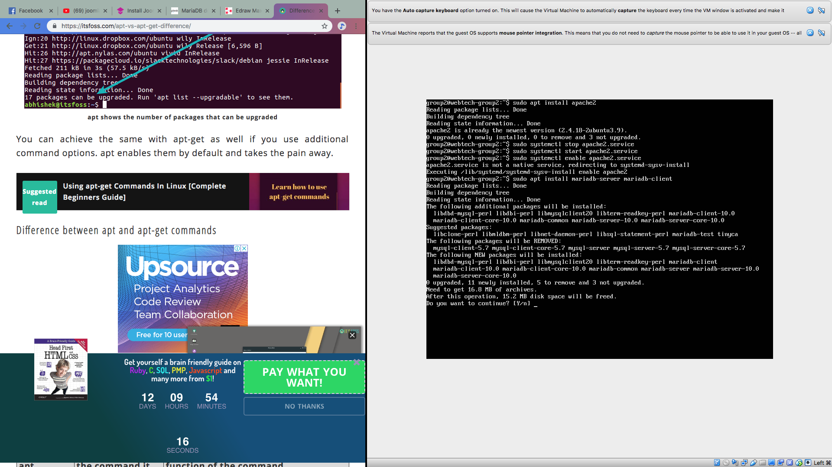

Step 2: After the Apache2 being installed, the stop apache2.service, start apache2.service and enable apache2.service can be used to apache2 service to always start up with the server boots



Step 3: To install MariaDB, type commands below sudo apt install mariadb-server mariadb-client



Step 4: After the MariaDB being installed, here are the commands

