**Read Me: How to get prototype up and running**

**Software needed:**

Microsoft SQL Server Management Studio 18

Visual Studio 2022

**To create the dummy database:**

* + Step 1: Open Microsoft SQL Server Management Studio 18 and connect to the server you have
  + Step 2: copy the text from PROG_DeweyDecimal_Database_Script.txt
  + Step 3: click New Query and paste the code you have copied from the textile
  + Step 4: Start Executing Code Eg. (Note to execute code click the Execute button indicated by the Red Arrow in Figure 1.1)

First highlight the code:

*Create database PROG_ST10117020;*

And click execute

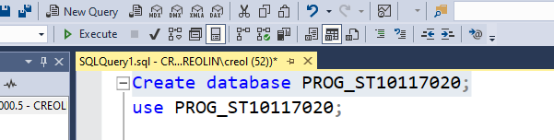

Figure 1.1

* + - Then following the same procedure highlight the code:

*use PROG_ST10117020;*

and click execute

* + - highlight the code:

*Create Table Users*

*(*

*UserID varchar(5) not null Primary key,*

*UserUsername varchar(20)not null,*

*UserEmail varchar(50)not null,*

*UserPassword varchar(100)not null*

*);*

and click execute

* + - highlight the code:

*insert into Users (UserID,UserUsername,UserEmail,UserPassword)*

*VALUES*

*('U01','Admin','Admin@gmail.com','1be9877831148a4c03331057e3acb6af88e3ea312a6e470c8ab1d6779f2df8c7'),*

*('U02','CreoZard5','creolingopal5@gmail.com','3513d9452af7c1768eeba7e47bdd0920aeb18360dc15a1a7759fc0f0e4f3ca02'),*

*('U03','SupaSayen','sn7@gmail.com','e3b0c44298fc1c149afbf4c8996fb92427ae41e4649b934ca495991b7852b855'),*

*('U04','DJ Uitveer','np8@gmail.com','1b56e72e957c16786a0c736d4a17c41f37c61e53b5e6f0a007414828ac7d311d'),*

*('U05','Reaper69','mak4@gmail.com','5f4f045d317c6bb4cce5e8c489dc0e6d8a31522ec0eaff5310d58c74033e7966'),*

*('U06','Sherlock Holmes','nal1@gmail.com','fa76d99ad957d952fb3738ae1ed7282a18d3bca1531c7efc273d52e16b774bd6'),*

*('U07','Swifty','ma9@gmail.com','e6f07d43b5c21db0fbb9a31feac2dc599787763393dd5acbfad80e247eb02ad5'),*

*('U08','KingKumz','kv10@gmail.com','8326e09ce4e90a419a510ed74895cf6713f2fb42b0b3ffc126527ec2b9e95872'),*

*('U09','Gods Kin','kp6@gmail.com','dc9f28b12dd1818ee42ffc92ecb940386214598837348d30d3c6c0b7b57e34c9'),*

*('U10','KeensterJnr','kp12@gmail.com','c886ff11f6a51b611a867475e31b1e8d22a8c1eb99cec8a57c83a32164f083e0');*

and click execute

* + - highlight the code:

*Create Table LeaderboardItems*

*(*

*LeaderboardID varchar(5) not null Primary key,*

*LeaderboardGameType varchar(50)not null,*

*LeaderboardScore int not null,*

*UserID varchar(5) not null,*

*FOREIGN KEY (UserID) references Users(UserID)*

*);*

and click execute

* + - highlight the code:

*insert into LeaderboardItems (LeaderboardID,LeaderboardGameType,LeaderboardScore,UserID)*

*VALUES*

*('L01','Ordering',100,'U01'),*

*('L02','Ordering',46,'U02'),*

*('L03','Ordering',76,'U03'),*

*('L04','Ordering',32,'U04'),*

*('L05','Ordering',15,'U05'),*

*('L06','Ordering',78,'U06'),*

*('L07','Ordering',45,'U07'),*

*('L08','Ordering',98,'U08'),*

*('L09','Ordering',23,'U09'),*

*('L10','Ordering',96,'U10');*

* + - and click execute
    - Optional * highlight the code:

*select * from Users;*

*select * from LeaderboardItems;*

to view all the temporary data we just created

**To connect the database to the Application:**

* + - Step 1 : Open the Folder PROG7312_POE_ST10117020 Figure 2.1 will show up

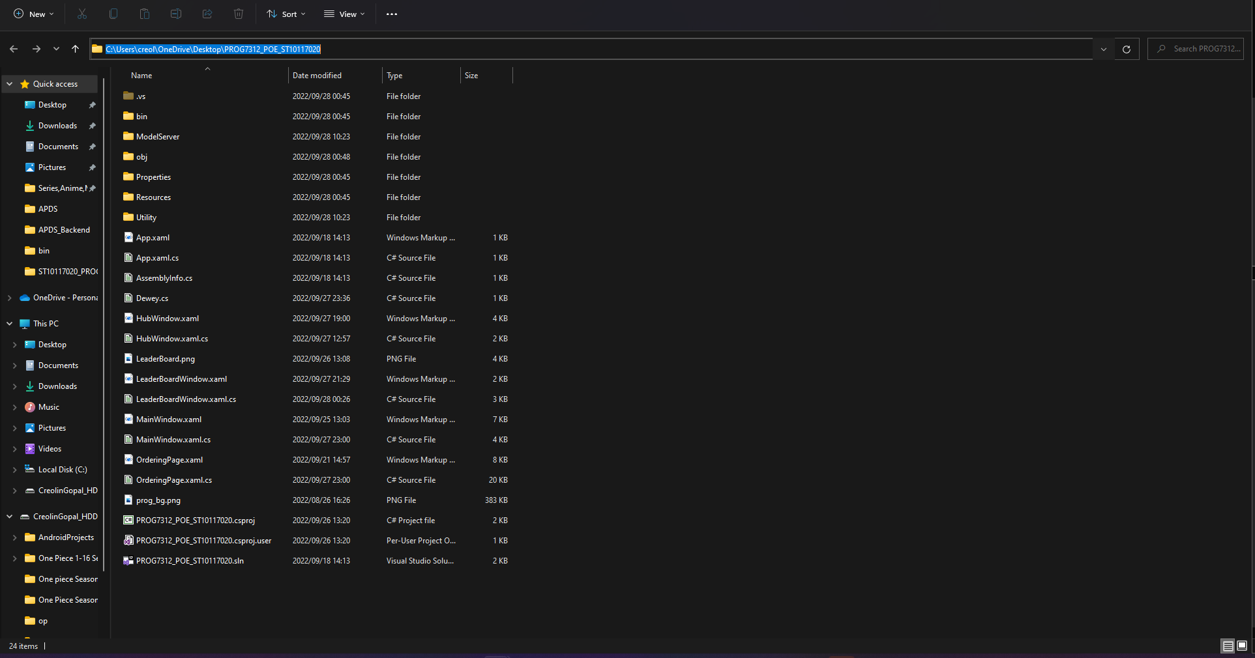



Figure 2.1

* + - Step 2 : Double left click on the file named PROG7312_POE_ST10117020.sln pointed to in Figure 2.1 and Figure 2.2 Should Showup

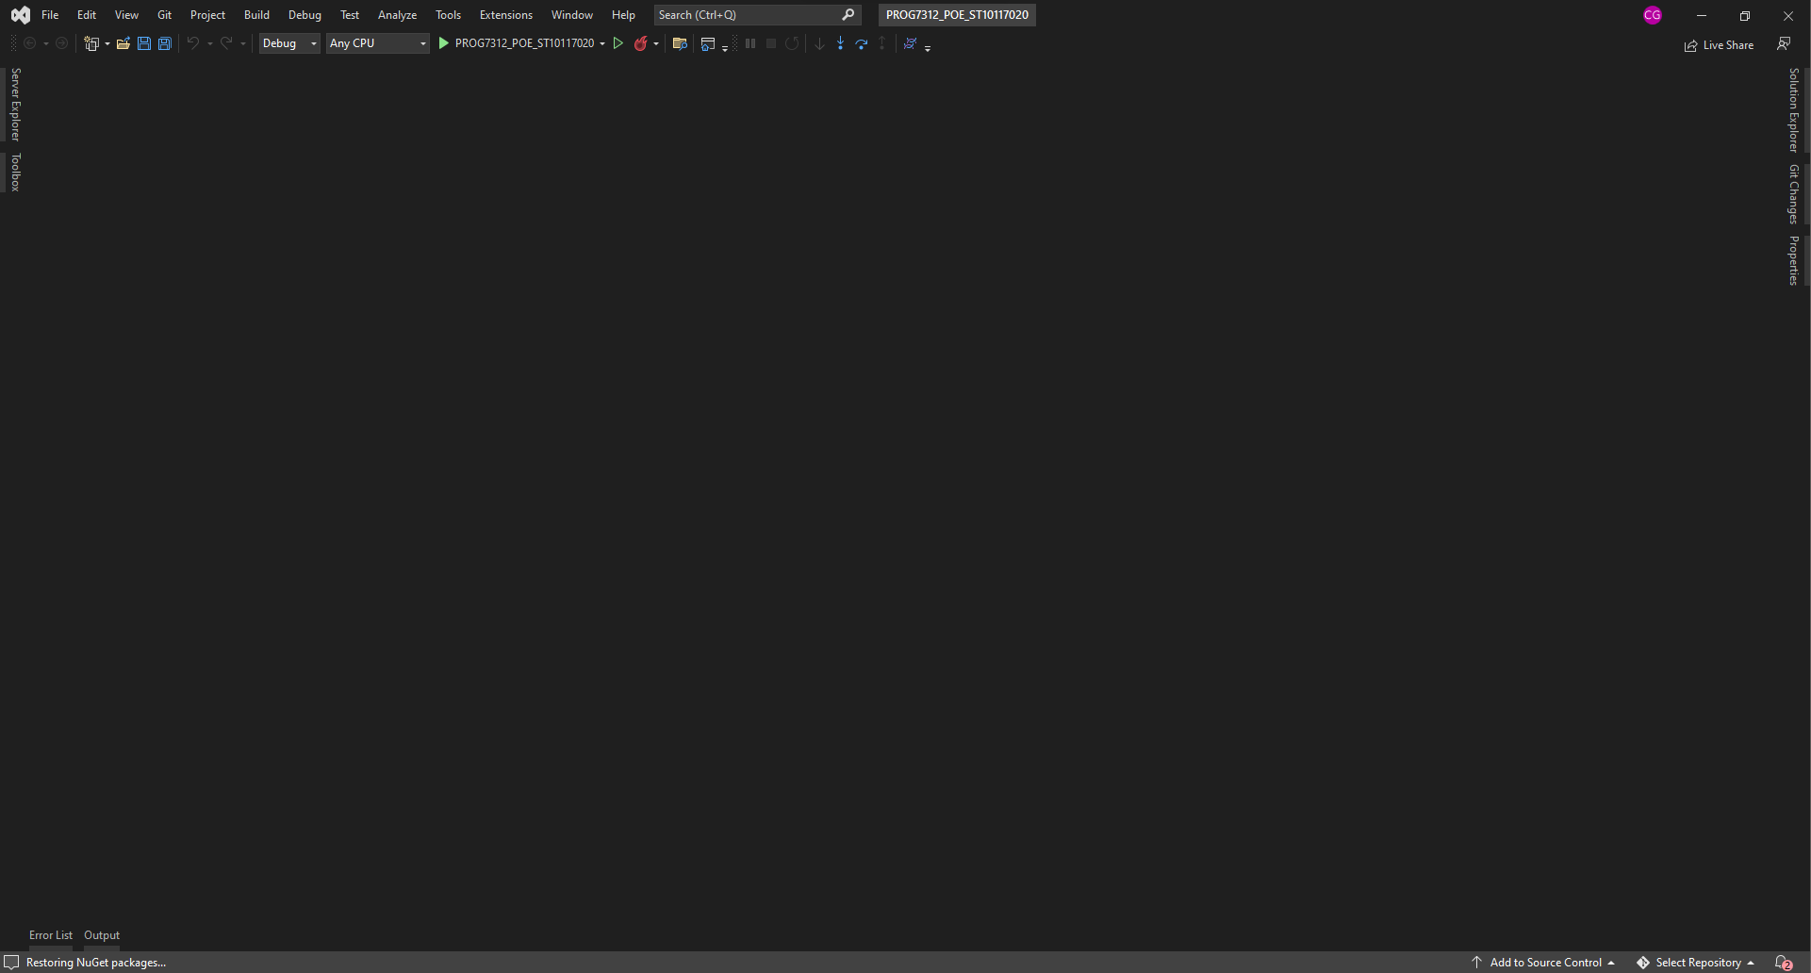

Figure 2.2

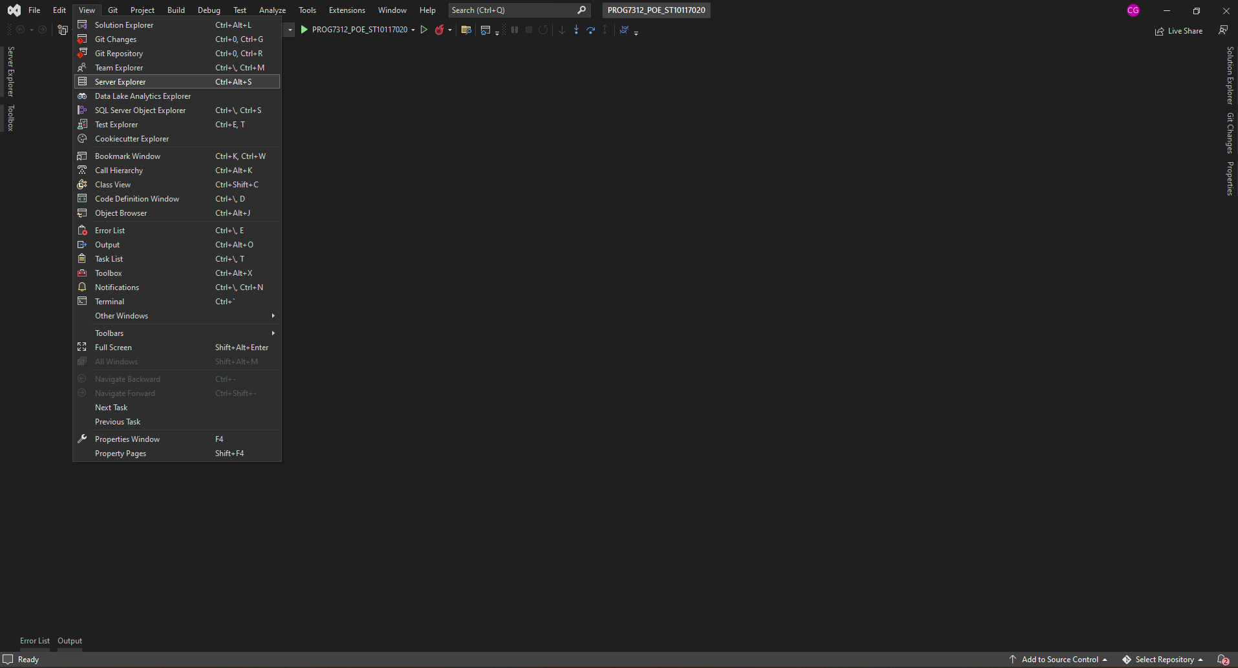

Figure 2.3

* + - Step 3 : On the Left-hand side of the screen there should be a tab labled 'Server Explorer' Pointed to in Figure 2.2 if not click the view button positioned at the top left of the screen and select 'Server Explorer' shown in Figure 2.3
    - Step 4 : Now Right Click on the 'Data Connections' option in the Server explorer tab and select 'New Connections' shown in in Figure 2.4

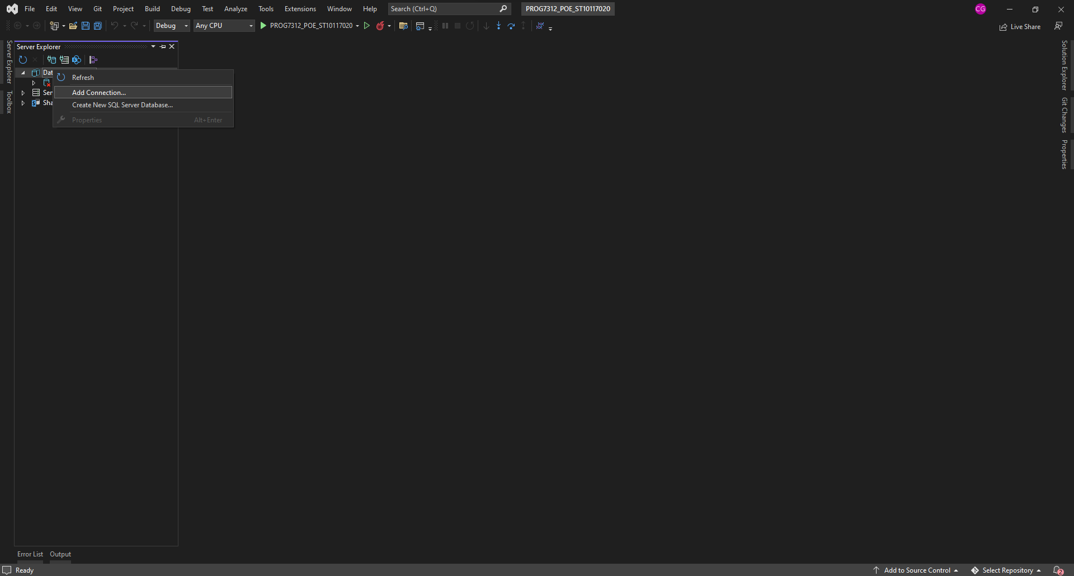

Figure 2.4

* 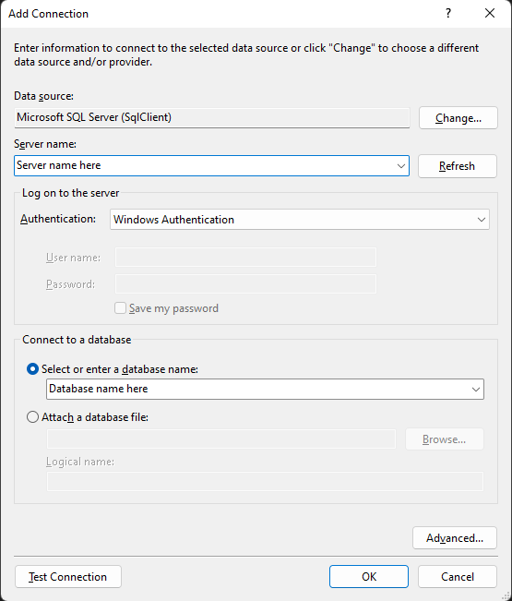Step 5 : The Pop-Up menu will now show and select your server name or paste your current server name in the area for Server name shown in Figure 2.5

Figure 2.5

* Step 6 : now select the name of the Database that you created *PROG_ST10117020* shown in Figure 2.5
* Step 7 : click test connection to know if the connection works before you proceed (to get rid of the popup message click 'ok')
* Step 8 : to complete the Connection click 'ok' located at the bottom right of the Pop-Up menu(upon loading you will see a connection appear on you server explorer )
* Step 9 : Right Click on the connection that popped up and select properties then a tab will open and copy the text at the option where it says connection string

Figure 2.6

* Step 10 : Open the Solution Explorer on the right of the screen by Left Clicking on the tab shown in Figure 2.7

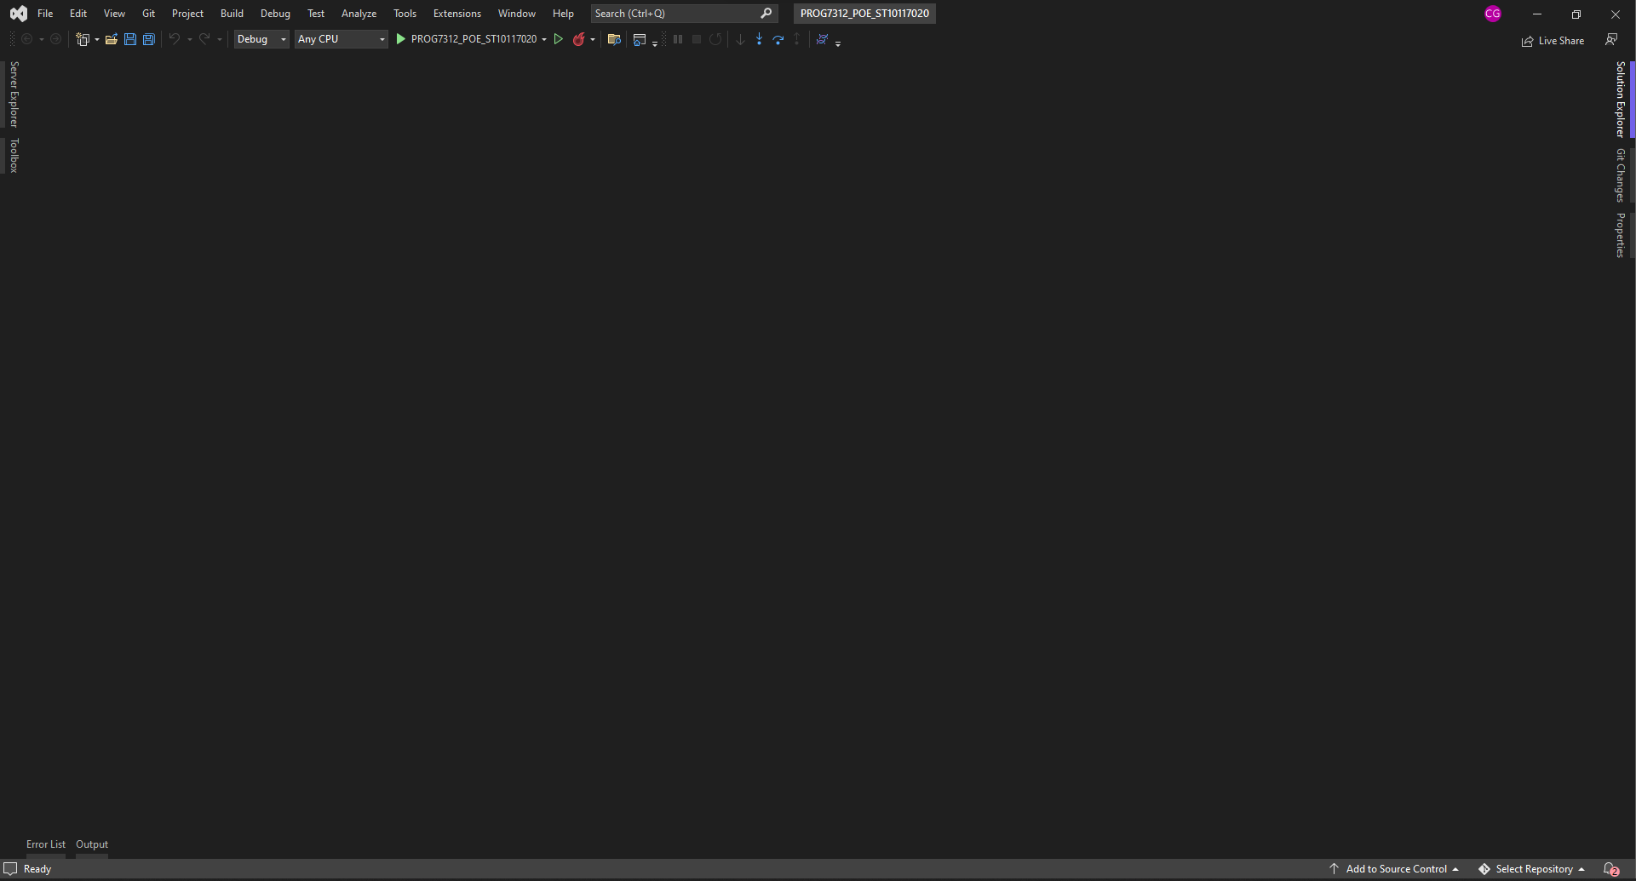

Figure 2.7

* Step 11 : Double left click on the file ConnectionString.cs shown in figure 2.8

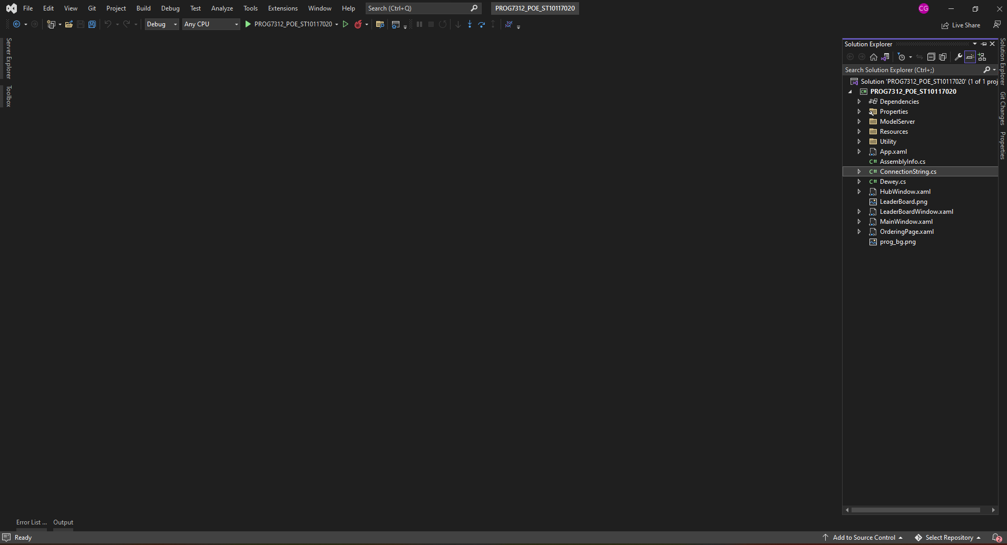

Figure 2.8

* Step 12: Here it will have public static string ConnectionString = "Data Source=*****;Initial Catalog=*****;Integrated Security=True"; shown in Figure 2.9 you have to replace all the text in between the '”' and '”' with the connection string you copied at Step 9

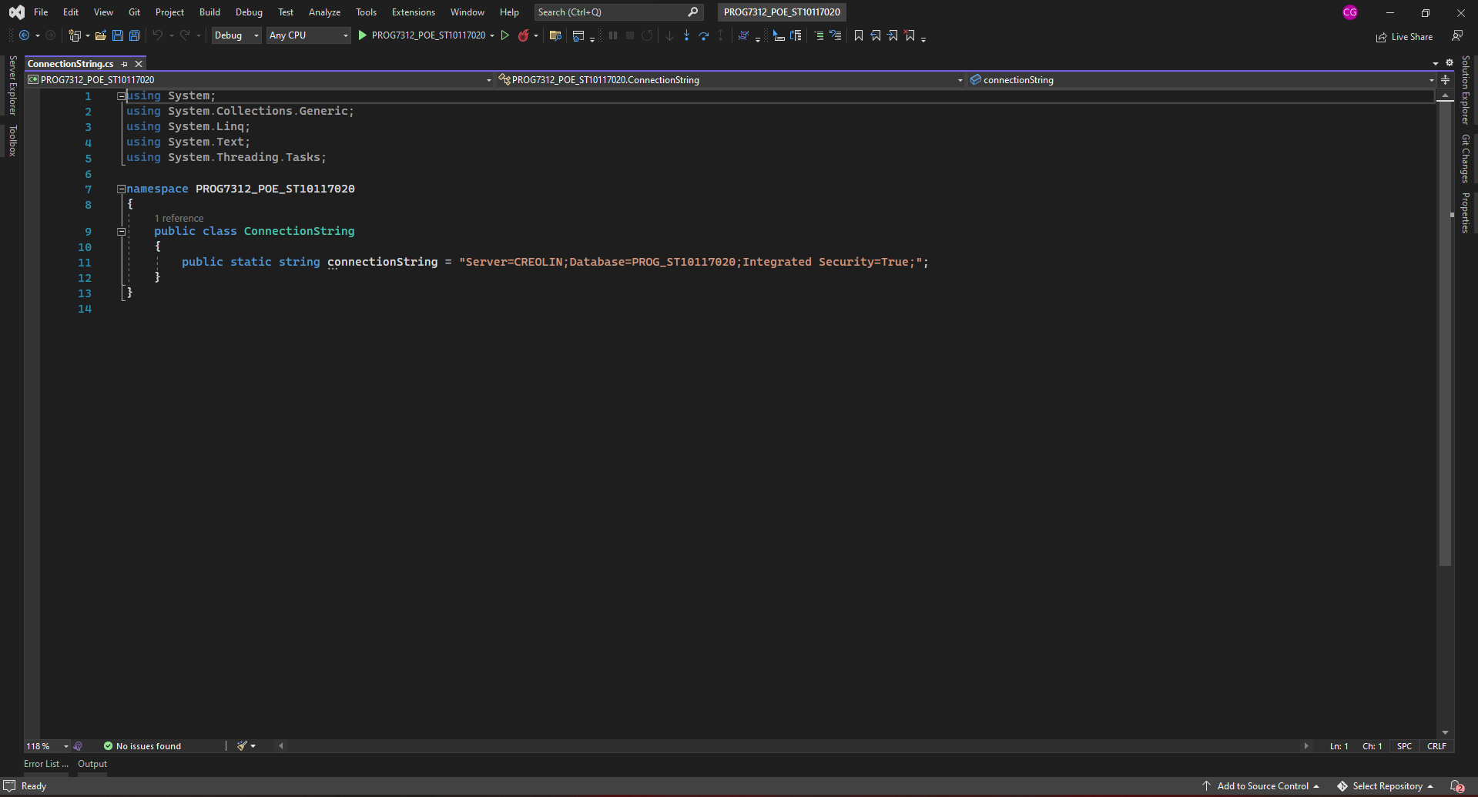

Figure 2.9

* A red letter on a black background

  Description automatically generated with low confidenceStep 13 : Now Left click Build and select Build Solution shown in 2.10

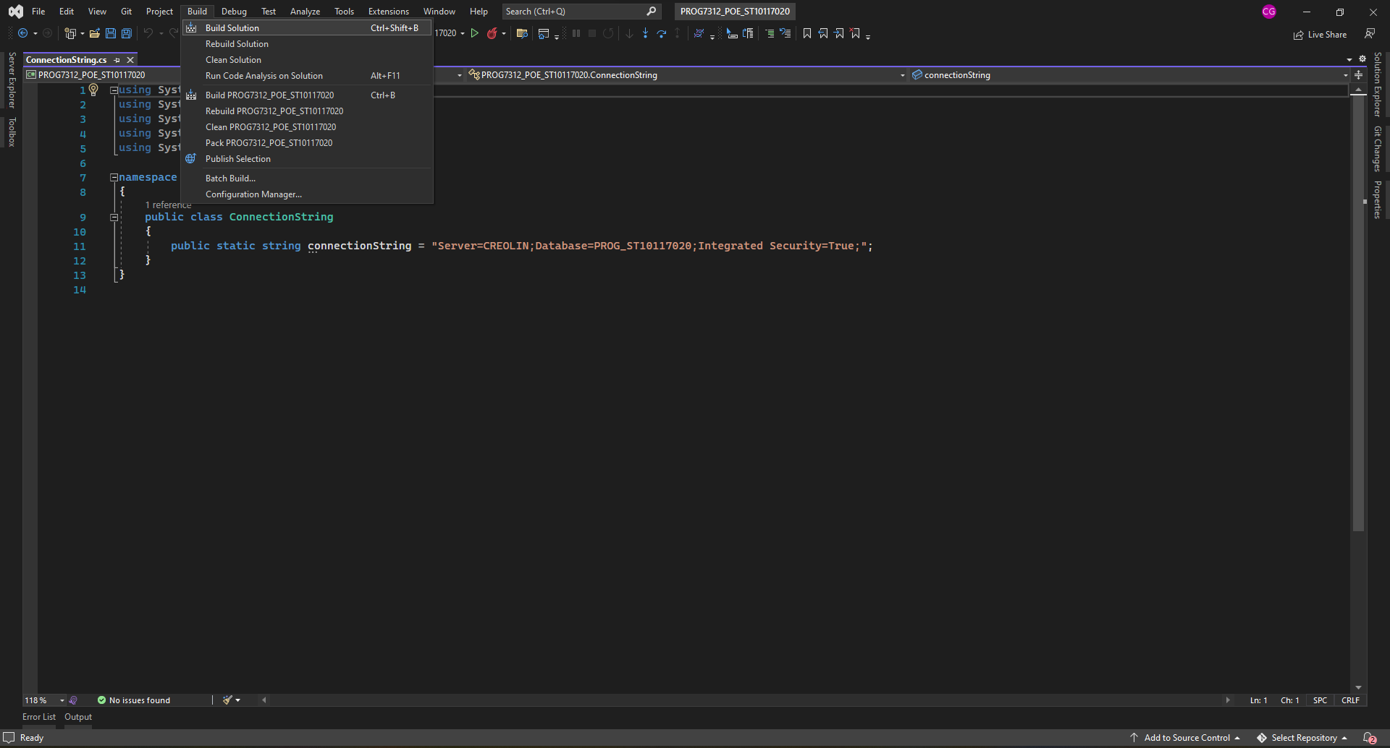

Figure 2.10

**How to run Grimoire Catcher NOTE : after the previous actions/connections are done**

* Step 1 : In the Visual Studios You will Double left click on the button at the top middle of the screen that has a green play button says PROG7312_POE_ST10117020 shown in Figure 2.11

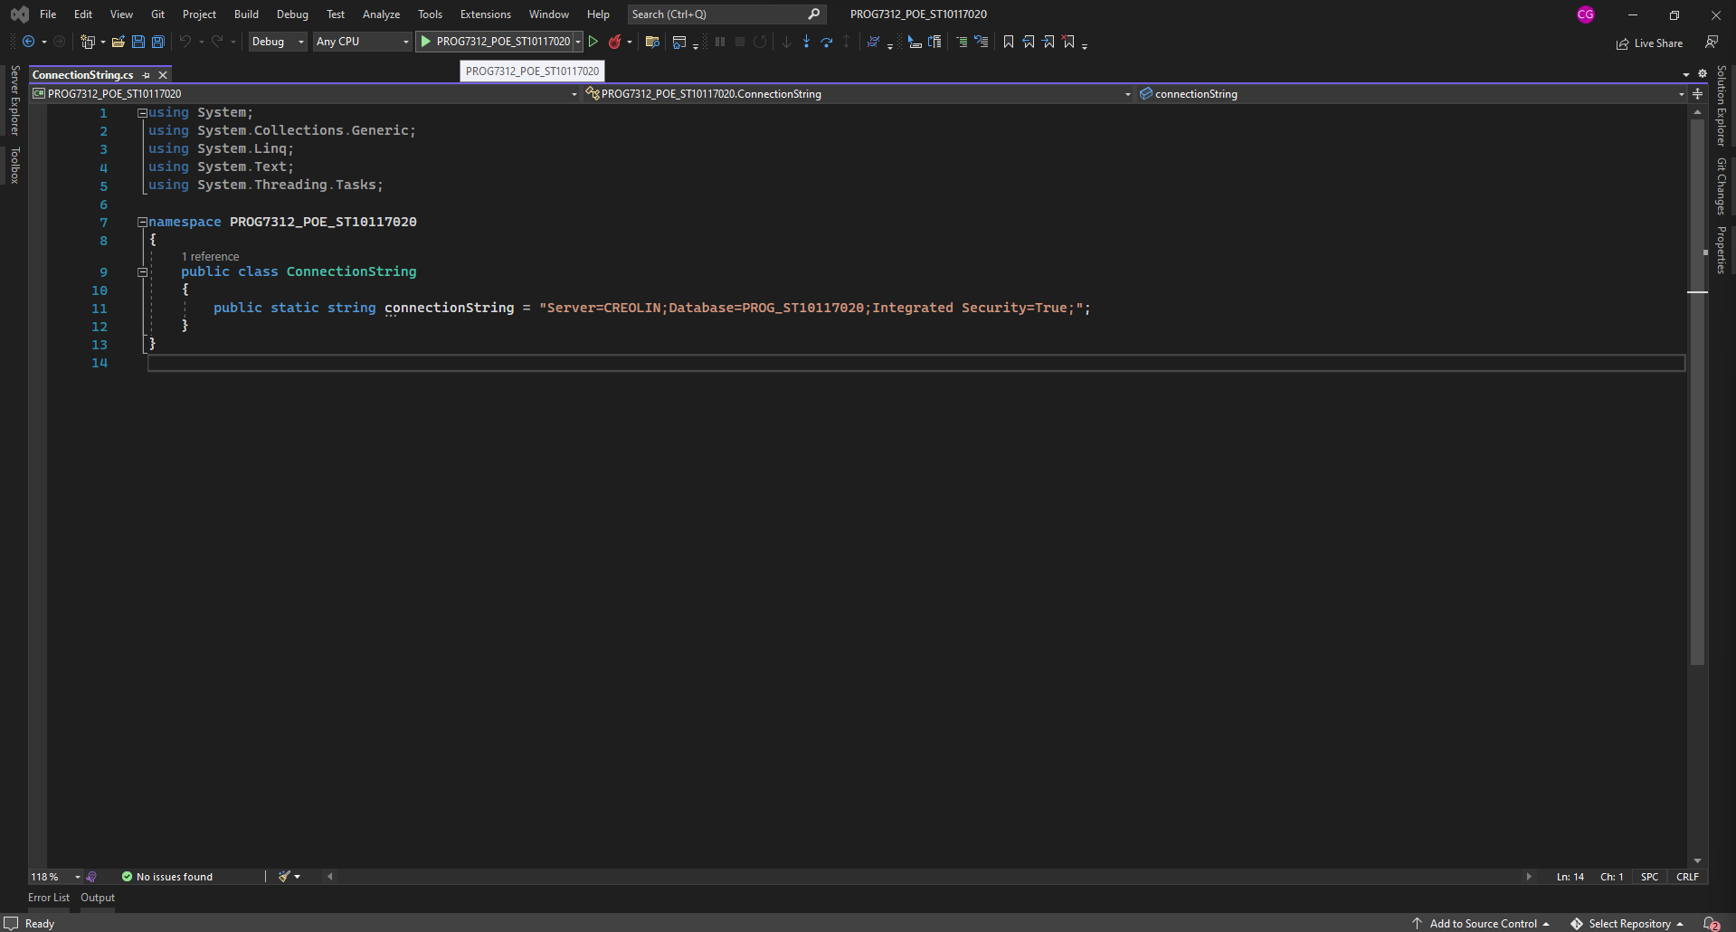

Figure 2.11